Ground State of 1D potential Well by Numerov Method

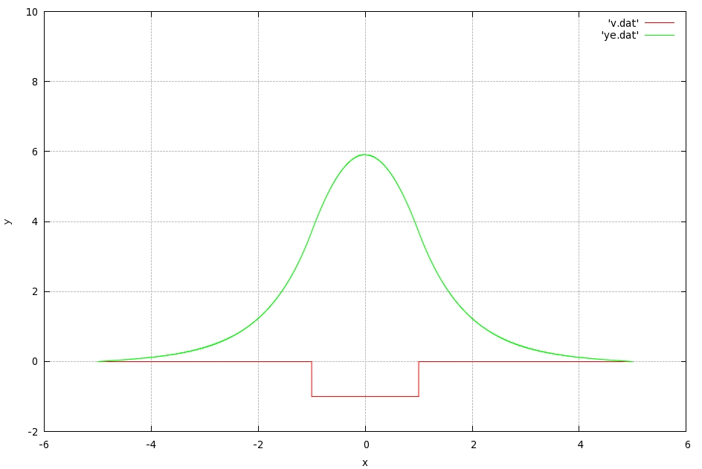
INPUTS:-

-1.0

1.0

0.001

5

0.0001

2

0.0

-0.999

0.0001

0.0001

0.01

# V0 , a, h, xm, del, Ns, xc,espt,cl,cr,ei

