**Project 1**

Deploying a web server in windows instance

1. create a windows instance using AMI : windows 2012 R2 base

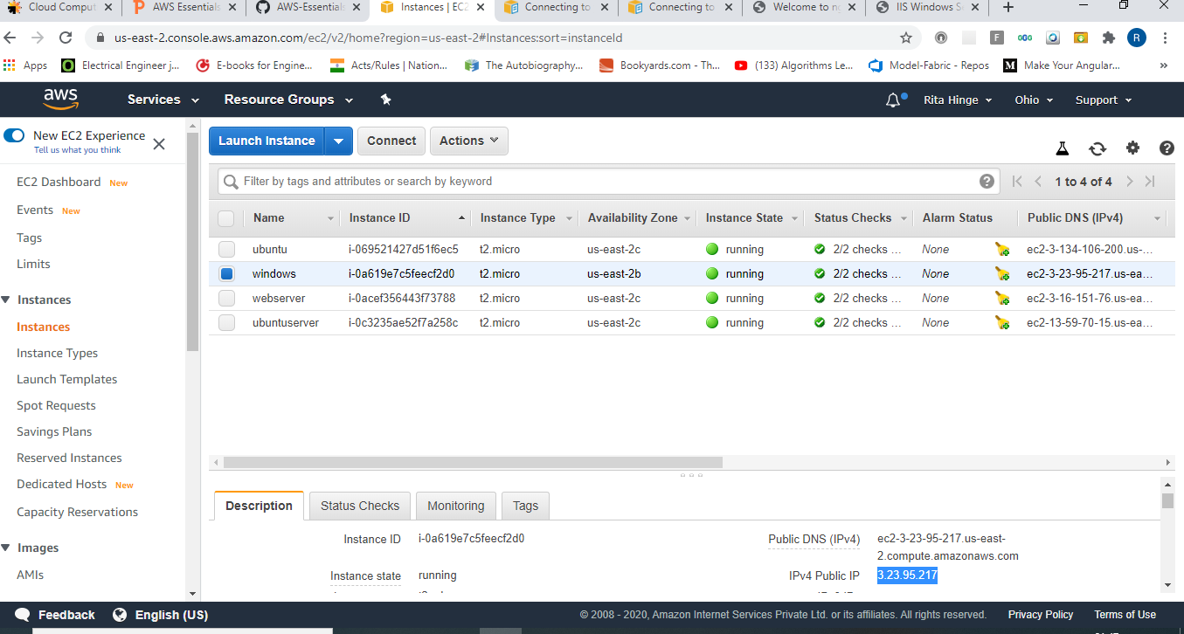

1. verify installation of IIS web server

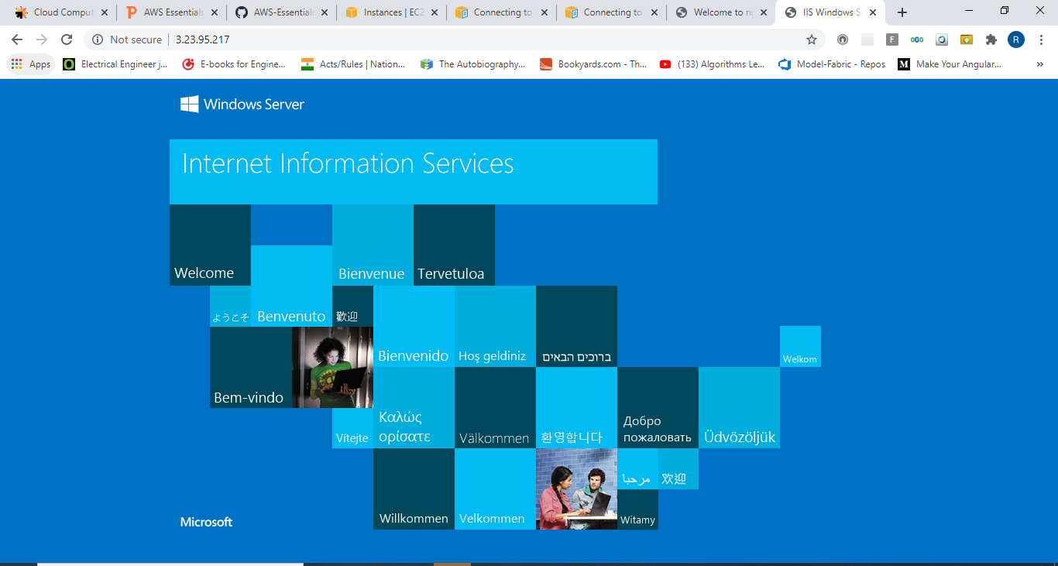

**Project 2**

Deploying web server on Ubuntu instance

1. create a windows instance using AMI

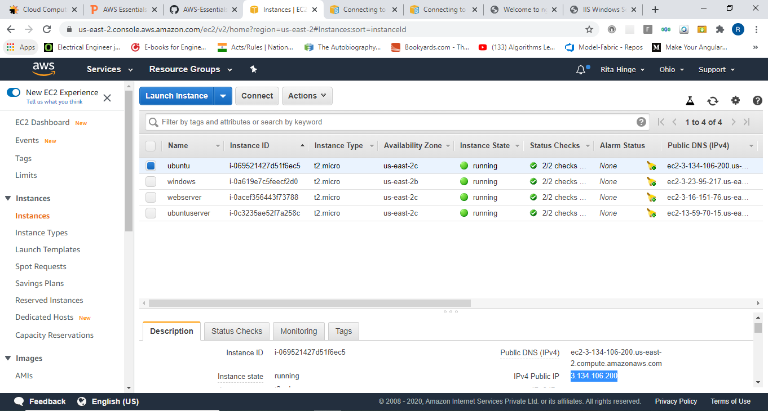

1. verify successful installation of nginx

