**Student-id : 201801015**

**Language Used: Python( Jupyter Notebook )**

**Code: If YOU COPY-PASTE PYTHON CODE THEN INDENTATION WILL BE RUINED AND CODE WONT RUN BECAUSE THE INDENTATION IS NOT COPIED. SO PLEASE USE THE IPYNB FILE ATTACHED AT THE END.**

from collections import defaultdict

import numpy

import sys

# INPUTS

r, c = input("Enter no. of Rows and Columns seperated by a space:").split(" ")

r, c = int(r), int(c)

col_i=[]

row_i=[]

for i in range(c):

col_i.append('D'+str

(int(i)+1))

for i in range(r):

row_i.append('S'+str(int(i)+1))

# Cost values

mat = numpy.zeros((r,c))

trial = [dict() for x in range(r)]

trial_l=[]

another_c=[]

current_net_cost={}

temp=[]

for i in range(r):

temp=input("Enter " + str(c) + " values for Row " +str(i+1) +" seperated by a space:").split(" ")

k=0

for j in range(c):

mat[i][j] = temp[j]

trial[i][col_i[j]]=int(temp[j])

trial_l.append(int(temp[j]))

current_net_cost[row_i[i]]=trial[i]

another_c.append(trial_l)

trial_l=[]

temp.clear()

# Ai values

current_supply={}

another_s=[]

temp=input("Enter " + str(r) + " Ai values seperated by a space:").split(" ")

for i in range(r):

current_supply[row_i[i]]=int(temp[i])

another_s.append(int(temp[i]))

temp.clear()

# Bi values

current_demand={}

another_d=[]

temp=input("Enter " + str(c) + " Bi values seperated by a space:").split(" ")

i=0

for i in range(c):

current_demand[col_i[i]]=int(temp[i])

another_d.append(int(temp[i]))

temp.clear()

col = sorted(current_demand.keys())

cDict = dict((k, defaultdict(int)) for k in current_net_cost)

g = {}

for x in current_supply:

g[x] = sorted(current_net_cost[x].keys(), key=lambda g: current_net_cost[x][g])

for x in current_demand:

g[x] = sorted(current_net_cost.keys(), key=lambda g: current_net_cost[g][x])

# VAN METHOD TO FIND INITIAL BASIC FEASIBLE SOLUTION

while g:

d = {}

for x in current_demand:

d[x] = (current_net_cost[g[x][1]][x] - current_net_cost[g[x][0]][x]) if len(g[x]) > 1 else current_net_cost[g[x][0]][x]

s = {}

for x in current_supply:

s[x] = (current_net_cost[x][g[x][1]] - current_net_cost[x][g[x][0]]) if len(g[x]) > 1 else current_net_cost[x][g[x][0]]

f = max(d, key=lambda n: d[n])

t = max(s, key=lambda n: s[n])

t, f = (f, g[f][0]) if d[f] > s[t] else (g[t][0], t)

v = min(current_supply[f], current_demand[t])

cDict[f][t] += v

current_demand[t] -= v

if current_demand[t] == 0:

for k, n in current_supply.items():

if n != 0:

g[k].remove(t)

del g[t]

del current_demand[t]

current_supply[f] -= v

if current_supply[f] == 0:

for k, n in current_demand.items():

if n != 0:

g[k].remove(f)

del g[f]

del current_supply[f]

basis = set()

nBasis=set()

checkB=[]

cost_final=[]

cost = 0

for g in sorted(current_net_cost):

trial=[]

temp_m=[]

for n in col:

trial=[]

y = cDict[g][n]

temp_m.append(int(y))

if y != 0:

trial.append(int(g[-1])-1)

trial.append(int(n[-1])-1)

basis.add((int(g[-1])-1, int(n[-1])-1))

checkB.append(trial)

else:

nBasis.add((int(g[-1])-1, int(n[-1])-1))

cost += y * current_net_cost[g][n]

cost_final.append(temp_m)

# OUTPUT 1

print("\nInitial BFS:")

for i in range(r):

for j in range(c):

if cost_final[i][j] != 0:

if i==r-1 and j==c-1:

tmp = ""

else:

tmp = ", "

print("X"+str(i+1)+""+str(j+1)+" = "+str(cost_final[i][j]), end = tmp)

print ("\nCost: ",cost)

# MODI METHOD TO FIND THE OPTIMAL SOLUTION

def cycle(m, n, basis):

basis = basis.copy()

row, col = [0]*m, [0]*n

for i, j in basis:

row[i] += 1

col[j] += 1

while True:

ex = True

for k in range(m):

if row[k] == 1:

ex = False

for i, j in basis:

if i == k:

col[j] -= 1

row[i] = 0

basis.remove((i, j))

break

for k in range(n):

if col[k] == 1:

ex = False

for i, j in basis:

if j == k:

row[i] -= 1

col[j] = 0

basis.remove((i, j))

break

if ex:

return basis

if len(basis) < 4:

return None

def poten(C, basis):

inf = float('inf')

u = [inf]*len(C)

v = [inf]*len(C[0])

u[0] = 0

for _ in range(len(basis)):

for i, j in basis:

if v[j] == inf and u[i] != inf:

v[j] = C[i][j] - u[i]

break

elif u[i] == inf and v[j] != inf:

u[i] = C[i][j] - v[j]

break

return u, v

def split(ii, jj, cyc):

neg, pos = set(), set()

pos.add((ii, jj))

for _ in range(len(cyc) >> 1):

for i, j in cyc:

if i == ii and j != jj:

neg_i, neg_j = i, j

break

neg.add((neg_i, neg_j))

for i, j in cyc:

if j == neg_j and i != neg_i:

ii, jj = i, j

break

pos.add((ii, jj))

return neg, pos

def modi(a, b, C, X, basis, nBasis):

m, n = len(a), len(b)

dif = sum(a) - sum(b)

if dif < 0:

a.append(abs(dif))

m += 1

C.append([0 for _ in range(n)])

elif dif > 0:

b.append(dif)

n += 1

for row in C:

row.append(0)

if len(nBasis) == 0:

return X

while True:

u, v = poten(C, basis)

ii, jj = min(nBasis, key=lambda x: C[x[0]][x[1]]-u[x[0]]-v[x[1]])

min_d = C[ii][jj]-u[ii]-v[jj]

if min_d >= 0:

return X

basis.add((ii, jj))

nBasis.remove((ii, jj))

cyc = cycle(m, n, basis)

neg, pos = split(ii, jj, cyc)

i_star, j_star = min(neg, key=lambda el: X[el[0]][el[1]])

theta = X[i_star][j_star]

for el in pos:

X[el[0]][el[1]] += theta

for el in neg:

X[el[0]][el[1]] -= theta

basis.remove((i_star, j_star))

nBasis.add((i_star, j_star))

# OUTPUT 2

print("\nOptimal Solution:")

Op = modi(another_s, another_d, another_c,cost_final,basis,nBasis)

for i in range(r):

for j in range(c):

if Op[i][j] != 0:

if i==r-1 and j==c-1:

tmp = ""

else:

tmp = ", "

print("X"+str(i+1)+""+str(j+1)+" = "+str(Op[i][j]), end=tmp)

opt = 0

for i in range(r):

for j in range(c):

opt = opt + Op[i][j]*mat[i][j]

print("\nOptimal Cost: "+str(int(opt)))

**Screenshot of output:**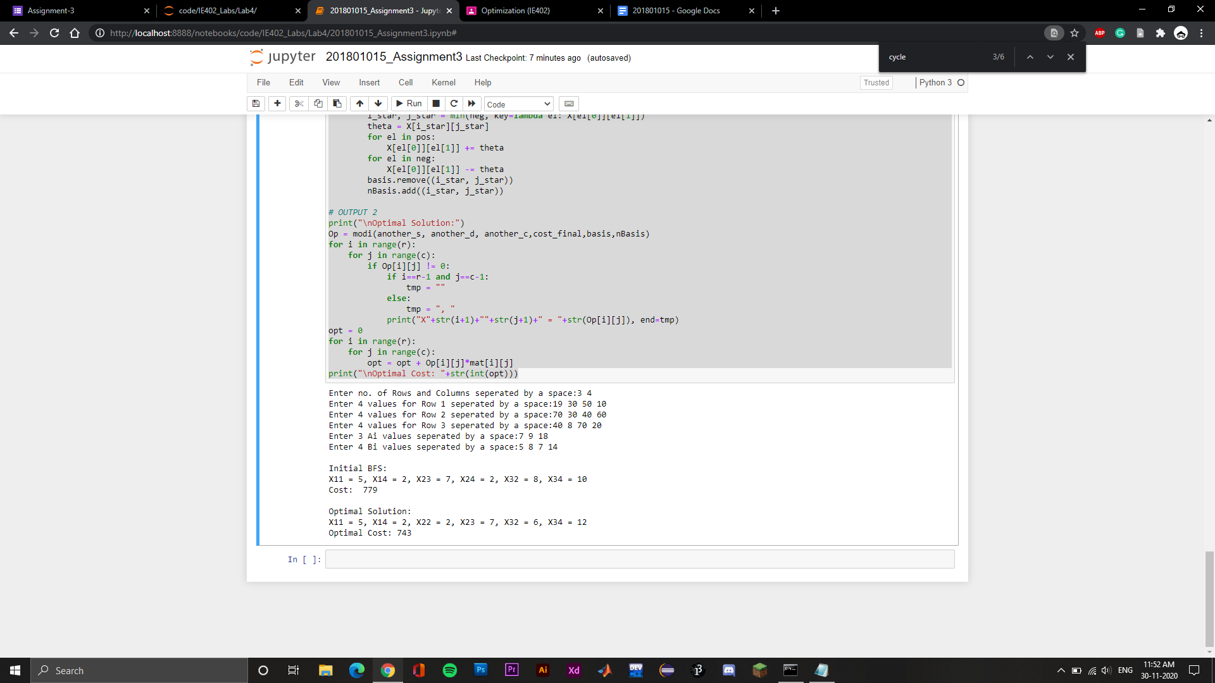

**IDE: Google Collab / Jupyter Notebook**

**GOOGLE COLLAB LINK:** [**COLLAB**](https://colab.research.google.com/drive/1J7ogBj2GeuEAXMCAFV8LfSWmOuAS3Spn?usp=sharing)

**AND DIRECTLY RUN IT IN COLLAB**

**JUPYTER NOTEBOOK CODE FILE:** [**JUPYTER**](https://drive.google.com/file/d/1aL0owZDSqtosmVTWxrKyg4rHxZXSSa8s/view?usp=sharing)

**AND OPEN IT IN JUPYTER NOTEBOOK**