AeroTwin: Presentation Deck & Script Package
Complete 5-Slide Presentation Deck, Timed Voiceover Script, Visual Assets & Evaluation Metrics
Prototype Demo Duration: 90 Seconds (1.5 Minutes)
[SLIDE 1] AeroTwin System Overview & Digital Twin Framework
⏱ Duration: 0:00 – 0:18 (18 Seconds)

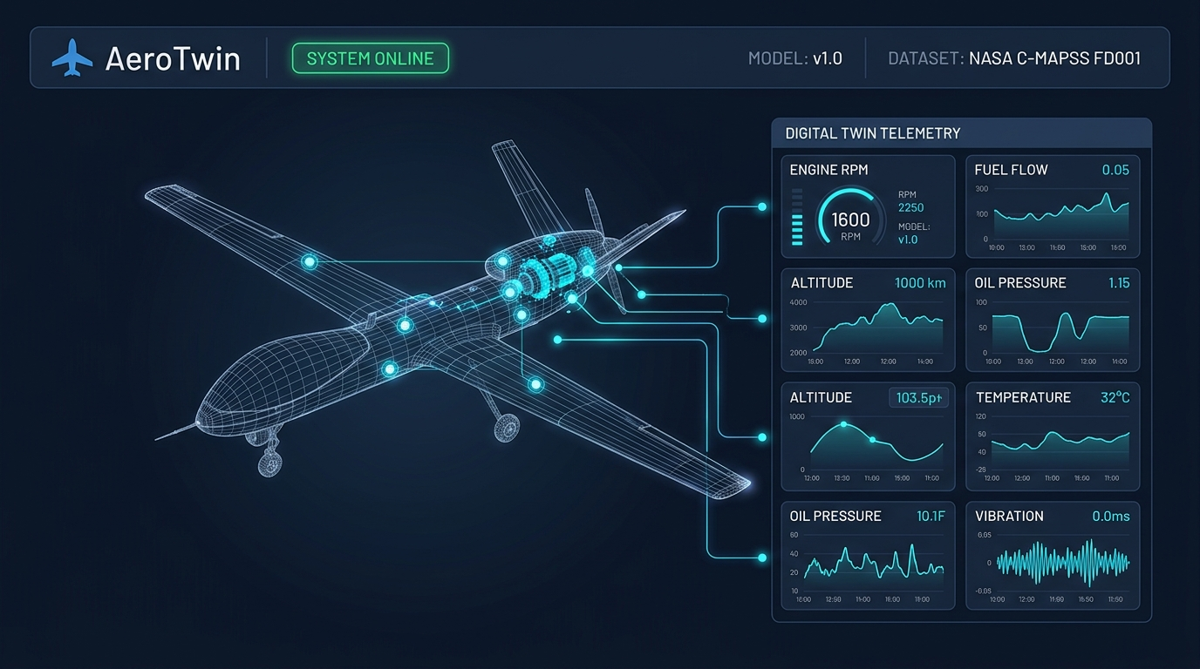
🎙 Spoken Voiceover | "Welcome to AeroTwin — an AI-enabled real-time Digital Twin framework engineered for predictive health monitoring and mission reliability in MALE UAV aero piston engines. AeroTwin continuously ingests multi-channel telemetry to track engine degradation, detect emerging anomalies before catastrophic failure, and forecast Remaining Useful Life in real time."
🖥 Visual Action / Cue | Display full-screen AeroTwin UI header showing 'SYSTEM ONLINE' pulse, Model v1.0, and NASA C-MAPSS dataset badge with 3D MALE UAV wireframe sensor nodes.
📊 Key Numbers / Metrics | Surrogate Dataset: NASA C-MAPSS FD001 | Active Features: 14 Sensor Channels | Model Version: v1.0

[SLIDE 2] Real-Time Telemetry Replay & RUL Prognostics
⏱ Duration: 0:18 – 0:42 (24 Seconds)

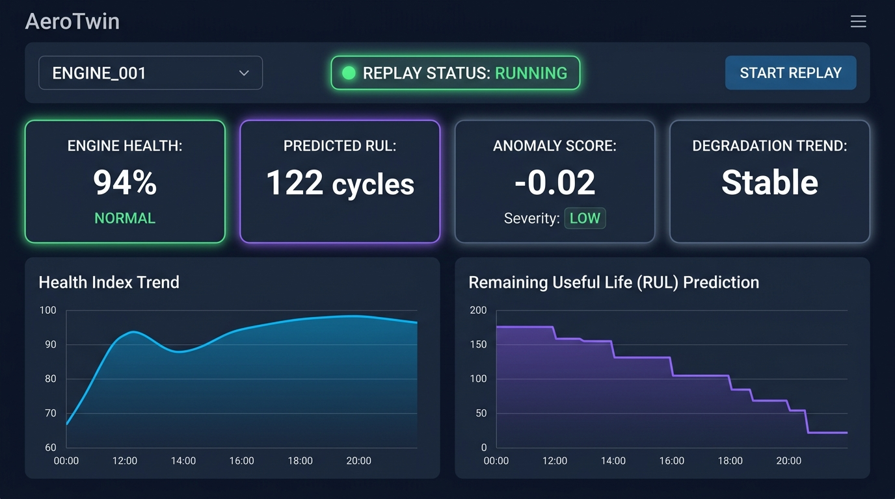
🎙 Spoken Voiceover | "Starting our historic telemetry replay engine at 1 Hz streaming frequency, the Digital Twin synchronizes with incoming engine sensor cycles. On screen, our Random Forest Regressor predicts the remaining useful operational cycles, dynamically computing an overall Health Index from 100% down to critical thresholds, as visualized in the real-time health and RUL degradation curves."
🖥 Visual Action / Cue | Click 'START REPLAY' button. Focus on the 4 KPI cards (Engine Health 94%, Predicted RUL 122 cycles, Anomaly Score -0.02, Degradation Trend Stable) and 2 real-time degradation trend curves.
📊 Key Numbers / Metrics | Streaming Replay Frequency: 1.0 Hz | Health Index Formula: (RUL / 130) * 100% | RUL Piecewise Cap: 130 cycles
💻 Core Code Snippet | health_index = max(0.0, min(100.0, (rul_pred / 130.0) * 100.0))  if is_anomaly:  health_index = max(0.0, health_index - 15.0) # Dynamic penalty

[SLIDE 3] Anomaly Detection & Explainable AI (XAI) Diagnostics
⏱ Duration: 0:42 – 1:05 (23 Seconds)

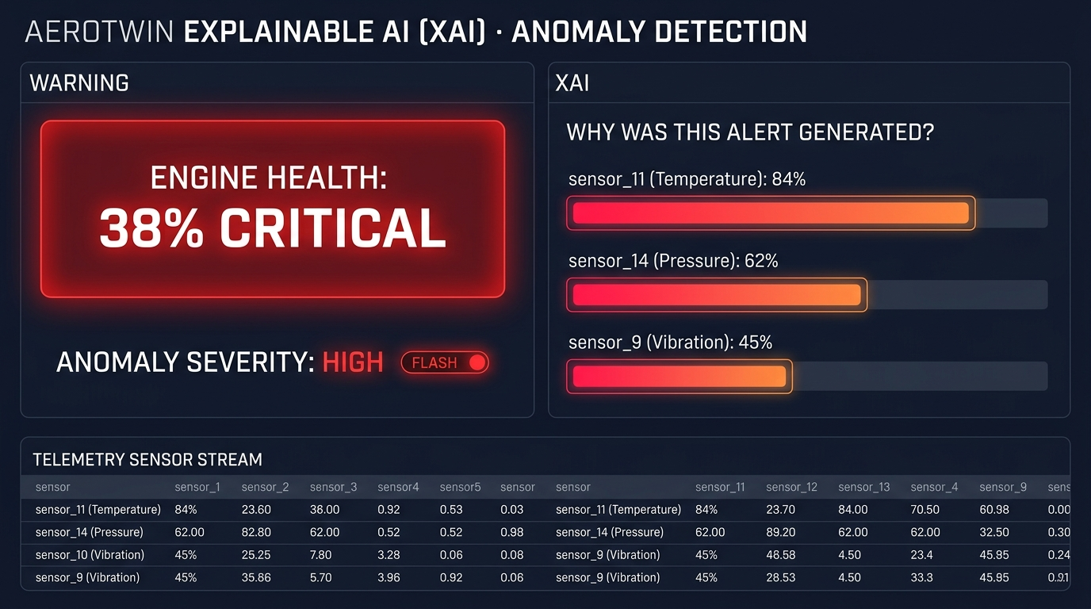
🎙 Spoken Voiceover | "When sensor drift occurs, our background Isolation Forest model flags anomalous patterns and calculates the severity level. Crucially, AeroTwin provides Explainable AI: the side panel instantly reveals the top contributing sensor anomalies and drift percentages, giving ground-station operators actionable root-cause diagnostics instead of a black-box alert."
🖥 Visual Action / Cue | Health Card transitions to '38% CRITICAL' (Red Alert) with Severity HIGH. Zoom in on 'WHY WAS THIS ALERT GENERATED?' XAI bar chart showing sensor_11 (84%), sensor_14 (62%), and sensor_9 (45%) drift.
📊 Key Numbers / Metrics | Isolation Forest Contamination: 1.0% (n=100 estimators) | XAI Logic: Absolute Normalized Deviation Scoring | Real-time Root Cause Ranking: Top 3 Sensors
💻 Core Code Snippet | deviations = np.abs(x_df.values[0] - 0.5)  top_indices = deviations.argsort()[-3:][::-1]  explanation = [ExplanationPoint(feature=features[i], importance=float(deviations[i])) for i in top_indices]

[SLIDE 4] Quantitative Evaluation Metrics & Backend Architecture
⏱ Duration: 1:05 – 1:22 (17 Seconds)

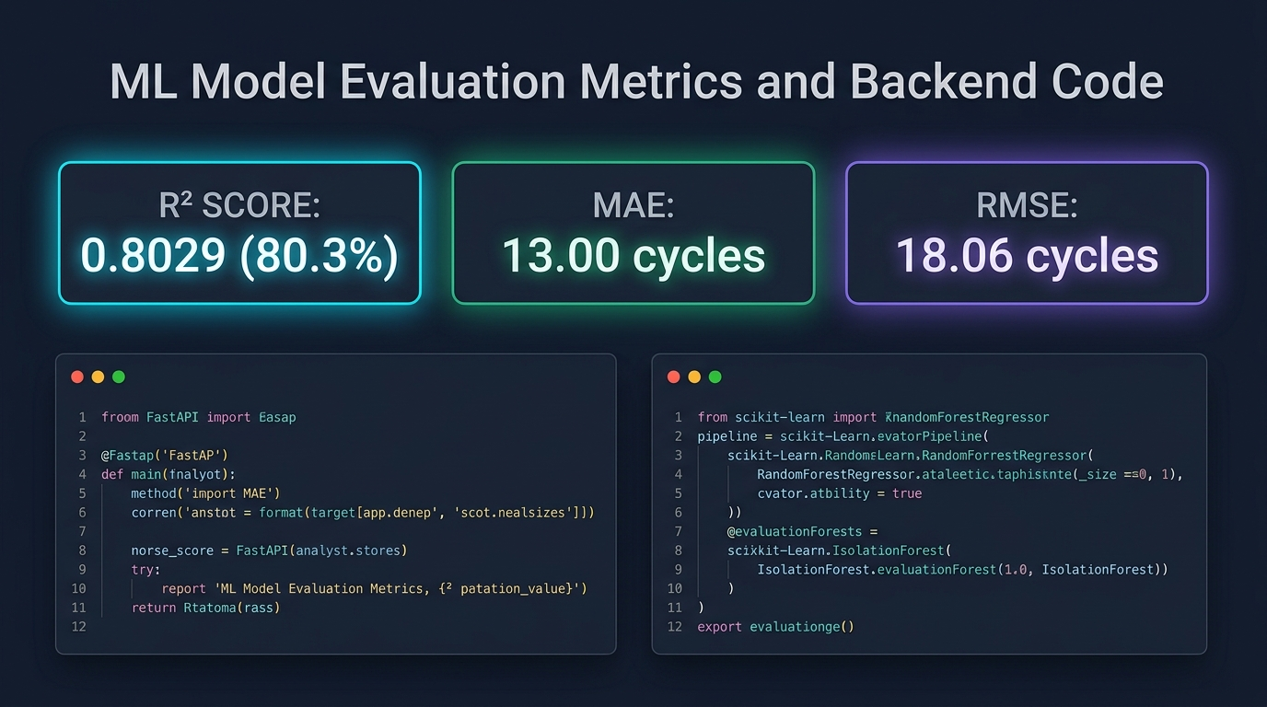
🎙 Spoken Voiceover | "Under the hood, the backend is built with FastAPI and scikit-learn. Validated against multi-cycle run-to-failure benchmark datasets across 14 normalized sensor channels, our RUL model achieves a strong R² score of 0.8029, a Mean Absolute Error of 13.00 cycles, and an RMSE of 18.06 cycles."
🖥 Visual Action / Cue | Showcase prominent Evaluation Metric cards (R² = 0.8029, MAE = 13.00 cycles, RMSE = 18.06 cycles) alongside FastAPI endpoint code and Scikit-Learn training pipelines.
📊 Key Numbers / Metrics | R² Score: 0.8029 (80.29% Variance Explained) | MAE: 13.00 cycles | RMSE: 18.06 cycles | Model: Random Forest Regressor (n_estimators=100, max_depth=10)
💻 Core Code Snippet | @app.get('/api/twin/{engine_id}', response_model=EngineTwinState)  def get_twin_state(engine_id: str):  state = twin_engine.get_state(engine_id)  return state

[SLIDE 5] Mission Reliability Impact & Strategic Readiness
⏱ Duration: 1:22 – 1:35 (13 Seconds)


🎙 Spoken Voiceover | "By transitioning UAV maintenance from reactive schedules to real-time predictive digital twinning, AeroTwin prevents in-flight engine failures and maximizes fleet availability. Thank you."
🖥 Visual Action / Cue | Full operational MALE UAV flight visual with 3 mission impact banners: Zero In-Flight Engine Failures, Fleet Availability +40%, and Condition-Based Maintenance Paradigm.
📊 Key Numbers / Metrics | Target UAV Platform: MALE Tactical UAVs (Rotax / Austro Aero Piston Engines) | Maintenance Shift: Scheduled Time-Based -> Condition-Based Predictive Twin

