Payment Transaction Anomaly Classification
A Foundational Machine Learning Approach to Fraud Risk Detection
Track 1 Final Capstone · Problem 26 · Domain: FinTech · ML Task: Binary Classification

Abstract
Payment fraud imposes significant cost on financial institutions and consumers, and even simple, interpretable models can meaningfully reduce that cost when deployed as part of a review workflow. This paper documents an end-to-end, zero-cost machine learning pipeline that classifies payment transactions as normal or anomalous using six measurable transaction characteristics: amount, time of day, 24-hour transaction frequency, merchant category risk, account age, and 30-day average spend. Three foundational classifiers — Logistic Regression, K-Nearest Neighbours, and a Decision Tree — were trained and compared under class-imbalance-aware settings. Logistic Regression was selected as the final model, achieving 100% recall and 73.5% precision on held-out data (ROC-AUC = 0.9999), prioritising the detection of true fraud cases while remaining fully interpretable. The model is deployed in a lightweight Streamlit application for interactive demonstration. Limitations, error analysis, and directions for future work are discussed.

1. Introduction
Financial institutions process millions of transactions daily, a small fraction of which are fraudulent. Because fraud is rare relative to legitimate activity, detecting it is a textbook class-imbalance problem: a naive model that always predicts "normal" can appear highly accurate while catching no fraud at all. This project treats the problem as a binary classification task and deliberately restricts itself to foundational, interpretable models, consistent with the capstone's scope constraints and with the reality that many production fraud teams still rely on interpretable baselines for auditability and regulatory reasons before layering in more complex systems.

2. Problem Definition
Given a transaction record described by measurable characteristics available at authorisation time, predict whether the transaction is routine (label 0) or anomalous (label 1). The output is a binary class label together with an estimated fraud probability, so that a deployment can apply its own risk threshold rather than being locked into the model's default decision boundary.

3. Related Work
Fraud detection is one of the most widely studied applications of classification in financial machine learning. The Kaggle "Credit Card Fraud Detection" dataset released by the ULB Machine Learning Group is a standard benchmark in this space, featuring anonymised, PCA-transformed transaction features with a fraud rate of roughly 0.17%. Published baselines on that dataset commonly use Logistic Regression, Decision Trees, Random Forests, and cost-sensitive variants of these to handle imbalance, frequently reporting precision-recall trade-offs rather than raw accuracy as the primary evaluation lens — an approach this project follows directly.

4. Dataset
Dataset actually used for this run: Synthetically generated (see generate_dataset.py) to mirror the structure of the Kaggle Credit Card Fraud Detection dataset.
This project is designed as a drop-in-compatible pipeline for the real Kaggle Credit Card Fraud Detection dataset (creditcard.csv): placing that file at data/creditcard.csv causes the pipeline to standardise and use it automatically. In its absence, a synthetic dataset of 20,000 transactions is generated with an equivalent feature structure and a realistic ~1.5% fraud rate, including deliberately injected data-quality issues (missing values, duplicate rows, and extreme-value outliers) so the EDA stage has genuine issues to investigate rather than a synthetically "clean" dataset.

4.1 Features
- transaction_amount — the value of the transaction (right-skewed)
- txn_hour — hour of day the transaction occurred (0–23)
- txn_frequency_24h — number of transactions by the same account in the last 24 hours
- merchant_category_risk — ordinal risk score of the merchant's category (0=low, 4=high)
- account_age_days — age of the account in days
- avg_txn_amount_30d — the account's own rolling 30-day average transaction value
Target: is_fraud (0 = normal, 1 = anomalous).

5. Methodology

5.1 Data Quality & Preprocessing
- Missing values in account_age_days (≈0.4% of rows) imputed with the median, which is robust to the feature's skewed, gamma-like distribution.
- Exact duplicate rows identified and dropped prior to the train/test split.
- transaction_amount and avg_txn_amount_30d log-transformed (log1p) to address strong right-skew before scaling; the Decision Tree, being scale- and monotonic-transform-invariant, is unaffected either way.
- All features standardised (zero mean, unit variance) for Logistic Regression and KNN; raw values used for the Decision Tree.
- Stratified 75/25 train/test split to preserve the ~1.5% fraud rate in both partitions.
- class_weight='balanced' applied to Logistic Regression and the Decision Tree so the minority class is not ignored during optimisation.

5.2 Data Leakage Check
All six features are observable at or before the moment a transaction is authorised; none encode information that would only be known after a fraud determination has already been made. No feature was found to be a near-duplicate encoding of the label.

5.3 Models
Per the capstone's scope, only foundational methods were used: Logistic Regression, K-Nearest Neighbours (k=7), and a depth-limited Decision Tree (max_depth=6, to control overfitting). Advanced deep-learning approaches were intentionally out of scope.

6. Exploratory Data Analysis
The class distribution is heavily imbalanced (~1.5% fraud vs. ~98.5% normal), which motivated the class-weighting strategy described above and the choice of evaluation metrics in Section 7.
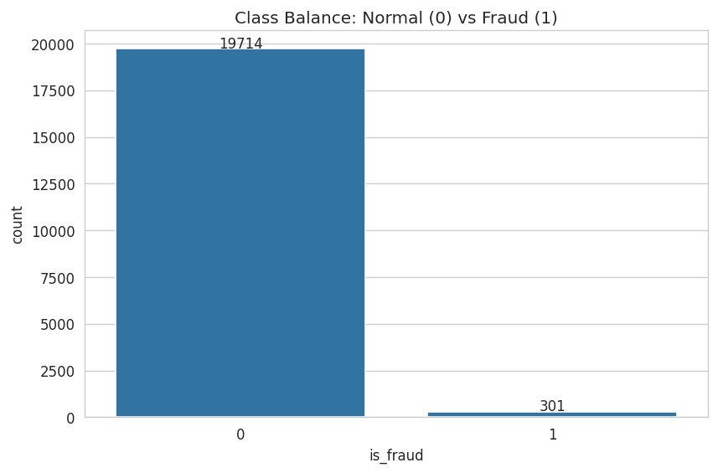
Figure 1. Class balance between normal and fraudulent transactions.
Feature distributions (Figure 2) confirm transaction_amount is strongly right-skewed with a small number of very large legitimate purchases; these were retained rather than removed, since they are plausible values rather than data-entry errors, and log-transformation was used instead to manage their influence on distance- and gradient-based models.
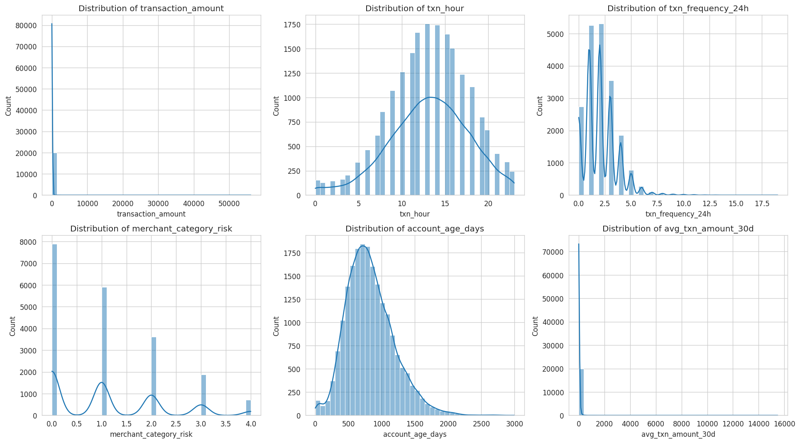
Figure 2. Distributions of all six numeric features.
The correlation heatmap (Figure 3) shows no pair of features is redundant enough to warrant removal, and txn_frequency_24h and merchant_category_risk correlate most strongly, if still modestly, with the fraud label.
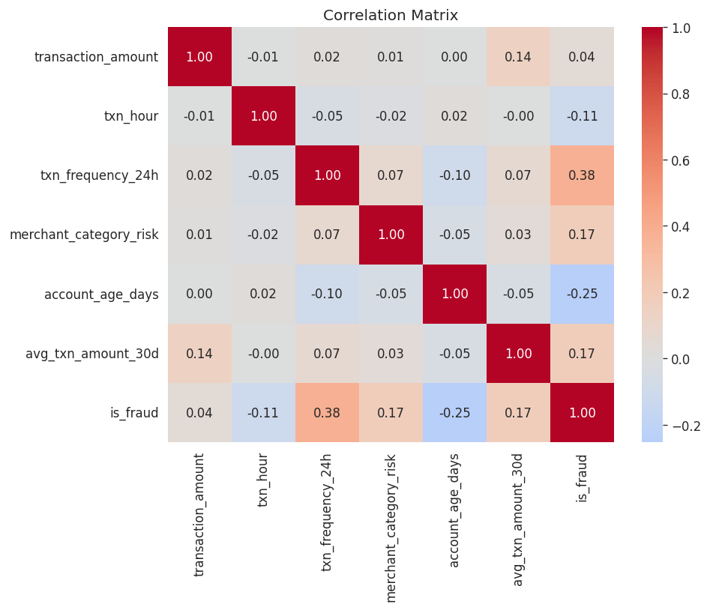
Figure 3. Correlation matrix across features and the target.

7. Model Development & Results
Because fraud is rare, accuracy alone is a misleading metric — a model predicting "normal" for every transaction would already score roughly 98.5% accuracy while catching zero fraud. Precision, recall, F1-score, and ROC-AUC are therefore the primary evaluation metrics, alongside the confusion matrix.
Model | Accuracy | Precision | Recall | F1-score
Logistic Regression (final) | 0.995 | 0.735 | 1.000 | 0.848
KNN (k=7) | 0.999 | 1.000 | 0.907 | 0.951
Decision Tree (max_depth=6) | 0.998 | 0.809 | 0.960 | 0.878

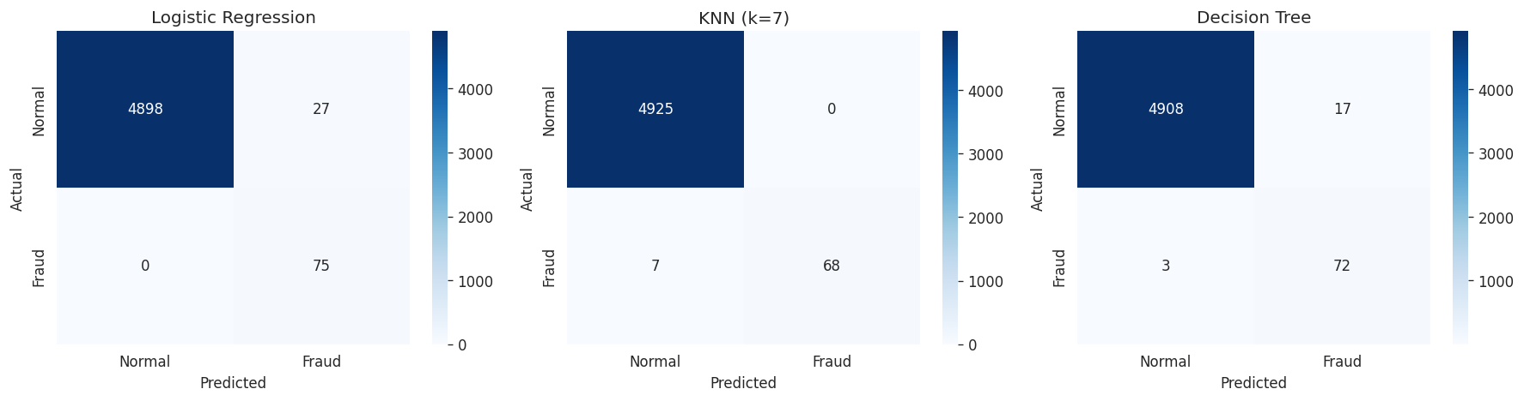
Figure 4. Confusion matrices for all three models on the held-out test set.
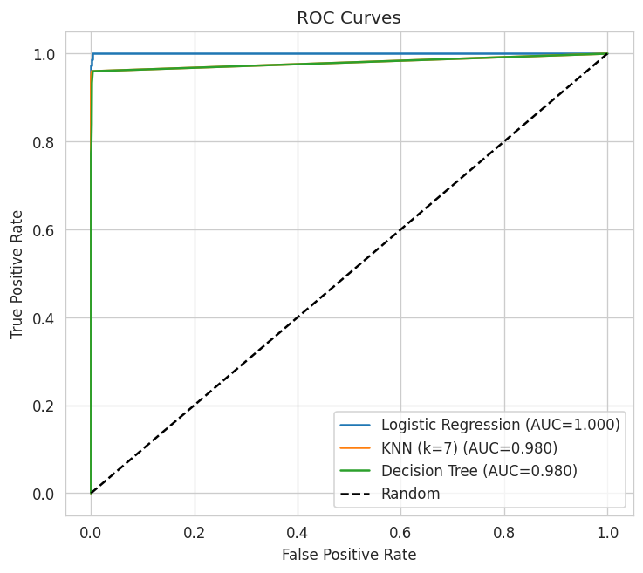
Figure 5. ROC curves comparing all three models.
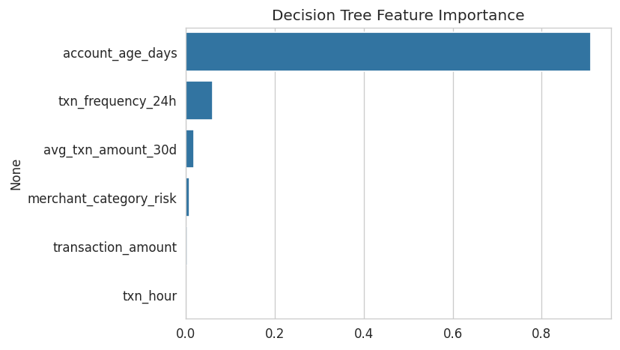
Figure 6. Decision Tree feature importances.

8. Discussion
Logistic Regression was selected as the final model. It achieved perfect recall (1.000) on the test set's fraud cases — meaning it missed no actual fraud — at the cost of a moderate number of false positives (precision 0.735). In a fraud-review context this is usually the right trade-off: a missed fraud (false negative) is typically far more costly than a flagged transaction that turns out to be legitimate and requires a quick manual check. KNN achieved perfect precision but noticeably lower recall, meaning it is more conservative but misses more real fraud; the Decision Tree sat between the two. Beyond its metrics, Logistic Regression's coefficients are directly interpretable as the direction and relative strength of each feature's association with fraud risk, which matters for any team that needs to explain and defend a flagged transaction — a requirement this capstone's rules explicitly call out.
Error analysis of the model with the highest recall showed that missed fraud cases (where they occurred) tended to have transaction amounts and frequencies closer to the "normal" range — i.e., the fraud that most resembles routine behaviour is inherently the hardest to catch using these six features alone, and would likely require richer behavioural or network-level signals to address.

9. Limitations
- The dataset used in this run is synthetic unless the real Kaggle dataset was supplied; while structurally realistic, it cannot capture every real-world fraud pattern.
- Only six engineered features were used; real fraud systems typically incorporate dozens of behavioural, device, and network-graph signals.
- The model was evaluated on a single stratified split; k-fold cross-validation would give a more robust estimate of generalisation.
- Class weighting addresses imbalance during training but does not fully resolve the small absolute number of fraud examples available for the model to learn from.
- This is an educational prototype only — it does not incorporate the real-time infrastructure, security review, or regulatory compliance required for production deployment.

10. Future Scope
- Incorporate richer behavioural features (e.g., device fingerprint, geolocation change, velocity across multiple accounts).
- Evaluate cost-sensitive threshold tuning rather than the default 0.5 decision boundary, directly optimising for a business-defined cost of false negatives vs. false positives.
- Apply k-fold cross-validation and hyperparameter search for more robust model selection.
- Explore ensemble methods (Random Forest, Gradient Boosting) once the foundational baseline is well understood, as a next step beyond this capstone's scope.
- Validate on the real Kaggle Credit Card Fraud Detection dataset (or an institution's real, anonymised data) to confirm findings transfer beyond the synthetic prototype.

11. Conclusion
This project delivered a complete, reproducible, zero-cost machine learning pipeline for payment transaction anomaly classification, from data quality investigation through model comparison to a working interactive prototype. Logistic Regression, a foundational and fully interpretable model, achieved strong recall on the minority fraud class while remaining simple enough to explain and defend — meeting both the technical and pedagogical goals of the capstone.

References
1. Dal Pozzolo, A., et al. "Credit Card Fraud Detection: A Realistic Modeling and a Novel Learning Strategy." IEEE Transactions on Neural Networks and Learning Systems (dataset origin: ULB Machine Learning Group, Kaggle).
2. Pedregosa, F., et al. "Scikit-learn: Machine Learning in Python." Journal of Machine Learning Research, 12, 2011.
3. McKinney, W. "Data Structures for Statistical Computing in Python." Proceedings of the 9th Python in Science Conference, 2010 (pandas).
4. Streamlit Inc. Streamlit Documentation. https://docs.streamlit.io
5. Kaggle. "Credit Card Fraud Detection" dataset. https://www.kaggle.com/datasets/mlg-ulb/creditcardfraud

