**Title: HEALTH AND EXERCISE**

**Introductions**

In this activity you will investigate the relationship between exercise and weight.

1. Click this link: <http://phet.colorado.edu/>

This is a screen shot of the website:

PHET.tiff

2. Click the “Play with sims” button.

3. Click “Biology” -> Click “Eating and Exercise”->Click “Run Now!”

4. It will take time to load and then this screen appears:

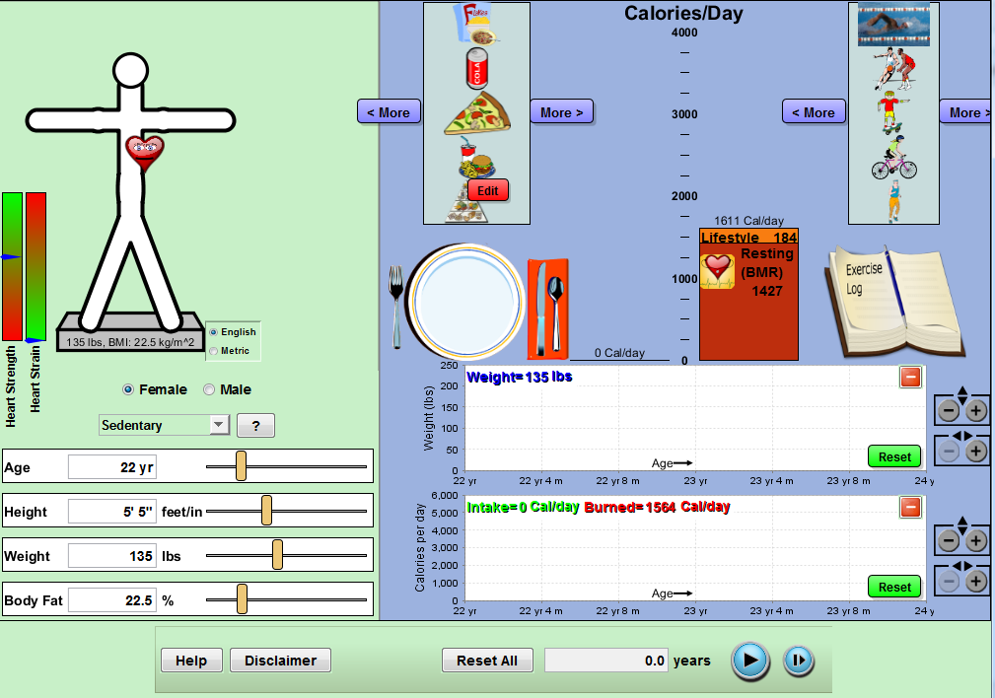

**EXPLORE:**

1. Select an age, height, weight and body fat (do not plug in the information that describes yourself)
2. Explore different diets one can consume in one day. Press play at the bottom of the screen to watch what happens to that person’s weight and calorie intake over a period of time.
3. Add different exercises and explores what happens

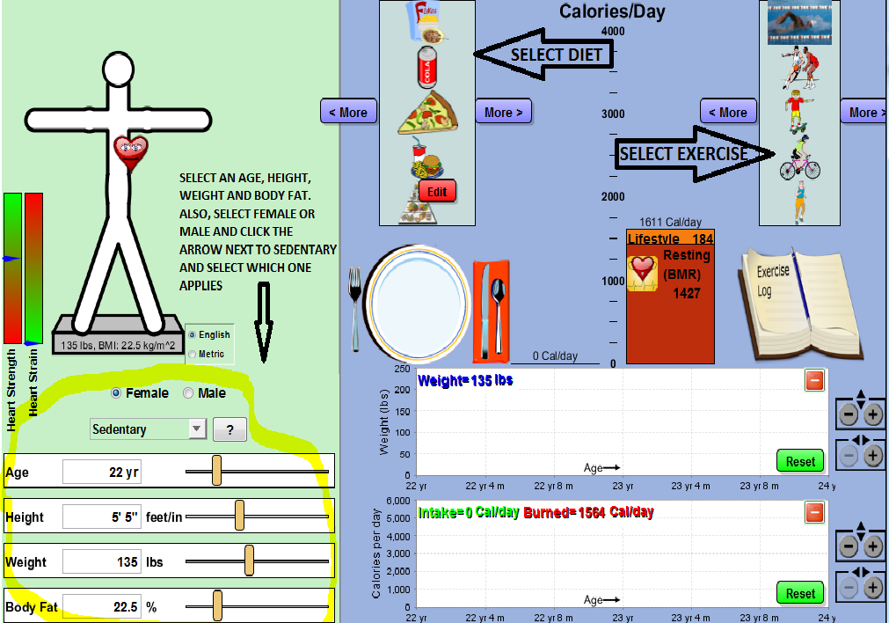

Questions:

1. What do you think affects an individual’s weight the most?
2. Is exercising important? Why or why not?

Explanation:

AIM: Determine how to maintain a healthy lifestyle: based on your food choices and exercise practices

**Reset simulation page to look like the first screen shot

*ACTIVITY 1- HOW HEALTHY ARE YOU:*

In the first chart, write out the food choices you made for BREAKFAST, LUNCH and DINNER yesterday (based on the options in the sim, drag each item onto the plate- you can select the food item more than once (IE: two tacos) )

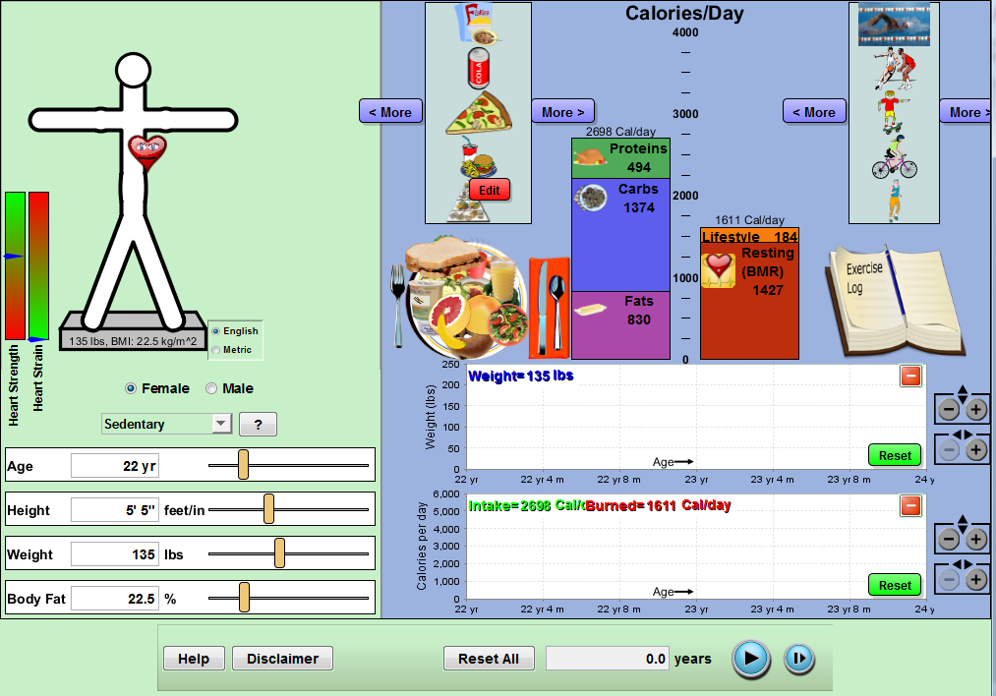

Select the foods you eat most often for all 3 main meals, plus snack time. Don’t cheat

|  |  |
| --- | --- |
| Food Selection |  |

Fill out the chart based on the information that is provided in the sims, after pressing the PLAY icon (Delete age and replace it with your age number)

|  |  |  |  |  |  |  |  |
| --- | --- | --- | --- | --- | --- | --- | --- |
|  | AGE | Age,4m | Age,8m | +1year | Age, 4m | Age,8m | +2years |
| Weight |  |  |  |  |  |  |  |
| Calories per day  Intake (green line) |  |  |  |  |  |  |  |

Take a screenshot of your findings:

Explain your findings. Did your weight increase over the 2 year span? Did your calorie per day intake (green line) increase or decrease?

ACTIVITY 2: WHAT IS YOUR FAVORITE EXERCISE?

**reset your screen

Place the same food selection onto the plate that you chose for activity 1.

In the first chart, write out the food choices you make for BREAKFAST, LUNCH and DINNER (based on the options in the sim, drag each item onto the plate):

|  |  |
| --- | --- |
| Food Selection |  |

On the exercise log, drag your exercise preferences that you perform most often:

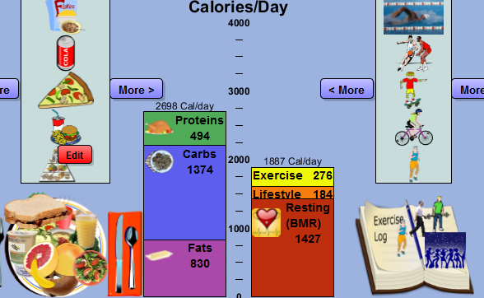

EXERCISE LOG: add the exercise routines you often do and/or sports you play consistently

|  |  |
| --- | --- |
| EXERCISE |  |

Fill out the chart based on the information that is provided in the sims, after pressing the PLAY icon:

|  |  |  |  |  |  |  |  |
| --- | --- | --- | --- | --- | --- | --- | --- |
|  | AGE | Age,4m | Age,8m | +1year | Age, 4m | Age,8m | +2years |
| Weight |  |  |  |  |  |  |  |
| Calories per day |  |  |  |  |  |  |  |

Take a screenshot of your findings:

1. Did your stats change after you added exercise? If so, was your answer correct to the question above, is there a relationship between weight and exercise?

1. Is there a relationship between weight and exercise? If so, does it matter the type of exercise you do?
   1. What do you think the recommended calorie consumption is for:
   2. **Women**- between the ages of 20-59=
   3. **Men**- between the ages of 20-59=
   4. **Boys**- between the ages of 6-11=
   5. **Boys**- between the ages of 12-19=
   6. **Girls**- between the ages of 6-11=
   7. **Girls**- between the ages of 12-19=

Application:

Now that you are health conscious, it’s your turn to become someone’s nutritionist…

*** RESET SCREEN

Think of a person that you can use in your experiment. It is your goal to figure out how many calories they need to intake to maintain their weight for a 1 year span. You are in charge of selecting their overall food consumption; what they will eat for breakfast, lunch, dinner and snack. You can also add in exercises if you think it will help achieve your goal. Record your findings below

|  |  |
| --- | --- |
| Gender |  |
| Age |  |
| Weight |  |
| Height |  |
| Body Fat |  |
| Lifestyle (where it says sedentary…) |  |
| Calorie per day intake goal |  |

List the food you are suggesting to your client and the exercise you are pushing them to do:

|  |  |
| --- | --- |
| Food |  |
| Exercise |  |
| Changes after 4 months: |  |

Once you set up your sim, press play. Record your findings for the first 4 months…

|  |  |  |
| --- | --- | --- |
|  | AGE | Age,4m |
| Weight |  |  |
| Calories per day |  |  |

If you’re happy with your results, press play and watch what happens over a two year span. If you are not, you can modify their food intake and exercise choice. You can add and/or drag out food items or exercise choices (*If you change anything, you must record the change on your chart above). Once you made your changes, press play and record what you see on the graph

|  |  |  |  |  |  |  |  |
| --- | --- | --- | --- | --- | --- | --- | --- |
|  | AGE | Age,4m | Age,8m | +1year | Age, 4m | Age,8m | +2years |
| Weight |  |  |  |  |  |  |  |
| Calories per day (intake/burned) |  |  |  |  |  |  |  |

Take a screenshot of your final result:

Compare your lifestyle to your clients. Would you change anything about your diet plan? If so what and why?

Did you make you more aware about health and exercise?

FOOD FOR THOUGHT:

1. What do you think the recommended calorie consumption is for… (answer/ average consumption
   1. **Women**- between the ages of 20-59= 2,000/ 1,750-2,000
   2. **Men**- between the ages of 20-59=2,500/ 2,000-2,500
   3. **Boys**- between the ages of 6-11=2,300
   4. **Boys**- between the ages of 12-19= 2,700
   5. **Girls**- between the ages of 6-11= 1,900
   6. **Girls**- between the ages of 12-19= 2,000