The Advantages of Species Physical Appearance Corresponding to Living Environment

7th Graders

**Learning Objective:** Students will be able to evaluate and analyze the survival rate of a species fur color depending on the environment they live in. Also, understand the predator and prey relationship.

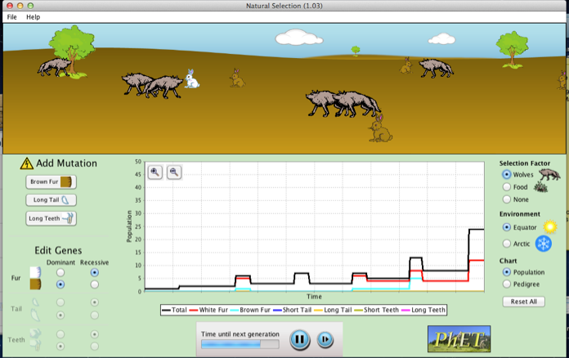**Instruction:**

**Part 1:**

1. Select “Equator” environment
2. Select “Add a Friend”
3. Select “Brown Fur” mutation
4. Wait until the population has multiply
5. Select “Wolves” under “selection factor”
6. Select “Food”
7. Observe change in population

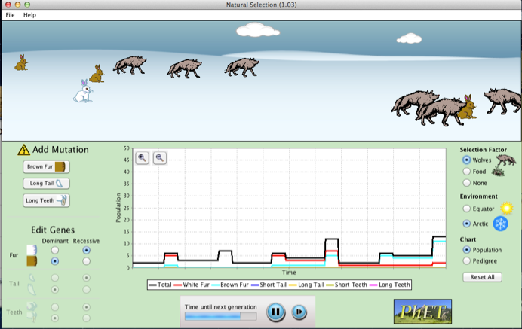

**Part 2:**

1. Select “Artic” environment
2. Select “Add a Friend”
3. Select “Brown Fur” mutation
4. Wait until the population has multiply
5. Select “Wolves” under “selection factor”
6. Select “Food”
7. Observe change in population

**Discussion Questions:**

1. How does the bunnies within the population differ from one another?
2. Due to mutation in the white parents what variation occurred in the offspring’s fur color?
3. Which species of bunnies survived under the “Equator” environment?
4. Which species of bunnies survived under the “Artic” environment?
5. What is the advantage of having a mutation involved in that specific population?
6. What traits inherited from parents to offspring increase their survival rate?

Answer Key

1. The bunnies within the population differ from another in the fur color.
2. Variations in fur color of the offspring changed from white to brown due to mutations in the white fur parents.
3. Under the equator environment the brown bunnies survived.
4. Under the artic environment the white bunnies survived.
5. The advantage of fur color helped disguised the bunnies from the wolves because they camouflaged with their living environment.
6. The inherited trait of fur color helped the bunnies adapt and survive in their environment.