Name: __________________________ Date: _______________  
Grade Level & Section: _____________

**Seeing Colors**

Objectives:

1. To identify the color a person can see.
2. To see what color appears when different colors are combined.
3. To know which part of the brain activates when a person sees color.

I. Procedure:

1. Enter or go to <https://phet.colorado.edu/sims/html/color-vision/latest/color-vision_en.html> to access the PhET stimulation color vision.
2. Click the RGB Bulbs Tab.

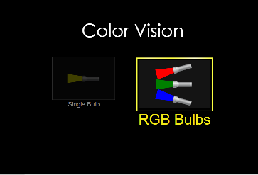

1. Slide the bars of each color to manipulate the RGB Bulbs.

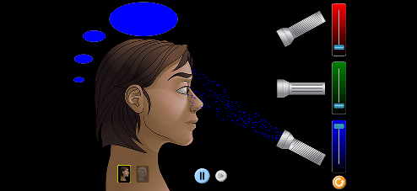

1. 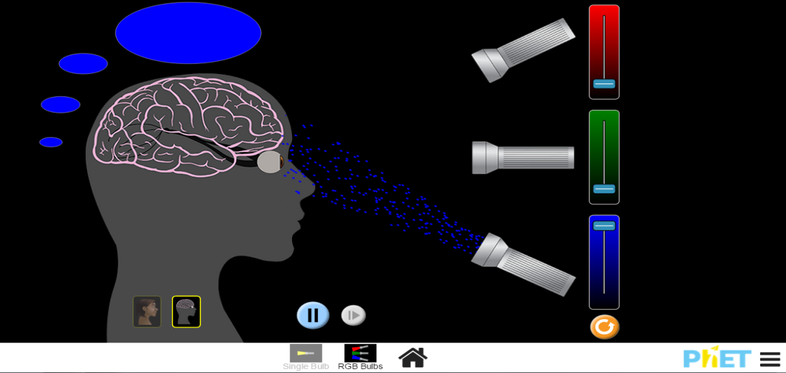For you to visualize the brain and nerves connected from the eyes you can click the button pointed by the arrow below.

**Answer the following questions:**

1. What color is seen when:  
   a. the last bar is slide to the very top? ________________

b. the second bar is slide to the very top? ______________  
c. the first bar is slide to the very top? ________________

1. What happens when you slide:  
   a. the first and the last bar of color to the very top? ____________  
   b. the first and the second bar to the very top? _____________  
   c. the second and the last bar to the top? _____________  
   d. the first, second, and third bar to the top? ___________
2. What do you think is/are the reason/s why when colors are combined makes another color? ______________________________________________________
3. Which part of the brain areas activated when a person sees color?  
   ______________________________________________________