
FULL STACK WEB DEVELOPMENT MDS273

Event Horizon

By
Abishai Tom, 2448005
Nikhil Jose, 2448041
Roshan Varghese, 2448046

December 16, 2024

Submitted To: Karthik Krishnamurthi

A project report submitted in partial fulfilment of the requirements for the award of degree of Master of Science (Data Science)
of
Christ (Deemed to be University)
April -2022

Project titled Event Horizon is a bonafide record of work done by Abishai Tom, 2448005, Nikhil Jose, 2448041 and Roshan Varghese, 2448046 of CHRIST (Deemed to be University), Bengaluru, in partial fulfillment of the requirements of 2nd Trimester M.Sc. Data Science during the year 2024-25.

Head of the Department

Valued-By:
1. Team Members: Abishai Tom, 2448005
Nikhil Jose, 2448041
Roshan Varghese, 2448046
2. CHRIST (Deemed to be University)
Date of Submission: December 16, 2024

ABSTRACT

TABLE OF CONTENTS

ABSTRACT 3
TABLE OF CONTENTS 4
1. INTRODUCTION 5
1.1. PROJECT DESCRIPTION 5
1.2. OBJECTIVES 5
1.3. OVERVIEW OF THE SERVICES 6
2. SYSTEM DESIGN 6
2.1. MODULES 6
2.2. DATABASE DESIGN 6
2.2.1. TABLES AND RELATIONSHIPS 6
3. IMPLEMENTATION 8
3.1. IMPLEMENTATION APPROACHES 8
3.2. CODING STANDARDS 8
3.3. CODING DETAILS 8
4. TESTING 8
4.1. TESTING CASES 8
4.2. TESTING APPROACHES 8
4.3. TESTING REPORTS 8
5. CONCLUSION 8
5.1. FUTURE SCOPE OF THE PROJECT 9
6. COURSE COMPLETION SCREENSHOT 9
6.1. ABISHAI TOM 2448005 9
6.2. NIKHIL JOSE 2448041 10
6.3. ROSHAN VARGHESE 2448046 10

INTRODUCTION

PROJECT DESCRIPTION
Event Horizon is a dynamic and user-centric website designed to simplify the process of selecting and accessing event management services. By acting as a mediator between users and various service providers, it ensures that individuals planning an event can seamlessly identify and connect with services tailored to their specific requirements. The platform streamlines the event-planning journey by offering detailed insights into available services, eliminating the hassle of extensive research and simplifying decision-making.

OBJECTIVES
- Mediation Role: At its core, Event Horizon serves as a bridge between users and service providers. By aggregating detailed information about various event services, the website reduces the time and effort users would otherwise spend researching and contacting multiple vendors.
- Simplified Decision-Making: Event Horizon’s interface is designed to help users quickly identify services that meet their needs.
  - When searching for a hall, users can compare locations, capacities, and features side-by-side, making it easier to find a suitable option.
  - For catering services, the platform categorizes providers based on cuisine types, budget ranges, and customer reviews.

OVERVIEW OF THE SERVICES
Event Horizon specializes in providing a wide range of event services, including:
- Hall Booking: Users can explore a curated list of halls available for booking, complete with detailed descriptions, features, and amenities. Each hall’s page includes a direct link to its official website, allowing users to gather additional information or finalize bookings without unnecessary complications.
- Photography: For capturing memorable moments, Event Horizon connects users with professional photography services. Users can view portfolios, service details, and contact information to choose the best photographer for their event.
- Decorations: The website showcases decorators with expertise in various themes and styles, enabling users to select options that align with their vision for the event.
- Catering: From traditional cuisines to bespoke menus, Event Horizon helps users find catering services that match their event’s culinary needs.
These offerings are presented in a user-friendly manner, ensuring that users can make informed decisions with minimal effort.

SYSTEM DESIGN

MODULES
The system is divided into several modules that collectively handle the event planning lifecycle. Below is a description of each module:
- User Authentication and Authorization: Manages user registration, login, and access control.
- Service Management: Allows users to browse and book services such as hall bookings, catering, decorations, and photography.
- Points of Contact (POC): Connects users to specific service providers or vendors.
- Contact Form: Collects and stores user feedback for services.
- Feedback System: Collects and stores user feedback for services.

DATABASE DESIGN

TABLES AND RELATIONSHIPS
- AuthUser
  - Table: Stores user credentials and role information.
  - Primary Key: AuthID
  - Columns:
    - AuthID: Unique identifier for each user (auto-incremented).
    - AName: Name of the user.
    - Mobile: User’s mobile number.
    - Email: User’s email address.
    - APassword: User’s encrypted password.
    - ARole: User’s role (e.g., user, admin).
- Services
  - Table: Stores information about the available services (hall bookings, catering, etc.).
  - Primary Key: ServiceID
  - Columns:
    - ServiceID: Unique identifier for each service.
    - ServiceName: Name of the service.
    - ServiceImage: Path or URL for the service image.
    - ServiceDescription: Description of the service.
- PointsOfContact
  - Table: Stores information about individual service providers (e.g., specific hall owners or caterers).
  - Primary Key: POCID
  - Foreign Key: ServiceID (references the Services table)
  - Columns:
    - POCID: Unique identifier for each Point of Contact.
    - ServiceID: Foreign key linking the POC to a service.
    - Name: Name of the service provider.
    - Price: Price of the service.
    - Capacity: Capacity offered by the provider.
    - Description: Description of the POC.
    - Address: Address of the provider.
    - MainImage, Image1, Image2, Image3, Image4: Images associated with the provider.
    - Amenities: List of amenities offered.
    - Link: External link to the provider’s website.
    - CuisinesOffered: Cuisines offered by catering services.
- ContactForm
  - Table: Stores messages submitted by users via the contact form.
  - Primary Key: id
  - Foreign Key: authid (references the AuthUser table)
  - Columns:
    - id: Unique identifier for each contact form submission.
    - name: Name of the user submitting the form.
    - email: Email of the user submitting the form.
    - message: The message submitted by the user.
    - submitted_at: Timestamp of when the message was submitted.
    - authid: Foreign key referencing the AuthUser table for identifying the user.
- Feedback
  - Table: Stores feedback submitted by users for services.
  - Primary Key: id
  - Foreign Key: authid (references the AuthUser table)
  - Columns:
    - id: Unique identifier for each feedback.
    - name: Name of the user submitting feedback.
    - email: Email of the user submitting feedback.
    - rating: Rating given by the user (e.g., 1-5).
    - message: Feedback message from the user.
    - submitted_at: Timestamp of when the feedback was submitted.
    - authid: Foreign key referencing the AuthUser table for identifying the user.

IMPLEMENTATION

IMPLEMENTATION APPROACHES
The implementation of Event Horizon will be carried out using best practices in web development to ensure that the platform is robust, user-friendly, scalable, and secure. The following approaches outline key strategies for implementing the website:
- Frontend development: HTML, CSS, and JavaScript will be the core technologies for creating the structure, style, and interactivity of the website.
- Backend Development: The backend will be built using Flask for handling the core functionality of the application, such as routing, database interaction, and user authentication.

CODING STANDARDS
Adhering to a consistent set of coding standards will ensure that the codebase is maintainable, readable, and efficient. Below are the coding standards used in the Event Horizon platform:
- Code Structure and Organization
- Commenting and Documentation
- Code Style and Formatting
- Version Control

CODING DETAILS
    - Client-Side code:
      - CSS Code:

VALIDATIONS

USER JOURNEY
    - Home Page
The initial landing page serves as a comprehensive overview of the services provided by Event Horizon. Users can browse through the available options, gaining insights into the breadth and depth of the services offered. However, to proceed further, users must sign up or log in.
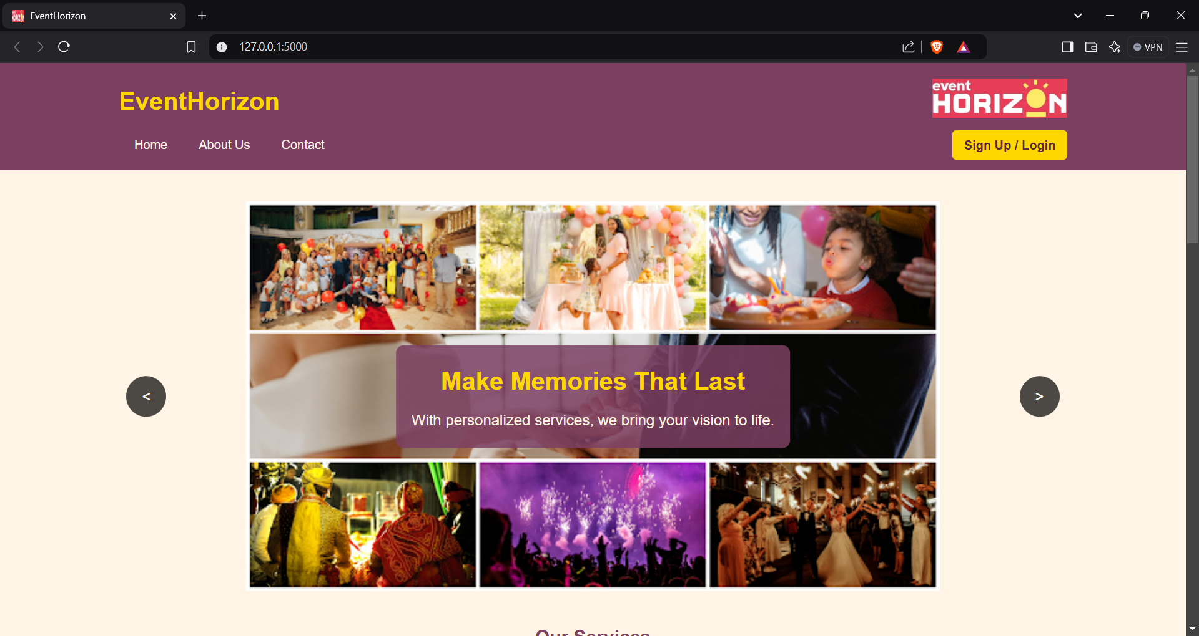
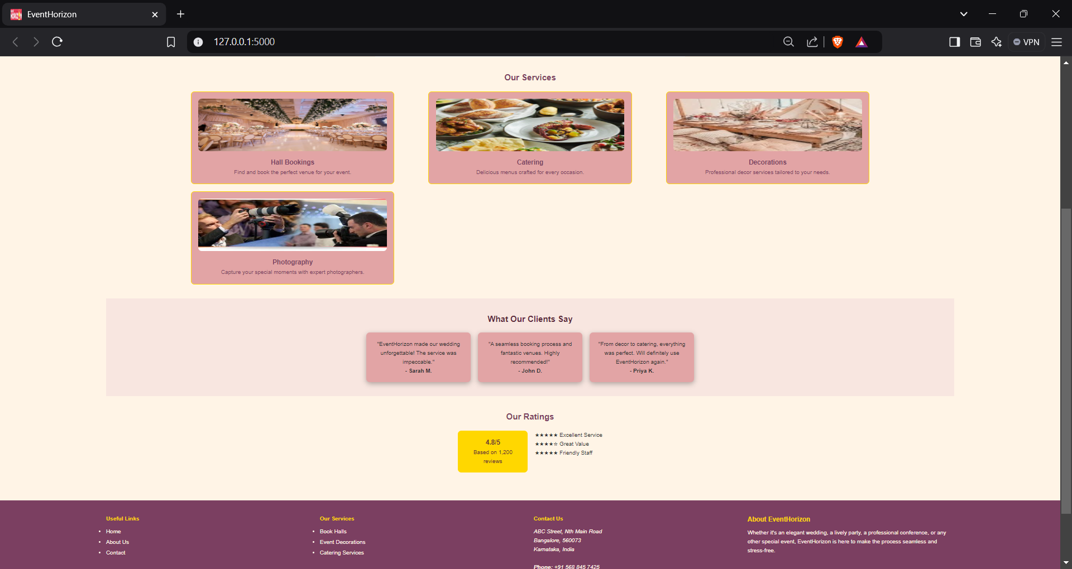
    - User Registration and Login
New users are required to create an account by signing up. This step ensures a personalized experience and allows users to keep track of their preferences and interactions on the platform. Returning users can log in directly, gaining access to advanced features and a tailored interface.
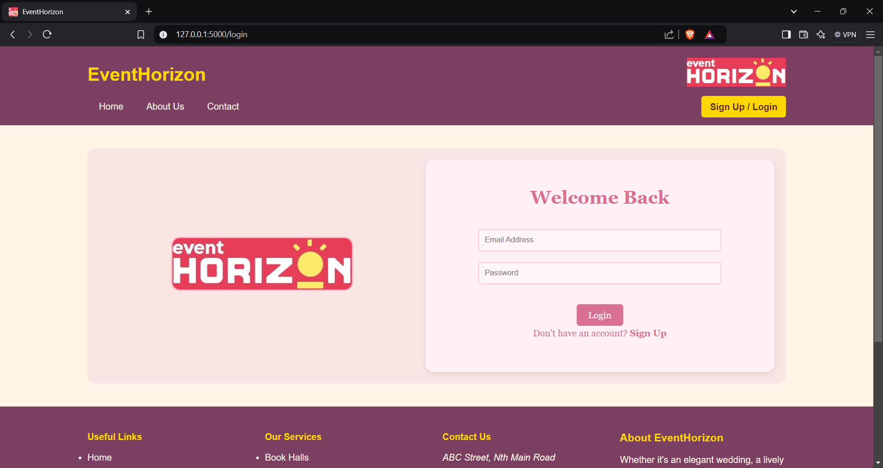
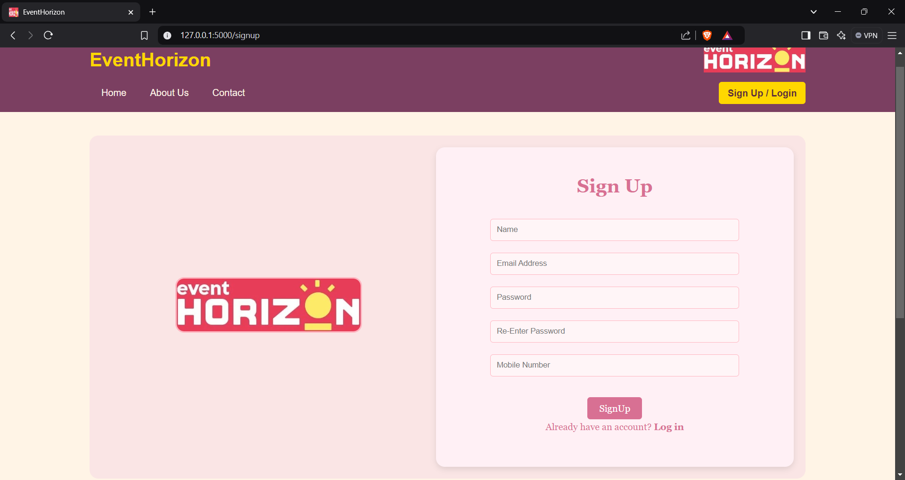
    - Services
    - Contact
    - Feedback

EXECUTION SCREENSHOTS

CONCLUSION
Event Horizon simplifies the event planning process by offering a comprehensive platform that connects users with a variety of event management services. By serving as an intermediary between users and service providers, the platform reduces the time, effort, and stress involved in organizing an event. Whether it's hall booking, photography, decorations, or catering, Event Horizon ensures that users can easily find, compare, and connect with services that meet their specific needs.

FUTURE SCOPE OF THE PROJECT
By addressing its current limitations and expanding its offerings, Event Horizon has the potential to become a comprehensive and indispensable platform for event planning in the future. Some of the future plans could include:
Expansion of Services: Event Horizon could expand its offerings to include additional event-related services such as entertainment (e.g., DJs, performers), transportation, or event staffing. This would make the platform even more comprehensive.
Integration with Payment Gateways: To further streamline the process, Event Horizon could integrate payment systems, allowing users to make bookings and pay for services directly on the platform. This would eliminate the need to visit third-party websites for payment.
Integrating an Admin Module: Integrating an Admin Module into Event Horizon would allow administrators to manage the platform's content, service providers, users, and bookings more efficiently. The admin module would serve as a backend interface for administrators to have full control over the platform, ensuring smooth operation and better user experience.

COURSE COMPLETION SCREENSHOT

ABISHAI TOM 2448005
Courses completed on Udemy
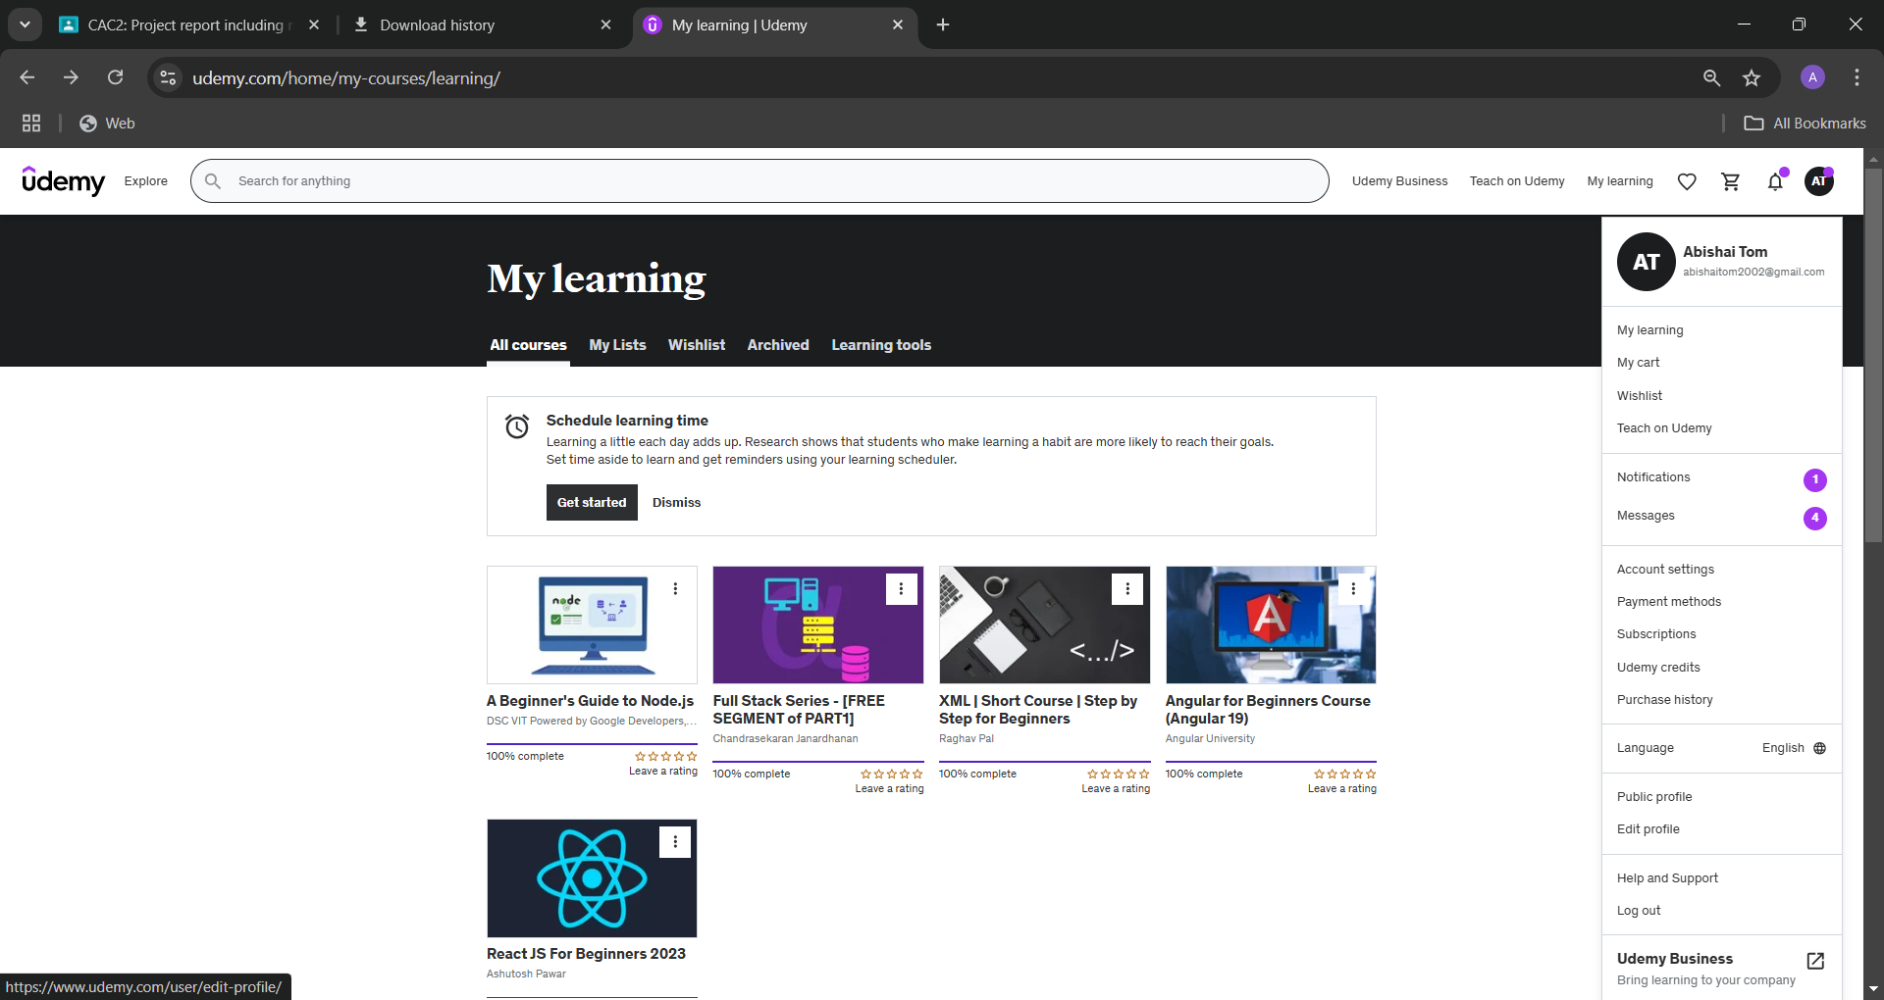
Courses completed on Simplilearn
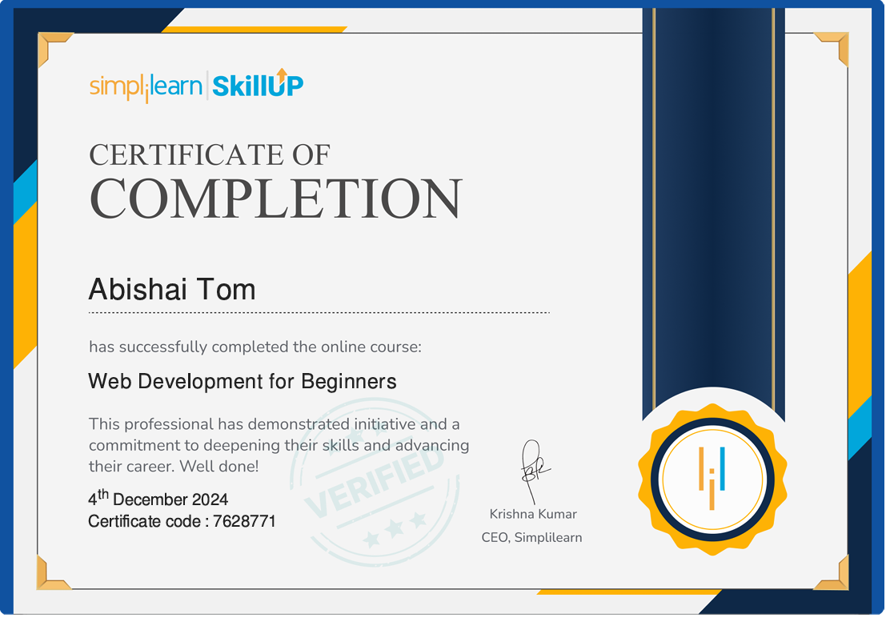
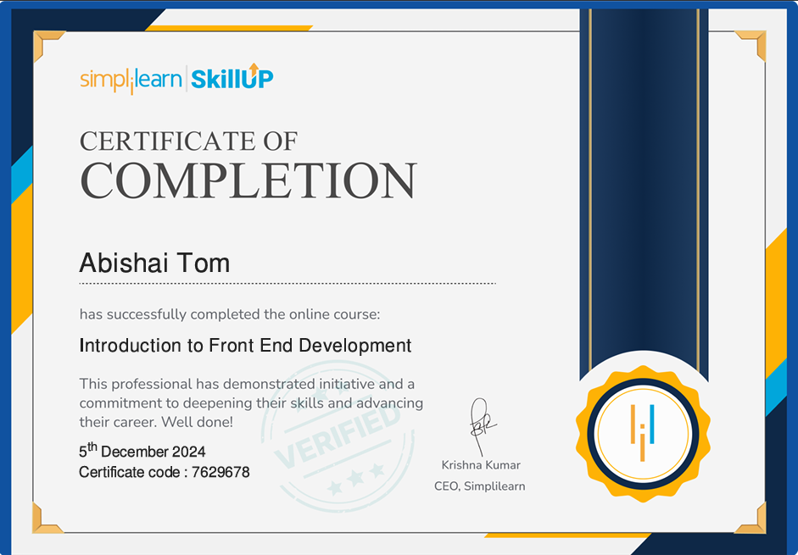
A total of 25 hours were completed.

NIKHIL JOSE 2448041

ROSHAN VARGHESE 2448046
Courses completed in Udemy
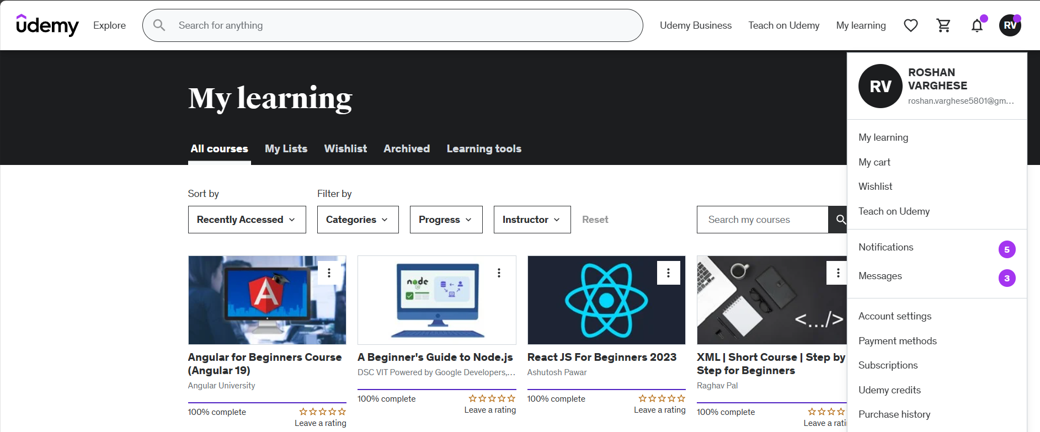
Courses completed in Simplilearn
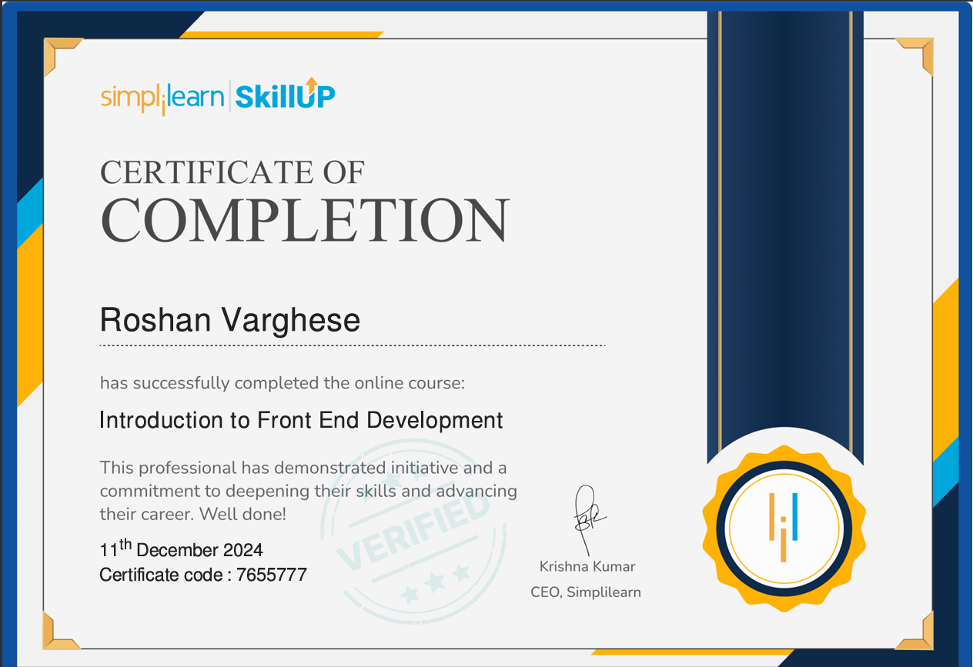
A total of 17 Hours was completed.

