MICROSOFT AZURE PROJECT
Project Documentation & Implementation Evidence
Azure Cloud Services, Virtual Machines, Containers, IIS and Cost Management

Project | Microsoft Azure Cloud Project
Documentation | Implementation Evidence Report
Platform | Microsoft Azure
Prepared by | Student Project

1. Project Overview
This document presents the implementation evidence collected during a Microsoft Azure project. The screenshots document different stages of the work, including a web interface, an electronic/IoT setup, assessment completion, image testing, Azure Cloud Shell and SSH access, Azure Container Instances, Windows Server with IIS, Azure Cost Management budgeting, and Windows network configuration.
The screenshots are included as practical evidence of the activities performed. They can be uploaded together with this document to a GitHub repository as a project record.

2. Objectives
- To gain practical experience with Microsoft Azure services.
- To understand basic virtual machine access using Azure Cloud Shell and SSH.
- To deploy and verify a container using Azure Container Instances.
- To understand web hosting using Windows Server and IIS.
- To observe Azure Cost Management and configure a budget.
- To document project implementation and testing results using screenshots.

3. Technologies / Services Observed
Technology / Service | Purpose
Microsoft Azure | Cloud platform used for deploying and managing resources.
Azure Cloud Shell | Browser-based shell used to execute Azure CLI commands.
Azure Virtual Machine | Cloud-based virtual machine accessed through SSH.
Azure Container Instances | Service used to run a container without managing a full virtual machine.
Windows Server | Server operating system used for the web-server demonstration.
IIS | Internet Information Services used to host and serve a web page.
Azure Cost Management | Used to monitor evaluated spend and configure a budget.
GitHub | Recommended repository for storing the final documentation and evidence files.

4. Implementation Evidence
The following screenshots are arranged in the order supplied for this documentation. Each figure includes a short description to make the evidence easy to understand when viewed in GitHub.

Figure 1 – Web application / project interface
Screenshot showing the completed web interface/project page running in a browser.
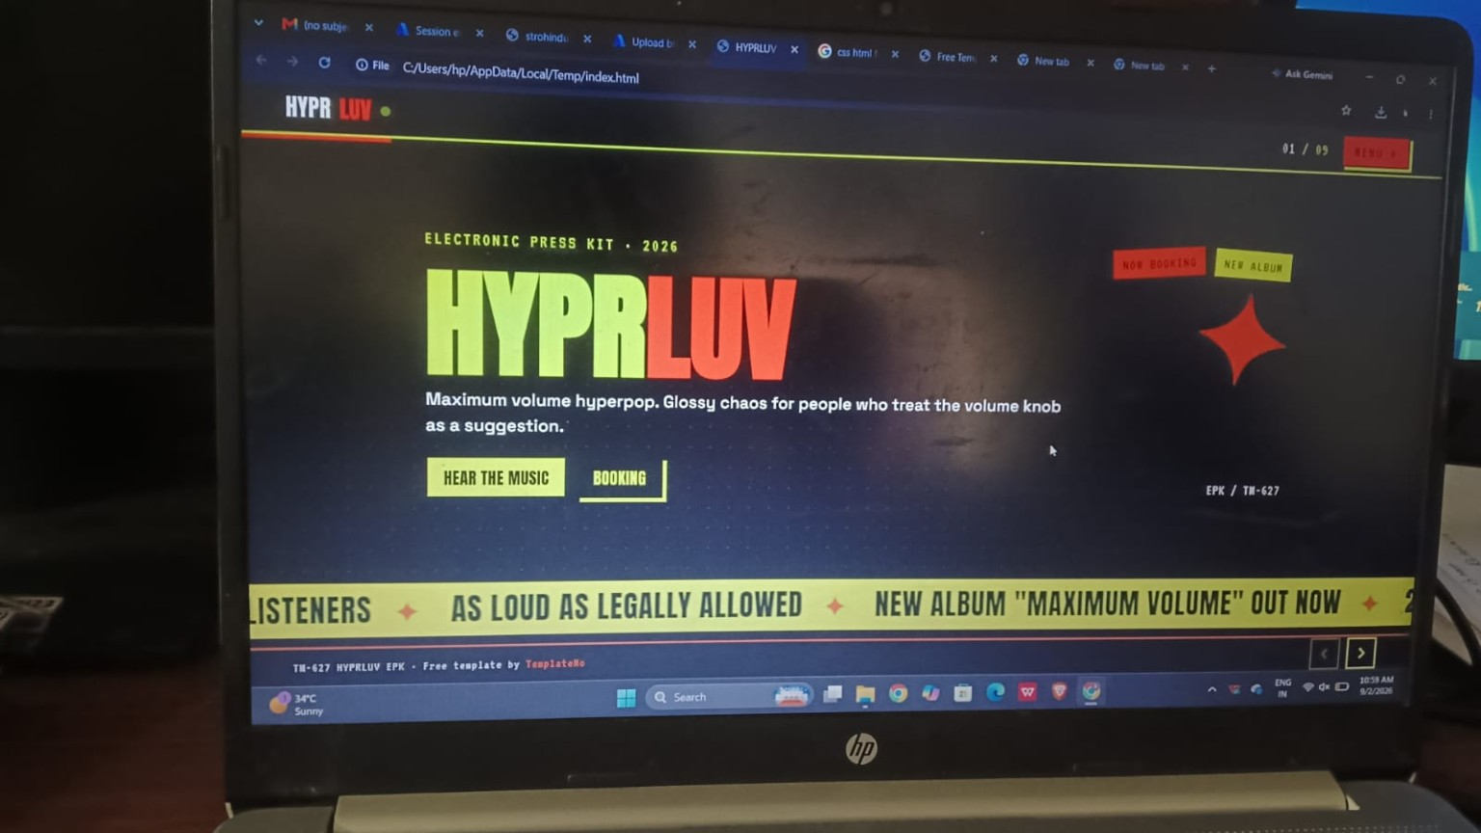
Figure 1: Web application / project interface

Figure 2 – Hardware / IoT setup
Screenshot showing an electronic circuit setup with a sensor/module, LED and development board.
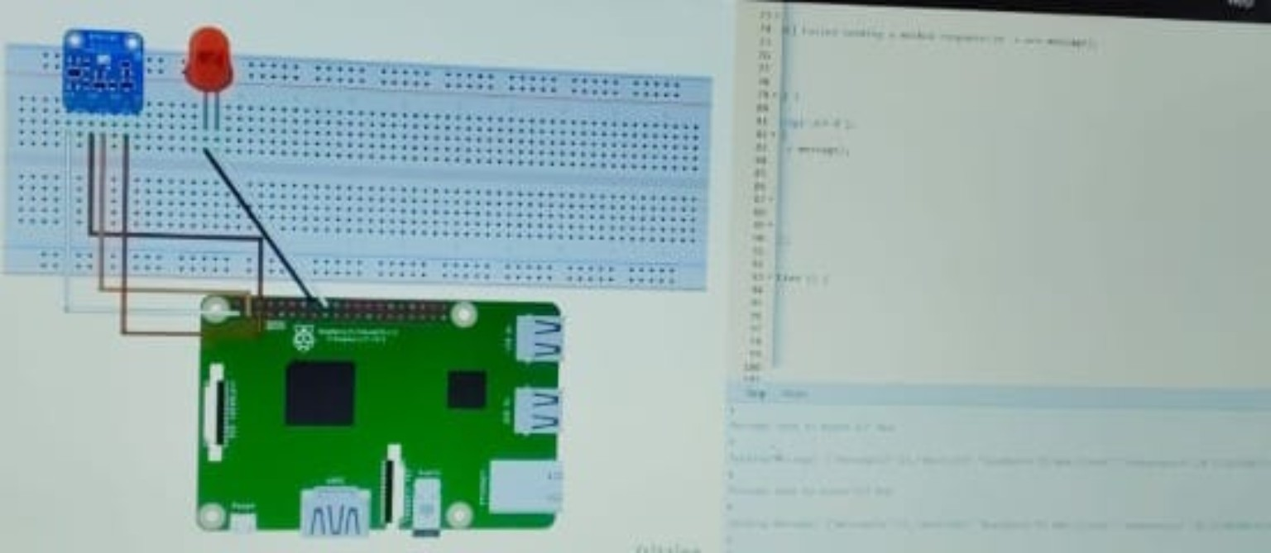
Figure 2: Hardware / IoT setup

Figure 3 – Assessment completion
Microsoft-related assessment result showing 21/25 correct (84%) and a passed status.
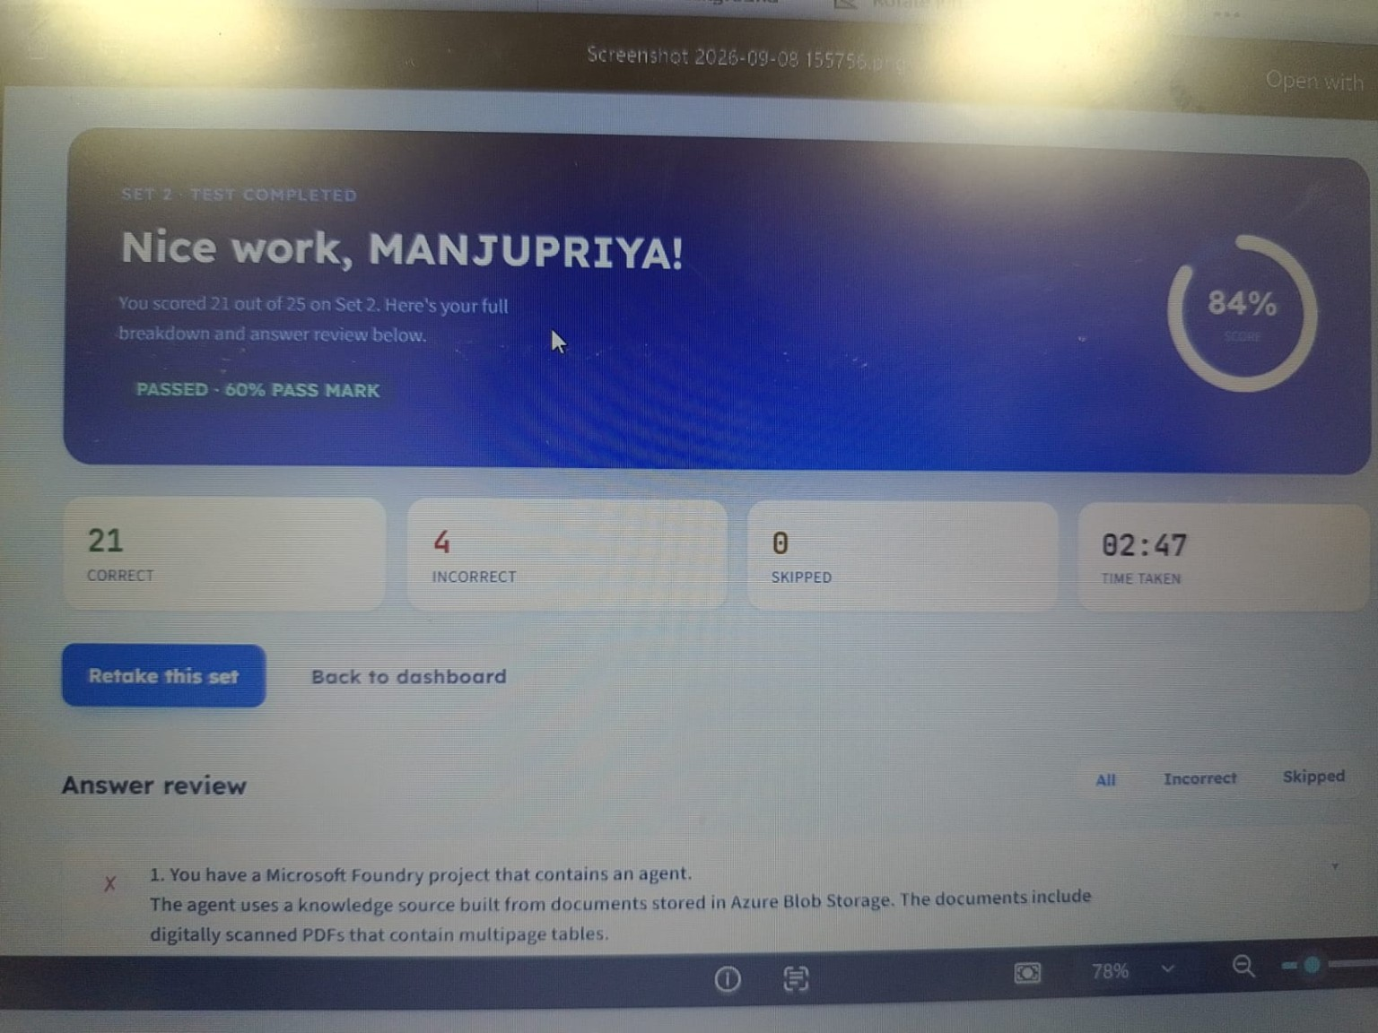
Figure 3: Assessment completion

Figure 4 – Image content used for testing
Screenshot showing an image of a dog and cat, representing image content used during testing.

Figure 4: Image content used for testing

Figure 5 – Azure Cloud Shell and SSH connection
Azure portal Cloud Shell showing an SSH command used to connect to a virtual machine and the host-key confirmation prompt.
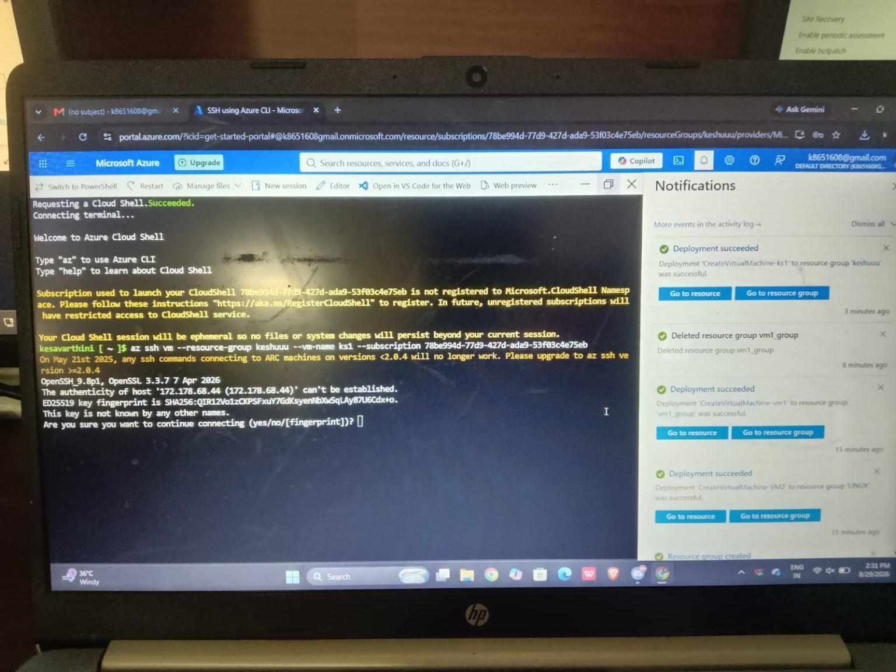
Figure 5: Azure Cloud Shell and SSH connection

Figure 6 – Azure Container Instances
Azure Container Instances welcome page, showing the deployed container instance interface.
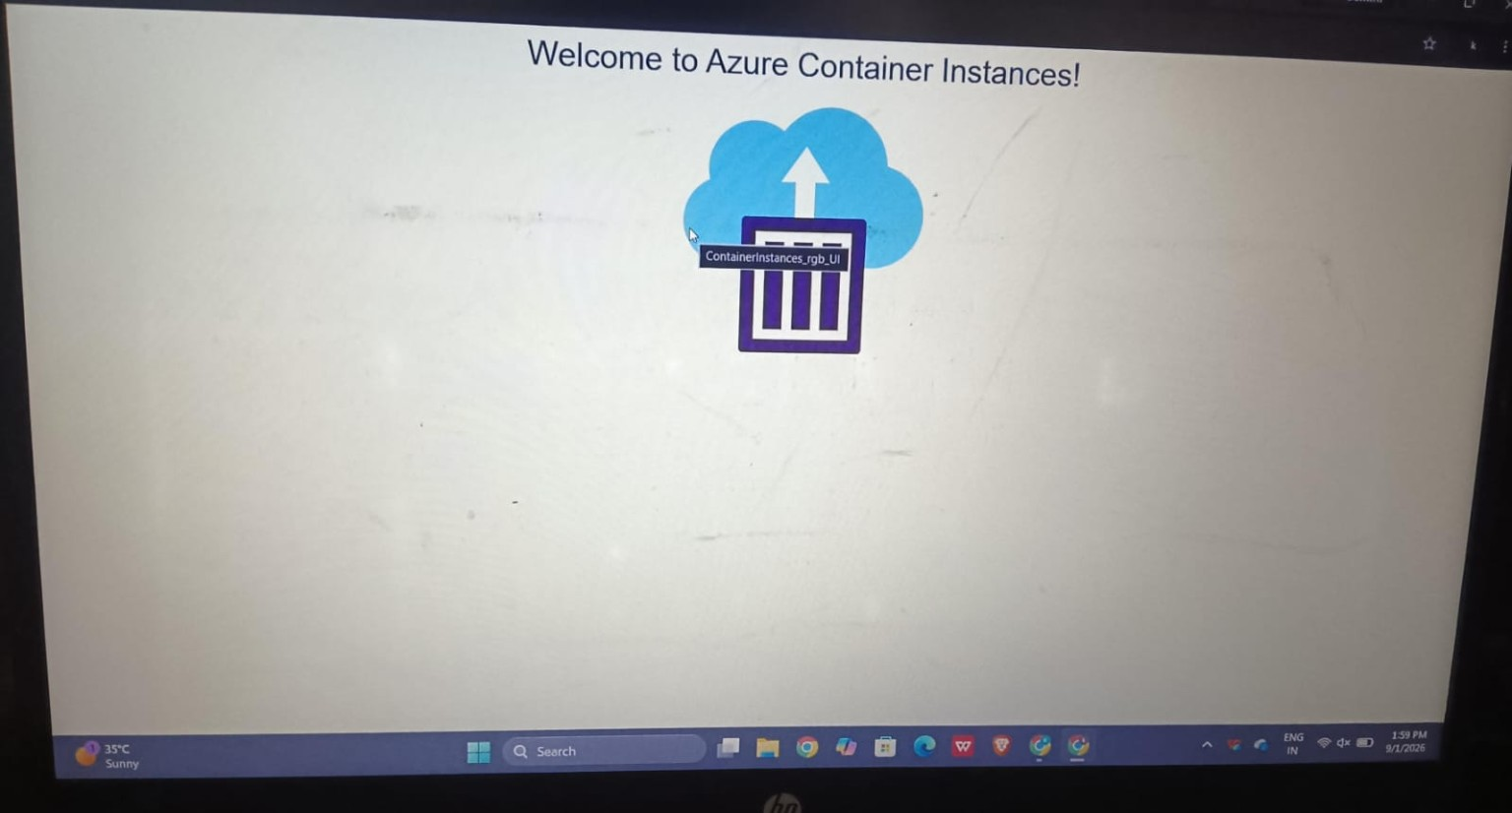
Figure 6: Azure Container Instances

Figure 7 – Windows Server with IIS
Windows Server screenshot showing the Internet Information Services (IIS) default welcome page being served through a browser.
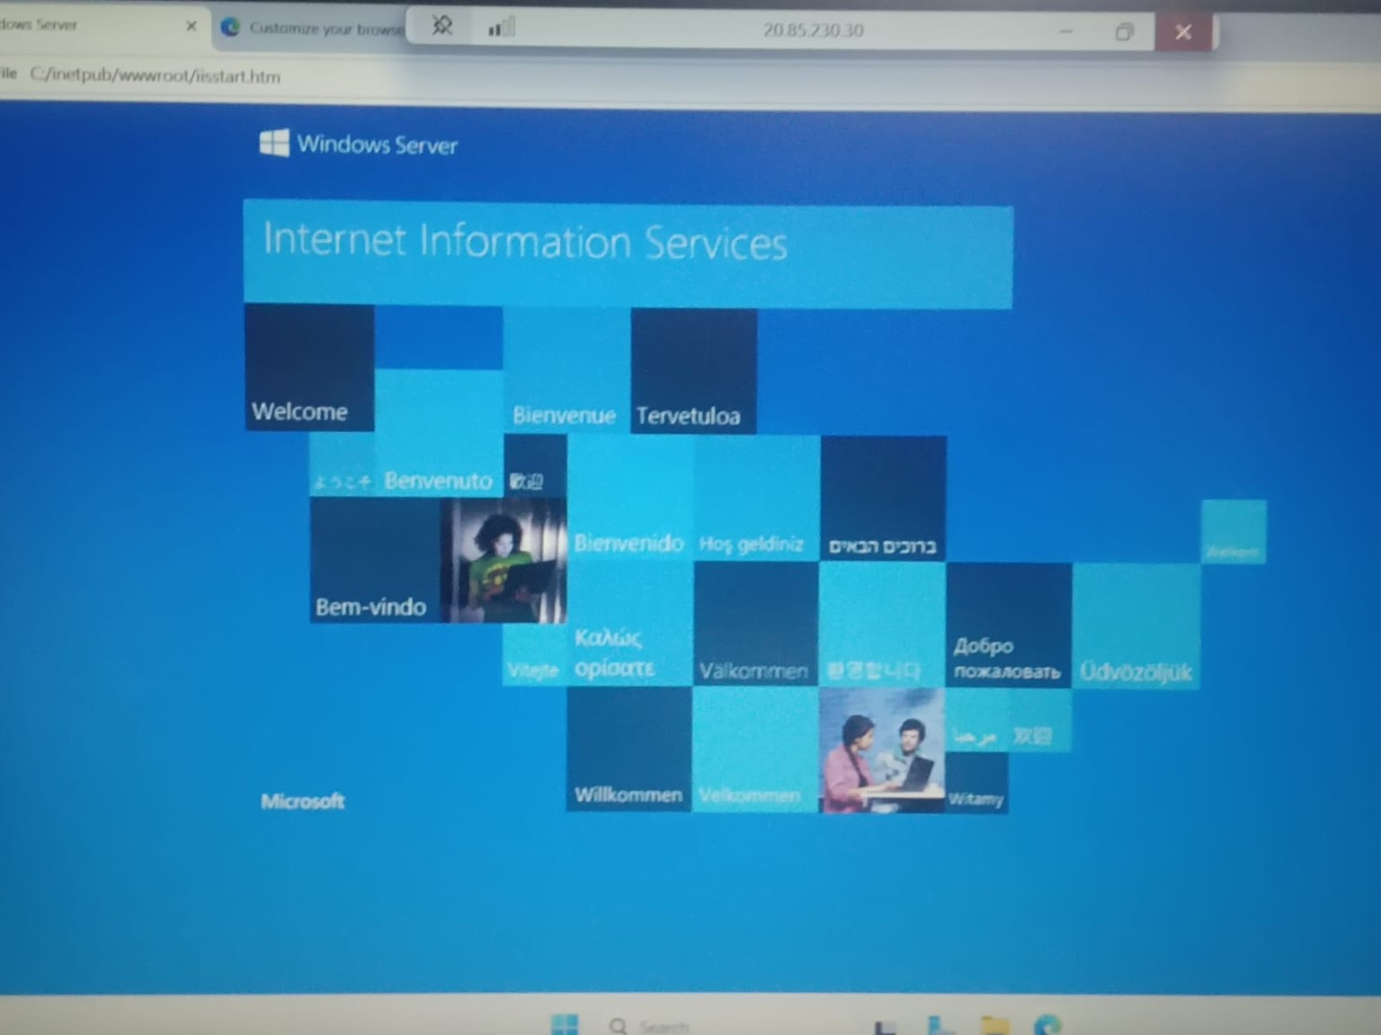
Figure 7: Windows Server with IIS

Figure 8 – Azure Cost Management budget
Azure Cost Management budget screen showing a monthly budget configuration and evaluated spend.
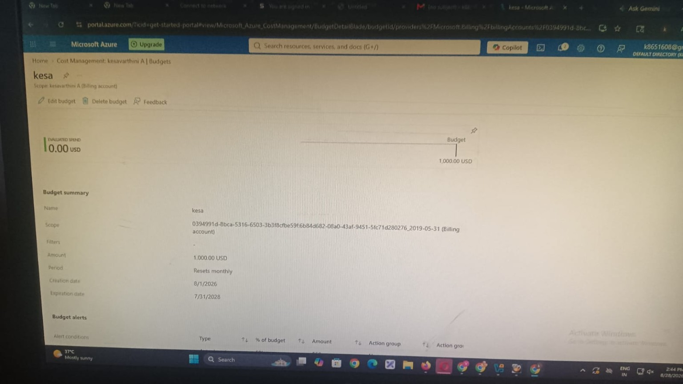
Figure 8: Azure Cost Management budget

Figure 9 – Windows Server network configuration
Windows desktop screenshot showing the network discovery prompt on a Windows environment.
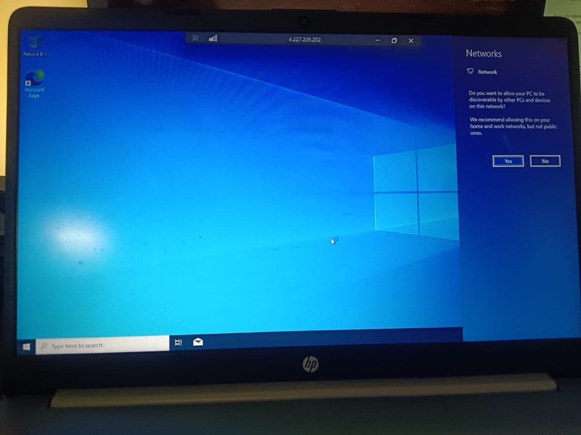
Figure 9: Windows Server network configuration

5. Results
- The project evidence shows successful interaction with multiple Azure resources and related environments.
- An Azure Cloud Shell session was established and an SSH command was used to access a virtual machine.
- An Azure Container Instance deployment was reached successfully and its welcome page was displayed.
- A Windows Server environment successfully displayed the IIS welcome page through a browser.
- Azure Cost Management showed a configured budget with evaluated spend information.
- The assessment screenshot records a score of 21/25 (84%) and a passed status.

6. Conclusion
The screenshots provide a consolidated record of the Microsoft Azure project activities and testing. They demonstrate practical exposure to cloud resources, virtual machine access, containers, web-server hosting, cost management and project verification. The complete evidence package can be maintained in GitHub so that the project work and implementation results are easy to review.

7. Suggested GitHub Folder Structure
- README.md
- Azure_Project_Documentation.docx
- screenshots/
- screenshots/01_web_interface.jpg
- screenshots/02_hardware_setup.jpg
- screenshots/03_assessment_result.jpg
- screenshots/04_image_testing.jpg
- screenshots/05_cloud_shell_ssh.jpg
- screenshots/06_container_instances.jpg
- screenshots/07_windows_server_iis.jpg
- screenshots/08_cost_management_budget.jpg
- screenshots/09_windows_network.jpg

8. Repository Note
This ZIP package contains the documentation and the original screenshots supplied for the project. The images are kept separately in the screenshots folder so they can also be viewed directly from GitHub.

