MA 374: Assignment 08
Date: 10/02/20
Roll No: 170123025

Q1)
a) The estimated historical volatilities of various stocks from the index using last 1 months data are:

NSE
Mahindra -- 0.38231209661194454
ONGC -- 0.2524563777049391
Sun Pharma -- 0.5711675532720871
Vedanta Ltd -- 0.40543098530429933
Wipro -- 0.21849330308611717
Cipla -- 0.2716255162522064
Eicher -- 0.31423392049898063
Hero -- 0.3223736429143638
Infosys -- 0.25068004235769203
ITC -- 0.21778354629305588

BSE
Asian Paints -- 0.31501667419422
Wipro -- 0.23234391476077765
Titan -- 0.2442023339338922
SBI -- 0.3514387928328876
L&T -- 0.23504902834843203
Infosys -- 0.2567770744258203
ICICI -- 0.23659293393936343
CoalIndia -- 0.2793594625302578
Bajaj Finance -- 0.35346761378511693
Axis Bank -- 0.28294167396546005

b) It is observed that increasing the strike prices decreases call option’s price but increases the put option’s price as expected.

Some plots of the observerd trend are included in the report, others are included in the submitted folder.

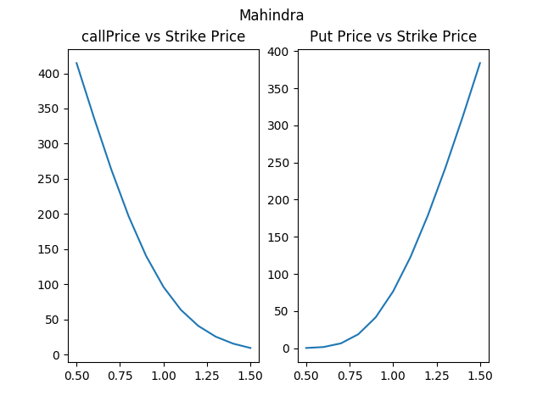
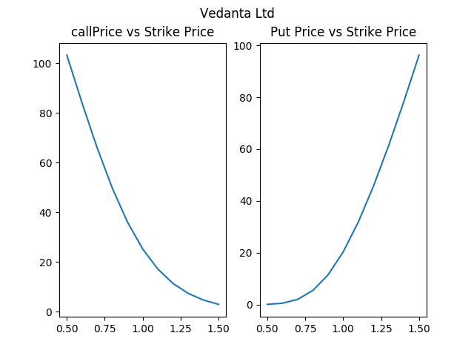
NSE:

BSE:
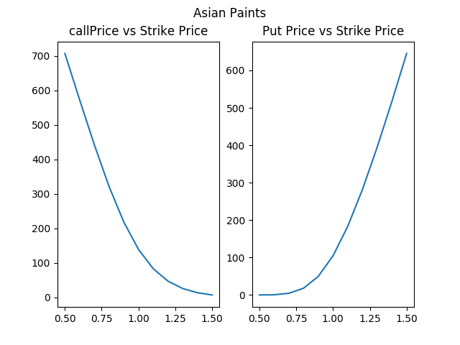
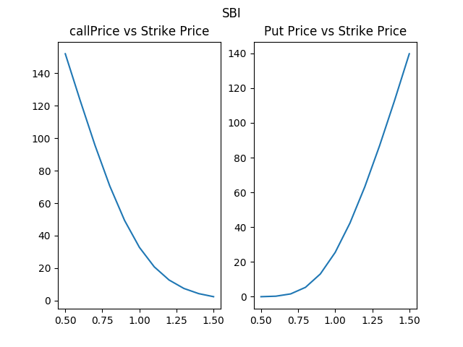

And the option prices first increased and then decreased with increase in loob back period, this behaviour is observed for both put and call options.
The maximum is observed to be reached when the look back period is 3 months in almost all the cases.

Some plots depicting the same are presented below

NSE:
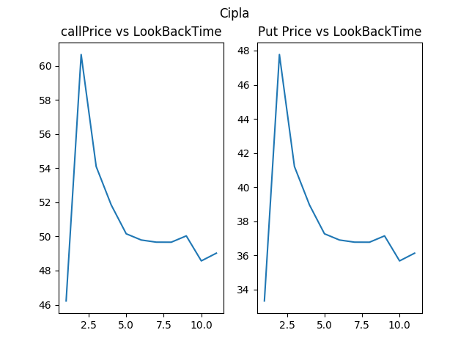
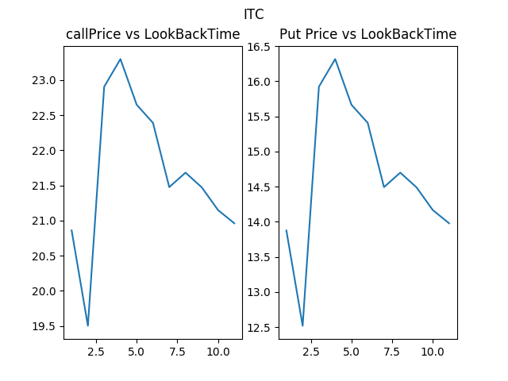

BSE:

