WIOM · GROWTH · ACTIVATION (L1)
June L1 Statics — Make-Framework, Scoring & Test Plan
How the 9 June L1 statics were built, how they score on the rendered art, what each campaign is testing, and how to run / stop / read them.
Wave: BRIEF-UNFLT-20260603 · 9 concepts (JUN26-C-038/039/040, T-041–T-046) · all L1, need-state NET, capture-bridge WiFi-as-launchpad, CTA Book Karein. Source of truth: Creative Registry + filenames + the v2 classification record. Scoring basis: the delivered 1:1 rendered art (embedded in §2).

1 · The framework we built these on
There was no single “how we made these” doc. This codifies the implicit framework so the next wave is briefed against one page — who we are making for, and the rules that governed the making.

Who: the L1 Ready Buyer — the job is reclassification, not flexibility
L1 is the active home-internet shopper choosing a provider this week — comparison-mode, defaulting to the WiFi/broadband schema. The job is category reclassification: “Wiom is just another WiFi” → “Wiom isn’t the WiFi I’m comparing — it’s recharge-wala ghar ka net.” Flexibility is the differentiator, but it lands after the category, never as the hook.
Clean-test guardrail A true-L1 creative may not use an L2 commitment/waste hook (“poore mahine ka paisa kyun”). If its hook is “avoid the monthly,” it is L2 wearing L1 clothes. No L3 hooks (hotspot / top-up / “ek phone se poora ghar”) this round.

The rules that governed the making
- Capture in the market’s familiarity, convert in the category. WiFi signal earns the first 2 seconds as a launchpad; never the destination or Wiom’s identity.
- Destination noun is “net” / “ghar ka net.” Never “recharge” as the final word (Contrast Doctrine v2.1 safety rule).
- Three memory anchors, unfragmented: Recharge-wala Ghar ka Net · Jitne din recharge, utne din net · Chale aapke hisaab se.
- User is the hero; Wiom is the enabler. Real homes, relatable family; no glowing routers / speed tests / app-UI as the visual hero.
- One job per frame; simple beats clever; zero confusion is the bar. Category first, then flexibility (the May-sprint craft rule).
- Single-variable test discipline. Four axes (story, protagonist, need-state, format) tagged; change one at a time.
- Two gates before spend. G1 category-frame integrity (ghar anchor + recharge-shape clear + no drift) and G2 contamination (kill-list words not used as identity).

2 · How each creative scores (Maanas framework)
Scored on the rendered art against the 6-dimension Evaluation Framework, after the Section-A brand gates + dual-persona test. Weights: Audience 15 · Motivation 30 · Promise 20 · Recharge-Mechanic 15 · CTA 10 · Thumb-Stop 10.
Concept | Aud 15 | Mot 30 | Prom 20 | Mech 15 | CTA 10 | TS 10 | Score | Theme | Flag
C-038 | 8 | 8 | 8 | 8 | 8 | 8 | 8.0 | Need-toggle (curiosity / QH) | Top recognition asset
C-039 | 7 | 6 | 8 | 8 | 8 | 5 | 7.0 | Calendar (direct / RR) | Explainer — no household (A6)
C-040 | 9 | 6 | 7 | 7 | 8 | 6 | 7.0 | Phone-search (curiosity / QH) | Phone in-hand OK; narrow range
T-041 | 6 | 6 | 6 | 7 | 8 | 5 | 6.3 | Router “Home net” (direct / RR) | Router-hero, no people (A6)
T-042 | 8 | 6 | 8 | 7 | 8 | 5 | 7.0 | Router “Ghar ka net” (direct / RR) | Router-hero (A6); Hindi anchor
T-043 | 7 | 7 | 7 | 8 | 8 | 7 | 7.3 | Family-router static (RR / peer) | Scene + chips; user-as-hero
T-044 | 7 | 7 | 7 | 8 | 8 | 6 | 7.2 | Family-router carousel (RR / peer) | Card-1 must stop alone
T-045 | 8 | 8 | 9 | 7 | 8 | 8 | 8.0 | “Yeh WiFi nahi” static (contrast / CMP) | A3 cleared (duration bar)
T-046 | 8 | 8 | 9 | 8 | 8 | 8 | 8.2 | “Yeh WiFi nahi” carousel (contrast / CMP) | Card-2 resolves destination

Gate reads T-045 / T-046 use “WiFi” — they pass via the A5 comparison carve-out (WiFi struck through, destination = Wiom / the category), NOT a clean A3 pass: highest reclassification power, highest contamination risk, and they fail if the destination lands as “a different WiFi.” T-045’s bottom bar reads recharge DURATIONS (1 / 2 / 7+ din), not “plan” — A3 clear. CTA is “Book Karein” on all 9 (fix the META_LEARN tag in the registry).

The creatives, with scorecards
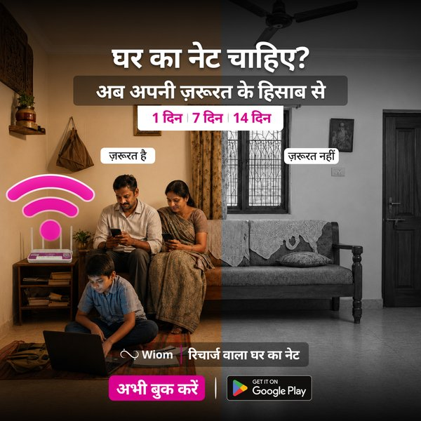 | C-038 · Static 1 — Need-toggle “Ghar ka net chahiye?” (QH / peer · Campaign)  Score 8.0 A8 M8 P8 Mech8 CTA8 TS8  Read. Split colour-vs-grey (“zā roorat hai / nahīn”) is the strongest scroll-stop in the set; chips present, family is the hero. The recognition asset the L1 brief praised.  Flag. Watch the on/off contrast still reads at flash speed in-feed.
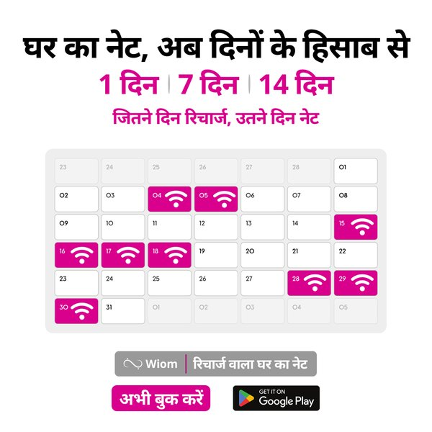 | C-039 · Static 2 — Calendar “dinon ke hisaab se” (RR / narrator · Campaign)  Score 7.0 A7 M6 P8 Mech8 CTA8 TS5  Read. Rule verbatim (“Jitne din recharge, utne din net”), mechanic crystal-clear. Cold explainer graphic — no household scene, low thumb-stop.  Flag. A6 user-as-hero is weak — it’s a chart, not a life. Consider a household-scene variant.
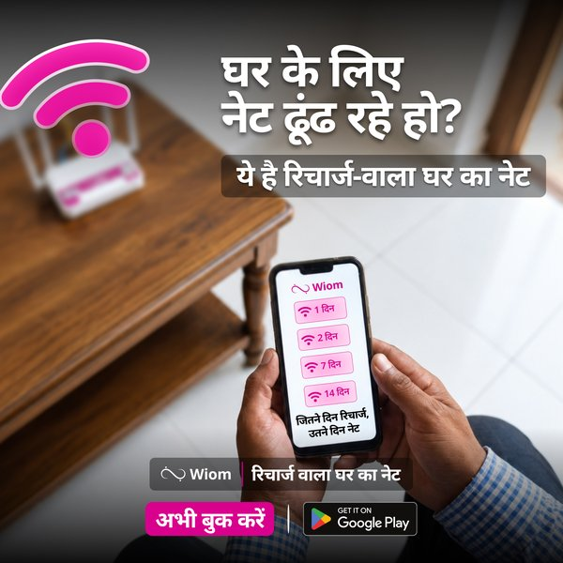 | C-040 · Static 3 — Phone-search “dhoondh rahe ho?” (QH / narrator · Campaign)  Score 7.0 A9 M6 P7 Mech7 CTA8 TS6  Read. Sharpest active-searcher capture; reclassifies to “recharge-wala ghar ka net”; app menu shows 1/2/7/14 din. Phone is in-hand in a home (not a sterile UI shot).  Flag. Narrow L1-only range — weak on the dual-persona Range test.
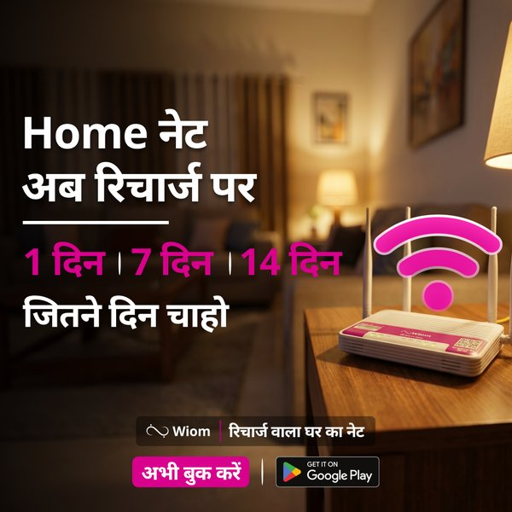 | T-041 · Static 4 — Router “Home net ab recharge par” (RR / narrator · Test, T-ART-02)  Score 6.3 A6 M6 P6 Mech7 CTA8 TS5  Read. The English-anchor arm, weaker by design. Identical visual to T-042; one word differs.  Flag. A6: router + pink glyph is the hero, no people. Held constant for the wording test.
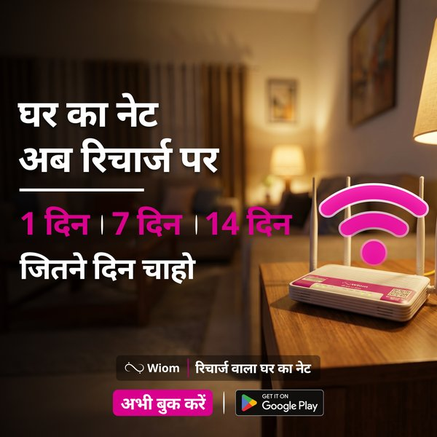 | T-042 · Static 4B — Router “Ghar ka net ab recharge par” (RR / narrator · Test, T-ART-02)  Score 7.0 A8 M6 P8 Mech7 CTA8 TS5  Read. The Hindi-anchor arm — stronger category-ID. The cleanest single-word pair in the wave.  Flag. Same router-hero A6 watch as T-041.
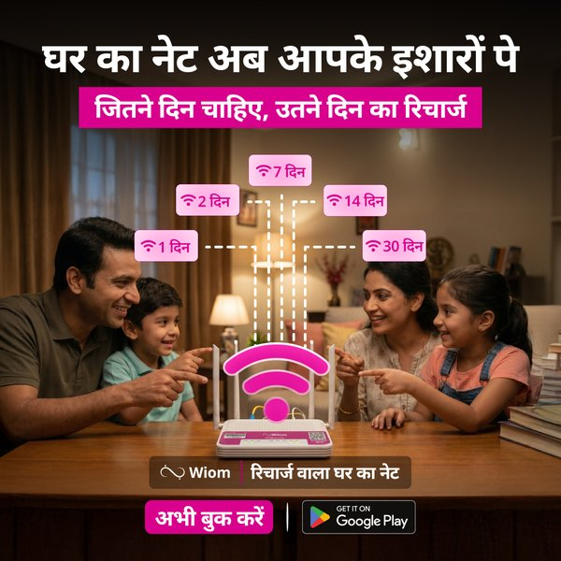 | T-043 · Static 7 — Family-router “apke ishaaron pe” + chips (RR / peer · Test, T-FMT-02)  Score 7.3 A7 M7 P7 Mech8 CTA8 TS7  Read. Family delight pointing at the router; floating chips 1/2/7/14/30 din carry the mechanic. Crams scene + chips into one frame. Strong user-as-hero.  Flag. Doubles as the static arm of the format test — read scale quality and learning engagement separately.
S1 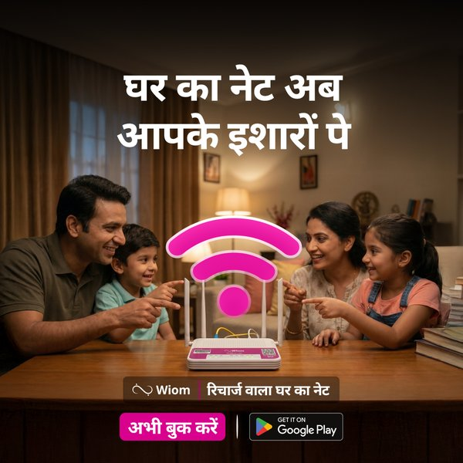  S2 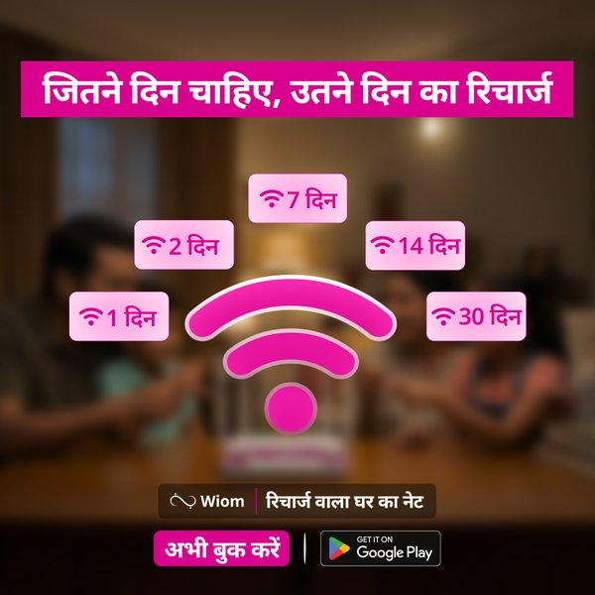 | T-044 · Carousel — family-scene → day-chips (RR / peer · Test, T-FMT-02)  Score 7.2 A7 M7 P7 Mech8 CTA8 TS6  Read. Two-beat: card 1 scene + category (no chips), card 2 the duration chips. Respects one-job-per-frame.  Flag. Card 1 must stop the scroll alone — it carries no mechanic. Not pixel-clean vs T-043 (badges).
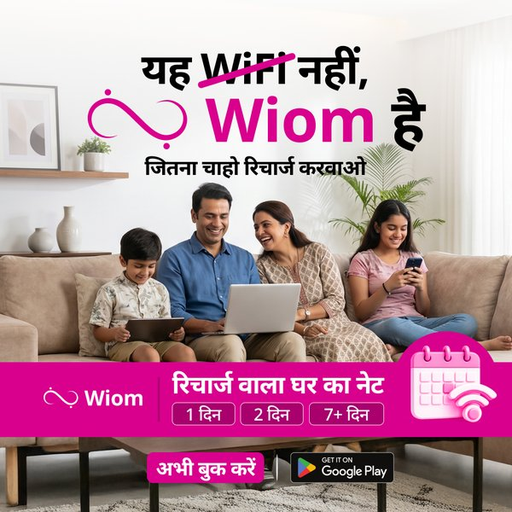 | T-045 · Static 6 — “Yeh WiFi nahi, Wiom hai” + duration bar (CMP / peer · Test, T-FMT-03)  Score 8.0 A8 M8 P9 Mech7 CTA8 TS8  Read. WiFi struck through → “Wiom hai”: the sharpest reclassification + strongest pattern-interrupt. Family scene; bottom bar carries durations + “recharge-wala ghar ka net.”  Flag. Subline ends on “recharge karwao” — net is anchored only in the lockup; highest contamination risk if destination slips to “different WiFi.”
S1 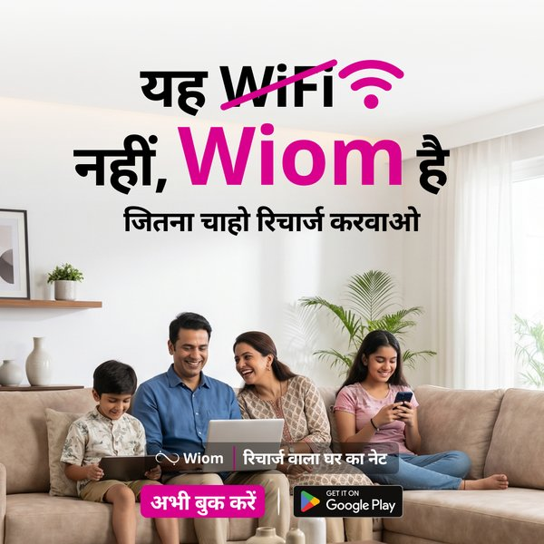  S2 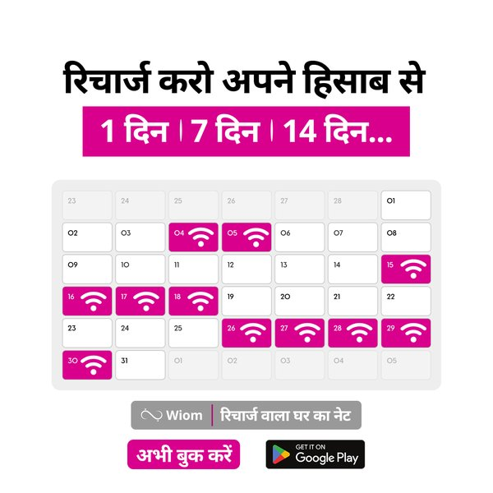 | T-046 · Carousel — contrast → recharge calendar (CMP / peer · Test, T-FMT-03)  Score 8.2 A8 M8 P9 Mech8 CTA8 TS8  Read. Highest scorer. Card 1 reclassifies (“WiFi nahi, Wiom hai”, family), card 2 resolves the destination on a recharge calendar. The second beat lowers the misread the static must risk alone.  Flag. The L1 creative the brief was built to find — watch its misread rate as closely as its CTR.

3 · What we are testing
Three questions sit inside the 9 concepts. The first two are designed single-variable reads; the third is a directional horse-race.

3.1 · Language anchor — “Home net” vs “Ghar ka net” (T-041 vs T-042 · T-ART-02)
Identical router visual; one word differs. The cleanest pair in the wave. Reads which anchor out-hooks the cold L1 audience and lands category-ID. Conversion directional only.

3.2 · Ad-unit format — all-in-one static vs 2-card carousel (T-FMT-02, T-FMT-03)
Same theme, two formats, on two themes: family-router (T-043 vs T-044) and category-contrast (T-045 vs T-046). The carousel splits the job across two cards (scene → mechanic; contrast → destination); the static does it in one frame. Not pixel-clean — the static carries chips / a bar the carousel’s first card doesn’t — so read format at the theme level, directionally.

3.3 · Theme spread — curiosity vs direct vs contrast (horse-race T-LRN-01)
Across the scale statics the themes vary: curiosity / question-hook (C-038, C-040), direct / rule-reveal (C-039, T-042/043), contrast (T-045). All variables co-vary here, so this ranks concepts to feed creative selection — no variable-level conclusion.

4 · How to run, stop & analyse
Two campaigns, two scorecards. Learning is engagement-powered and judged on creative pull; Scale is recharge-quality-powered and judged on down-funnel quality at CAC. T-043 and T-045 do double duty — they deliver in Scale and act as the static arm of the format tests in Learning — so their two reads use different metrics and stay separate.

Learning campaign · T-041/042 · T-043↔T-044 · T-045↔T-046
 | Learning campaign | —
Objective | Clean reads on language anchor (3.1) and format (3.2), per theme. Not a booking engine. | Soft CTA / observe-mode is correct here.
Primary metric | CTR / hook-rate + install-rate (creative pull), matched budget, same ad-set. | BFC / CPBFC directional only — volume can’t power booking significance.
Duration | 5–7+ days: run to engagement significance (impressions-powered), not booking significance. | OBSERVE days 1–7 — no winner calls early.
When to stop | At engagement significance OR the decision deadline, whichever first — EOD Friday Wk 3, decide on whatever data exists. | Kill a cell on comprehension fail: destination reads “WiFi/broadband”, or any headline ending on “recharge.”
How to analyse | 3.1: winner on CTR at matched spend. 3.2: winner on engagement per theme; cross-check the two themes for format×theme interaction (directional). | Read carousel vs static per-theme, never pooled. Attribute format at theme level (not pixel-clean).

Scale campaign · C-038 · C-039 · C-040 · T-043 · T-045
 | Scale campaign | —
Objective | Deliver recharge-quality L1 bookings within ₹400 CAC; the 5 statics also feed the directional horse-race (T-LRN-01). | Capacity-gated zones only.
Primary metric | CAC per coverage-sustaining booking + first-recharge quality — NOT booking volume. | Volume without recharge quality is invalid growth.
Duration | Run while CAC ≤ ₹400 and recharge-quality holds. First read Wk 2; scale/kill by EOD Friday Wk 3; winners continue. | Then ongoing, re-read on the matched-cohort delta.
When to stop | Kill a static if: CAC > ₹400 with no improving trend by deadline; OR category-ID-positive but coverage-continuity < live L2 set by Wk 2. | Command-Center recharge-quality red → auto-pause, regardless of volume.
How to analyse | Rank the 5 statics on CPI + down-funnel recharge quality (feeds creative selection only — no variable claims). | Watch T-045 specifically for the “different WiFi” misread in comments / comprehension.

Pre-flight, every concept Confirm before spend: G1 (ghar anchor + recharge-shape clear + no drift), G2 (no kill-list word as identity), Book Karein + Play Store icon present, one-idea-once / legibility. A concept that fails a gate is fixed or killed before it runs.

Learning-log context (confirm before logging) Suggested entry: “June L1 statics wave (BRIEF-UNFLT-20260603). Testing (1) language anchor Home-net vs Ghar-ka-net, (2) static vs carousel on family-router & WiFi-contrast themes, (3) directional theme horse-race. L1 reclassification job, clean-test guardrail (no L2/L3 hooks). Read: Learning on engagement/install; Scale on first-recharge quality at ≤₹400 CAC. Decision deadline EOD Fri Wk 3.” — tell me your wording if this isn’t it.

