Peer-graded Assignment: Regression Models

Nikhil

June 24, 2017

## Executive Summary

Miles per gallon (MPG) is an important criteria for assessing and rating automobiles. It depends of various factors: fuel quality, weight, number of cylinders, engine efficiency, transmission efficiency, driver's ability, road conditions, etc. This report tries to explain the difference between the impact of automatic and manual transmission on MPG.

## R Markdown

## mpg cyl disp hp drat wt qsec vs am gear carb  
## Mazda RX4 21.0 6 160 110 3.90 2.620 16.46 0 1 4 4  
## Mazda RX4 Wag 21.0 6 160 110 3.90 2.875 17.02 0 1 4 4  
## Datsun 710 22.8 4 108 93 3.85 2.320 18.61 1 1 4 1  
## Hornet 4 Drive 21.4 6 258 110 3.08 3.215 19.44 1 0 3 1  
## Hornet Sportabout 18.7 8 360 175 3.15 3.440 17.02 0 0 3 2  
## Valiant 18.1 6 225 105 2.76 3.460 20.22 1 0 3 1

## Min. 1st Qu. Median Mean 3rd Qu. Max.   
## 10.40 15.43 19.20 20.09 22.80 33.90

## Min. 1st Qu. Median Mean 3rd Qu. Max.   
## 0.0000 0.0000 0.0000 0.4062 1.0000 1.0000

## 0 1   
## 19 13

## mpg cyl disp hp drat wt qsec vs am gear carb  
## Mazda RX4 21.0 6 160 110 3.90 2.620 16.46 0 1 4 4  
## Mazda RX4 Wag 21.0 6 160 110 3.90 2.875 17.02 0 1 4 4  
## Datsun 710 22.8 4 108 93 3.85 2.320 18.61 1 1 4 1  
## Hornet 4 Drive 21.4 6 258 110 3.08 3.215 19.44 1 0 3 1  
## Hornet Sportabout 18.7 8 360 175 3.15 3.440 17.02 0 0 3 2  
## Valiant 18.1 6 225 105 2.76 3.460 20.22 1 0 3 1  
## wpc  
## Mazda RX4 0.4366667  
## Mazda RX4 Wag 0.4791667  
## Datsun 710 0.5800000  
## Hornet 4 Drive 0.5358333  
## Hornet Sportabout 0.4300000  
## Valiant 0.5766667

## Including Plots

library(ggplot2)  
ggplot(data = mtcars,aes(x=mpg,y=am)) + geom_point(aes(size = mtcars$drat,colour = mtcars$drat))

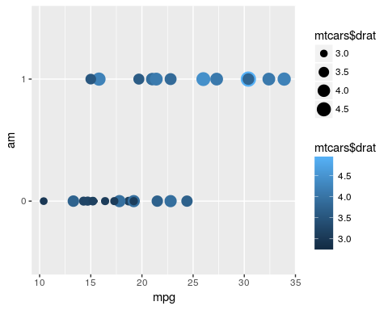

fit <- lm(mpg ~ am - 1,data = mtcars)  
  
fit

##   
## Call:  
## lm(formula = mpg ~ am - 1, data = mtcars)  
##   
## Coefficients:  
## am0 am1   
## 17.15 24.39

# summary(fit)  
  
fit2 <- lm(mpg ~ am + wt - 1,data = mtcars)  
  
fit2

##   
## Call:  
## lm(formula = mpg ~ am + wt - 1, data = mtcars)  
##   
## Coefficients:  
## am0 am1 wt   
## 37.322 37.298 -5.353

# summary(fit2)  
  
fit3 <- lm(mpg ~ am + cyl - 1,data = mtcars)  
  
fit3

##   
## Call:  
## lm(formula = mpg ~ am + cyl - 1, data = mtcars)  
##   
## Coefficients:  
## am0 am1 cyl   
## 34.522 37.089 -2.501

# summary(fit3)  
  
lm(mpg ~ am + drat -1,data = mtcars)

##   
## Call:  
## lm(formula = mpg ~ am + drat - 1, data = mtcars)  
##   
## Coefficients:  
## am0 am1 drat   
## -1.9499 0.8572 5.8111