In this program we used + for combining two strings

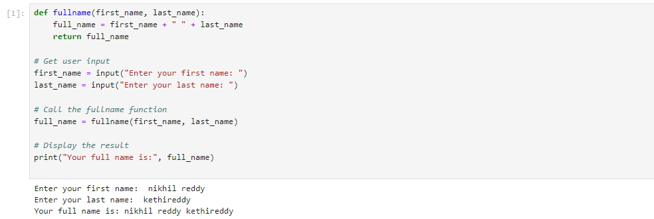

In this program we used [::2] for printing the alternate character in the string

In this program we used open and r function to open a file r to read a file and w to write in a file. And we used split function to split the words and count the words.

In this program we are takes no of customers and taking the inches and converting them to cm.

