**HW #1 - Ansible**

Github link: <https://github.com/nikhilkhanchandani/projects/tree/main/272>

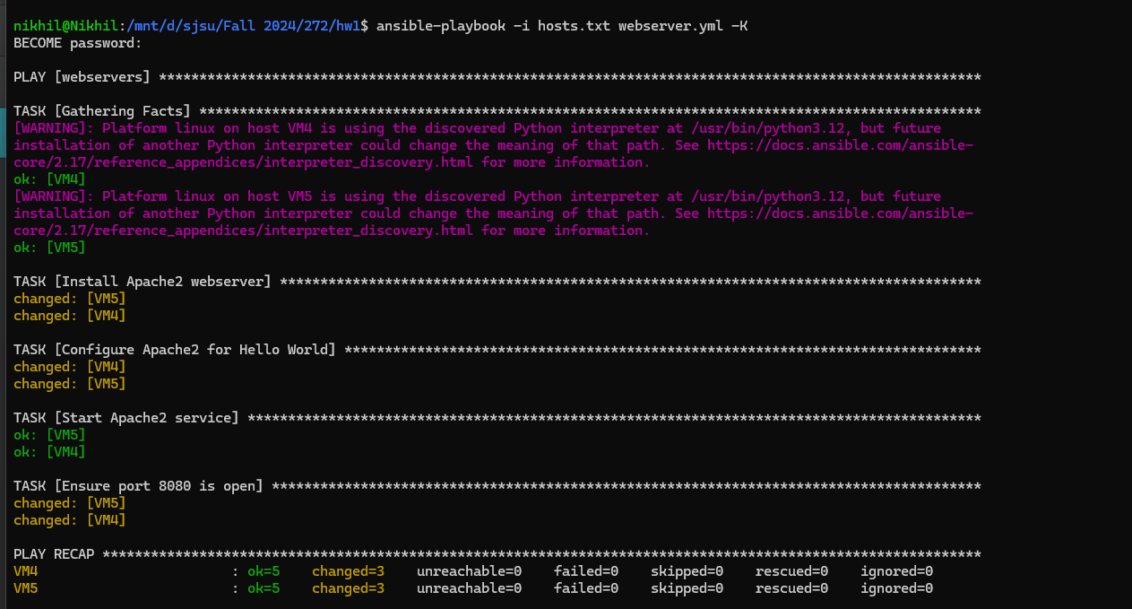

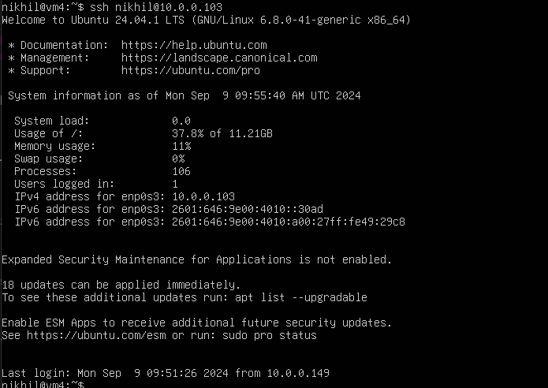

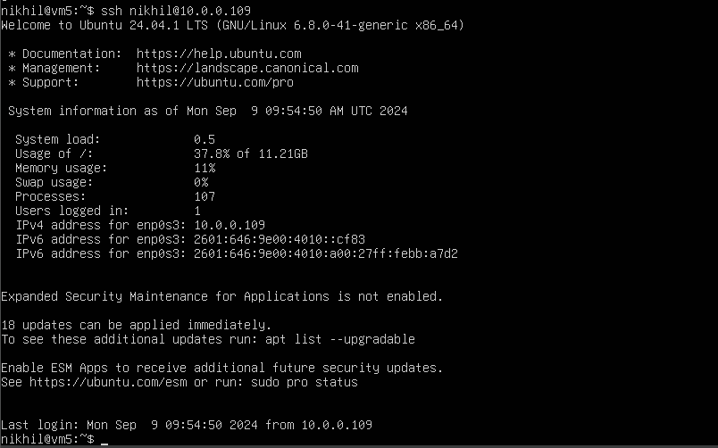





Hosts.txt

[webservers]

VM4 ansible_host=10.0.0.103

VM5 ansible_host=10.0.0.109

Webserver.yml

---

- hosts: webservers

become: true # Enable elevated privileges

tasks:

- name: Install Apache2 webserver

apt:

name: apache2

state: present

update_cache: true

- name: Configure Apache2 for Hello World

lineinfile:

path: /var/www/html/index.html

line: 'Hello World from SJSU-{{ inventory_hostname }}'

create: true

state: present

- name: Start Apache2 service

service:

name: apache2

state: started

enabled: true

- name: Ensure port 8080 is open

ufw:

port: 8080 # Use 'port' parameter

protocol: tcp # Use 'protocol' parameter

state: enabled # Use 'enabled' state