Celebal Summer Internship 2026
Week 2 Task: E-Commerce Sales Database

Name- Nikhil Shivaji Khot
StudentId:CT_CSI_DE_1019
College: MIT-WPU

Section A:- Basic_queries

Q1. Write a query to display all columns and rows from the customer's table.
Query:

Output:
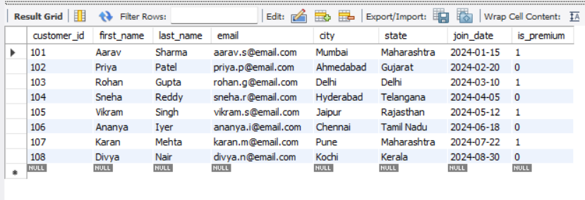

Q2. Retrieve only the first_name, last_name, and city of all customers.
Query:
Output
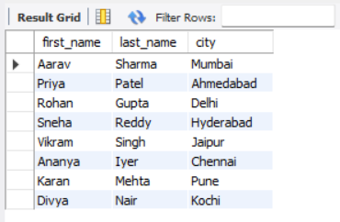

Q3. List all unique categories available in the products table.
Query:
Output:
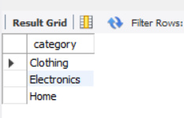

Q4. Identify the Primary Key of each table in the schema. Explain why a Primary Key must be unique and NOT NULL.

A Primary Key serves as a unique identifier for each row in a database table.
It must be UNIQUE to guarantee that individual records can be cleanly targeted without any ambiguity or mix-ups. It must be NOT NULL because an absent or unknown identifier cannot reliably map to or represent a real entity in the database.

Query:

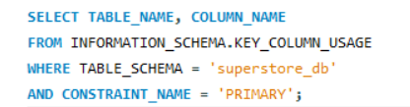
Output
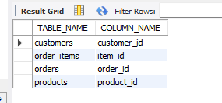

Q5. What constraints are applied to the email column in the customers table? What would happen if you tried to insert a duplicate email?
Ans:- Constraints applied: VARCHAR(100), UNIQUE, and NOT NULL.
If an attempt is made to insert a duplicate email address, MySQL will reject the query and trigger an Error Code 1062 (Duplicate entry). The engine aborts the insert statement to keep the dataset valid.

Q6. Try inserting a product with unit_price = -50. What happens and which constraint prevents it? Write both the INSERT statement and explain the error.

Running the query below causes a constraint violation because of the rule `CHECK (unit_price > 0)` defined inside our table design. MySQL drops the execution with Error Code 3819 (Check constraint is violated).
Query:-

Output:

Section B:- Filtering Queries

Q7. Retrieve all orders with status = 'Delivered'.
Query:

Output:
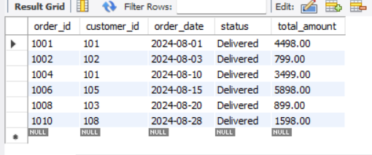

Q8. Find all products in the 'Electronics' category with a unit_price greater than ₹2000.
Query:-

Output:-
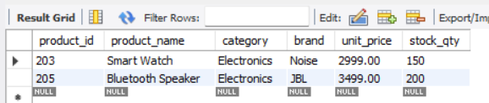

Q9. List all customers who joined in the year 2024 and belong to the state 'Maharashtra'.
Query:-

Output:- 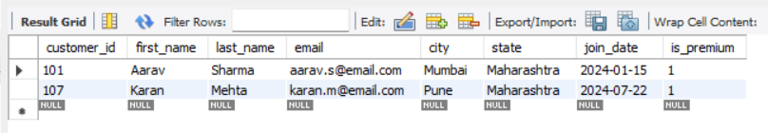
Q10. Find all orders placed between '2024-08-10' and '2024-08-25' (inclusive) that are NOT cancelled.
Query:-
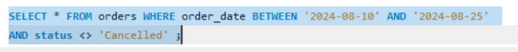

Output:-
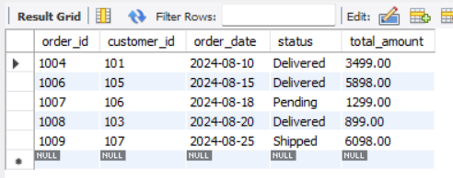

Q11. Explain what the index idx_orders_date does. How would it improve the performance of a query that filters orders by order_date? Write a sample query that would benefit from this index.
Ans:-The index `idx_orders_date` creates a separate, ordered lookup structure mapping dates to row locations.
Instead of checking every row in the orders table line-by-line (Full Table Scan), MySQL jumps directly to the relevant dates.
This drastically decreases disk I/O operations and response times on large tables.

Query:
Output:-
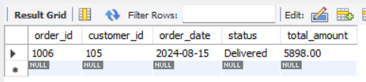

Q12. If you run: SELECT * FROM customers WHERE YEAR(join_date) = 2024; — would the index on join_date be used? Explain why or why not, and rewrite the query to be index-friendly (SARGable).

Ans:-No, the index on join_date would NOT be used effectively. Wrapping an indexed column inside a scalar function like YEAR() forces the database engine to compute the function value for every single row in the table, rendering the predicate non-SARGable.
Query:-
Output:-
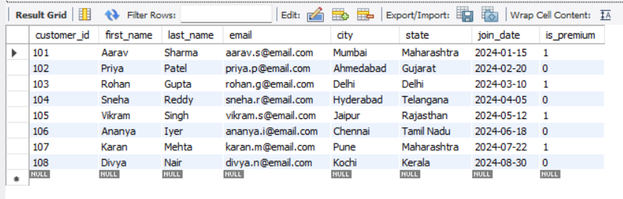

Section C:- Aggregation Queries

Q13. Count the total number of orders in the orders table.
Query:

Output:
` 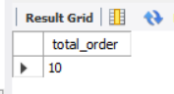
Q14. Find the total revenue (SUM of total_amount) from all 'Delivered' orders.
Query:
Output:
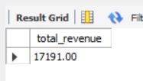

Q15. Calculate the average unit_price of products in each category.
Query:-
Output:-
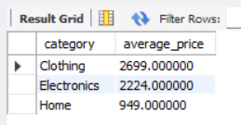

Q16. For each order status, find the count of orders and the total revenue. Sort the result by total revenue in descending order.
Query:
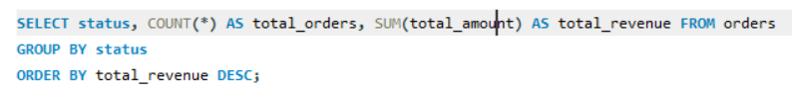
Output:
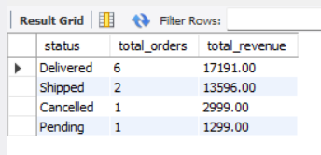

Q17. Find the most expensive (MAX) and cheapest (MIN) product in each category.
Query:
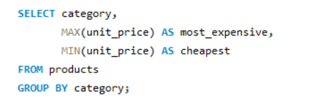
Output:
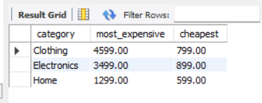

Q18. List all product categories where the average unit_price is greater than ₹2000. (Hint: Use HAVING clause)
Query:
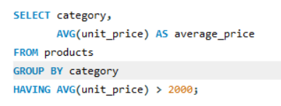

Output:-
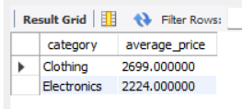

Section D — Joins Queries

Q19. Write an INNER JOIN query to display each order along with the customer's first_name and last_name. Show: order_id, order_date, first_name, last_name, total_amount.
Query:
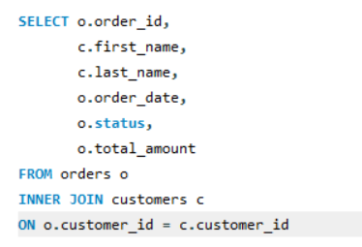
Output:
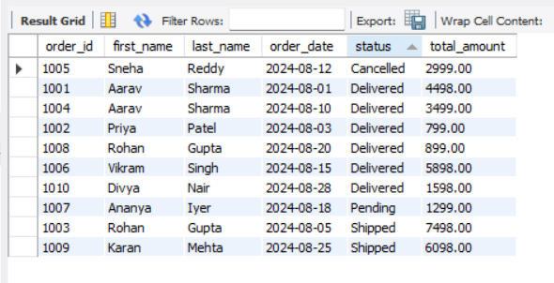

Q20. Using a LEFT JOIN, list ALL customers and their orders (if any). Customers with no orders should still appear with NULL values for order columns.
Query:
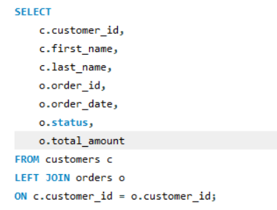
Output:
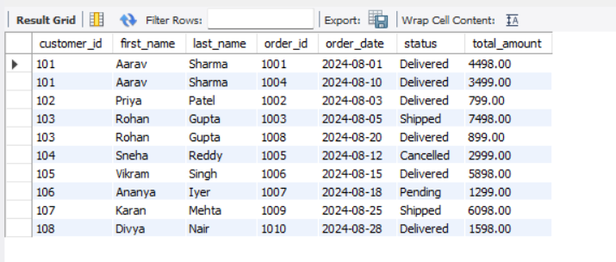

Q21. Write a query using JOINs across three tables (orders → order_items → products) to show: order_id, product_name, quantity, unit_price, and discount_pct for each order item.
Query:
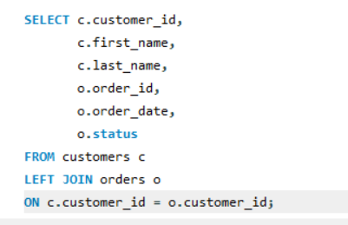
Output:
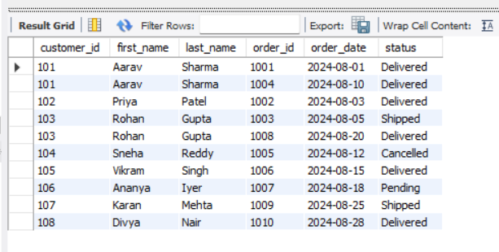

Q22. Explain the difference between LEFT JOIN and RIGHT JOIN with an example from this schema. When would you use a FULL OUTER JOIN?
LEFT JOIN: Keeps all rows from the left table (e.g., customers) even if there is no match in the right table (e.g., orders). Unmatched fields from the right table display as NULL.
Example: Customers LEFT JOIN orders` lists all registered customers, including those who haven't ordered yet.
Query
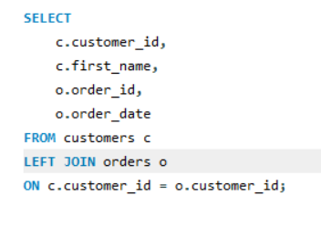
Output
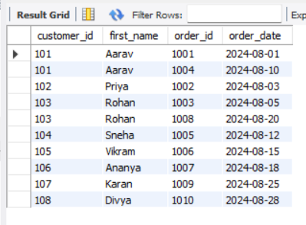

RIGHT JOIN: Keeps all rows from the right table (e.g., orders) even if there is no match in the left table (e.g., customers).
Example: `customers RIGHT JOIN orders` would list all orders, ensuring no transaction row is left out.

Q23. Identify all Foreign Key relationships in the schema. Explain what would happen if you tried to insert an order with customer_id = 999 (which doesn't exist in customers).
Foreign Keys Identified:
1. order.customer_id references customers.customer_id
2. order_items order_id references orders.order_id
3. order_items product_id references products.product_id

If you attempt to insert a record into the `orders` table with a customer_id of 999, MySQL will block the operation and throw an Error Code 1452 (Foreign key constraint violation). This safeguard protects referential integrity by preventing "orphan" rows that point to non-existent parent records

Section E — Advanced Queries

Q24. Write a query using CASE to classify products into price tiers:
• 'Budget' → unit_price < 1000
• 'Mid-Range' → unit_price BETWEEN 1000 AND 3000
• 'Premium' → unit_price > 3000
Display: product_name, unit_price, price_tier.
Query:
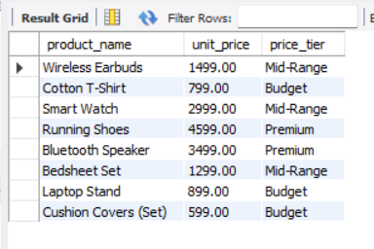
Output:

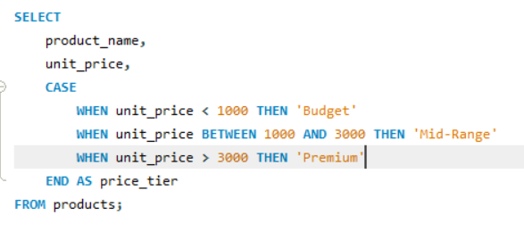

Q25. Using a CASE statement inside an aggregate function, count how many orders are 'Delivered' vs 'Not Delivered' (all other statuses). Display the result in a single row.
Query:

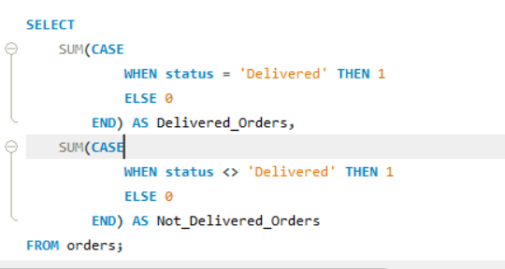
Output:

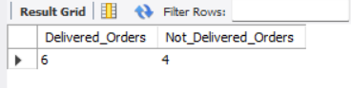

Q26. Explain each letter of ACID:
• A – Atomicity
• C – Consistency
• I – Isolation
• D – Durability
Give a real-world example (e.g., bank transfer) showing why each property is important.

A – Atomicity
Definition: A transaction is completed entirely or not at all.
Example: During a ₹5,000 bank transfer, if the system crashes after deducting money from Account A but before adding it to Account B, the transaction is rolled back.
Importance: Prevents partial transactions.

C – Consistency
Definition: A transaction keeps the database in a valid and consistent state.
Example: After transferring ₹5,000, the total balance across both accounts remains the same.
Importance: Maintains data integrity and database rules.

I – Isolation
Definition: Multiple transactions run independently without affecting each other.
Example: If two people withdraw money from the same account simultaneously, each transaction is processed safely without conflicts.
Importance: Prevents incorrect or conflicting results.

D – Durability
Definition: Once a transaction is committed, it is permanently saved.
Example: After a successful ₹5,000 transfer, the transaction remains recorded even if the system crashes.
Importance: Prevents data loss after successful transactions.

Q27. Write a SQL transaction that does the following atomically:
1. Insert a new order (order_id=1011, customer_id=102, today's date, 'Pending', 1598.00)
2. Insert two order items for that order
3. Update the stock_qty of the purchased products
4. If any step fails, ROLLBACK the entire transaction. Otherwise, COMMIT.
Write the complete BEGIN...COMMIT/ROLLBACK block.

Query:

Output:

Step 1:
Query:
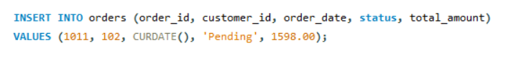
Output:

Step 2:
Query:
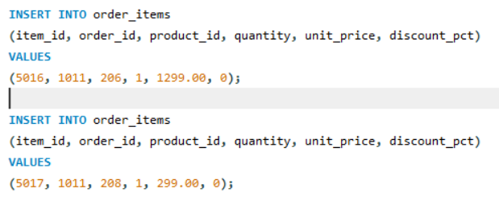
Output:

Step 3:
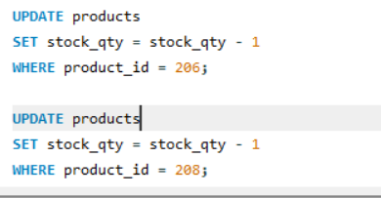

Output:

Step 4:
Query:
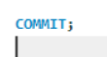
Output:

