Celebal Summer Internship 2026

Week 4 – ASSIGNMENT

Azure Cloud Fundamentals and Data Pipeline Implementation using ADF
Student Name: Nikhil Khot
Student ID: CT_CSI_DE_1019
Institution: MIT World Peace University

Objective
To understand core Azure cloud concepts and build a functional, end-to-end data integration pipeline using Azure Resource Groups, Azure Storage Accounts, and Azure Data Factory (ADF).

Task 1: Explore Azure Portal & Create a Resource Group

Explanation
A Resource Group in Azure is a logical container that holds related resources for an Azure solution. In this task, a dedicated resource group named nikhildemo was created to group all related components (Storage Account and Data Factory) together for simplified management, billing, and access control.

Resource Group overview page showing the name 'nikhildemo' and the list of deployment resources inside it
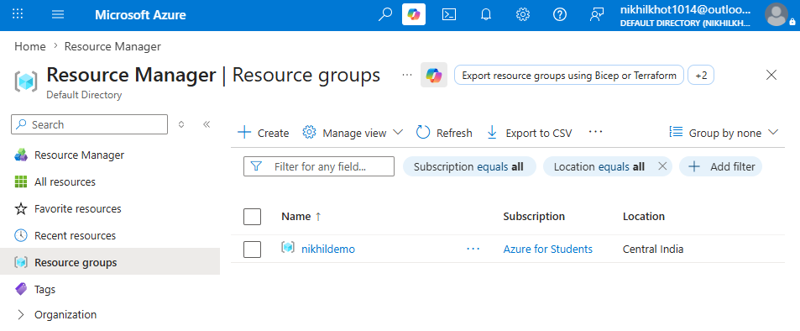

Task 2: Storage Setup

Explanation
An Azure Storage Account provides a scalable, secure namespace for data. Inside the storage account, a Blob Container was provisioned to store unstructured file data. For this pipeline, a source CSV file (Sample - Superstore.csv) was uploaded into the container to act as the primary dataset for ingestion.

Storage Account Container view clearly showing the uploaded 'Sample - Superstore.csv' file inside the source container
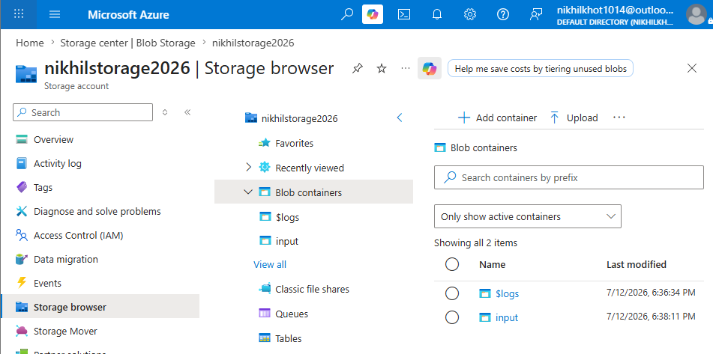

Task 3: ADF Basics

Explanation
Azure Data Factory (ADF) is a cloud-based data integration service that allows the creation of data-driven workflows.
- Linked Services act as connection strings that define the connection information to external resources (e.g., Azure Blob Storage).
- Datasets represent the data structures within the data stores pointed to by the Linked Service.
- A Get Metadata activity is utilized to inspect the properties of the source data (such as verifying file existence or column structure) before any movement happens.

Deliverable 3.1: Linked Service

ADF Studio -> Manage -> Linked Services page showing the active connection to your Blob Storage
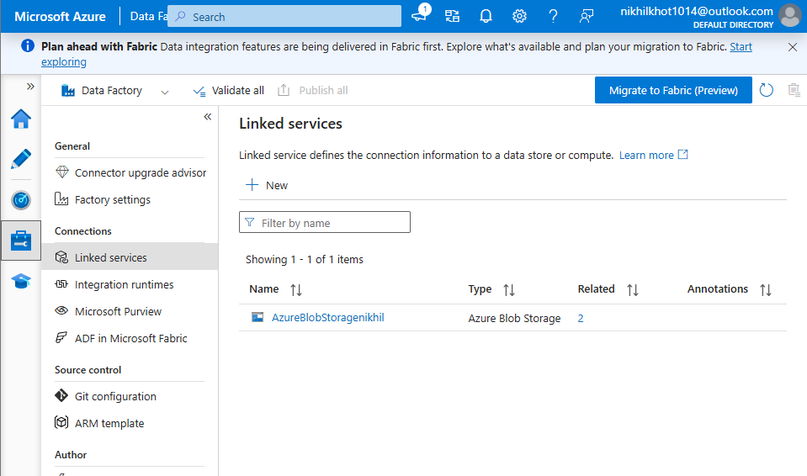

Deliverable 3.2: Dataset

ADF Studio -> Author -> Dataset connection settings for 'nikhilds_source_csv'
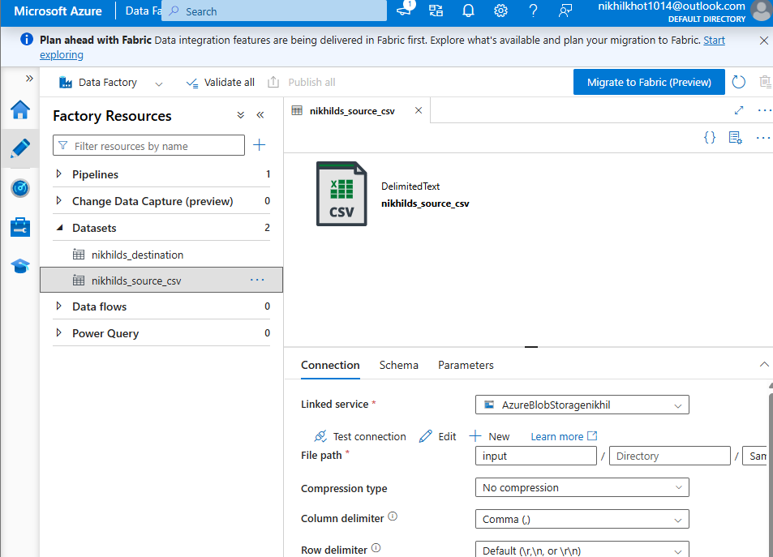

Deliverable 3.3: Get Metadata Activity

The standalone pipeline canvas 'pl_get_metadata' showing the Get Metadata activity block
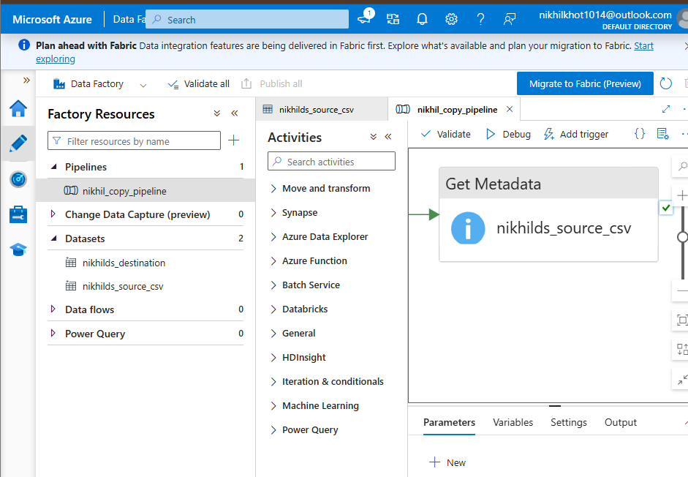

Task 4: Pipeline Development

Explanation
A data pipeline is a logical grouping of activities that perform a task together. Here, a copy pipeline named nikhil_copy_pipeline was designed using the Copy Data activity. The activity explicitly maps nikhilds_source_csv as the source dataset and nikhilds_destination as the sink (destination) dataset.

The design canvas of 'nikhil_copy_pipeline' showing the Copy Data activity block before execution
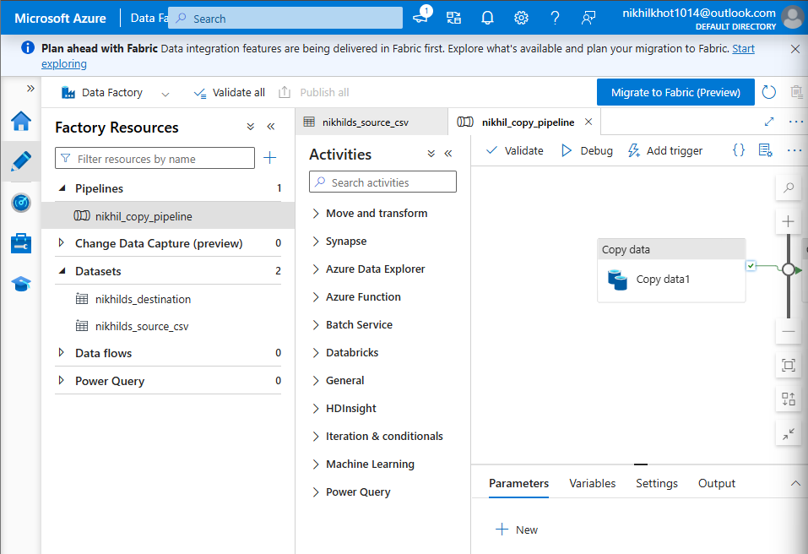

Task 5: Pipeline Execution

Explanation
The designed pipeline was executed using the Debug feature within ADF Studio, which compiles and runs the activities on-demand. During the initial execution, a data format discrepancy (DelimitedTextMoreColumnsThanDefined) caused by formatting anomalies in the raw CSV was successfully resolved by clearing the rigid schema configuration, allowing the structural copy to process seamlessly.

The entire ADF Studio browser window showing 'nikhil_copy_pipeline' with the bottom 'Output' tab open, displaying a green checkmark and 'Succeeded' status next to the Copy activity

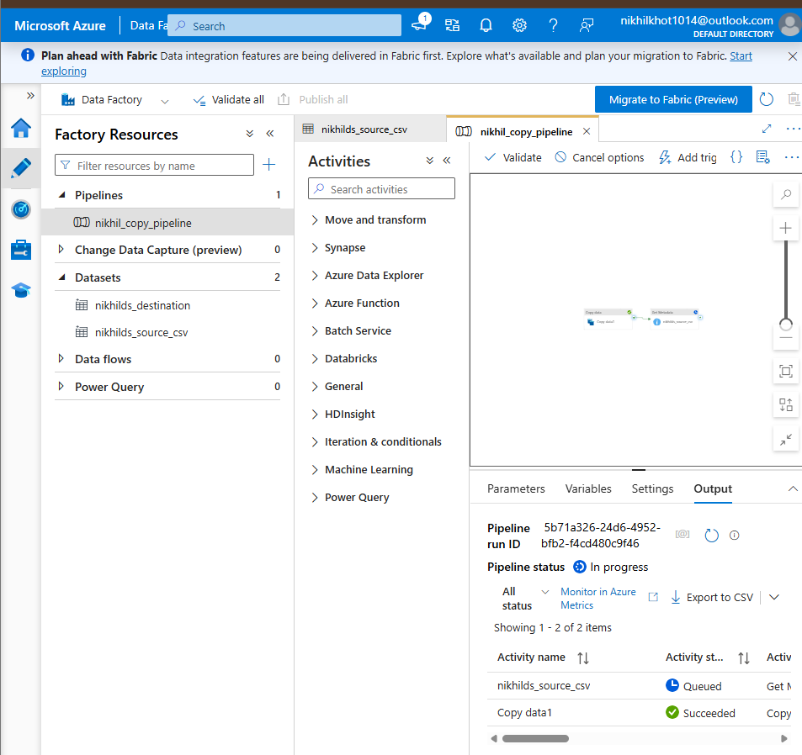

Task 6: IAM Roles (Identity & Access Management)

Explanation
Azure Access Control (IAM) enforces security principles using Role-Based Access Control (RBAC). To secure data operations, permissions must be explicitly granted:
- Reader/Contributor roles allow management access to human operators.
- Storage Blob Data Contributor access was assigned directly to the Managed Identity of the Data Factory (nikhil-pipeline-demo). This securely permits the ADF service instance to read and write blob files without hardcoding security keys.
Azure Portal -> Storage Account -> Access control (IAM) -> 'Role assignments' tab showing your ADF 'Izhan-pipeline-demo' listed as a Storage Blob Data Contributor
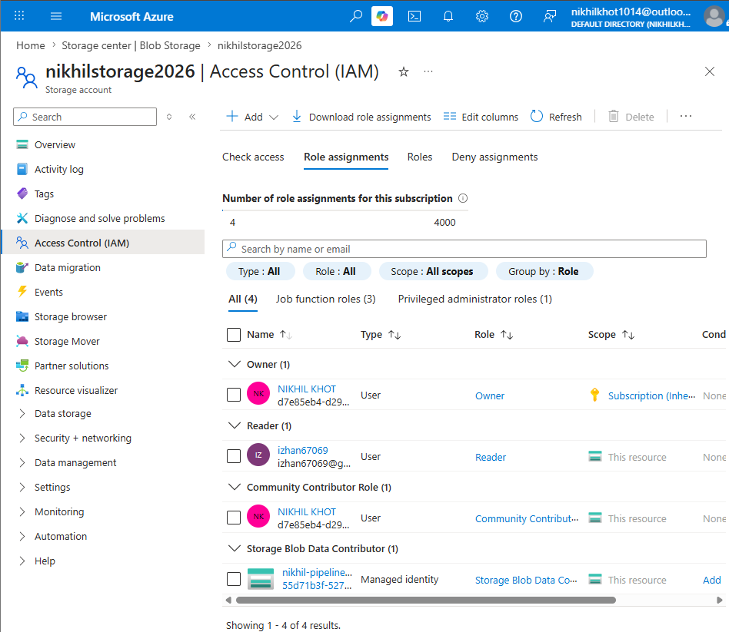

Mini Project (Final Task)

Problem Statement
Build a complete integrated pipeline that reads a CSV file from Blob Storage, checks its properties, and processes it securely using Azure Data Factory to a target destination.

Implementation Summary
The final integrated workflow combines structural metadata confirmation with data relocation. A single pipeline runs sequentially to ensure the input file satisfies structure rules via the Get Metadata check before invoking the Copy Data operation to place the output file safely into the final destination container.
The combined pipeline canvas showing both 'Get Metadata' and 'Copy Data' activities chained together with a green arrow, and both showing a 'Succeeded' status in the Output log:
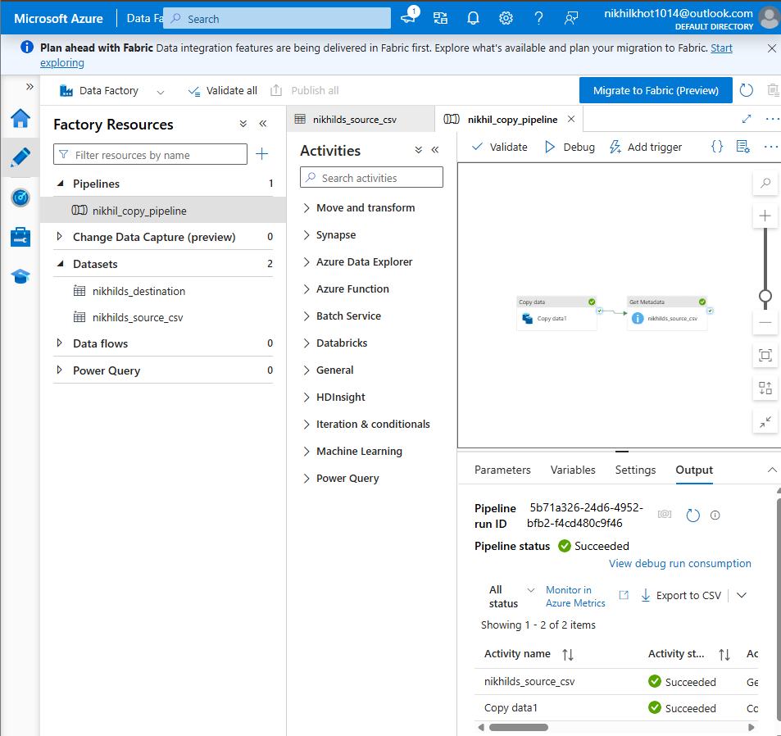

Azure Portal Storage browser showing the successfully generated target file inside the destination container folder:
