Celebal Summer Internship 2026
Week 3 Task
Name- Nikhil Shivaji Khot
Student_Id: CT_CSI_DE_1019
College: MIT-WPU

Task:
Step 1: Setup Data
- Import the Superstore dataset into a table named superstore_raw.
- Create these 3 tables from it:
- customers
- orders
- products
- Insert data into these tables using SELECT DISTINCT.

Queries:
- Customers Table
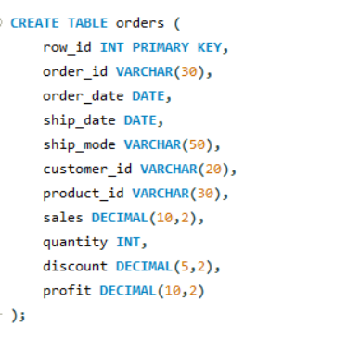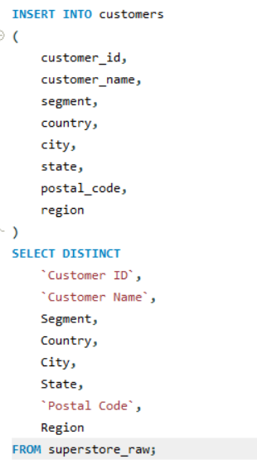

- Products Table

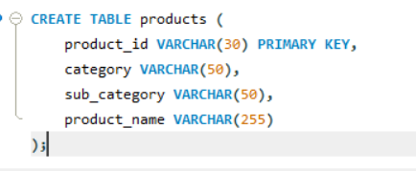

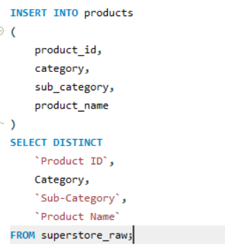

- Orders Table

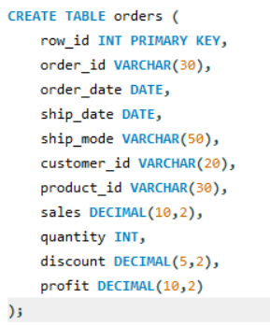
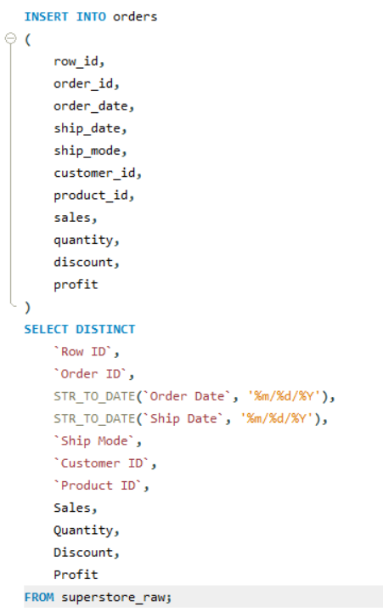

Step 2: Perform Required Queries
Write and execute SQL queries for each of the following:

- Find all orders where sales are greater than the average sales. (Subquery)
Query:
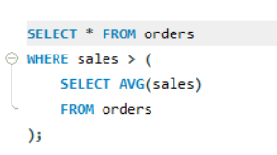
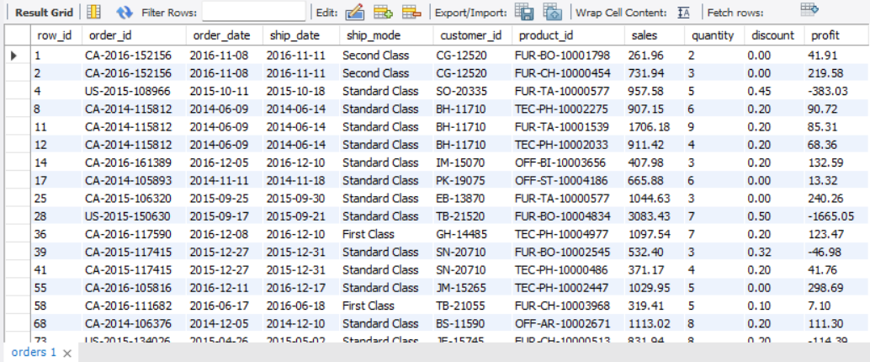
- Find the highest sales order for each customer. (Subquery)
Query:
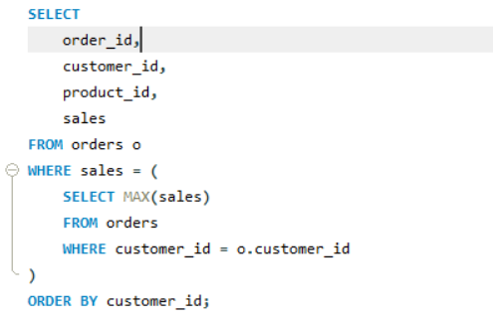
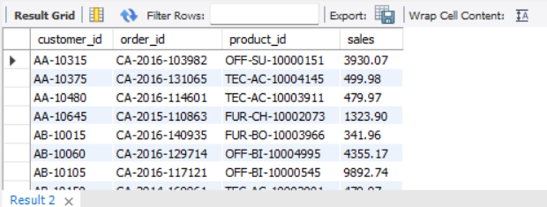

- Calculate total sales for each customer. (CTE)
Query
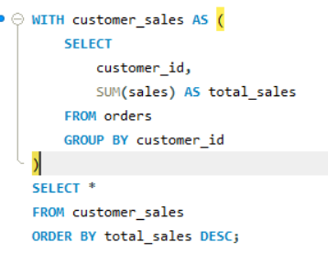
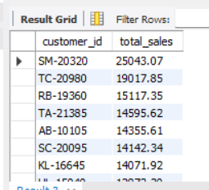

- Find customers whose total sales are above average. (CTE + Subquery)
Query
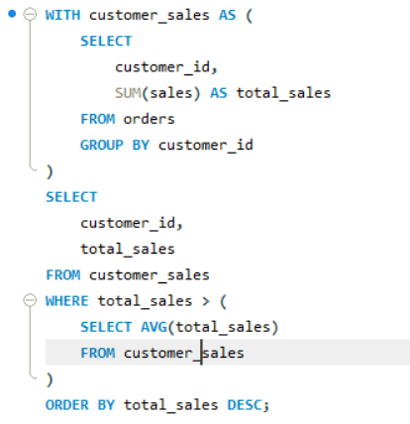

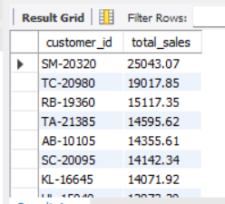

- Rank all customers based on total sales. (Window Function)
Query
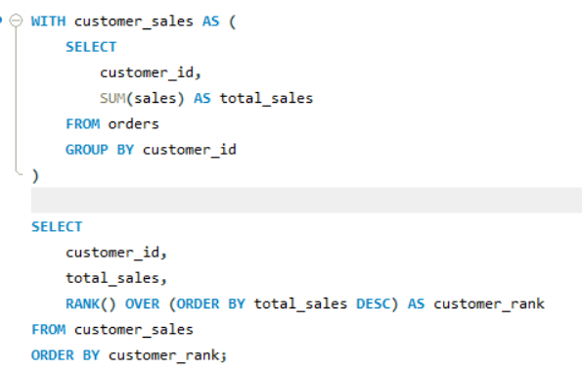
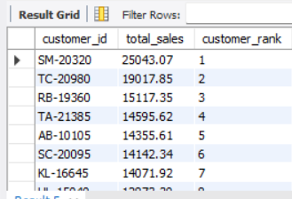

- Assign row numbers to each order within a customer. (Window Function + PARTITION BY)
Query
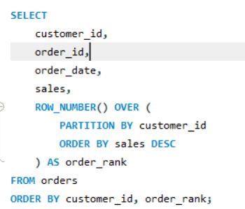
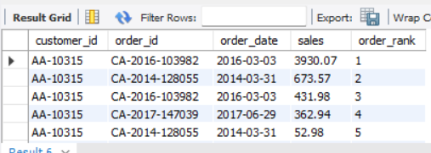

- Display top 3 customers based on total sales. (Window Function)
Query:
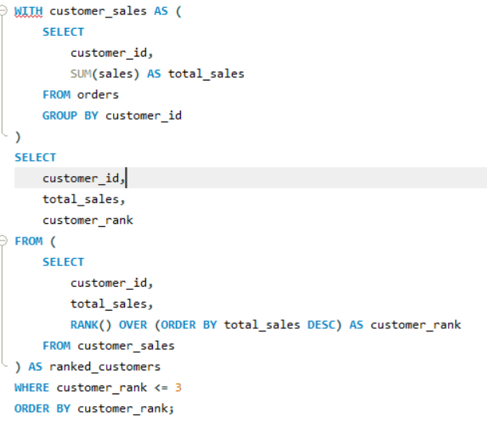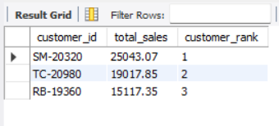

Step 3: Final Combined Query

Write one final query that shows:
- Customer Name
- Total Sales
- Rank

Query:

