Celebal Excellence Internship 2026

Week 6 – ASSIGNMENT

Student Name: Nikhil Khot
Student ID: CT_CSI_DE_1019
Institution: MIT World Peace University

Q1: Explain the roles of the Driver, Cluster Manager, and Executor in a Spark application.

Driver: Think of this as the manager. It runs the main SparkSession, takes the code you write, breaks it down into actual tasks, and tells the workers what to do.
Cluster Manager: This is the infrastructure layer, like YARN or Kubernetes. Its job is just to handle the physical resources—basically allocating the RAM and CPU for the cluster.
Executor: These are the doers. They live on the worker nodes, actually run the tasks the Driver assigns them, and handle the data storage in memory or on disk.

Q2: How does Spark’s Lazy Evaluation strategy improve performance when chain-processing large datasets?

Spark doesn't actually process data the second you tell it to. Instead, it just builds a roadmap, called a Directed Acyclic Graph (DAG), of all the operations you want to perform. It only starts the heavy lifting once you call an Action (like .show() or .count()).
This is smart because the Catalyst Optimizer can look at the whole plan beforehand and skip unnecessary steps, merge operations, or filter out data earlier, which saves a ton of time and memory.
Q3: Read CSV file with headers and schema inference.

import os
# Point directly to the specific CSV file rather than the directory
csv_file_path = r"D:\CELEBAL_CEI_IZHAN\WEEK5_Celebal\ecommerce dataset\Ecommerce.csv"
df = spark.read.csv(csv_file_path, header=True, inferSchema=True)
df.show(5)


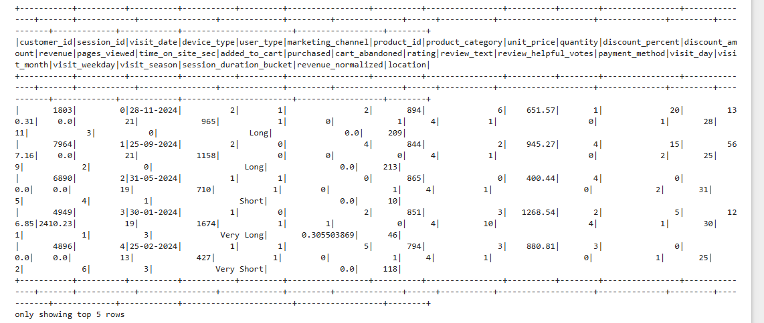

Q4: What is the difference between CSV and Parquet in terms of storage (row-based vs. columnar) and why does it matter for performance?

CSV (Row-based): It's basically a flat text file. If you only need one specific column, Spark still has to read the entire file line by line to find it. It's slow and uncompressed.
Parquet (Columnar): This is much more efficient because data is stored by columns. If you only need two columns, Spark just grabs those specific chunks from disk and ignores the rest.
It also supports compression, which makes a huge difference in storage and performance.

Q5: Select columns product_id and price where category is 'Electronics'.

from pyspark.sql.functions import col

# Explicitly cast to string if product_category holds string values
q5_result = df.filter(col("product_category").cast("string") == "Electronics") \
.select("product_id", col("unit_price").alias("price"))

q5_result.show(5)
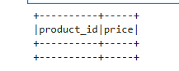

Q6: Rename column old_name to new_name and cast price from String to Double.

from pyspark.sql.functions import col
from pyspark.sql.types import DoubleType
df_revised = df.withColumn("price", col("unit_price").cast(DoubleType()))
# Verify
df_revised.select("unit_price", "price").show(5)

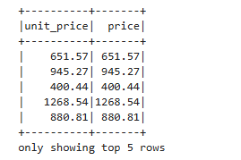

Q7: How does Spark use the Lineage Graph (DAG) to provide fault tolerance if a worker node fails?

Because DataFrames in Spark are immutable (you can't change them once created), Spark keeps a paper trail of every transformation used to build them, called the Lineage Graph. If a node fails and we lose a piece of data, Spark doesn't need to restart the whole job. It just looks at the DAG to see which operations created that specific missing part and re-runs those specific steps on a different node.

Q8: Filter DataFrame df_orders for status 'Completed' AND amount > 1000.

from pyspark.sql.functions import col
# Filter for completed orders with revenue > 1000
df_filtered_orders = df.filter(
(col("purchased") == 1) & (col("revenue") > 1000)
)
# Display the output
df_filtered_orders.select("customer_id", "purchased", "revenue", "unit_price").show(5)
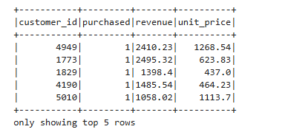

Q9: Explain the concept of Predicate Pushdown in Parquet and how it affects the amount of data loaded into memory.

This is an optimization trick where Spark pushes the filter logic down to the storage layer. Instead of reading the whole Parquet file into memory and then filtering it, Spark checks the file's metadata first (like min/max values). If a block of data doesn't match your filter criteria, Spark simply skips that block entirely without ever reading it, which massively cuts down on I/O and RAM usage.

Q10: Add new column final_price as base_price multiplied by 1.18.

from pyspark.sql.functions import col

# Add final_price column with 18% tax applied on unit_price
df_with_tax = df.withColumn("final_price", col("unit_price") * 1.18)
# Verify the result
df_with_tax.select("product_id", "unit_price", "final_price").show(5)
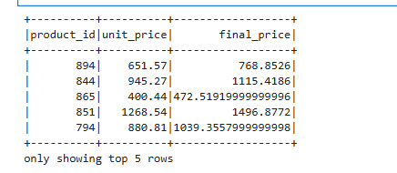

Q11: What is the difference between Transformations and Actions? Provide two examples of each.

Transformations: These define what you want to do (like filter, select, or groupBy), but they don't happen immediately. They just update the logical plan.
Actions: These actually trigger the computation. They force Spark to execute the plan and return a result to the driver or save the data somewhere (e.g., show, count, collect).

Q12: Load Parquet file, filter out null user_id rows, and save as CSV.

from pyspark.sql.functions import col

# 1. Filter out null customer_ids
df_clean = df.filter(col("customer_id").isNotNull())

# 2. Convert to Pandas and write to CSV
df_clean.toPandas().to_csv("data/output_cleaned_csv.csv", index=False)

print("Data successfully filtered and saved to CSV via Pandas!")
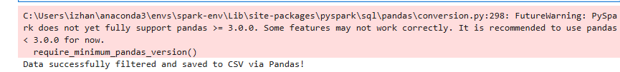

Q13: In Spark Architecture, what is the difference between Client Mode and Cluster Mode?
Client Mode: The Driver runs on your local machine. This is great for playing around or debugging in a notebook, but if your laptop loses Wi-Fi, the whole job dies.

Cluster Mode: The Driver runs on one of the worker nodes in the cluster itself. This is the way to go for production because it's stable—the cluster manages the job, so it doesn't matter what happens to your local machine.

Q14: Filter a dataset for region 'North' OR priority 'High'.

from pyspark.sql.functions import col

# Example using actual dataset columns with OR (|) logic
q14_result = df.filter((col("marketing_channel") == 2) | (col("device_type") == 1))

# Display top 5 rows
q14_result.select("customer_id", "marketing_channel", "device_type").show(5)

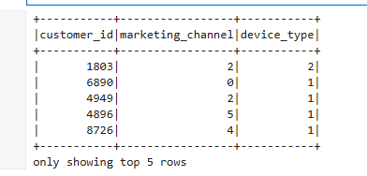

Q15: When exploring a dataset, why is it safer to use .show(5) instead of .collect() on a multi-terabyte dataset?

.show(5) is just a preview. It grabs a tiny sample from one partition and displays it. It's fast and safe.
.collect() is dangerous on big data. It attempts to pull every single row from every partition into the memory of your Driver node. If your dataset is huge (terabytes), your Driver will run out of memory and crash instantly.

