Infynite Internal Server: Order Status Flow
From a new request to dispatch and completion, including the three delivery routes (courier, hand delivery, customer pickup) and how print jobs and stock link to the order.
Version 2026-10-23. Describes the system as built and tested. Statuses are changed on the order page (Orders > open an order > Status).

1. The order statuses
Status | Meaning | Set by | Notes
Requested | The order has been entered (walk-in, phone or e-mail) with its files. | Sales / Owner | Created from Orders > New order.
Under review | Files and details are being checked. | Sales / Owner
Quoted | A price has been recorded. | Sales / Owner | Use "Send quote" (a price is required). The Price calculator can fill it in.
Approved | The customer agreed to the quote. | Sales / Owner | Production can then plan print jobs.
Scheduled | Planned on a printer and a date. | Production / Owner | Set by hand (optional; starting a job also moves the order on).
Printing | At least one print job is running. | Automatic or Production / Owner | Start on the first print job moves an Approved or Scheduled order here.
Quality check | Printing is finished; the quality list is checked. | Automatic or Production / Owner | Moves here when the last open job is finished. Rework: set back to Printing.
Ready / Dispatched | The order leaves (courier, hand delivery) or is ready at the counter (pickup). | Production / Owner | The history records the route. The dispatch time is stored.
Completed | Delivered to, or collected by, the customer. | Production / Owner | Final status.
Cancelled | The order will not go ahead. | Sales / Owner | Any status. Queued print jobs are removed; one already printing is flagged.
Failed | The order could not be produced. | Production / Owner | Any status. Same clean-up of queued jobs.

Status flow diagram
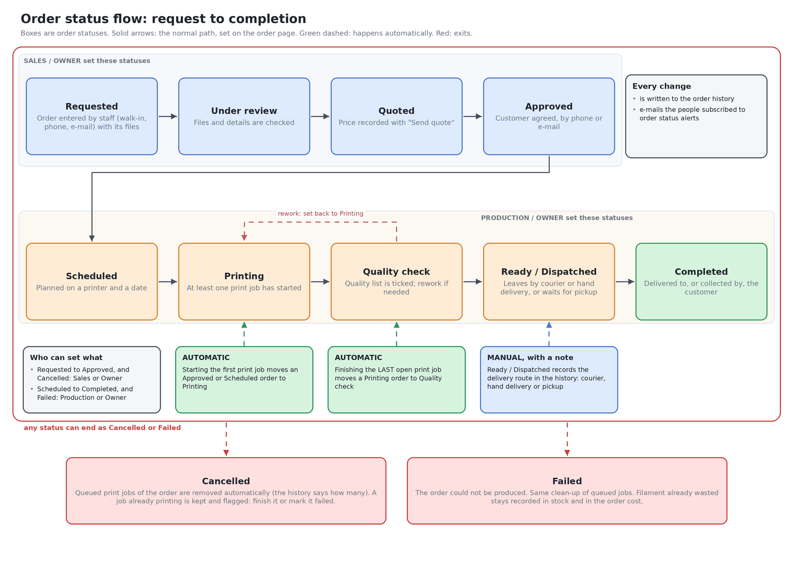

2. Dispatch: three ways to reach the customer
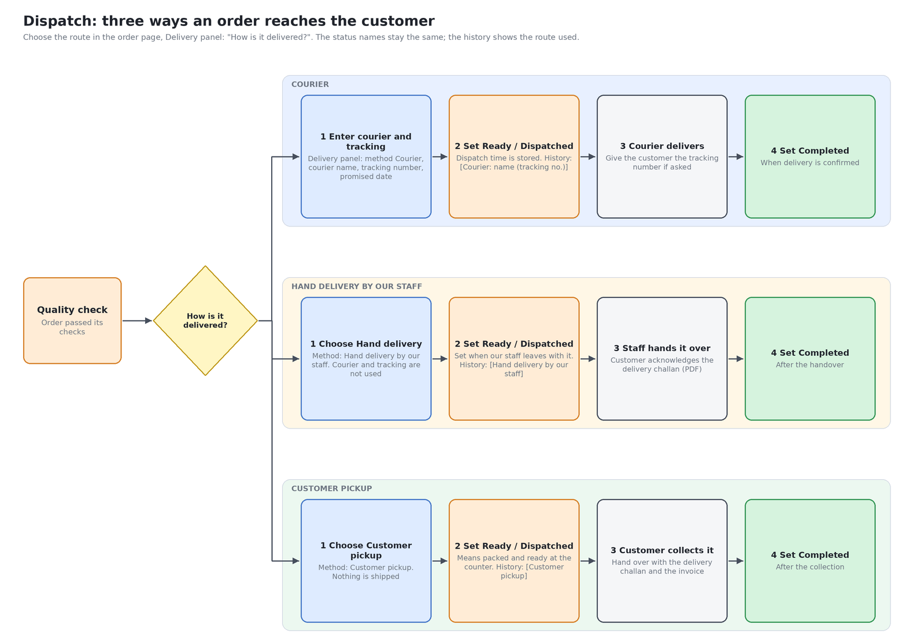
 | Courier | Hand delivery by our staff | Customer pickup
Set up (order page, Delivery panel) | Method Courier, courier name, tracking number, promised date | Method Hand delivery; promised date. Courier and tracking are not used | Method Customer pickup; promised date. Courier and tracking are cleared
"Ready / Dispatched" means | The parcel has been handed to the courier | Our staff has left with the order | Packed and waiting at the counter
History note on dispatch | [Courier: name (tracking no.)] | [Hand delivery by our staff] | [Customer pickup]
"Completed" is set when | Delivery is confirmed | The customer has received it | The customer has collected it
Documents | Delivery challan PDF (shows delivery method, courier and tracking) | Delivery challan PDF | Delivery challan PDF (hand over with the invoice)

Choosing a route is optional but recommended: orders without a route still work as before. Changing the route after dispatch is allowed; the earlier history note stays as it was.

3. Print jobs, stock and the order
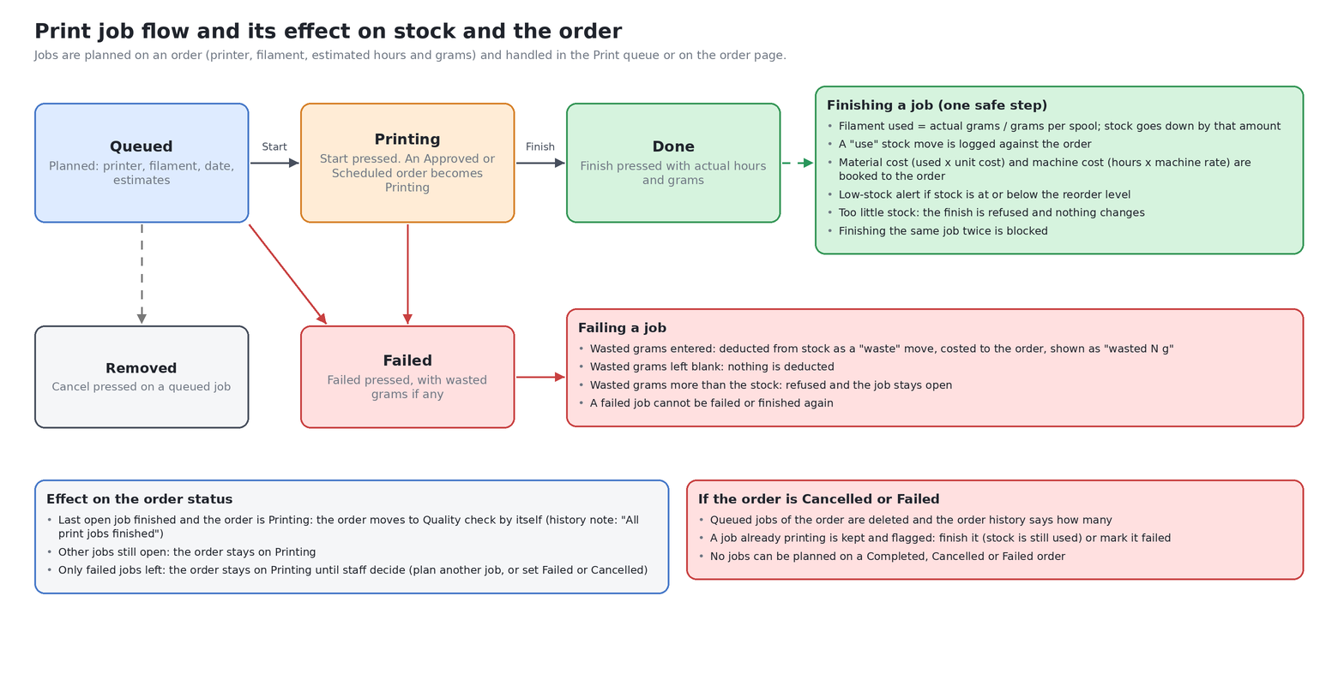

4. Good to know
- Nothing detects a finished print by itself: a person presses Finish in the Print queue (or on the order page) and enters the actual hours and grams. That press deducts the filament, books the costs and, if it was the last open job, moves the order to Quality check.
- Wasted filament on a failed print is only recorded when grams are typed next to the Failed button. Leave it blank and nothing is deducted.
- Statuses can be set in any order by people with the right role (for example back from Quality check to Printing for rework). The diagram shows the normal path.
- There is no automatic link to couriers: tracking numbers are typed in, and "Completed" is set by hand after delivery or collection.
- Invoices and payments are separate from the order status. An invoice can be issued from the order at any time; paying it does not change the status.
- Every status change is written to the order history (who, when, note) and e-mailed to people subscribed to "order status" alerts in Admin settings > Notifications.

