FULL STACK DEVELOPMENT - REPORT 1 - FIGMA DESIGN

**RECIPE BOOK**



# 

# Introduction:

The Recipe Book site is designed to make cooking, meal planning, and grocery shopping easier and more enjoyable for users of all skill levels. Whether you're an experienced chef or a beginner in the kitchen, this app offers a streamlined approach to discovering new recipes, organizing ingredients, and preparing meals. Its user-friendly interface allows users to search for recipes based on preferences, dietary restrictions, or available ingredients, ensuring that there’s something for everyone. From simple weekday dinners to elaborate meals for special occasions, Recipe Book provides a variety of recipes that can fit into any lifestyle.

**Key Features:**

**1. Landing Page**

The landing page serves as the entry point for the menu, featuring the restaurant’s branding with a minimalistic and inviting design. It includes two clearly labeled buttons, “Menu” and “Back,” allowing smooth navigation. The yellow-and-white color scheme creates a bright, welcoming vibe that aligns with the restaurant’s identity.

**2. Scrollable Categories**

The menu is divided into interactive, scrollable sections, including Starters, Main Course, Desserts, Shakes, and Sundaes. This ensures that all items are easily accessible without cluttering the screen, providing an organized browsing experience for the user**.**

**3. Imagery and Descriptions**

Each menu item is presented with an appetizing image, a concise yet descriptive text about the dish, and its price. This combination offers a complete and visually engaging representation of the food, making it easier for customers to make informed decisions.

**4.User-Friendly Interface:**

The design focuses on providing a simple and intuitive navigation experience, with a visually appealing layout that makes it easy for users to find recipes and cooking instructions quickly**.**

**5.Step-by-Step Recipe Instructions:**

Each recipe is broken down into clear, sequential steps, with the option to view cooking times and additional tips, allowing users to follow along easily.

**6.High-Quality Recipe Images:**

High-resolution images of the finished dish, as well as step-by-step photos or illustrations, are included to give users a visual reference and help guide them through the cooking process.

**Use Cases:**

**1. Kitchen/Cooking**

The app provides clear, step-by-step instructions to ensure easy cooking for both beginners and experienced chefs. It displays high-quality images that act as a visual guide to help users achieve the perfect result. The ingredient list with quantities ensures no ingredients are missed, and recipes can be followed efficiently.

**2. Grocery Shopping**

Users can generate a shopping list directly from selected recipes, making it easy to pick up necessary ingredients. The ingredient list is organized by quantity, ensuring users buy exactly what they need. The app also allows users to check items they already have, streamlining the shopping process.

**3. Office/Lunch Planning**

The design helps busy professionals find quick, easy recipes for lunch that fit into their schedules. It provides options for meals that can be prepped in advance or made quickly during the workday. Users can filter recipes based on nutritional needs, ensuring they stay healthy while at work.

**5. Dietary Needs**

The app offers tailored recipe suggestions based on dietary restrictions like gluten-free, low-carb, or vegan. It filters out ingredients that don’t align with specific health needs, helping users stick to their dietary goals. Users can also rely on reviews and ratings to confirm that recipes meet their specific needs.

**6. Special Occasions**

For events like parties or dinners, the app helps users find recipes that are both impressive and manageable for large groups. It provides detailed cooking instructions that suit varying levels of expertise. Users can save these recipes to their favorites list for future occasions or events.

**7. Learning (Beginner Cook)**

The app offers beginner-friendly recipes that break down cooking into manageable steps. Clear instructions and helpful images make it easier for someone new to cooking to follow along without confusion. The app’s simple interface allows beginners to gradually build their skills with confidence.

**FIGMADESIGN:**

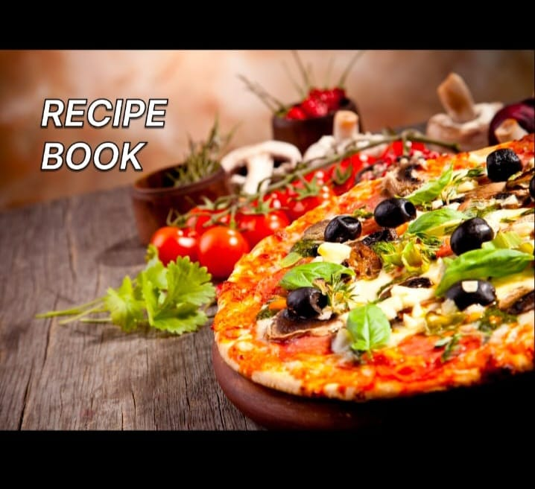

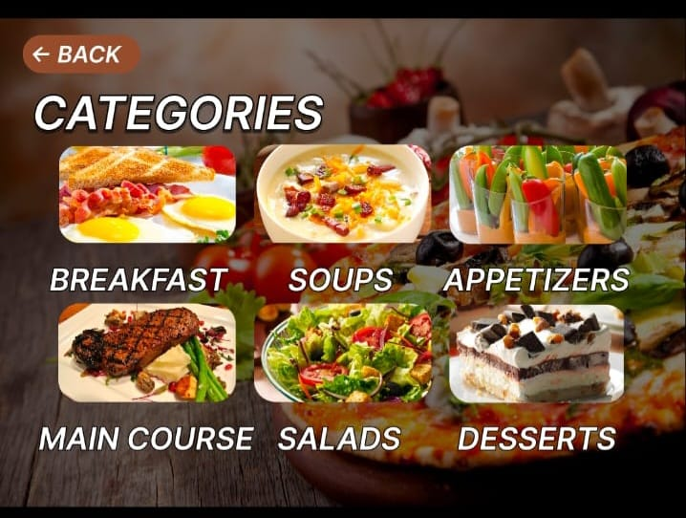 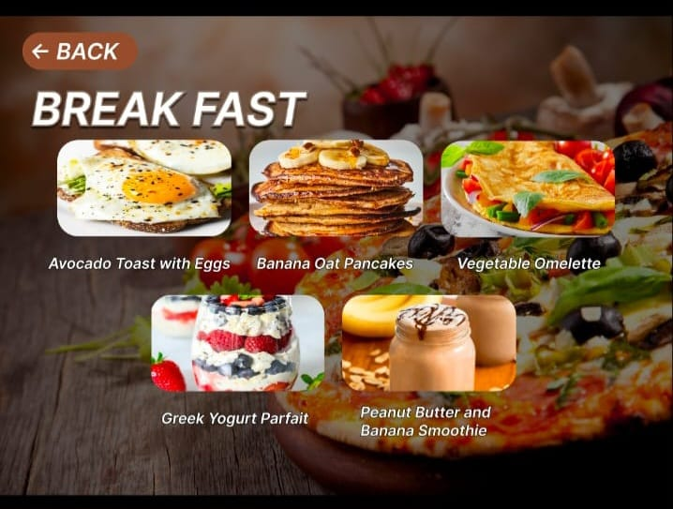

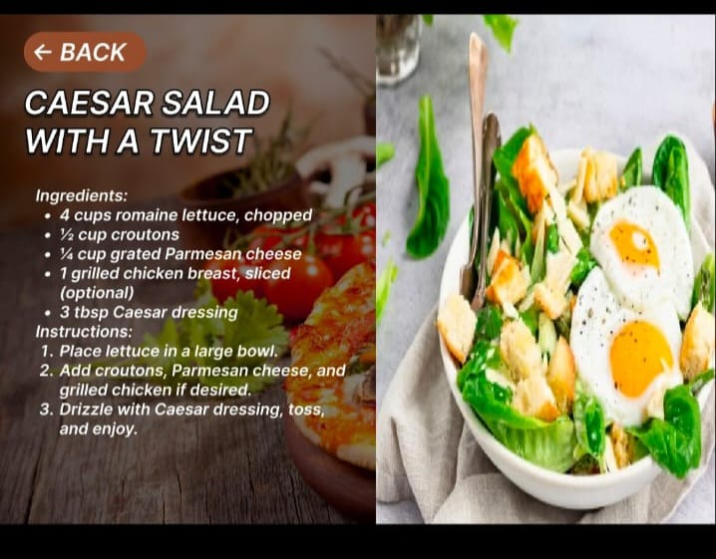 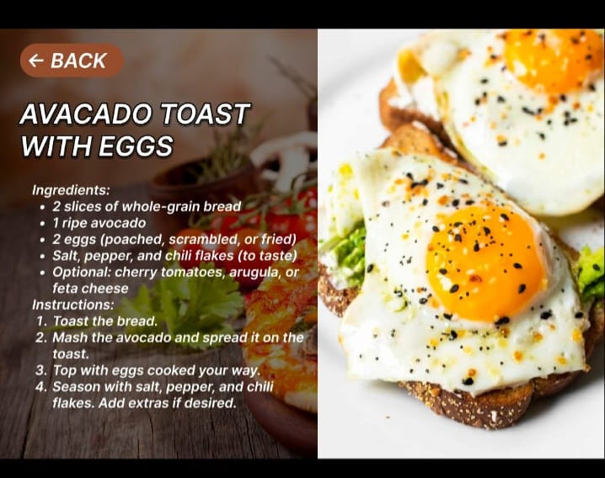––

**Prototype Link:**

https://www.figma.com/proto/M6gISSnAROPMboCdETJEnn/Recipe-book?page-id=0%3A1&node-id=1-2&p=f&viewport=393%2C237%2C0.05&t=oZ9xlWGnXQTLjFKC-1&scaling=min-zoom&content-scaling=fixed&starting-point-node-id=1%3A2

**Done By:**

Nikhil K