**EMPLOYEE MANAGEMENT SYSTEM USING SPRING BOOT AND MAVEN**

**Project Description:**

This project is a web application built with Spring MVC, offering efficient employee information management with CRUD (Create, Read, Update, Delete) operations:

* Retrieve all employees
* Add a new employee
* Update existing employee details
* Delete an employee record

**Tech Stack:**

The application uses:

* Java 17, Spring Boot, Spring MVC
* Thymeleaf templates and Bootstrap for UI
* Spring Data JPA and Hibernate for data access
* Maven for dependency management
* MySQL for data storage

**Installation:**

1. Clone the repository:

git clone <https://github.com/AAdewunmi/SpringBoot-Employee-Management-System.git>

1. Open the project folder in an IDE (e.g., Spring Tool Suite 4).
2. Configure a MySQL database named demo.

**How to use:**

1. Create a demo database in MySQL.
2. Open the project in an IDE and run it as a Spring Boot application.
3. Hibernate will automatically create an employee table.
4. Add initial data via MySQL Workbench.
5. Access the application at localhost:8080/.
6. Use the web interface to add, update, and delete employee records.

**Demo:**

1. All Employee UI:

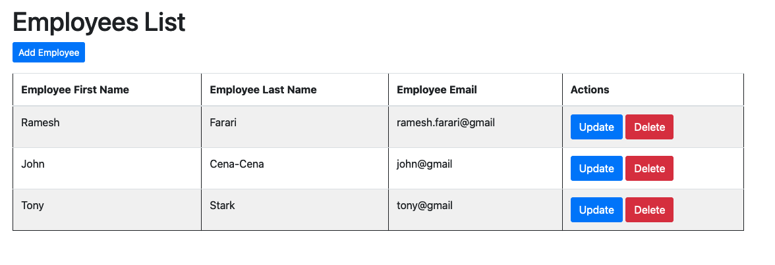

1. Add Employee UI:

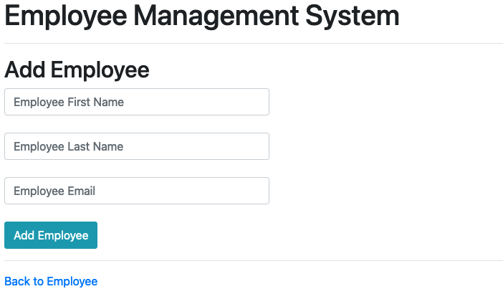

1. Update UI:

