**git init**

Usage: git init [repository name]

 This command is used to start a new repository.

GitInit Command - Git Commands - Edureka

**git clone**

Usage: git clone [url]

This command is used to obtain a repository from an existing URL.

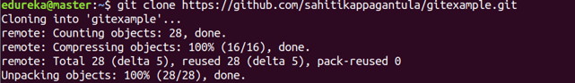

**git add**

Usage: git add [file]

This command adds a file to the staging area.

Git Add Command - Git Commands - Edureka

**git commit**

Usage: git commit -m “[ Type in the commit message]”

This command records or snapshots the file permanently in the version history.

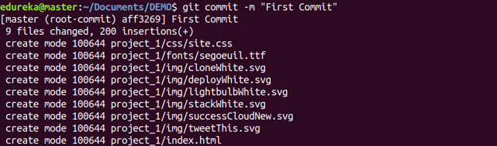

Usage: git commit -a

This command commits any files you’ve added with the git add command and also commits any files you’ve changed since then.

Git Commit Command - Git Commands - Edureka

**git diff**



Usage: git diff [first branch] [second branch]

This command shows the differences between the two branches mentioned.

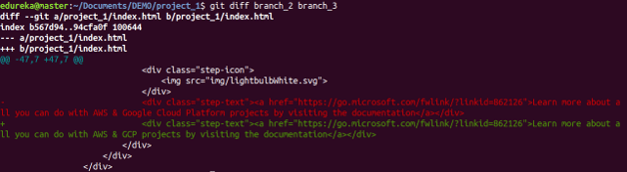

**git reset**

Usage: git reset [file]

This command unstages the file, but it preserves the file contents.

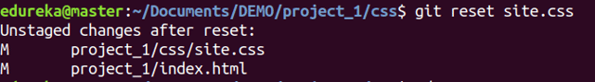

Usage: git reset [commit]

This command undoes all the commits after the specified commit and preserves the changes locally.

Git Reset Command - Git Commands - Edureka

Usage: git reset –hard [commit]  This command discards all history and goes back to the specified commit.

Git Reset Command - Git Commands - Edureka

**git status**

Usage: git status

This command lists all the files that have to be committed.

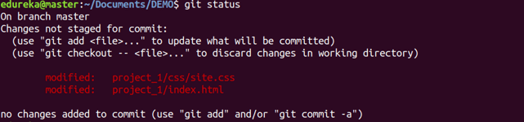

**git rm**

Usage: git rm [file]

This command deletes the file from your working directory and stages the deletion.

Git Rm Command - Git Commands - Edureka

**git log**

Usage: git log

This command is used to list the version history for the current branch.

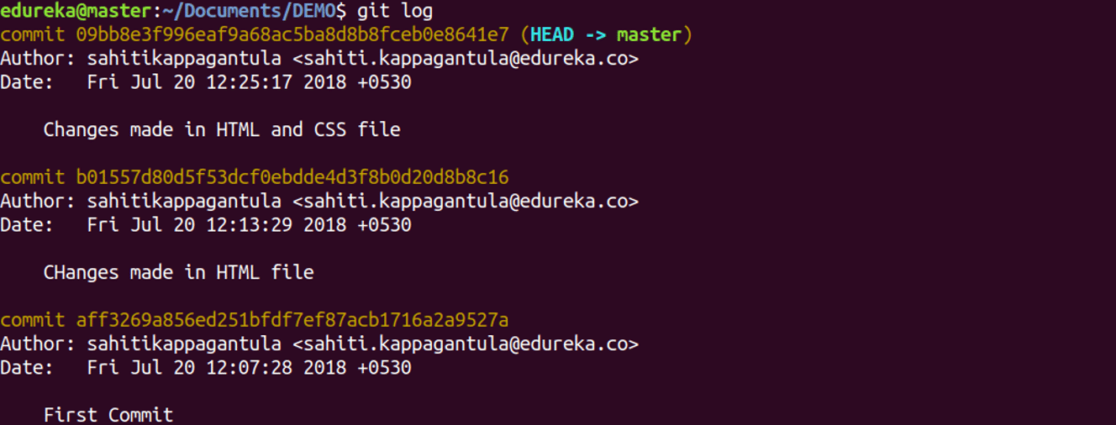

Usage: git log –follow[file]

This command lists version history for a file, including the renaming of files also.

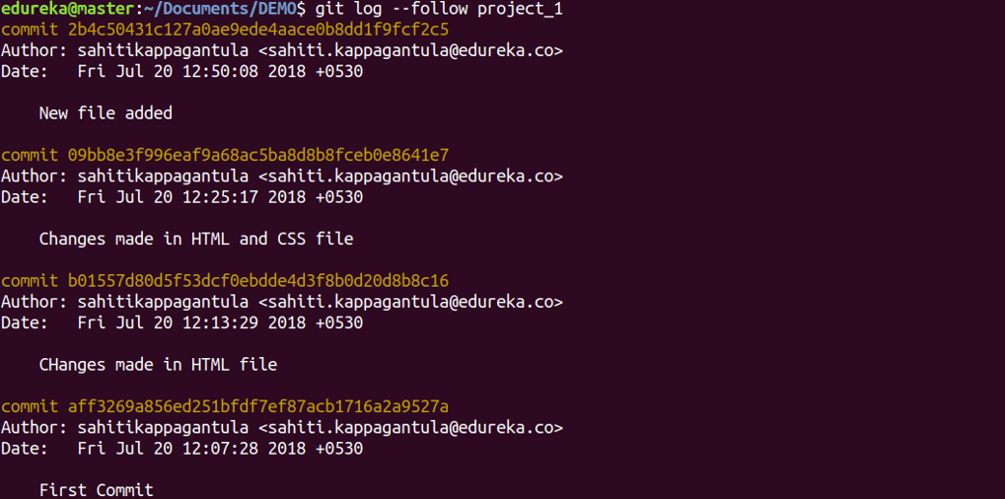

**git show**

Usage: git show [commit]

This command shows the metadata and content changes of the specified commit.

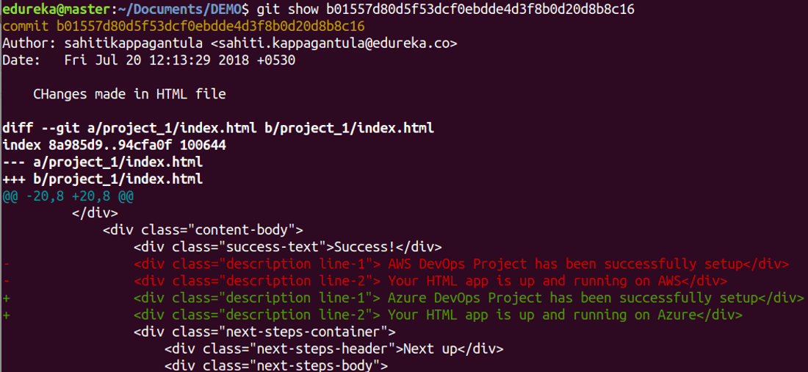

**git tag**

Usage: git tag [commitID]

This command is used to give tags to the specified commit.

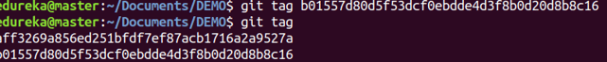

**git branch**

Usage: git branch

This command lists all the local branches in the current repository.

Git Branch Command - Git Commands - Edureka

Usage: git branch [branch name]

This command creates a new branch.

Git Branch Command - Git Commands - Edureka

Usage: git branch -d [branch name]

This command deletes the feature branch.

Git Branch Command - Git Commands - Edureka

**git remote**

Usage: git remote add [variable name] [Remote Server Link]

This command is used to connect your local repository to the remote server.

Git Remote Command - Git Commands - Edureka

**git push**

Usage: git push [variable name] master

This command sends the committed changes of master branch to your remote repository.

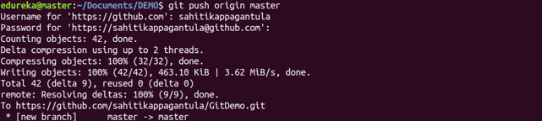

Usage: git push [variable name] [branch]

This command sends the branch commits to your remote repository.

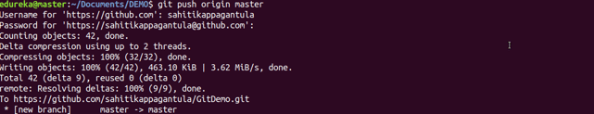

Usage: git push –all [variable name]

This command pushes all branches to your remote repository.

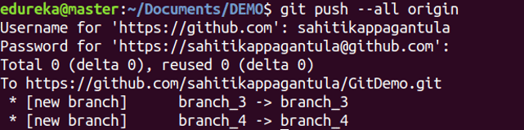

Usage: git push [variable name] :[branch name]

This command deletes a branch on your remote repository.

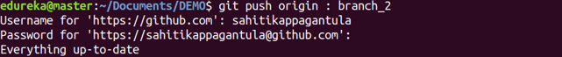

**git pull**

Usage: git pull [Repository Link]

This command fetches and merges changes on the remote server to your working directory.

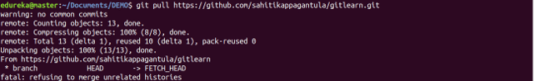

**git stash**

Usage: git stash save

This command temporarily stores all the modified tracked files.

Git Stash Command - Git Commands - Edureka

Usage: git stash pop

This command restores the most recently stashed files.

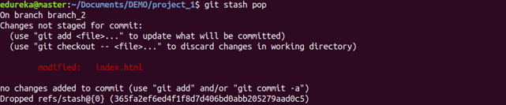

Usage: git stash list

This command lists all stashed changesets.

Git Stash Command - Git Commands - Edureka

Usage: git stash drop

This command discards the most recently stashed changeset.

Git Stash Command - Git Commands - Edureka