SEMANTIC
SEGMENTATION
ML MODEL

Presented By :
Bharatiya Javascript Party
Team Members -
- Nikhil Kumar Tiwari (25BAI11440)
- Anubhav Kumar (25MIM10178)
- Aashutosh Sharma (25BAI11135)
- Yuvraj Sinha (25BCE11305)

1. Project Objectives
- Primary Goal: Train a robust semantic segmentation model using synthetic datasets to accurately segment desert environments for off-road autonomy.
- Generalization: Evaluate how the model performs in novel, unseen scenarios within the same desert biome.
- Optimization: Benchmark the model to improve accuracy, generalizability, and efficiency for real-world deployment

2. Methodology
- Data Source: Utilized synthetic data from Duality AI’s Falcon digital twin simulation platform.

- Training Workflow:
  - Training: Ran train.py to generate model checkpoints and logs. Code was run on Google Colab.
  - Testing: Used a simple frontend web app on a separate location to ensure the model did not simply memorize the training set.

- Class Mapping: Focused on 10 critical classes, including high-risk obstacles like Logs (ID 700) and Rocks (ID 800).

3. Results & Performance Metrics
Accuracy Metric: Measured performance using the Intersection over Union (IoU) score to evaluate pixel classification accuracy (mAP50,mAP50-95).
These are the accuracy metrics that were generated during the training , the accuracy started poorly when Epoch = 1 and gradually increased with time.
Inference Speed: Monitored to ensure the model predicts at a rate of < 50ms per image.
4. Data Set Provided
-> Offroad Segmentation Training Dataset ZIP {
->> ..
->> Train ->>> Color_images
->>> Segmentation
->> Val ->>> Color_images
->>> Segmentation }
Loss Analysis: Analyzed training loss graphs to ensure the model steadily converged without underfitting or overfitting.
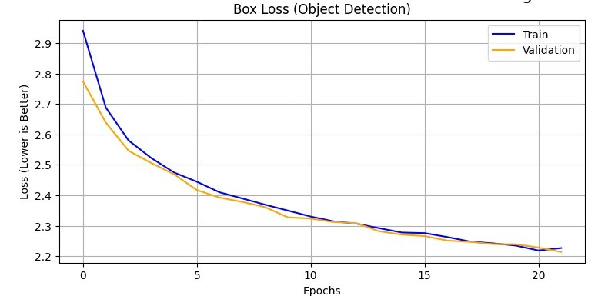
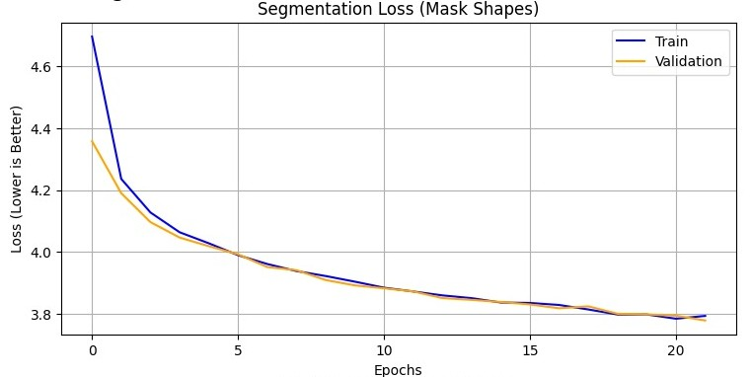
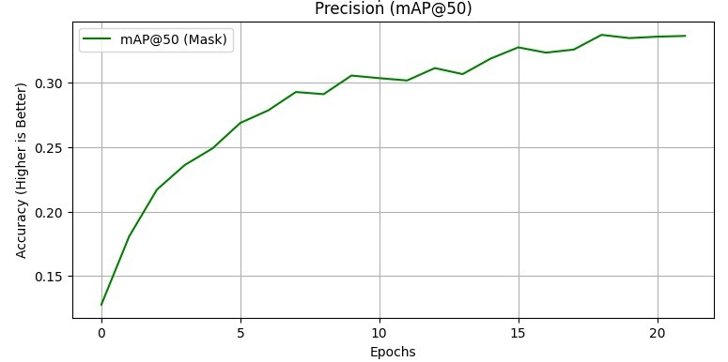

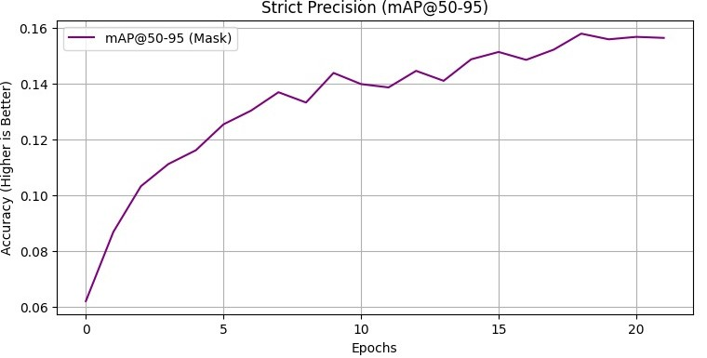

5. CONCLUSION
We successfully built an end to end pipeline for off road terrain segmentation. The system runs in real-time.
Future Work 1: Deploy the model onto an NVIDIA Jetson Nano for live field testing.
Future Work 2: Integrate depth estimation (Stereo Vision) to determine the height of the segmented “Rocks” to differentiate between small pebbles (drivable) and large boulders (obstacles).
6. REFERENCES
https://opencv.org/
https://pytorch.org/
https://www.ultralytics.com/
https://colab.research.google.com/
https://tqdm.github.io/

