Build Handover: The Selection Dashboard (MVP)
A step-by-step brief for building the MVP. Assumes no prior context. Read top to bottom.

0. How to read this
You are building a small, good-looking web page (a “dashboard”) that compares two food-delivery apps, DoorDash and Uber Eats, across US cities, and shows how the picture changes each month. This document gives you the what, the why, the exact numbers, a picture of the result, real sample data, and the simplest way to build it. You do not need to know this industry.
Companion files: Dashboard_Sample_Data.xlsx (open first: real scrape rows + the finished table, with two months of data), and app.py (a working, branded starter you can run in minutes).

1. The 30-second version
For every US metro, count how many restaurants each app offers (more = more “choice”). The dashboard shows, for three kinds of metro (DoorDash leads / close / Uber Eats leads), three toggle-able things: the choice gap (Selection), how many restaurants are on one app only (Exclusives), and how the delivery fees compare — plus, for each, how it moved since last month. It refreshes monthly.

2. Why we are building it
Our client invests based on which app is winning. “Winning” mostly means: which app offers more restaurant choice in a city, and whether that lead is growing. The dashboard is the monthly scoreboard, and the month-over-month movement is the part the client cares about most.

3. Words you must know (plain English)
Word | What it means
Platform / app | DoorDash or Uber Eats.
Restaurant listing | One restaurant available on one app. “Listed” = available there.
Metro / CBSA | A city area (e.g. “Austin, TX”). Treat CBSA = one city market.
Selection | How many restaurants an app offers in a metro. Higher = more choice.
Dominant vs Battleground | Dominant = one app clearly leads. Battleground = close. This label is GIVEN to you.
Exclusive | A restaurant on only ONE app.
Delivery fee | What the customer pays for delivery. Lower = cheaper. We compare the average per app.
Period | One month of data (e.g. 2026-06). Each refresh adds a new period so we can compare months.
Estimated / dummy | A flagged stand-in number used where live data is thin, so the dashboard looks complete.
MVP | Minimum Viable Product. Simplest version that works and looks decent.

4. The data you will use
Three files exist already. You do not scrape anything; you read what is there.
- DoorDash data (~250,000 rows). One row = one restaurant seen from one address. Clean and reliable.
- Uber Eats data (similar size). Same idea, but needs a clean-up step first (gotcha 1) and its live coverage is currently thin.
- Addresses list (786 addresses across 262 metros). Tells you which metro each address belongs to.
Open Dashboard_Sample_Data.xlsx → tab “raw_data_sample” to see REAL rows. Note the real quirks: DoorDash fees are text like $0 delivery fee over $12, eta can be Closed, and Uber’s review_count is banded (“3,000+”, “500+”). We are NOT using Google reviews for now.

5. What you are building: the 3-view dashboard
Three columns = the three kinds of metro. A toggle switches between three measures. Each metro shows the two apps and a small arrow for how it moved since last month. Mock of the finished MVP (numbers illustrative, colors real):
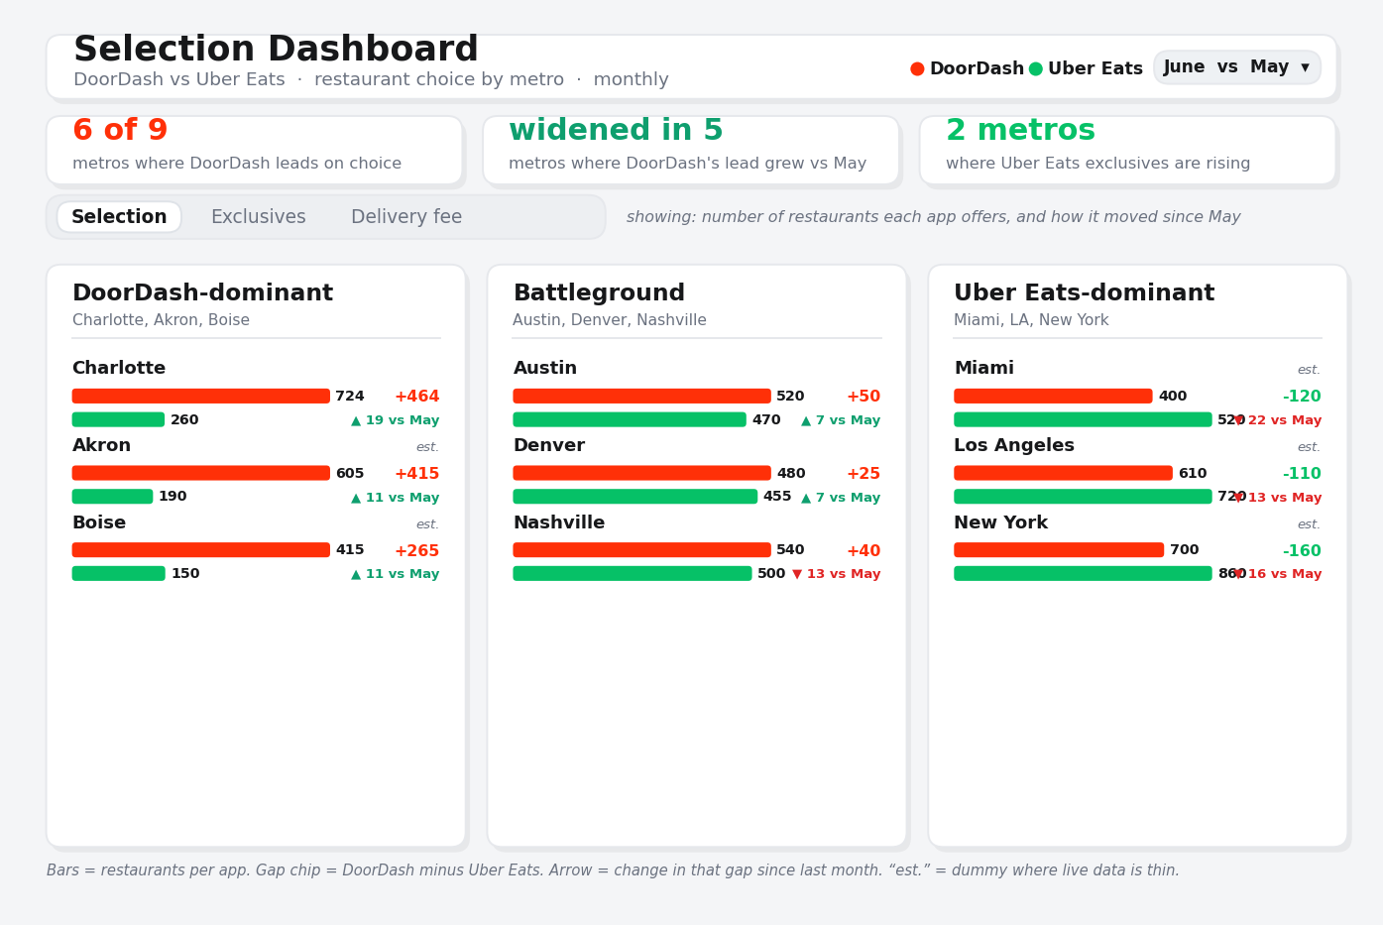
Columns (given): DoorDash-dominant, Battleground, Uber Eats-dominant. Toggle (you calculate): Selection, Exclusives, Delivery fee. Red = DoorDash, Green = Uber Eats. Arrows = change vs last month.

6. The three measures, with worked examples

6a. Selection (the main one)
Count how many DIFFERENT restaurants each app has in the metro (same restaurant seen at 3 addresses still counts once). Austin: 520 vs 500, DoorDash leads by 20. Charlotte: 724 vs 260, leads by 464. The gap (DoorDash minus Uber Eats) is the headline.

6b. Exclusives
Restaurants on ONE app only. Match restaurants across the apps (by name + metro). A metro of 300: 220 on both, 80 DoorDash-only, so DoorDash exclusives = 80. Track whether that shifts month to month.

6c. Delivery fee
Average the delivery fee each app charges. LOWER is better (cheaper), so read these bars the opposite way. Akron: DoorDash $0.90 vs Uber Eats $2.40. The fee text needs light parsing (“$0 delivery fee” → 0, “$1.99” → 1.99).

7. Showing movement over time (this is what David asked for)
David does not just want this month’s snapshot; he wants to see it MOVE: is DoorDash’s lead widening, are exclusives shifting, are fees creeping up. The dashboard handles this with one simple idea: one refresh = one month.
- Each month you re-run the numbers and ADD rows with a new period (2026-05, 2026-06, ...). Nothing is overwritten; the months stack up.
- The dashboard shows the latest month, and next to each metro a small arrow: how the gap changed vs the previous month. In the mock, Charlotte reads “+464 gap, ▲ 19 vs May” — the lead grew by 19.
- A month picker at the top lets you view any month and compare to the one before it.
- This answers David’s three movement questions directly: is the selection lead widening or narrowing, are exclusives rising, are fees rising.
- Once you have three or more months, add a small trend line per group. For the MVP, this-month-vs-last-month is enough. The sample already has two months (May and June) so the comparison works the moment you run it.
Not the same thing: David also mentioned a one-time “restaurant tenure” study (using each restaurant’s earliest review date). That is a separate standalone analysis, NOT part of this dashboard.

8. Make it look like a product (this matters)
The client was clear: not a college project. Aim for clean and calm, like a real app.
- Use the brands’ own colors. DoorDash = red (#FF3008), Uber Eats = green (#06C167). Every bar, dot and label follows this.
- White cards, generous spacing, rounded corners, soft shadows, a few headline numbers (KPI tiles) up top. One accent per app, lots of white space. No rainbow colors, no clutter.
- The starter app.py already has these colors and styling built in. Match it.

Dummy data for the MVP
The MVP should look complete. Where live data is thin (mostly Uber Eats), fill a realistic dummy number so the picture is whole, and always flag it: the sample uses a ue_data column (“live” / “estimated”) and the screen shows “est.” on those rows. Never pass dummy off as real.

9. How the numbers get made (the pipeline)
- Start with raw rows (one restaurant at one address).
- Roll up to one row per metro per app: unique restaurants (Selection), match across apps (Exclusives), average the fee (Delivery fee).
- Fill and flag thin metros with a realistic dummy value marked “estimated.”
- Stamp the month and APPEND: add a period value (e.g. 2026-06) and add the rows to the table. Never overwrite past months.
- Attach the group label (dominant / battleground / Uber-dominant) from the team’s mapping.
- The dashboard reads that table, draws the bars, and compares the latest month to the previous one automatically.
The finished table looks exactly like Dashboard_Sample_Data.xlsx → tab “dashboard_table” (note the period column and the two months).

10. The simplest way to build it
Use Streamlit. You already have a working, branded starter: app.py.
- Install:
pip install streamlit pandas openpyxl altair
- Put app.py and Dashboard_Sample_Data.xlsx in the same folder.
- Run:
streamlit run app.py
- A web page opens by itself, already showing the 3 groups, the toggle, the month picker, and brand colors.
Share online later (David said Render is fine): free render.com account, connect the folder, it hosts the page at a link. Do this LAST.

11. Step-by-step plan (in order)
- Run the starter app. Confirm the 3 columns, the toggle, the month picker, the vs-last-month arrows, and the red/green colors. (30 min)
- Build the real dashboard_table for DoorDash for ONE month: unique restaurants, exclusives, average fee per metro, with a period value. (half a day)
- Clean the Uber Eats file (gotcha 1), add its numbers; fill thin metros with flagged dummy values. (half a day)
- Do a second month so the comparison is real; append it with a new period.
- Point the app at your real table (same columns). It should just work.
- Polish to match the mock, then deploy to Render and send the link.

12. What “done” looks like (MVP acceptance)
- A clean page shows three metro groups in DoorDash red and Uber Eats green.
- A toggle switches Selection / Exclusives / Delivery fee; a month picker switches the period.
- Each metro shows both apps and an arrow for how it moved vs last month.
- Real data where available; thin spots filled with clearly-flagged dummy values.
- It looks like a product, not a college project. Rough edges fine; we iterate.

13. Gotchas (read before you trust any number)
1) Clean the Uber Eats file first. It repeats national brands and shops (Walgreens, 7-Eleven, Home Depot, CVS) across hundreds of cities. Drop any store that shows up in many unrelated cities before counting. Ask the team for the “localization filter” guide. You can see a CVS example in the sample raw rows.
2) The group labels are an input. Dominant vs battleground comes from the team’s mapping. Ask for that file; do not invent it from the counts.
3) Count restaurants once. The same restaurant appears at several addresses on purpose. Count unique per metro, not raw rows.
4) “Closed” is normal. About 30% show as closed at scrape time (just their hours). Still count them as listed.
5) Keep every month. Never overwrite past periods; the whole point is comparison over time.
6) Dummy is allowed, but always flagged. Fill thin data to keep the picture whole, and mark it “estimated.”

14. Questions to ask before you start
- Where is the metro group mapping (dominant vs battleground)?
- Do we have the Uber Eats localization filter guide?
- For exclusives, is name + metro matching good enough for the MVP?
- Which months of data do we already have, and how thin is Uber Eats in each?

Start with step 1: run the starter app and watch the month comparison work. Then replace the sample with real numbers, one measure and one month at a time.

