Retail Operations Copilot
End to End Workflow
  - Punjab Sports Mart
Implementation and presentation guide | 10 October 2026
Our application helps retail employees turn an operational issue into a recommendation supported by company policies and business records. This guide explains the problem, the implemented workflow, the technology choices, a complete example, and the meaning of the evaluation results.

1 The problem we solve
Store employees handle payment failures, stock shortages, price mismatches, returns and quality complaints. Resolving an issue can require searching a policy, checking several records and finding the correct person to contact. The copilot brings these tasks into one interface.

2 The product and its users
A cashier, inventory associate, store manager, regional manager or customer service employee enters a question in ordinary language. The application returns category, urgency, evidence, recommended next steps and human escalation details. It supports decisions; it does not perform real refunds, stock changes or ticket submission.

3 The complete workflow
1. Enter an issue in the Streamlit interface.
2. Send it to the FastAPI backend and validate the request.
3. Check safety, mask sensitive information and handle limited typos.
4. Apply rules to assign category, priority and a confidence score.
5. Retrieve policy sections and analyse CSV records when relevant.
6. Draft guidance using Groq or a deterministic template fallback.
7. Apply escalation rules and prepare a simulated ticket.
8. Display the answer, sources, findings and workflow trace.
The backend runs these components in sequence. The agents are specialised Python modules coordinated by an orchestrator; they are not five separately trained AI models.

How to use this guide
Pages 2 and 3 explain the implementation. Page 4 walks through the stock-out example. Page 5 explains outputs and analytics. Pages 6 and 7 support the Product and Evaluation Lead during judging.

4 Technology and project structure
The interface collects questions. The backend performs the work. Policies and CSVs provide the evidence, while pretrained models support search and optional answer generation.
Technology | Job in this application | Why it fits
Python | Main application language | One language for APIs, rules and data analysis.
Streamlit | Forms, results, charts and evaluation screen | Fast development of a usable prototype.
FastAPI and Uvicorn | Backend endpoints and server | Separates processing from the interface.
Pydantic and Requests | Request validation and HTTP communication | Checks inputs and connects the two application layers.
Pandas | CSV filtering, joins, grouping and calculations | Keeps numeric findings tied to records.
Sentence Transformers | Semantic embeddings using all-MiniLM-L6-v2 by default | Finds policy text with similar meaning.
FAISS | Searches normalised policy vectors | Retrieves relevant sections from a local index.
scikit-learn | TF-IDF fallback retrieval | Provides search if the transformer cannot load.
Groq SDK | Optional hosted answer generation | Turns supplied evidence into readable guidance.
python-dotenv | Loads configuration | Keeps settings separate from application logic.

The default generation model in the code is openai/gpt-oss-20b, accessed through Groq. Environment configuration can override it. Groq is the inference service; the model is the system generating the text.

Main files
app.py builds the interface. backend/main.py defines the API and evaluation. config.py defines paths and settings. safety_agent.py, triage_agent.py, retrieval_agent.py and data_agent.py implement specialised responsibilities. orchestrator.py connects them and prepares responses and escalation.

What happens at startup
The backend loads nine CSV tables and splits five Markdown policy documents into sections. The embedding model is loaded on the first search, so startup does not wait for it. This makes the first search potentially slower. No custom classifier training is implemented.

5 How a request is processed

Step 1 Receive and validate the issue
The employee selects a role and clicks Analyze issue. Streamlit sends the issue and role as JSON to POST /triage. FastAPI validates the request, including length limits. The role selector supplies context; it is not identity verification or access control.

Step 2 Check safety and normalise input
The safety module uses text patterns to detect instruction overrides and restricted-data requests. It redacts card-like numbers and certain credentials, and partially masks phone numbers and email addresses. It also corrects close matches in a small retail vocabulary. A detected restricted request returns a refusal and Security ticket preview without calling Groq. Local triage and retrieval still occur before that return.

Step 3 Assign category and priority
Ordered Python rules recognise issue phrases. A store-wide payment outage can become P1; a repeated stock-out becomes P2; a routine register issue becomes P3; reporting questions can become P4. Rule ordering matters because the first matching condition wins. The confidence value is manually assigned by the rule, not a calibrated probability.

Step 4 Retrieve policy evidence
Documents are split at section headings, retaining the filename and section identifier. The Sentence Transformer embeds the question and sections. FAISS compares normalised vectors and returns up to three positive-scoring matches. If the transformer fails to load, TF-IDF is used. Without FAISS, local vector calculations provide ranking.
The displayed citations mainly come from explicit category-to-section mappings. The orchestrator loads those exact sections and adds suitable semantic search results as supporting context. Citation selection is therefore not purely similarity-based.

Step 5 Analyse supported data questions
The data agent detects supported phrases and applies predefined Pandas operations. It can inspect inventory, recent cases, receipts, returns and vendor-related quality records. It does not create arbitrary SQL or execute model-generated code. Some scenarios have dedicated product branches.

Step 6 Draft and route the response
Groq receives the sanitised issue, triage decision, policy passages and calculated findings. Instructions require evidence-based wording and human review for approval-required actions. If generation is unavailable, category templates and CSV findings are returned. Escalation rules then select the team and prepare a preview. The current workflow escalates P1, P2, low-confidence and approval-required cases.

6 A complete stock out example
Employee question: “English Willow Cricket Bat is out of stock again at Store ST002. Why is this happening?”
Safety checks allow the operational question to continue. Triage assigns Inventory and Replenishment, P2, with a heuristic confidence of 0.85. “Why is this happening” activates analytics, and the English Willow branch checks the relevant records.
Record | Value
Product and SKU | English Willow Cricket Bat | SKU1001
Store | ST002
On-hand quantity | 0
System quantity | 4
Reorder point | 10
Vendor | V001 | Jalandhar Willow Works
Recorded vendor fill rate | 68%

The receipt evidence
Receipt date | Ordered | Received | Shortfall
9 October 2026 | 50 | 18 | 32
8 October 2026 | 45 | 20 | 25

The implemented answer reports that two of two recent deliveries were short. Both quantities were below the purchase order quantities. The application also reports zero on-hand stock and the vendor’s stored 68% fill rate.
Across these two receipts, 38 of 95 ordered units were received, equivalent to 40%. This is a separate calculation from the stored 68% vendor metric; the two figures describe different scopes. The current answer reports the stored vendor metric and the count of short deliveries.

What the system concludes
Short or partial deliveries are a likely contributor to the shortage. The evidence does not establish the sole cause or prove vendor fault. The on-hand versus system discrepancy also merits review. The recommendation is to review receipts and open orders and request a count or replenishment check.

Policy and human handoff
The selected policy sections cover stock-outs and replenishment, short shipments, and root-cause hints. The four data sources are inventory.csv, receipts.csv, product_master.csv and vendor_master.csv. The P2 matrix entry routes the case to Store Manager + Inventory Lead, with a 60-minute response target. The application prepares a preview; it does not contact the team or place an order.

7 Outputs analytics and fallback behaviour

What appears on the screen
Output field | Meaning in the stock out example
Category and priority | Inventory and Replenishment | P2
Confidence | 85%, a heuristic rule score
Answer | Findings, likely explanation and recommended next steps
Citations | Policy filenames and section identifiers
Data used | The four CSV sources supporting the analysis
Analytics table | Matching receipt records
Escalation | Required; Store Manager + Inventory Lead
Ticket preview | Sanitised summary, team, queue, SLA and approval flag
Agent trace and model mode | Processing stages and generation or fallback mode

The analytics screen
The dashboard shows active case count, category distribution, priority distribution and active cases by region. Active currently means any status other than Closed. Region totals join support cases to store records. These are summaries of the supplied dataset, not live store feeds.
Supported questions include unresolved P1/P2 cases over the last 24 hours, quality and return summaries, vendor quality-record comparisons and inventory lookups. The fixed anchor is 10 October 2026 at 12:00 IST, so the 24-hour window begins on 9 October at 12:00. This keeps case-study answers repeatable.

What happens when something fails
If the backend is unavailable, the interface displays an error. If the embedding model cannot load, retrieval falls back to TF-IDF. If FAISS is unavailable, local similarity calculations are used. If Groq is unavailable, the response uses predefined guidance with calculated findings. Fallback guidance must be maintained when policies change.

Boundaries of the application
Tickets, refunds, vendor claims, quarantine and stock changes are not executed. A displayed SLA is a target from the routing table, not a monitored service commitment. The system does not authenticate the selected user role. Policy grounding and masking reduce risk, but the code does not provide a comprehensive final verifier for every generated claim or sensitive output.

8 Evaluation and what the results mean
The evaluation checks the application against 11 supplied public examples. POST /evaluate runs the prompts through handle_issue with external generation disabled, compares results with expected labels and writes outputs/predictions.csv. The evaluation screen displays the metrics and case-level results.
Verified saved result | Outcome
Category agreement with public labels | 11 of 11 | 100%
Priority agreement with public labels | 11 of 11 | 100%
Scope | Supplied public examples only
Answer mode used by evaluation | Deterministic responses; Groq disabled

How to interpret the other checks
Citation presence checks whether the result contains citations. Expected-source hit checks for an expected filename, not complete section-level support. Safety pass rate checks flags for two specified public cases. Data-use rate checks whether a data source was listed for selected cases; it does not verify every calculation.
These checks are useful initial evidence. They do not establish production accuracy, resistance to every attack, live language-model answer quality or measured employee time savings.

Product and Evaluation Lead responsibilities
Explain the user problem and expected behaviour. Present results with their scope. Review whether guidance is useful, calculations are supported, critical cases are escalated and actions remain within human authority. Distinguish what has been tested from future improvements.

Recommended next evaluation work
- Test new wording, negation, typos and messages containing more than one issue.
- Prioritise critical-issue detection, especially differently worded store-wide outages.
- Check each cited section against the claim it is intended to support.
- Manually verify CSV filters, joins, date boundaries and calculations.
- Evaluate live generated answers separately from deterministic responses.
- Test sensitive-data handling and refusals with broader harmless and adversarial examples.
These are recommended improvements, not claims of completed testing. The saved public results should be described as an initial benchmark on a small, known set.

9 Presentation notes and implementation reference

A short script for the Product and Evaluation Lead
“Our Retail Operations Copilot helps store employees move from a question to a supported next step. It checks the input, assigns category and urgency, retrieves policies and analyses operational records. It then presents guidance, sources and human escalation details.”
“For example, the English Willow bat at ST002 has zero stock and two recent short deliveries. The application identifies partial deliveries as a likely contributor and prepares an inventory escalation preview. It does not claim to prove the sole cause or carry out the action.”
“Our saved evaluation matches all category and priority labels on the 11 supplied public examples. That is a useful initial result, not a guarantee for unseen questions. We want to expand wording coverage, check source support more deeply and evaluate live generated answers separately.”

Design choices you can justify
Rules make the specified priority decisions easy to inspect. Pandas keeps calculations explicit. Policy retrieval provides evidence beyond model memory. Separating Streamlit from FastAPI allows the processing layer to be reused. Fallbacks keep supported functions usable when model services fail. Mock actions keep the prototype within its defined scope.

Claims to describe accurately
There is no custom trained classifier. Confidence is heuristic. The default embedding model is pretrained. Citations combine controlled mappings with supporting retrieval. Agent calls run sequentially. Some analytics are scenario-specific. Role selection is not access control. Public-case agreement is not production accuracy.

Useful terms
SKU: a product identifier. RAG: retrieve information before generating an answer. Embedding: a numerical text representation used for similarity search. API: the interface through which programs exchange requests. JSON: a named-field data format. SLA: a target response time. PII: information that identifies a person.

Implementation reference
Project root: CASE_STUDY. Core sources: app.py; backend/main.py; backend/config.py; backend/orchestrator.py; backend/safety_agent.py; backend/triage_agent.py; backend/retrieval_agent.py; backend/data_agent.py. Requirements: requirements.txt. Policies and records: Use Case 3/knowledge_base and Use Case 3/data. Evaluation inputs: Use Case 3/evaluation/public_test_cases.csv. Saved results: outputs/predictions.csv.
The implementation workflow is a logical description of the application, not a claim about the chronological order in which individual team members wrote the code.

10 End to end workflow diagram
Read the main path from top to bottom. The red branch shows a detected restricted request. Evaluation is a separate testing workflow, not an extra step for each employee question.
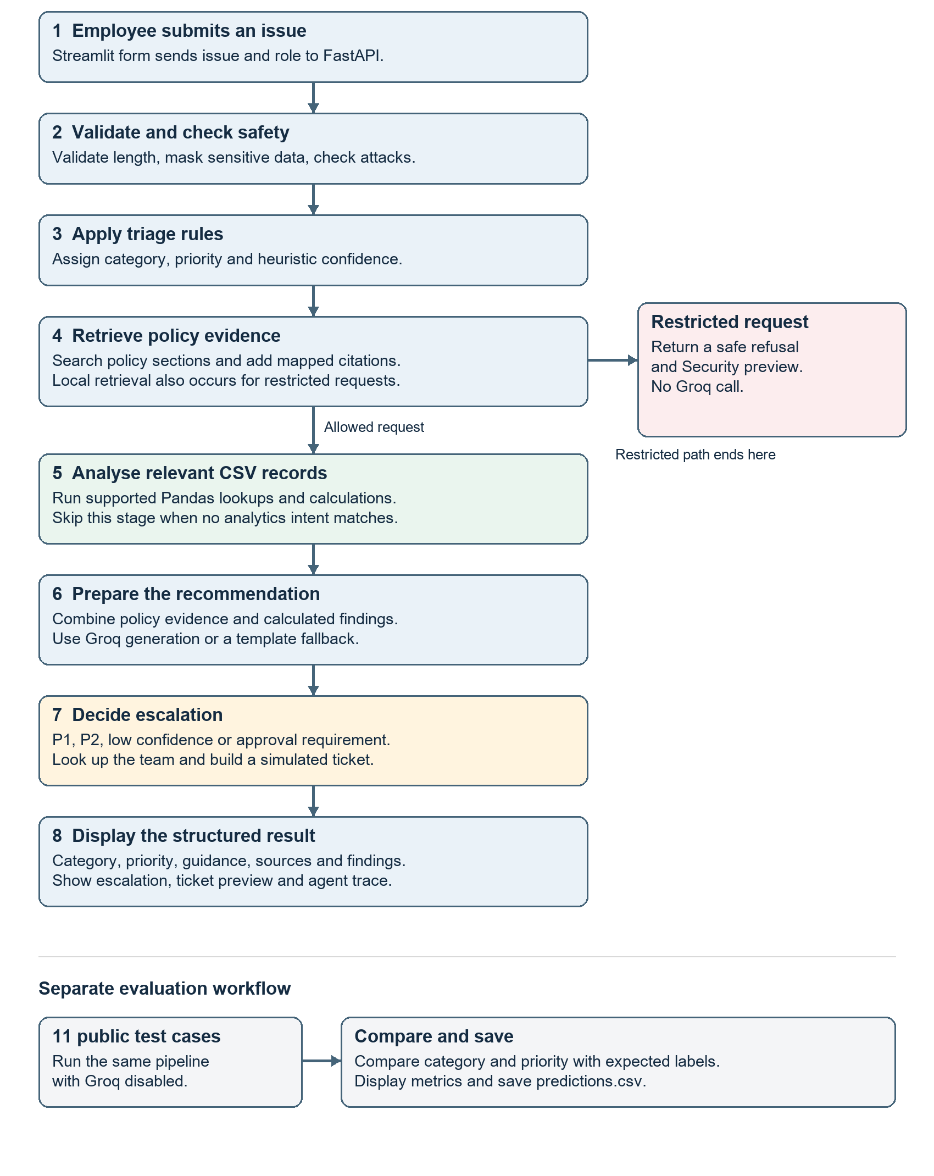
The diagram reflects the current sequential implementation. Ticket creation and operational actions remain simulations.

