Rapid EV Charging: Grid-Level Challenges and a Supercapacitor-Based Energy Buffering Solution
Author - Nikhil kushwah, Co-Author Aastha Tiwari
Department of Electrical Engineering
Samrat Ashok Technological Institute (SATI), Vidisha, Madhya Pradesh, India
Email
Abstract—Rapid charging of electric vehicles (EVs) is essential for long-distance travel and commercial fleet operation, and the battery and power-electronics technologies needed for it already exist. However, charging a 70 kWh vehicle from 0% to 80% in 10 minutes requires an average battery-side power of about 336 kW, or roughly 373 kW at the grid for a 90% efficient charger; ten simultaneous sessions demand about 3.73 MW. At a 1 kV DC bus this means 3,730 A, a copper cross-section of about 746 mm² at 5 A/mm², very large low-voltage transformers, and considerable resistive heating. Such sudden, high-magnitude loads are difficult for the distribution grid to absorb. This paper quantifies these problems and then examines local energy buffering at the charging station as a solution. A Li-ion battery buffer is analysed and its limitations (cost, footprint, degradation, round-trip loss, fire risk, and thermal management) are traced to its electrochemical working principle. A supercapacitor buffer, which stores energy in the electric double layer, is then analysed through worked examples; a 200 kW, 10 s power boost needs only about 0.56 kWh of stored energy. The comparison shows that supercapacitors are well suited to short-duration power peaks, whereas their low energy density limits them for bulk energy supply, which motivates hybrid designs.
Index Terms—electric vehicles, rapid charging, energy storage, supercapacitor, lithium-ion battery, grid impact, peak shaving
I. INTRODUCTION
Charging time and limited driving range are among the main factors constraining the shift from petrol and diesel vehicles to EVs [1]. Conventional EV charging can take several hours, and users of everyday vehicles have little time and patience for it. Rapid charging makes EVs practical for long-distance travel and reduces vehicle downtime for commercial fleets such as electric taxis and trucks.
The vehicle-side technology for rapid charging is already available. StoreDot and Polestar demonstrated a 77 kWh pack charged from 10% to 80% in under 10 minutes using silicon-dominant cells [2], and BYD announced 1 MW flash chargers that it says add 400 km of range in five minutes using silicon-carbide power devices rated up to 1,500 V [1]. The same idea is familiar from consumer electronics, where technologies such as OPPO SuperVOOC and Xiaomi HyperCharge charge smartphones to 80% in roughly 10–20 minutes.
If the need and the technology both exist, the obstacle lies in the infrastructure: rapid charging demands very high power for a very short time. This paper (i) quantifies the power, current, conductor, transformer, and thermal demands of rapid charging; (ii) examines a battery-based energy buffer at the charging station and its limitations; (iii) analyses a supercapacitor-based buffer with worked examples; and (iv) compares the two and discusses the open challenges.
II. NEED FOR AND ENABLING TECHNOLOGY OF RAPID CHARGING
A. Need for Rapid Charging
Four motivations recur: (1) conventional charging takes several hours; (2) users lack the time and patience to wait that long; (3) shorter stops make EVs more practical for long-distance travel; and (4) commercial fleets lose revenue whenever vehicles sit idle while charging.
B. Enabling Technology
Rapid charging relies on high-C-rate battery technology, in which cells accept charge currents many times their capacity per hour. Pushing Li-ion cells to high C-rates raises heat generation and the risk of lithium plating and accelerated degradation [3], so cell design, thermal management, and charger power electronics must advance together.
III. PROBLEM: POWER, CURRENT, AND HEAT
A. Power Demand of a Single Vehicle
The average power needed to deliver an energy E in a time t is
$P=\frac{E}{t}$ (1)
Consider a 70 kWh battery charged from 0% to 80% in 10 minutes. The energy required is E = 0.8 × 70 = 56 kWh and t = 10/60 = 0.1667 h, so P = 56/0.1667 ≈ 336 kW, assuming ideal 100% efficiency. Allowing for a charger efficiency of 90% (an assumption made in this paper), the grid-side power is 336/0.9 ≈ 373 kW per vehicle.
B. Effect of Multiple Vehicles
For ten vehicles charging simultaneously the grid-side demand is 10 × 373 kW = 3,730 kW ≈ 3.7 MW. This equals the simultaneous load of about 2,500 households at 1.5 kW each, or the rated output of roughly 7,460 solar panels of 500 W each. Because the load appears suddenly and varies with vehicle arrivals, the grid cannot readily absorb it, and local distribution networks would require substantial reinforcement [10].
C. Current and Conductor Size
For a DC bus voltage V the current is
$I=\frac{P}{V}$ (2)
At V = 1 kV, one vehicle needs 373 A and ten vehicles need 3,730 A (at 800 V the per-vehicle current would rise to about 466 A). With a current density J the required copper cross-section is
$A=\frac{I}{J}$ (3)
Using a simple design value of J = 5 A/mm², one vehicle requires about 75 mm² and ten vehicles about 746 mm², equivalent to a solid copper conductor roughly 31 mm in diameter (Table I). For comparison, conductors of a typical 132 kV overhead line in India are often 150–300 mm² of aluminium-based conductor, yet the same 3.73 MW at 132 kV would be only about 16 A. Delivering rapid-charging power at low voltage therefore demands conductors comparable in size to those of a transmission line.
TABLE I
Rapid-charging demand of a 70 kWh EV (0–80% in 10 min, 1 kV DC)
Quantity | 1 EV | 10 EVs
Battery-side power (ideal) | 336 kW | 3.36 MW
Grid-side power (η = 0.9) | 373 kW | 3.73 MW
Current at 1 kV DC | 373 A | 3,730 A
Copper area at 5 A/mm² | ≈75 mm² | ≈746 mm²
Equivalent solid diameter | ≈9.8 mm | ≈31 mm
Conductor loss at 5 A/mm² | ≈32 W/m | ≈321 W/m

D. Transformer Requirements
Large transformers are normally built to deliver power at high voltage, for example 33 kV. Here the secondary must supply thousands of amperes at a low voltage of roughly 0.8–1 kV. The transformer itself must therefore carry very high current, so its winding cross-section and busbars must be very large, of the order of 3 cm in equivalent conductor diameter.
E. Thermal Effects
Ultra-fast charging converts part of the transferred power into heat in transformers, cables, busbars, and connectors. The conductor loss is
$P_{loss}=I^{2}R$ (4)
For copper (ρ = 1.72 × 10⁻⁸ Ω·m) of 746 mm² carrying 3,730 A, R ≈ 23 μΩ/m and the loss is about 321 W per metre of conductor, before counting connector and transformer losses. The higher the current, the more difficult and important thermal management becomes.
IV. ENERGY-STORAGE BUFFERING AT THE CHARGING STATION
A. Concept
Instead of drawing peak power from the grid, the station carries local energy storage (Fig. 1). The storage is charged slowly from the grid at low power, then discharges rapidly into the vehicle without creating a sudden load on the grid; after discharging, it is recharged slowly again, and the cycle repeats.
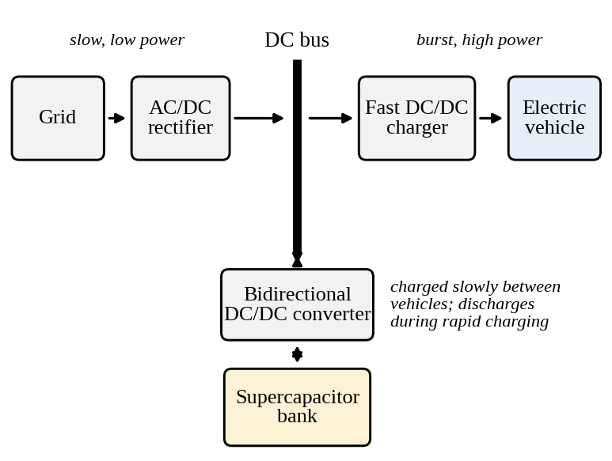
Fig. 1. Charging station with an energy buffer on the DC bus. The grid supplies the buffer slowly; the buffer supplies the vehicle in bursts.
B. Battery-Based Buffer and Its Limitations
A stationary Li-ion battery is the most obvious buffer, but it has several drawbacks:
- Multiple battery units are needed to meet the demand, so the initial investment is high.
- A large physical space is needed for the batteries.
- Continuous charging and discharging causes battery degradation.
- Round-trip efficiency losses reduce the benefit.
- Li-ion batteries carry a high safety and fire risk.
- Thermal management is very difficult at high power.
C. Working Physics of the Li-ion Battery
During charging, lithium ions and electrons combine with graphite at the anode, Li⁺ + e⁻ + C₆ → LiC₆; discharging reverses the reaction, LiC₆ → C₆ + Li⁺ + e⁻ [4]. The cell voltage is related to the Gibbs free-energy change by
$E=−\frac{ΔG}{nF}$ (5)
where n is the number of electrons transferred and F ≈ 96,485 C/mol is the Faraday constant. Because each charge or discharge physically moves ions through the electrolyte and into or out of the electrode material, the process limits electron flow and raises internal resistance, generates heat, and degrades the battery after a threshold number of cycles [3], [4].
V. SUPERCAPACITOR-BASED ENERGY BUFFER
A. Working Principle
A supercapacitor is not simply a normal capacitor with two metal plates. It uses porous electrodes, an electrolyte, ions, and an enormous internal surface area [5]–[7]. When voltage is applied, positive ions move toward the negative electrode and negative ions toward the positive electrode, forming extremely thin electric double layers at the interfaces, so the effective charge-separation distance is extremely small. Since
$C=\frac{εA}{d}$ (6)
capacitance rises as the area A increases and the distance d decreases, which gives supercapacitors their enormous capacitance. The stored energy follows
$E=\frac{1}{2}CV^{2}$ (7)
The operating voltage of the bank is set by its physical construction; series stacking of cells (typically rated at a few volts each [8]) allows banks from about 100 V to 1,000 V, provided cell voltage balancing is implemented.
B. Energy Versus Power: A Worked Example
Take a capacitor bank with C = 100 F, V_{max} = 48 V, and ESR = 10 mΩ. Its stored energy is E = ½(100)(48)² = 115,200 J = 32 Wh. If it can deliver 1,000 A for a short period, the power is P = VI = 48 kW. The energy is small (32 Wh) but the power is large (48 kW); this is the key characteristic. Dividing energy by power gives t = 32 Wh / 48 kW = 2.4 s, an upper bound, because the voltage cannot stay at 48 V while the capacitor discharges: V = Q/C falls as charge leaves.
If the bank is used only between 48 V and 24 V, the usable energy is
$ΔE=\frac{1}{2}C(V_{max}^{2}−V_{min}^{2})$ (8)
which gives ½(100)(48² − 24²) = 86,400 J = 24 Wh, i.e., 75% of the total, lasting 1.8 s at 48 kW. At 1,000 A the ESR also drops about 10 V and dissipates I²R = 10 kW, so 48 kW is an optimistic bound and real delivery is lower.
C. A 10-Second EV Power Boost
Suppose a charger normally receives 300 kW from the grid but the vehicle temporarily needs 500 kW. The supercapacitor supplies the 200 kW difference for 10 s (Fig. 2). The energy required is E = Pt = 200,000 × 10 = 2 MJ ≈ 556 Wh, about 0.56 kWh. The supercapacitor stores little energy, but it must deliver 200 kW; this is exactly where it becomes attractive.
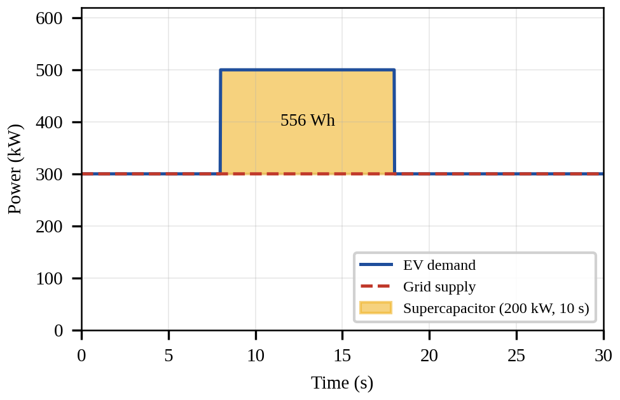
Fig. 2. Ten-second power boost: the grid supply stays at 300 kW while the supercapacitor supplies the 200 kW excess.
D. Sizing Against Bus Voltage
For a required energy E and a usable window from V_{max} down to V_{min}, the capacitance needed is
$C_{req}=\frac{2E}{V_{max}^{2}−V_{min}^{2}}$ (9)
Because energy scales with V², raising the bus voltage sharply reduces the capacitance required. For E = 2 MJ and V_{min} = V_{max}/2, about 2,315 F is needed at 48 V but only about 5.3 F at 1 kV (Fig. 3). A 1 kV string of roughly 370 series cells of 2.7 V would then need cells of about 2,000 F each, since series connection divides capacitance by the number of cells.
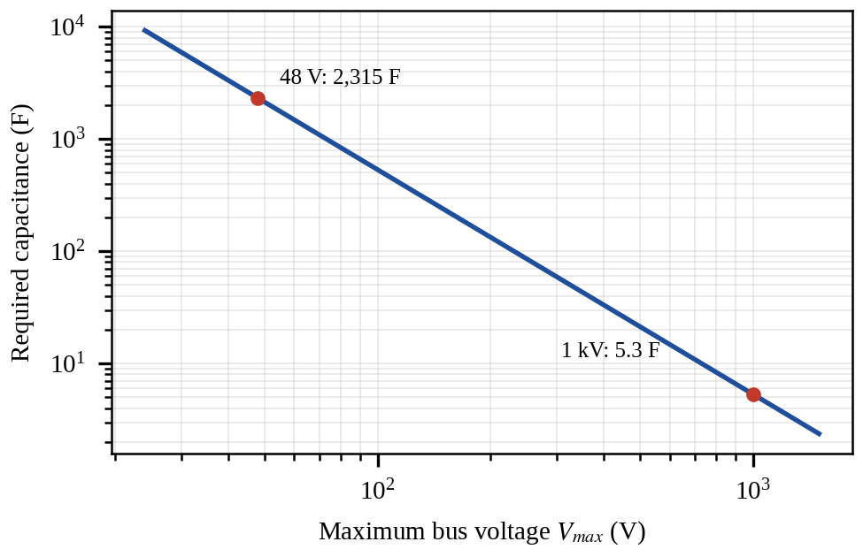
Fig. 3. Capacitance needed to deliver 2 MJ (200 kW for 10 s) with V_{min} = V_{max}/2, versus maximum bus voltage.
VI. COMPARISON OF LI-ION BATTERY AND SUPERCAPACITOR
In a Li-ion battery, ion diffusion leads to a chemical or electrochemical reaction and then energy storage, which is a comparatively slow process. Lithium ions must travel through the electrolyte and enter or leave the electrode materials, causing electrolyte transport limits, ion diffusion limits, and heat generation. In a supercapacitor, ions primarily move charge onto electrode surfaces without an actual ion-exchange reaction: ion movement leads to charge accumulation at the electrode surface and then to electric-field energy storage, which is extremely fast. Its very large electrode area and low internal resistance give it a very high power density [5], [6].
TABLE II
Li-ion battery versus supercapacitor
Characteristic | Li-ion battery | Supercapacitor
Energy density | High | Low
Power density | Moderate | Very high
Charge/discharge speed | Moderate | Very fast
Cycle life | Limited | Very high
Response time | ms–seconds | Milliseconds
Suitable for | Long-duration energy | Short-duration power peaks

The main advantages of supercapacitors over Li-ion buffers are an extremely high cycle life, very fast charging and discharging, and very high power capability. Cycle-induced degradation is far lower than in Li-ion cells, although supercapacitors are not ageless: elevated voltage and temperature still shorten their life [8].
VII. LIMITATIONS AND CHALLENGES OF SUPERCAPACITORS
- Ions must still move through the electrolyte to form the double layer, so at extremely high currents ion transport can become a limiting factor.
- The electrolyte has finite ionic conductivity and resistance, which at high current produces voltage drop and heat.
- Supercapacitors generally lose stored energy faster than Li-ion batteries when left unused.
- Terminal voltage falls linearly with the charge removed (V = Q/C), so a wide-input-range bidirectional converter is needed and only part of the stored energy (75% for a 2:1 voltage window) is usable.
- Energy density is low. A supercapacitor can deliver enormous power but stores relatively little energy. This is the biggest limitation for the EV application.
The last point can be quantified. Ten vehicles each taking 56 kWh represent 560 kWh per charging round. Commercial supercapacitors store only a few Wh/kg [5], [8]; assuming about 5 Wh/kg as an order-of-magnitude figure, storing 560 kWh would need on the order of 100 tonnes of cells, whereas the 0.56 kWh of the 10-second boost example corresponds to roughly 110 kg. Supercapacitors are therefore not a practical stand-alone source for the bulk energy of many 10-minute charges, but they are practical for short power peaks.
VIII. CONCLUSION AND FUTURE WORK
Rapid EV charging is needed and technically feasible on the vehicle side, but it shifts the challenge to the grid: a 70 kWh vehicle charged 0–80% in 10 minutes needs about 336 kW (about 373 kW grid-side), and ten vehicles need about 3.73 MW, which corresponds to 3,730 A at 1 kV, about 746 mm² of copper, very large low-voltage transformers, and significant heat. Local energy storage can decouple the vehicle’s power demand from the grid. Li-ion buffers suffer from cost, size, degradation, efficiency, fire risk, and thermal difficulty. Supercapacitors offer faster response, longer life, and higher power capability, and the 10-second boost example shows that they need to store only about 0.56 kWh to supply 200 kW. Their low energy density, self-discharge, and voltage variation limit them to short-duration power buffering. A hybrid arrangement, with supercapacitors handling power peaks and transients and a smaller battery or the grid supplying the average energy, appears to be the most practical route.
Future work includes optimal sizing of hybrid supercapacitor–battery buffers, converter design for wide voltage windows, thermal modelling of high-current busbars and connectors, experimental validation on a prototype, economic analysis, and the impact of improving energy density through emerging technologies such as ion capacitors.
REFERENCES
[1] “China’s BYD launches EV charging system it says works nearly as fast as a fill up,” Associated Press, Mar. 2025.
[2] “StoreDot and Polestar showcase world’s first 10-minute EV charge,” Autocar Professional, Apr. 30, 2024.
[3] A. Tomaszewska et al., “Lithium-ion battery fast charging: A review,” eTransportation, vol. 1, Art. no. 100011, Aug. 2019.
[4] J. B. Goodenough and K.-S. Park, “The Li-ion rechargeable battery: A perspective,” J. Amer. Chem. Soc., vol. 135, no. 4, pp. 1167–1176, 2013.
[5] M. Winter and R. J. Brodd, “What are batteries, fuel cells, and supercapacitors?,” Chem. Rev., vol. 104, no. 10, pp. 4245–4270, 2004.
[6] P. Simon and Y. Gogotsi, “Materials for electrochemical capacitors,” Nature Mater., vol. 7, no. 11, pp. 845–854, Nov. 2008.
[7] B. E. Conway, Electrochemical Supercapacitors: Scientific Fundamentals and Technological Applications. New York, NY, USA: Kluwer/Plenum, 1999.
[8] A. Burke, “Ultracapacitors: Why, how, and where is the technology,” J. Power Sources, vol. 91, no. 1, pp. 37–50, Nov. 2000.
[9] P. Sharma and T. S. Bhatti, “A review on electrochemical double-layer capacitors,” Energy Convers. Manage., vol. 51, no. 12, pp. 2901–2912, Dec. 2010.
[10] S. Habib, M. Kamran, and U. Rashid, “Impact analysis of vehicle-to-grid technology and charging strategies of electric vehicles on distribution networks—A review,” J. Power Sources, vol. 277, pp. 205–214, Mar. 2015.

