With the single-day spike in [COVID-19](https://indianexpress.com/about/coronavirus/) cases setting records last week, India’s second wave is feared to be longer and more intense than the first one. Many states have announced partial lockdowns and more are likely to follow. The fear of a full lockdown has already led some migrant workers to move back from industrial centres and cities to their native villages.

Governments do not seem to have learnt from the experiences of last year’s lockdown, which disrupted supply chains, led to considerable decline in output growth, increased unemployment, reduced earnings and savings and jeopardised the food and livelihood security of millions of workers in the country. The worst hit were the migrant workers.

The migrants, who faced the brunt of the [pandemic](https://indianexpress.com/article/explained/pandemic-explained-who-novel-coronavirus-covid19-what-is-a-pandemic-6309727/), have not fully recovered from their last year’s experiences. In a recent study by ICRIER in collaboration with the Inferential Survey Statistics and Research Foundation (ISSRF), we examined the impact of the pandemic on migrant workers using a survey of 2,917 migrants in six states — Bihar, Chhattisgarh, Jharkhand, Odisha, Uttar Pradesh and West Bengal. These states account for two-thirds of the reverse migration witnessed during the first lockdown. We conducted the survey in three phases: Phase-1 between June and August 2020, Phase-2 between November and December 2020 and Phase-3 during the last week of February 2021. Our purpose was to capture the varying degrees of vulnerabilities among the migrants prior to, during, and after the first lockdown.

The study found that the sudden imposition of the lockdown had a severe impact on the earnings and savings of the migrants once they returned to their villages. More than a third of the reverse migrants (38.6 per cent) reported having no work after returning to their native place. With no proper employment opportunity in their native places, the household incomes of migrants fell by as much as 85 per cent during the first wave (see Figure 2).

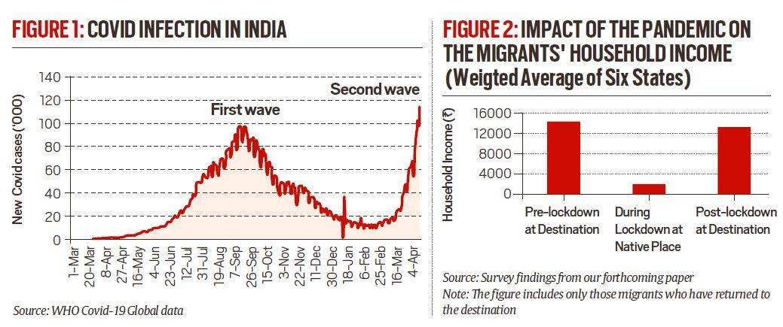

Source: WHO Covid-19 Global data. (Graphics: Ritesh Kumar)

With the revival of economic activities post-first lockdown, we found that, on average, 63.5 per cent of migrants from these six states returned to the destination areas by February 2021, while 36.5 per cent remained at their native places. Notably, remigration to the destination post-lockdown was the highest from Bihar (92.5 per cent), followed by Uttar Pradesh and Odisha (65 per cent each). In comparison, migrants from West Bengal (40.3 per cent) and Jharkhand (31.2 per cent) were hesitant to return post-lockdown.

Although the migrant’s household income has increased after remigration to their destination places, there is still a contraction of 7.7 per cent in their income relative to the pre-lockdown level. Moreover, another lockdown — even the fear of one — can upset the momentum of this recovery. And, if the migrants decide to return to their native place, their household income could drop by more than 80 per cent, much like what happened after the first lockdown.

Interestingly, the study also finds that while some relief and welfare measures announced by the Centre and state governments did reach the migrants, many other measures bypassed them. For example, the survey revealed that almost 74 per cent migrants had access to some form of subsidised cereal (rice or wheat) but only 12 per cent got access to subsidised pulses. Moreover, only 7.7 per cent of the migrants reported being engaged under the MGNREGA or any other public work at their native place. The demand-driven skill training under the Garib Kalyan Rozgar Yojana (GKRY) did not reach most of these migrants. For instance, only 1.4 per cent of the migrants reported getting any skill upgradation or training at the native place in our survey. These employment schemes, including GKRY, have either neglected these migrants or they did not want to be engaged in MGNREGA work. Notably, many migrant workers reported a fall in the quality of food consumed during the lockdown and post-lockdown compared to the pre-lockdown state.

The examination of the first wave of COVID infection offers important policy lessons for managing the ongoing second wave. First, we need to digitise all data on migrants to formulate any action plan in case another mass exodus starts. This needs to be backed by a periodic database on migrant workers, say every five years, for any meaningful policies and action plan based on this data.

Second, the portability of entitlements and social safety nets needs to be prioritised. This could be done with the “One-nation, one-ration card” with an option to receive cash or grain in kind, or by providing health insurance and treatment at any place or through a universal social protection programme for the vulnerable section