Name: Nikhil Lohar

Subject: Data & Decisions

**Assignment For R- Programming**

>library(readxl)

>fidelityfunds <- read_excel("C:/Users/nikhi/Desktop/fidelityfunds.xlsx",

>View(fidelityfunds)

1. **Descriptive Statistics for Fidelity® Low-Priced Stock Fund and Fidelity® Floating Rate High Income Fund**
2. Code: >summary(fidelityfunds$FLPSX)
3. Code: >summary(fidelityfunds$FFRHX)

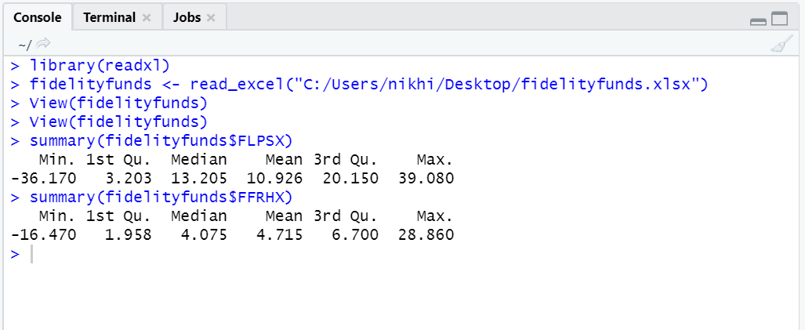

1. **Histogram for** **Fidelity® Low-Priced Stock Fund and Fidelity® Floating Rate High Income Fund**
2. Code: >hist(fidelityfunds$FLPSX, breaks=4, main="Histogram for Low-priced stock Fund", xlab="Fidelity Funds")

**Low-Priced Stock Fund**

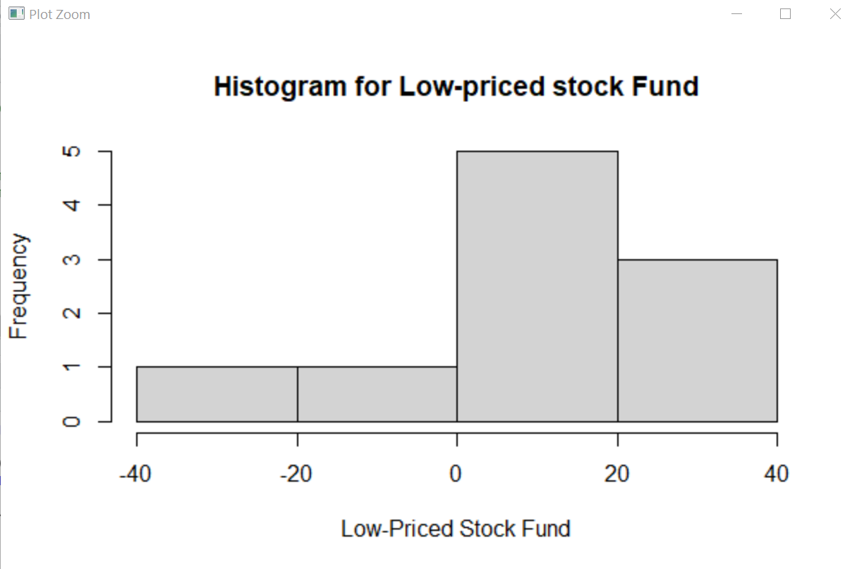

1. Code: >hist(fidelityfunds$FFRHX, breaks=4, main="Histogram for Floating Rate High Income Fund", xlab="Floating Rate High Income Fund")

**Floating Rate High Income Fund**

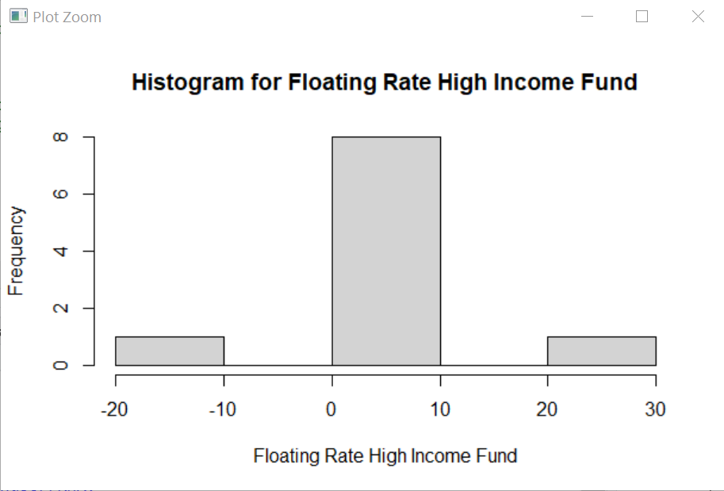

1. **Boxplot for Stock and Bond**
2. Code: >boxplot(fidelityfunds$FLPSX, fidelityfunds$FFRHX, main="Boxplot", names=c("Stock","Bond"))

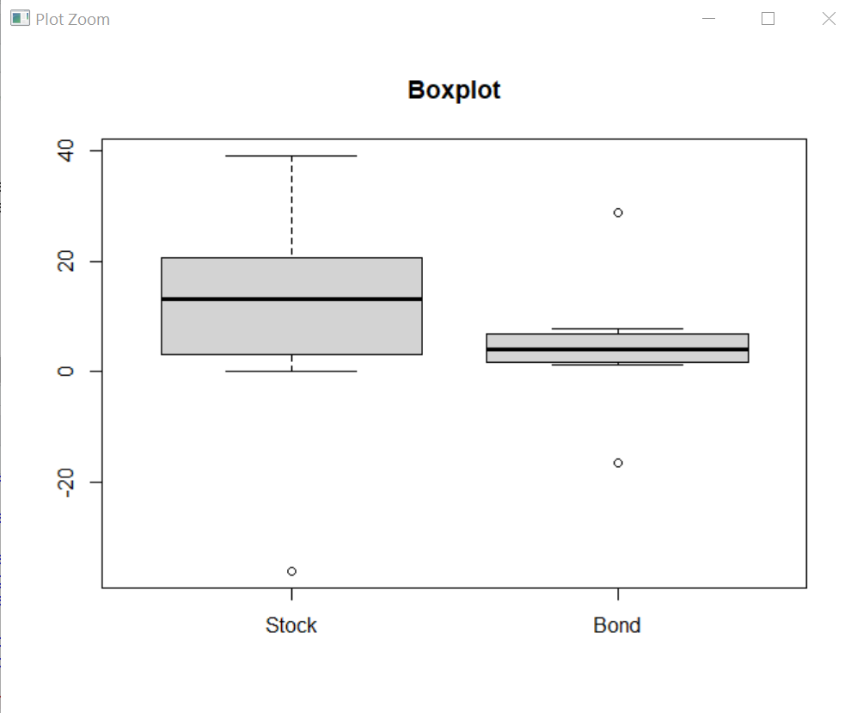

1. **Diversification of Funds and Stock**
2. Code: >cor(fidelityfunds$FLPSX, fidelityfunds$FFRHX)

Result: > cor(fidelityfunds$FLPSX, fidelityfunds$FFRHX)

[1] 0.8645521

1. Code: plot(fidelityfunds$FLPSX, fidelityfunds$FFRHX, main="Scatterplot", ylab="Percent Return Of FLPSX", xlab="Percent Return of FFRHX")

