Muzicast: Design Document
Team 3
February 17, 2011

Revision History

Version | Date | Authors | Details
1.0 | February 17, 2011 | Nikhil Marathe, Shreya Agrawal, Swati Ittan | Initial version

Table of contents

1. Introduction
1.1 Purpose
1.2 Scope
2. System Overview
3. System Architecture
3.1Architectural design and decomposition description
3.2 Design Rationale
4. Data design
4.1 Data Description
5. Detailed design
5.1 Activity Diagrams
5.2 Use cases
5.3 Sequence Diagrams [TODO: (Nikhil) The server one which you were talking about in lab]
6. Human Interface Design
6.1 Overview of user interface
6.2 standard elements
7. Requirements Matrix

- Introduction
  - Purpose
The purpose of this design document is to describe the architecture and system design of Music Streaming Server with Web Interface MUZICAST. This gives us an overview of all different components comprised. It will act as a blue print for the programmers to follow and it will act as the baseline for limiting the changes in the scope of the project. Thus it provides an understanding of how Muzicast has to be built.
  - Scope
This document covers all the system components and their basic description such as collection scanner, streaming server and web interface. It also gives a light on how the data is stored in the database with complete description of tables.
This gives us an overview on the human web interface and in the end gives us a proof that all requirements in SRS are covered in design document as well.

- System Overview

The system will follow the three-tier architectural style and be organized into three layers: the interface layer, application layer and the storage layer. The interface layer will be the graphical user interface that allows the users to interact with the system. It will be implemented using the Model-View-Controller. The application layer will contain the logic and rules for retrieving data and playing music in accordance with the user’s needs. Finally, the storage layer will form a database based on the folder of songs selected and store the metadata required for the system.
- System Architecture
  - Architectural design and decomposition description
The system consists of three main components: collection scanner, streaming server and user interface.
Collection Scanner
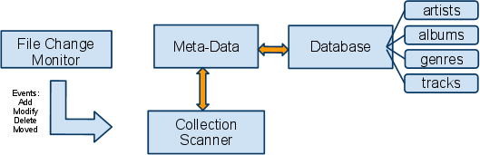

The Collection Scanner is the only component that has WRITE access to the collection meta-data stored in the database. It launches a File Change Monitor module which monitors all the collection directories for any changes.
When a file is added the scanner will read its meta-data and make the entries in all the tables in the database.
When a file is deleted the scanner will track down the meta-data according to filename and remove its entries from the database. When a file is modified (perhaps the user manually changed tags), the scanner will update its meta-data. When a file is moved it changes the meta-data to point to the proper location so that the streamer can play it. In addition, on the first run of the program, and whenever the administrator requests a complete Rescan, the collection scanner iterates through all the directories specified by the user and re-adds all tracks to the collection, bringing the actual music and meta-data in sync with each other. When Muzicast is restarted, the collection scanner also checks if their have been any modifications to the music and tries to bring the meta-data up to date while minimizing the number of operations.
Streaming server
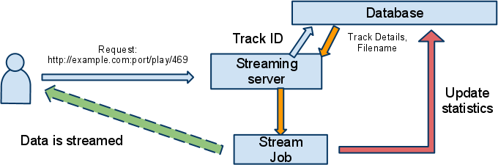

The streaming server handles a request to play a track based on the ID sent as the track endpoint (eg. 469). It then gets information about the track from the database and spawns a stream job to handle responding back to the client. If the track does not exist, a predefined clip plays which notifies the user that the track has been deleted. Otherwise the actual file is streamed and the statistics are updated so that the web interface can retrieve latest statistics.
Web interface


The web interface follows a light-weight Model-View-Controller design pattern since like all request-response cycles it fits in well with the separation of concerns provided by MVC. The model is obviously the meta-data store, the controllers are various URL endpoints triggered based on the client’s usage and the views are the data returned by the server.

Other than this, certain controllers are also responsible for carrying out background tasks and managing the streaming server and collection scanner processes.

3.2 Design Rationale
The three-tier architecture style shall be used because it not only separates the user interface and the metadata, but also provides an application logic layer. The application layer provides a middle layer that allows the data files and the GUI components to be loosely coupled. The application layer can be modified with little effort if there are any changes to the format of the data files and the interface layer will need little or no modification. This makes the system easy to maintain and modify and also hides the complexity of processing data from the users. Thus it will be like client server architecture.

Playlists
The playlists concept in Muzicast is: There are playlists and then there is the active playlist. All user additions and deletions can only be done on the active playlist. Only the active playlist can be downloaded. The active playlist is displayed on all pages in the web interface.
Unregistered users only have 1 playlist which is the active playlist and persists only for that browser session.
Registered users may have any number of saved playlists, any one of them can be set to active by going to the Playlist Manager.
Playlist downloads are served up in the PLS format. Although not as good as the superior XSPF format, the PLS format has wider support and is thus chosen.

Controllers
The modules register URL routes with the Flask Application dispatcher and the functions get called based on the client’s URL access. Listed are the URL endpoints, controller functions and any associated utility functions used by controllers:

Firstrun
- /firstrun
  - Default redirect whenever first run is not done
  - Creates database, tables, configuration file
  - Makes Muzicast ready to run.

Main
- / - main.index
  - Show Muzicast home page with top tracks and recent tracks
  - Helpers:
    - top_tracks - show top 10 tracks
    - recent_tracks - show 10 recently played tracks
- /playlist/clear - main.clear_playlist
  - clear the active playlist
- /playlist/download/playlist.pls
  - Return the active playlist as a downloadable .pls file which can be inserted into music players.

Admin
- /admin/ - admin.index
  - Show administration interface if logged in, otherwise redirect to admin login page.
- /admin/login - admin.login
  - Show and perform administration login by setting up session
- /admin/password - admin.change_password
  - Handle admin password change.
- /admin/dirlist - admin.dirlist
  - Endpoint which enables the Directory List on the administration page to be dynamically updated via AJAX. Returns a JSON tree understandable by the jstree json_data module.
- /admin/stop - admin.stop
  - Stop Muzicast including all processes of the web interface, scanner and streaming server.
- /admin/rescan - admin.rescan
  - TODO:
- /admin/save_directories - admin.save_directories
  - Save Directory List updates as directories to be scanned by the collection scanner.

Artist
- /artists/<page> - artist.artists_page
  - Returns artists 10 at a time based on page number.
  - Helper: artist.top_artists
    - returns top artists from statistics
  - Associated: /artists - artist.artists
    - Returns page number 1
- /artist/<id> - artist.index
  - Individual artist information for artist with <id>.
- /artist/add/<id> - artist.add_artist_to_playlist
  - Add all tracks by artist to current playlist

Album
- /albums/<page> - album.albums_page
  - Returns albums 10 at a time based on page number.
  - Helper: album.top_albums
    - returns top albums from statistics
  - Associated: /albums - album.albums
    - Returns page number 1
- /album/<id> - album.index
  - Individual album information for album with <id>.
- /album/add/<id> - album.add_album_to_playlist
  - Add all tracks by album to current playlist
- /album/cover/<id> - album.cover
  - If there is no such album, return a 400 error (because this should never occur unless it was malicious)
  - If the album have cover-art available, send that as an image, otherwise send a filler image.

Track
- /tracks/<page> - track.tracks_page
  - Return tracks 20 at a time based on page number.
  - Associated: /tracks - track.tracks
    - Returns page number 1
- /track/<id> - track.index
  - Individual track information for track with <id>.
- /track/add/<id> - track.add_track_to_playlist
  - Add this track to active playlist.
- /track/delete/<id> - track.delete_track_from_playlist
  - Removes track from active playlist

Genre
- /genres/<page> - genre.genres_page
  - Return genres 10 at a time based on page number.
  - Helper: genre.top_genres
    - returns top genres from statistics
  - Associated: /genres - genre.genres
    - Returns page number 1
- /genre/<id> - genre.index
  - Individual genre tracks for genre with <id>.
- /genre/add/<id> - track.add_genre_to_playlist
  - Add all track in this genre to active playlist.

User
- /user/register - user.register
  - Displays user registration form and handles registration
- /user/login - user.login
  - Displays login form and handles login (session based)
- /user/edit - user.edit
  - Change user password
- /user/delete - user.delete
  - Permanently delete user account and playlists
- /user/logout - user.logout
  - Destroy the session to log the user out.

Playlist
- /playlist/save - playlist.save_current
  - Save active playlist to user’s permanent store.
- /playlist/manage - playlist.manage
  - show list of saved playlists
- /playlist/makeactive/<id> - playlist.set_active
  - Set playlist saved as id <id> to the active playlist for the user session.
- /playlist/delete/<id> - playlist.delete
  - Delete playlist saved as id <id>.
- Helpers.
  - add_to_playlist - add track to active playlist
  - delete_from_playlist - remove track from active playlist
  - playlist_contains - check if track exists in active playlist
  - playlist_clear - clear all tracks from active playlist
  - playlist_entries - return Track information for all tracks in active playlist
  - playlist_name - name of active playlist if it is a saved playlist

Search
- /search/?query=<search term>
  - Search over database and display search results.

- Data design
  - Data description
When the software is run for the first time, a SQLite3 database is created. The meta-data of the file is read and its entry is made in the appropriate tables. The following is the ER diagram of the database which depicts the relationship of the tables.
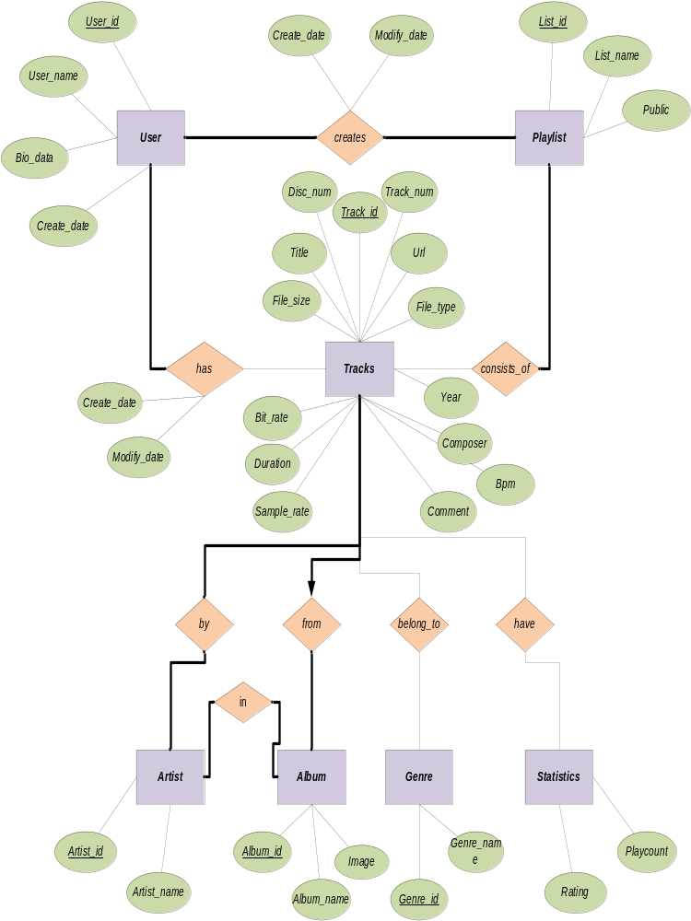The various tables are:
- Artist
Column name: name, album
- Album
Column name: name, artist, image, tracks
- Genre
Column name: name, tracks
- Composer
Column name: name
- Track
Column name: artist, album, genre, composer, year, title, comment, track number, disc number, bit rate, duration, file size, file type, bpm, create date, modify date
- Track statistics
Column name: track, last played, play count

- Album statistics
Column name: album, last played, play count

- Artist statistics
Column name: artist, last played, play count

- Genre statistics
Column name: genre, last played, play count

- User
Column name: username, bio data, create date
- Playlist
Column name: list name, public

- Detailed Design
  - Activity Diagram

LOGIN
Start
Login
End
2
1
Enter old and new password
22
Change password

1

NO

YES
Save password

1
Delete account
NO
Enter password
Click on delete account button
Go to home page
2

YES

See the saved playlist
Click on a playlist
Manage playlist
Add song
Save it
Saved playlist gets modified
New playlist is saved
Same name as original
1
Playlist doesn’t get modified

NO
YES

YES

NO

YES
NO

YES
NO

YES
2

1
Logout
2
Register
Enter username

REGISTER
Start
Enter password
Click on register button

End

Start
Click on any track
Static page for track open
1
End
1
Click on name of artist
2

Different artists get displayed

Next page
Click on the artist
NO
NO
2
YES
YES
Display more artists
Tracks are displayed
NOTE: Same for genre and album
  - Use cases

ADMIN

Change Password
Stop
Create user registration

Scan Directories for music


Forgot Passwordor
Delete registered user
LOGIN
ADMINISTRATOR

UNREGISTERED USER

Create one time playlist

Browse tracks
Add tracks to playlist

Add entire album to playlist
Browse albums

Browse tracks
Add tracks to playlist

Browse genre
Browse artist
Browse top tracks
Add tracks to playlist

Browse recently played tracks
Add tracks to playlist

Remove songs from playlist

Search

REGISTERED USER

Register
Login
Create playlist
Save the playlist

Change password
Delete account
Open saved playlist
Open it
Modify it

NOTE: As well as all the accessibility of an unregistered user.

  - Sequence diagrams

:Stream job
Do_GET() stream_song(self , id)
Get_track()

Opt
Track exists
Update_statistics()

An object named server of streamserver class is formed which creates a socket and listens the entire request at the specified port number. When there is a get request from the client the id of the song is extracted and another function is called, stream_song, to stream the requested song. The track is extracted from the database based on the id and the data is sent and the statistics for that song, album, artist and genre are updated.

: collection scanner : observer : scan runner
start ()
configuration_changed ()

add_directory (self, dir, full_scan=False)
scan()
remove_directory (self, dir) alt
full=true full_scan()
schedule (todo) else incremental_scan ()
start ()

When the software is run, a file system event on_modified occurs which creates and initializes an object of class Collection Scanner and calls the function configuration_changed. This function creates a GlobalConfig object, named config and initializes it. In the initialization part another object is created which parses the config file if it exists and sends the parsed data to the config object…[TODO: (nikhil) don’t know what is happening in try…except] If full scan of the directory needs to be done then all the existing tables, if existing, will be deleted. Watches, a dictionary, keeps track of the directories that need to be looked for in case of any event occurs within them. The function, then, carries out the difference in the existing directories to old directories and deletes the missing directory not found in new one but found in older one by referring to the keys in watches. In case of addition of any directories, an object of scanrunner class is created asynchronously and full scan of that directory is done. We do full scan by fetching the album cover and entering the meta-data for the music files in the database.
- Human Interface Design
  - Overview of user interface
This software is an easy to use music streaming server. It is user friendly, interoperable, cross-platform and efficient music sharing system. It can be used for running radio stations. In internal networks, the user can use the software to share music with friends/ co-workers for events like parties. The user who is not logged in can create a single playlist while a logged in user can create and save multiple playlists. There is also search feature for searching of the tracks on the server. The user can also get lots of information about the tracks related to their album name and artist name. Also, the user gets to know the top tracks on regular basis.

[TODO: need to add screen shots]
  - Standard elements
The following standard elements are present on all pages delivered via the web interface.
- Muzicast logo + caption
- Navigation tab
- Playlist (if present) and its options
- Footer with copyright details etc.
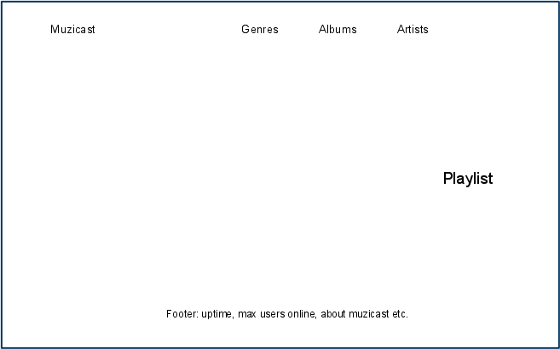

Home page
The Home page should show the following.
- Top tracks
- Top albums
- Top artists
- Current listeners count

- Requirement Matrix

ID | Technical assumptions and/or customer needs | Functional description | System component
1 | Friendly user interface | User needs to have certain basic knowledge of operating computers but the interface should be easily understandable and comprehensible | Web interface
2 | Friendly Admin interface | Admin needs to have certain basic knowledge of operating computers but never the less the interface should be easily understandable and comprehensible | Web interface
3 | Interoperate with existing players | Most of the available players support ICY protocol and our server would be based on the same | todo
4 | Streaming music in spite of the presence of firewalls | The ICY protocol runs over http protocol which is not filtered by most firewalls | Streaming server
5 | Portability | Runs on all common platforms without recompilation | todo
6 | Live scan for updates | Server should intelligently look for changes in the shared folder of the administrator and make suitable changes in its database | Collection scanner
7 | Live Statistics | It should provide useful statistics about most listened and shared songs | Collection scanner
8 | Custom Playlists | The user should be able to create, add, modify and save playlists | Web interface
9 | Scalable | Large number of user should be able to simultaneously logon to the server and use Muzicast | todo
10 | Availability of decent internet connectivity with the client | Internet connection of the user should be such that it supports the minimum bit rate of the streamed mp3 file | Does not require system component
11 | User has certain softwares and hardware for optimum performance of Muzicast | User must have certain version of a internet browser and music player that support ICY protocol and hardware should be such that it is able to support a running | Does not require system component

