Muzicast: Design Document

Team 3

February 17, 2011

Revision History

Version | Date | Details
1.0 | February 17, 2011 | Initial version

Muzicast: Design Document
Team 3
February 17, 2011

Introduction

Collection Scanner
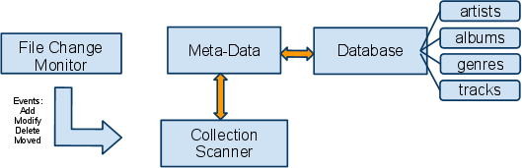

The Collection Scanner is the only component that has WRITE access to the collection meta-data stored in the database.
It launches a File Change Monitor module which monitors all the collection directories
for any changes.
When a file is added the scanner will read its meta-data and make the entries in all the tables in the database.
When a file is deleted the scanner will track down the meta-data according to filename and remove its entries from the database.
When a file is modified (perhaps the user manually changed tags), the scanner will update its meta-data.
When a file is moved it changes the meta-data to point to the proper location so that the streamer can play it.

Streaming server
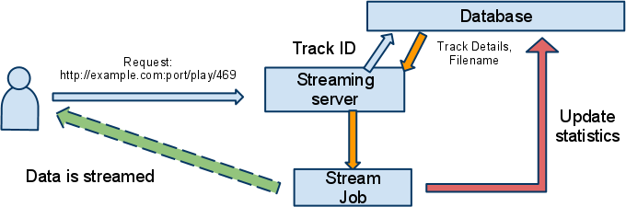

The streaming server handles a request to play a track based on the ID sent as the track endpoint (eg. 469). It then gets information about the track from the database and spawns a stream job to handle responding back to the client. If the track does not exist, a predefined clip plays which notifies the user that the track has been deleted. Otherwise the actual file is streamed and the statistics are updated so that the web interface can retrieve latest statistics.

Web interface


Client-Server interaction

Standard elements
The following standard elements are present on all pages delivered via the web interface.
- Muzicast logo + caption
- Navigation tab
- Playlist (if present) and its options
- Footer with copyright details etc.
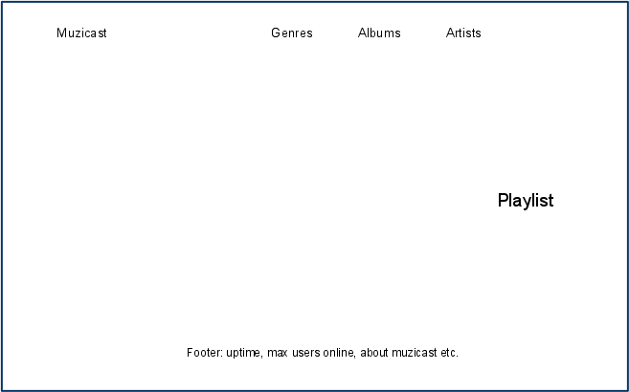

Home page
The Home page should show the following.
- Top tracks
- Top albums
- Top artists
- Current listeners count

User flow

Data flow

