ClariFIRE
Explainable AI–Driven, Dynamic Climate-Aware Geospatial System for Wildfire Hazard and Community Risk Mapping
Nikhil Muthukumar | Project B90
Synopsys Silicon Valley Science and Technology Championship - 2026

Abstract
Wildfire risk in California is intensifying. Prolonged drought, fuel buildup, and expanding development intersect across fire-prone regions. Existing hazard systems are often static, poorly validated, or evaluated under unrealistic conditions that inflate performance. Many omit social vulnerability, limiting their usefulness for equitable mitigation. This project engineered a scalable, interpretable wildfire hazard and risk system designed to generalize to future fire seasons, handle extreme class imbalance, and connect environmental predictions to community vulnerability planning.
ClariFIRE predicts probabilistic wildfire hazard statewide by integrating terrain, vegetation indices, and seasonal climate and drought indicators. Through structured feature engineering including anomaly normalization, lagged fuel memory variables, and nonlinear interaction terms, the feature space expanded from 22 to 34 predictors. Each addition was evaluated under strict validation to improve fire concentration in temporal and spatial testing without overfitting. Gradient boosting (XGBoost) was selected based on superior ranking consistency and concentration performance.
The system was evaluated using unbalanced testing at real prevalence averaging 0.49%, temporal holdout with 2004–2020 training and 2022–2025 testing, and spatial cross-validation. Under realistic conditions, ROC-AUC reached 0.94. Under conservative temporal and spatial validation, ROC-AUC ranged from 0.77–0.81. Critically, in these validation regimes, the top 20% highest-risk areas captured 51–66% of wildfire events.
SHAP explainability was applied globally and at county levels. Hazard predictions were translated into community-level risk maps by integrating population exposure and the CDC Social Vulnerability Index. ClariFIRE shows that wildfire risk, though rare, is spatially structured, predictable under realistic constraints, and actionable when integrated with social vulnerability, enabling equitable, data-driven mitigation planning.

1. Introduction and Rationale
Over the past decade, wildfires have emerged as one of California's most damaging hazards, with frequency, size, and severity increasing due to warming temperatures, drying conditions, and earlier spring snowmelt. Climate-driven fire weather seasons are lengthening statewide and globally, indicating a systematic intensification of conditions conducive to ignition and spread. These trends underscore the need for dynamic hazard mapping techniques that account for short-term climate variability rather than relying solely on static fuel or terrain factors.
Reliable fire-occurrence labels are essential for training and evaluating a predictive model. The MODIS Collection 6 burned area product (MCD64A1) provides a validated, consistent record with improved detection of small burns. Predictors combine static environmental drivers, topography from SRTM and vegetation condition via NDVI, with dynamic meteorological and drought indicators from gridMET, SPEI, and EDDI, which together capture fuel moisture stress and short-term “flash drought” signals.
Hazard alone indicates where fires are likely; risk also depends on exposure (population and infrastructure) and vulnerability (social and medical factors limiting response and recovery). The U.S. Census Bureau's American Community Survey (ACS) supplies tract-level population density as a measure of exposure, and the CDC Social Vulnerability Index (SVI) identifies where communities may struggle most during evacuations, outages, or recovery. Combining these layers with hazard predictions turns a purely environmental model into an actionable planning tool.
This project advances beyond existing wildfire-hazard models by integrating open-source datasets, seasonally adaptive climate inputs, and explainable AI (SHAP) to quantify each factor's contribution to predicted hazard. Traditional logistic regression or static random-forest approaches typically report ROC-AUC values between 0.80 and 0.92; ClariFIRE's XGBoost-based model reaches a PR-AUC of 0.955 and ROC-AUC of 0.945 under optimistic testing, while maintaining interpretability and, more importantly, remaining structured and actionable under much stricter, realistic validation (Section 5).

2. Project Goal and Design Criteria
Goal: Design and implement a dynamic, AI-driven geospatial system to predict wildfire hazard across California by integrating terrain, vegetation, and climate/drought indicators; translate hazard into community risk by overlaying exposure (ACS population density) and vulnerability (CDC SVI); and make every prediction explainable via SHAP so planners can understand and act on the results.

Design Criteria (summary)
- Accuracy: ≥ 0.85 PR-AUC on held-out test data, since wildfire labels are extremely imbalanced and precision–recall is a more reliable metric than raw accuracy.
- Generalizability: no more than a 10% PR-AUC decline under leave-one-year-out or leave-one-region-out validation, so the model is useful beyond the exact data it was trained on.
- Interpretability: SHAP should consistently surface NDVI, drought indices, and temperature/humidity as top drivers, with a ≥ 2% PR-AUC or Recall@10% drop when a top-5 feature is removed.
- Community relevance: risk maps should highlight overlap between high hazard, high exposure, and high vulnerability, validated against historical fire perimeters (e.g., Camp Fire, Glass Fire) with Recall@10% ≥ 0.50.
- Scalability (stretch goal): statewide hazard rasters should export within Google Earth Engine's free-tier quotas.

Key Constraints
- Spatial resolution fixed at gridMET scale (~4.6 km) for statewide runs; finer-resolution imagery (10–30 m) reserved for local validation only.
- Fire labels bounded by MODIS MCD64A1 availability (2004–2023).
- Computation limited to Google Earth Engine's public quotas and a local machine, favoring efficient tree-based models (RF/XGBoost) over deep learning.
- Only publicly available, open-source datasets and software are used, for replicability.
- Pilot geographic scope is California; methodology is transferable but not validated elsewhere.

3. System Design and Methods
ClariFIRE follows a data-to-decision pipeline that combines geospatial data ingestion, feature engineering in Google Earth Engine, model development in Python, explainability analysis, and a final inference/risk-overlay stage (Figure 1).
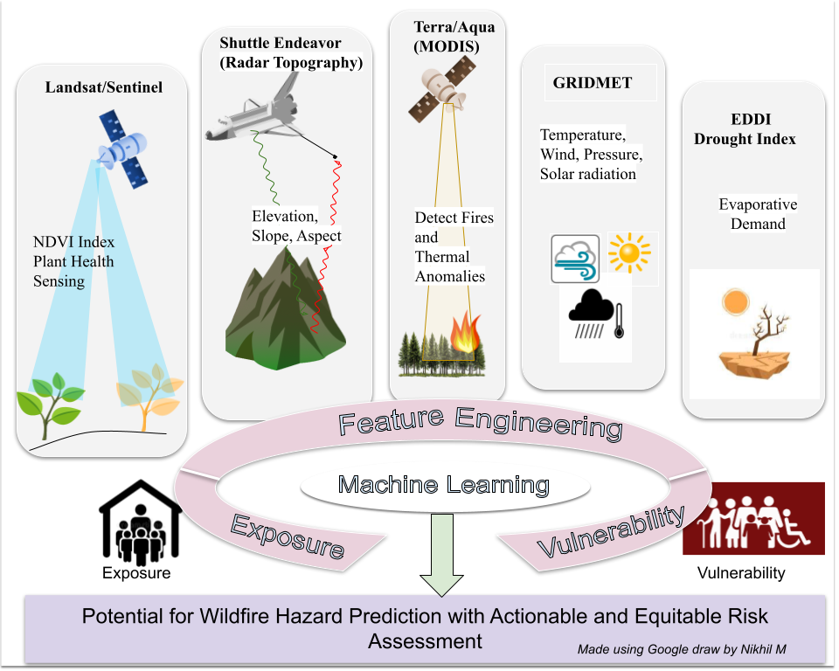
Figure 1. Conceptual system overview: multi-source satellite and climate inputs feed feature engineering and machine learning, which is combined with exposure and vulnerability layers to produce hazard and risk outputs.

3.1 Data Ingestion
- Fire history (labels): MODIS MCD64A1 burned-area product, 2004–2023, used as ground truth.
- Vegetation condition: Sentinel-2 (10 m) and Landsat (30 m) imagery, used to compute NDVI.
- Terrain: SRTM elevation, slope, and aspect.
- Climate: gridMET daily temperature, precipitation, humidity, solar radiation, and wind at ~4.6 km resolution.
- Drought: SPEI (longer-term) and EDDI (short-term evaporative demand).
- Exposure: ACS 5-year tract-level population density.
- Vulnerability: CDC Social Vulnerability Index (income, age, disability, housing, language).

3.2 Feature Engineering
Seasonal composites were built for a spring “antecedent” window (March–May) and the June–August peak fire season, using only pre-season predictors to forecast summer burn risk and avoid data leakage. Terrain, vegetation, climate, and drought layers were stacked, and stratified sampling balanced burned vs. unburned pixels for training while evaluation always used the full, unbalanced distribution. Anomaly normalization, one-year lagged fuel-memory variables, and nonlinear interaction terms expanded the feature space from 22 to 34 predictors (Figure 2).
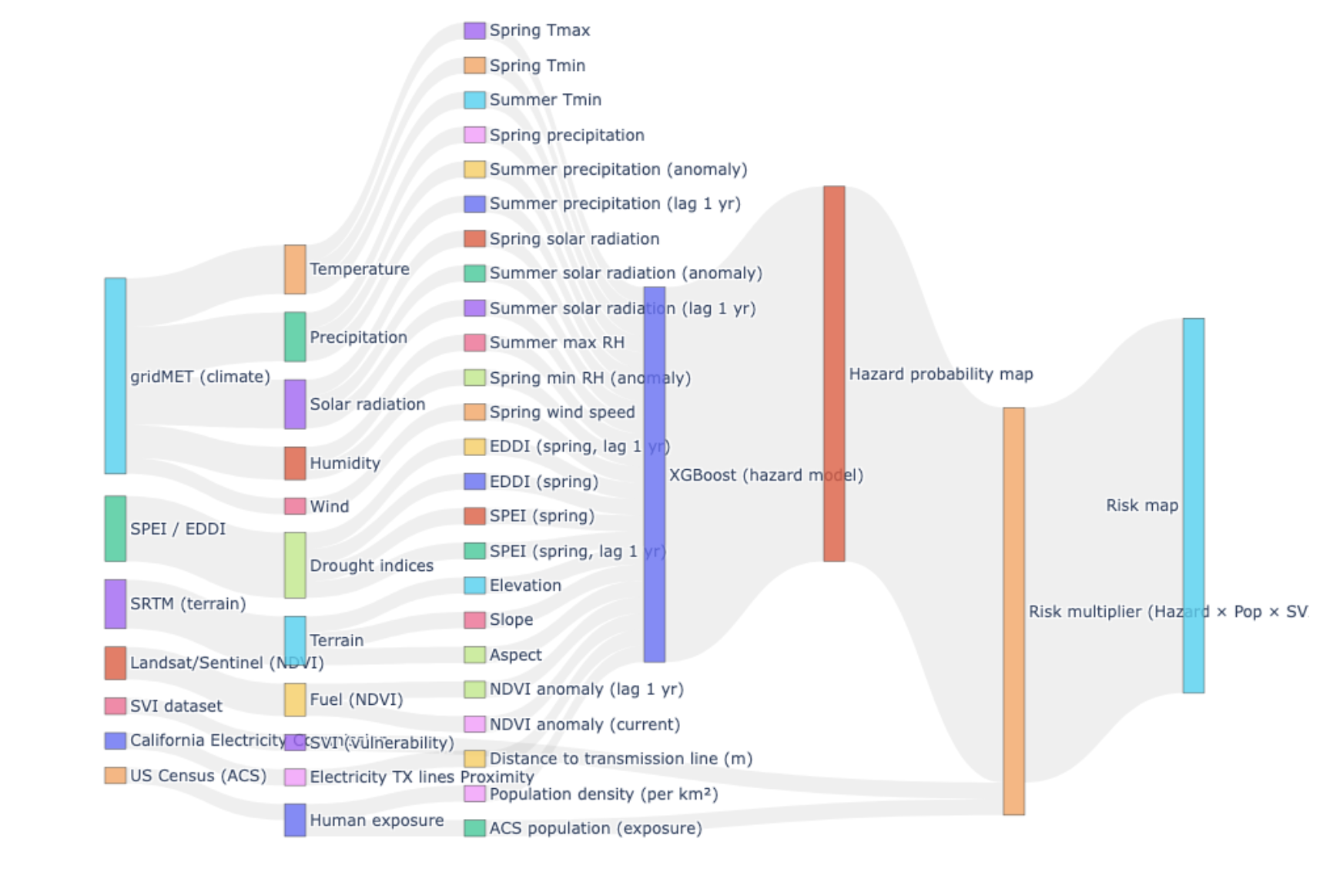
Figure 2. Feature construction flow: raw multi-source layers are transformed into a 34-predictor feature stack feeding the XGBoost hazard model, which is then combined with exposure and vulnerability data to produce hazard and risk maps.

3.3 Model Development
Random Forest, XGBoost, LightGBM, CatBoost, and a stacked ensemble were trained and compared on precision, recall, F1-score, ROC-AUC, PR-AUC, and top-k% concentration. Tree-based ensembles were chosen over deep learning because the data is structured/tabular, and trees handle severe class imbalance and interactions robustly while remaining computationally efficient enough to run within Google Earth Engine and local-machine quotas. XGBoost was selected as the final model based on the best combination of ranking performance and fire concentration under realistic validation.

3.4 Explainability and Deployment
SHAP (SHapley Additive exPlanations) values were computed globally and at the county level to quantify each feature's contribution, and to diagnose true positives, false positives, and false negatives. The trained model produces a hazard probability map for any requested area of interest; hazard is then combined with ACS population density (exposure) and CDC SVI (vulnerability) as Risk = Hazard × Exposure × Vulnerability, and served through an interactive web map with adjustable layer opacity and county-level SHAP drivers (Section 6).

4. Data Sources
Layer | Source | Role
Burned area (labels) | MODIS MCD64A1 (2004–2023) | Ground-truth fire occurrence
Vegetation (NDVI) | Sentinel-2 / Landsat | Fuel health and stress
Terrain | SRTM | Elevation, slope, aspect
Climate | gridMET (~4.6 km) | Temperature, precip, humidity, wind, solar radiation
Drought | SPEI, EDDI | Long- and short-term moisture stress
Exposure | US Census ACS | Tract-level population density
Vulnerability | CDC SVI | Social vulnerability index
Ignition pathway | CA electric transmission lines | Distance-to-infrastructure feature

5. Results

5.1 Class Imbalance and Environmental Signal
Wildfire is extremely rare at the grid-cell level: annual burn prevalence stayed below 1% in most years between 2004 and 2025, spiking above 1.5% only in the most severe seasons (Figure 3). Despite this rarity, burned and unburned pixels show systematic, measurable shifts in NDVI, temperature, and drought indices, with partial separation between classes indicating real environmental signal rather than noise (Figure 4).
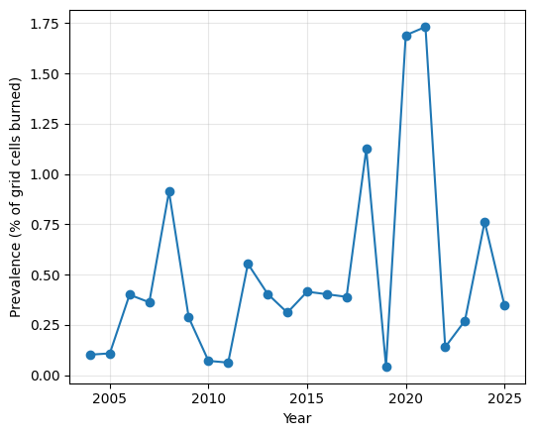
Figure 3. Annual burn prevalence (% of grid cells burned), 2004–2025. Wildfire is rare (<1% typical) and highly variable year to year.
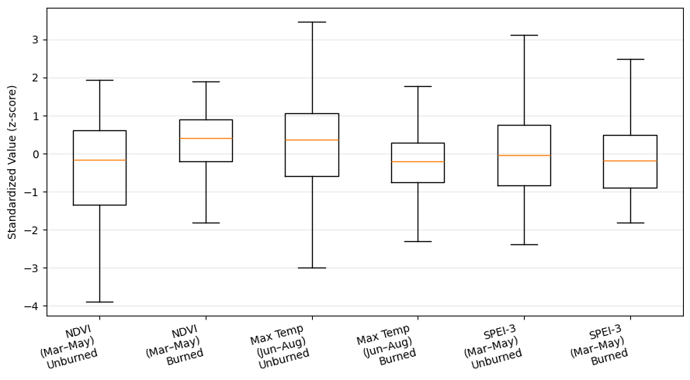
Figure 4. Distributions of key features (NDVI, max temperature, SPEI-3) for burned vs. unburned pixels, showing systematic separation despite overlap.

5.2 Model Comparison
Under an artificially balanced (50% fire) test set, XGBoost slightly outperformed Random Forest, reaching ROC-AUC = 0.967 and PR-AUC (average precision) = 0.965, versus 0.960 and 0.959 for Random Forest (Figures 5–6). On the realistic, unbalanced test set (mean prevalence 0.49%), average precision fell to 0.512, far above the 0.005 random baseline, confirming the model concentrates true fire risk into a small fraction of flagged area even though raw PR-AUC necessarily drops with prevalence (Figure 7).
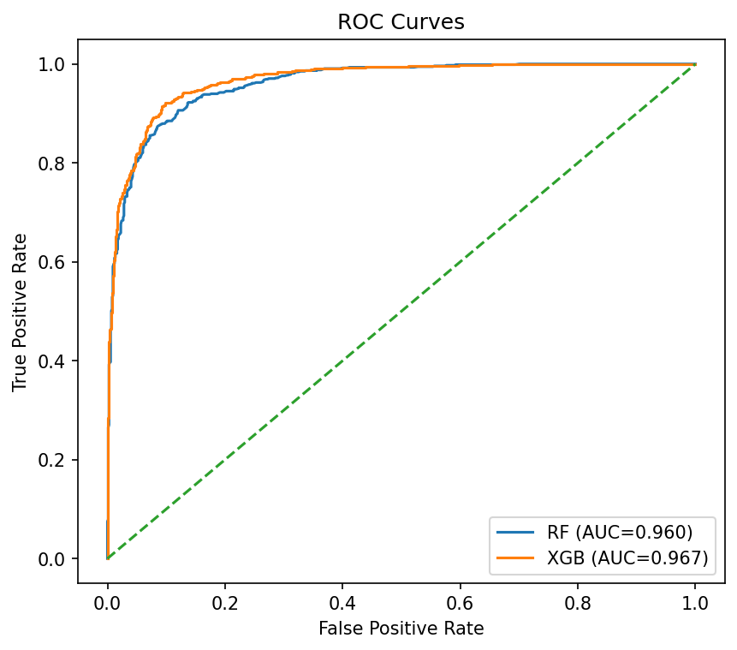  Figure 5. ROC curves (balanced test): XGB AUC=0.967 vs. RF AUC=0.960. | 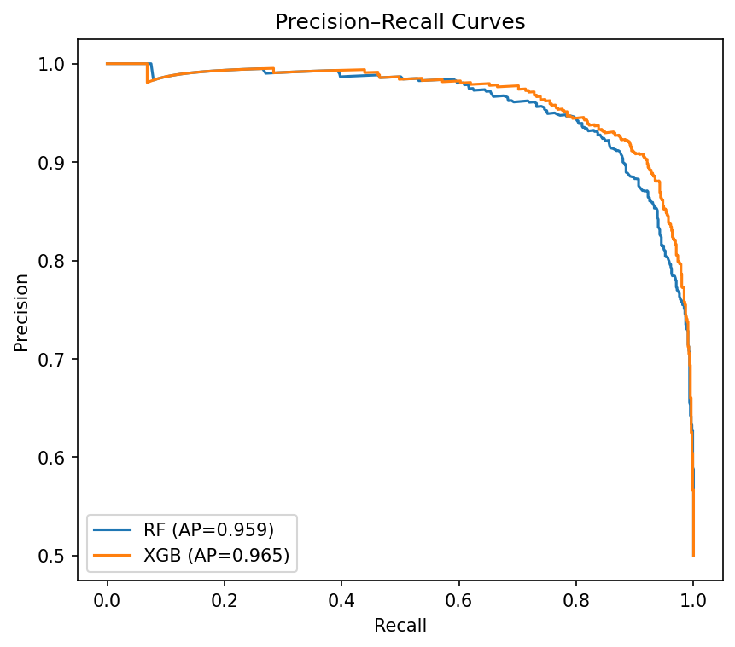  Figure 6. PR curves (balanced test): XGB AP=0.965 vs. RF AP=0.959.
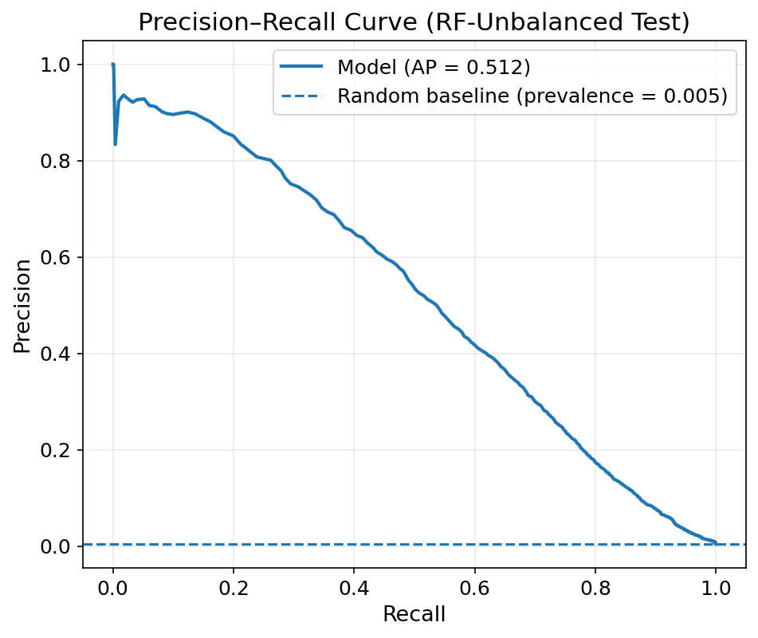
Figure 7. Precision–Recall curve on the realistic, unbalanced test set (Random Forest shown; AP = 0.512 vs. a 0.005 random baseline).

5.3 Concentration of Risk and Spatial Generalization
Because wildfire mitigation resources are limited, the most operationally important metric is how much of the actual fire activity falls inside the highest-risk area flagged by the model. On the unbalanced historical dataset, the top 20% of flagged area captured 95% of fires (Figure 8), though this number is measured on historical, non-held-out data and drops under the stricter validation described next. To test generalization to unseen regions, spatial cross-validation divided California into a 4×4 grid of contiguous blocks (Figure 9) and held out entire blocks per fold, preventing geographic leakage between neighboring pixels.
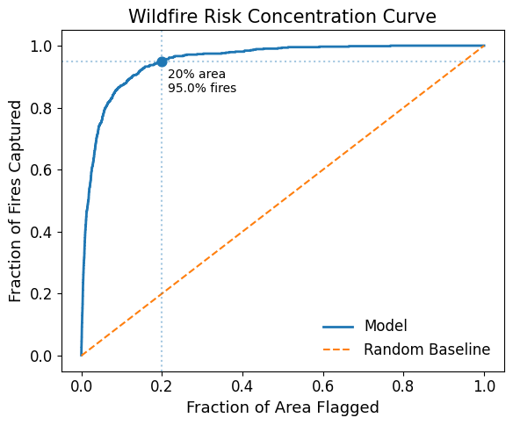  Figure 8. Top-20% flagged area captures 95% of fires (historical, non-held-out data). | 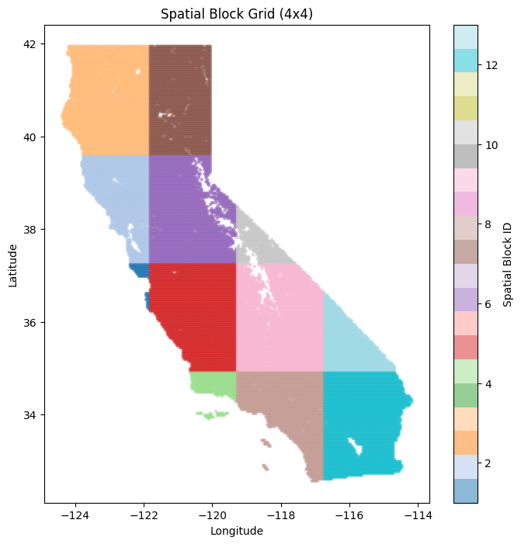  Figure 9. Spatial CV: 4×4 block grid; entire blocks held out per fold.

5.4 Temporal and Spatial Generalization
Temporal cross-validation trained on 2004–2020 and evaluated on the withheld 2022–2025 seasons, simulating real forecasting of future fire seasons.
Across the top-performing model/feature-set combinations, ROC-AUC ranged from 0.747–0.817 under temporal CV and 0.770–0.806 under spatial CV, with top-20% capture ranging 54–67% (Table 1). Random Forest with population density or electric-transmission-line-distance features performed most consistently across both regimes.
Validation | Model | Feature set | ROC-AUC | PR-AUC | Top 10% | Top 20%
Temporal CV | Random Forest | + Pop Density | 0.817 | 0.048 | 48.9% | 66.9%
Temporal CV | Random Forest | + Elec Line Dist | 0.814 | 0.044 | 49.7% | 66.5%
Temporal CV | CatBoost | Raw | 0.811 | 0.045 | 51.6% | 66.9%
Temporal CV | XGBoost | + Pop Density | 0.808 | 0.058 | 49.0% | 65.4%
Spatial CV | Random Forest | + Elec Line Dist | 0.806 | 0.019 | 40.8% | 55.2%
Spatial CV | XGBoost | + Pop Density | 0.787 | 0.012 | 33.9% | 55.7%
Spatial CV | CatBoost | + Lag 1yr | 0.775 | 0.013 | 33.3% | 55.5%

Viewed together, increasing validation strictness lowers headline scores but predictive structure clearly persists: ROC-AUC declines from 0.96 (optimistic) to 0.81 (spatial CV), while top-20% fire capture declines from 96% to 55–67%, still far above the 20% expected under random targeting (Figure 10, Table 2).
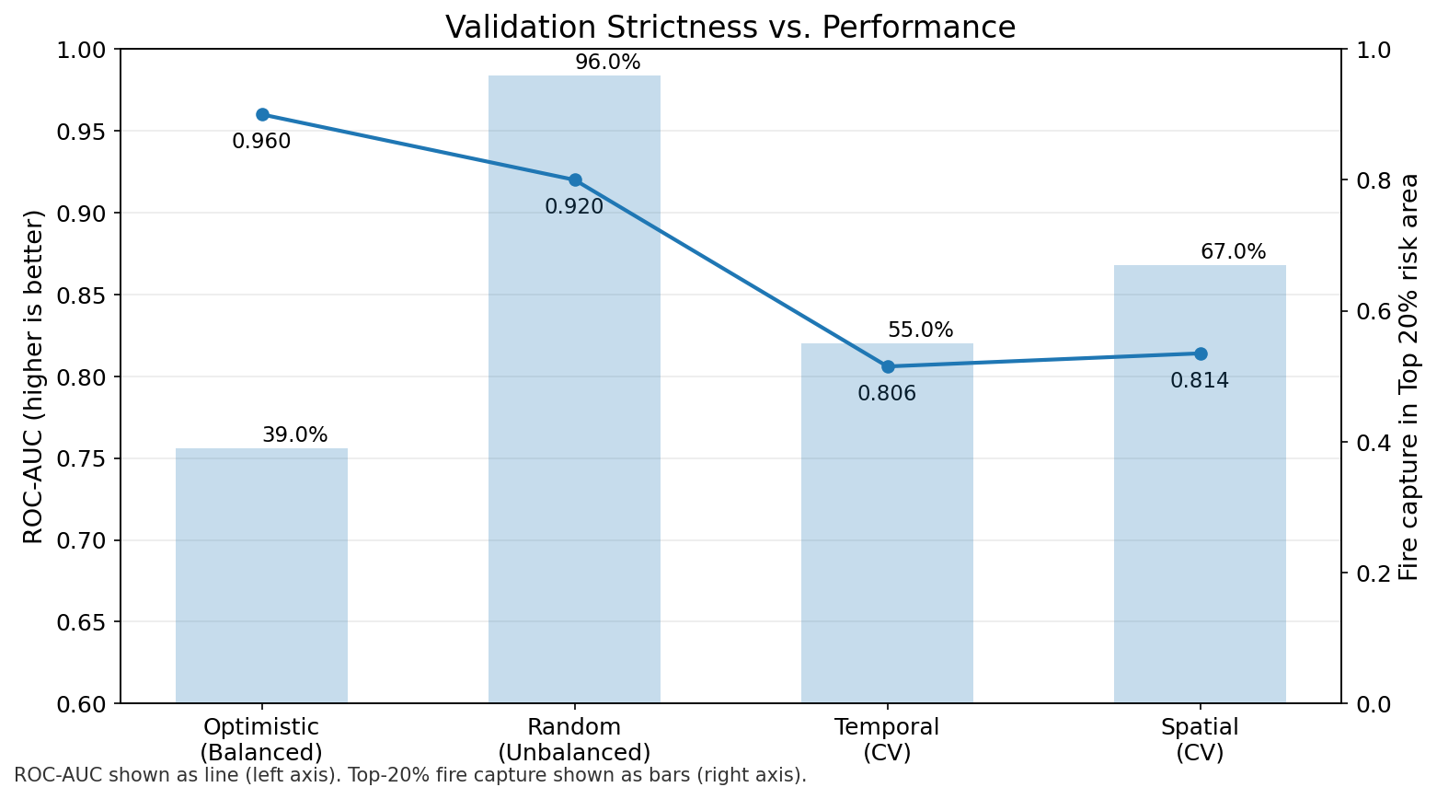
Figure 10. ROC-AUC (line) and top-20% fire capture (bars) across increasingly strict validation regimes.
Metric | Optimistic  (Balanced) | Realistic  (Unbalanced) | Temporal CV | Spatial CV
Test prevalence | 50% | 0.49% (mean) | 0.14–0.77% | 0.1–0.8%
ROC-AUC | 0.96 | 0.92 | 0.806 | 0.814
PR-AUC | 0.96 | 0.51 | 0.019 | 0.044
Top 20% capture | 39%* | 96% | 55.2% | 66.5%
* With 50% test prevalence, top-20% capture is mathematically capped near 40%; the observed value approaches this ceiling and is not directly comparable to the other columns.

5.5 Explainability (SHAP)
Global SHAP analysis shows burn probability is driven primarily by summer humidity/atmospheric dryness, lagged NDVI anomaly (prior-year vegetation stress), spring solar radiation, and persistent drought indices, with proximity to electrical infrastructure contributing an ignition-pathway signal (Figure 11). Low summer humidity directly reduces fuel moisture and raises ignition and spread potential, while lagged NDVI captures fuel conditions carried over from the prior year, both consistent with established wildfire science, supporting the model's interpretability design criterion.
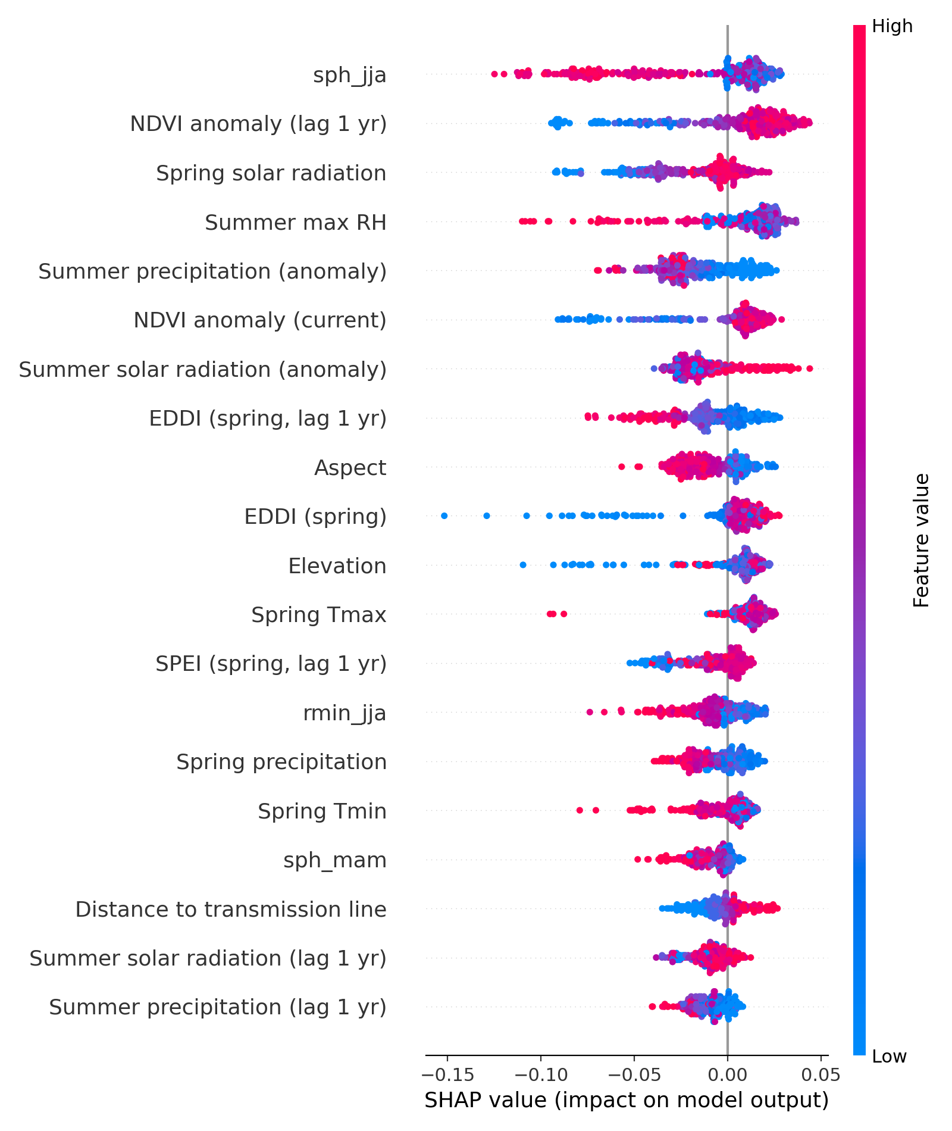
Figure 11. Global SHAP summary for the burn class: features ranked by mean absolute SHAP value, colored by feature value (red = high, blue = low).

6. Deployment and Discussion
The trained model is served through an interactive web application that overlays hazard probability, exposure, vulnerability, and combined risk layers on a satellite or street basemap, with adjustable opacity and county-level SHAP drivers for planners (Figure 12). This closes the loop from raw geospatial data to an actionable, explainable decision-support tool.
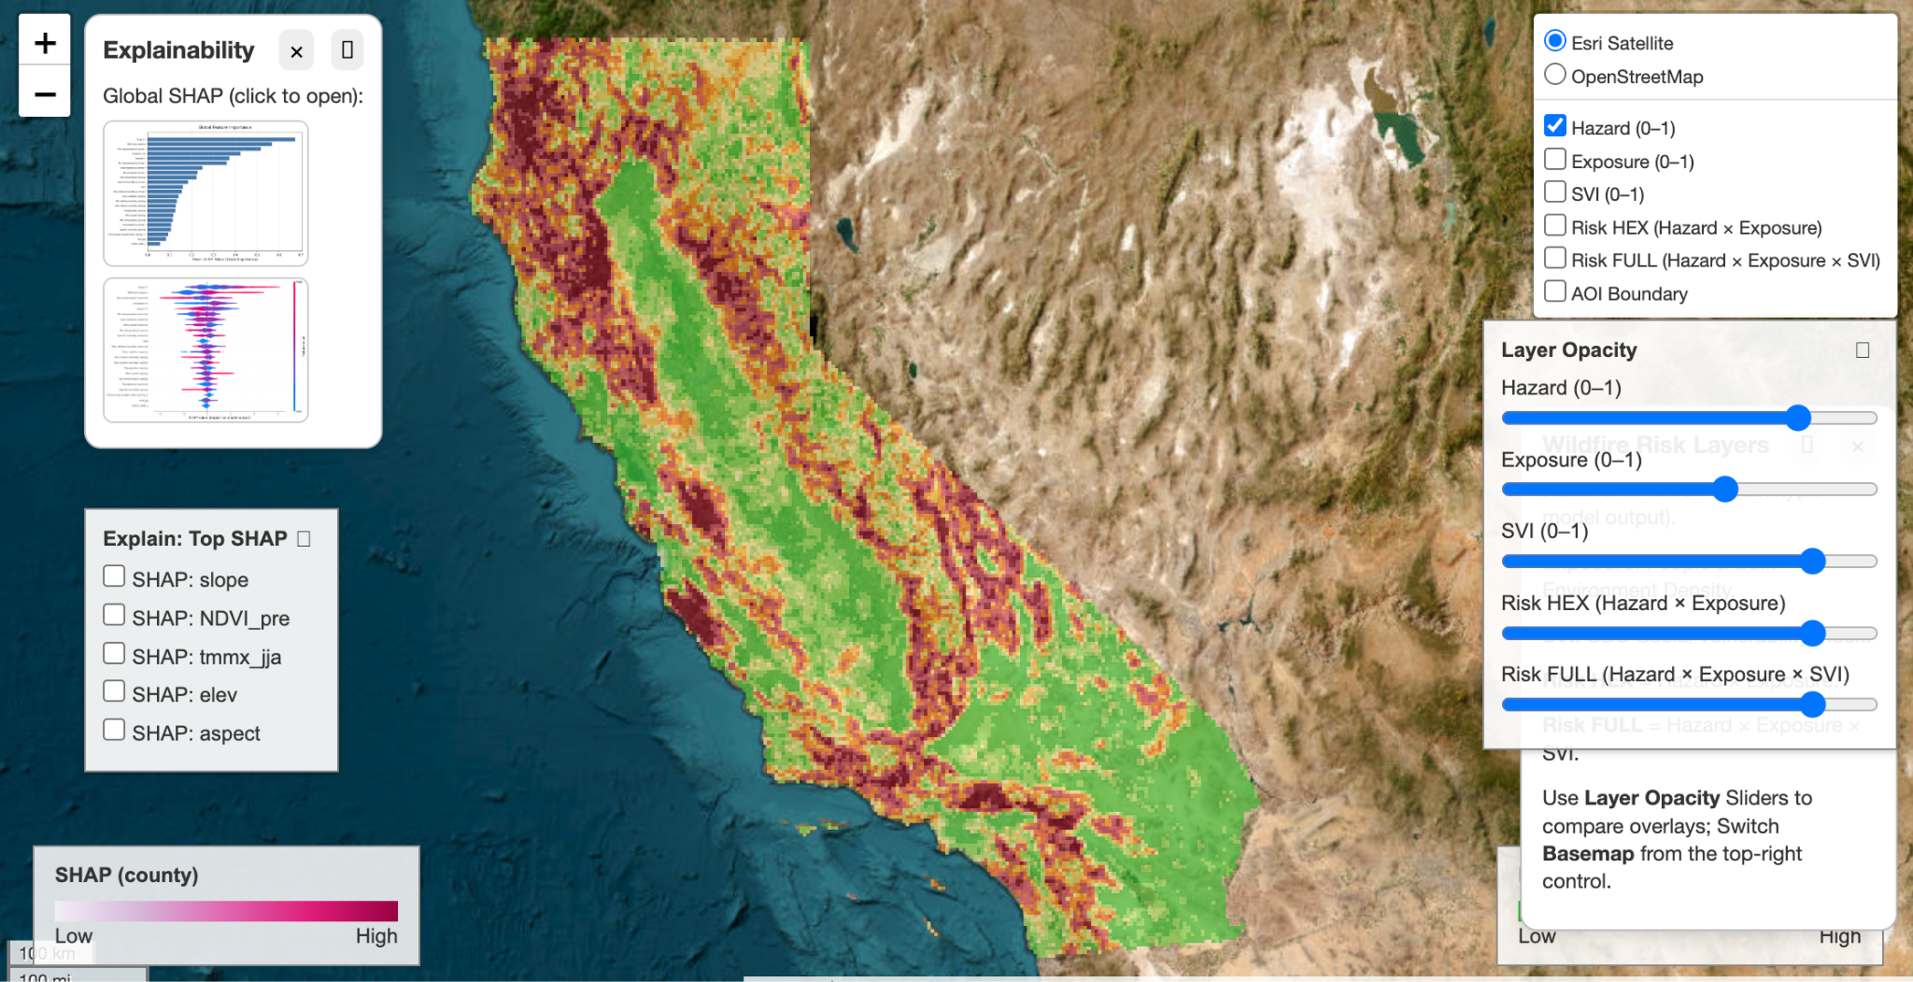
Figure 12. ClariFIRE web application: statewide hazard layer over California with SHAP explainability panels and adjustable risk-layer controls.
Taken together, the results show that wildfire hazard is rare but spatially structured, not random. Under strict temporal and spatial holdout, the conditions that best simulate real deployment, predictive structure persists (ROC-AUC ≈ 0.81, top-20% capture 55–67%), even though headline scores are far lower than under optimistic, balanced testing. Feature engineering including drought anomalies, lagged fuel memory, and climate interaction terms materially improved fire concentration under these stricter conditions, and SHAP confirms the model relies on physically meaningful drivers (humidity, vegetation stress, drought, solar radiation) rather than spurious correlations. Because operational wildfire mitigation is resource-constrained, the top-20%-capture metric is arguably more actionable than ROC-AUC alone: it directly answers how much fire risk can be addressed if only a fifth of the landscape can be prioritized for treatment or monitoring.
Limitations follow directly from the project's constraints: statewide analysis is capped at ~4.6 km gridMET resolution, fire labels are bounded by MODIS availability (2004–2023), and the pilot is scoped to California, so transfer to other vegetation types, fire regimes, and data environments would require re-validation.

7. Conclusion
ClariFIRE integrates terrain, vegetation, climate, and drought indicators into a probabilistic, statewide wildfire hazard model, and connects that hazard signal to community vulnerability through population exposure and the CDC Social Vulnerability Index. Under realistic, leakage-free temporal and spatial validation, the model sustains meaningful predictive structure (ROC-AUC 0.77–0.81; top-20% fire capture 51–66%), and SHAP explainability confirms that predictions are driven by physically grounded environmental factors. By coupling interpretability with dynamic climate adaptation and an accessible web interface, ClariFIRE supports transparent, data-driven, and equitable wildfire preparedness for the communities most at risk.

References
Abatzoglou, John T. “Development of Gridded Surface Meteorological Data for Ecological Applications and Modelling.” International Journal of Climatology, vol. 33, no. 1, 2013, pp. 121–31. Wiley, https://doi.org/10.1002/joc.3413.
Abatzoglou, John T., and A. Park Williams. “Impact of Anthropogenic Climate Change on Wildfire across Western US Forests.” Proceedings of the National Academy of Sciences, vol. 113, no. 42, 2016, pp. 11770–75. https://doi.org/10.1073/pnas.1607171113.
Boschetti, Luigi, et al. “Global Validation of the Collection 6 MODIS Burned Area Product.” Remote Sensing of Environment, vol. 235, 2019, Article 111490.
Farr, Thomas G., et al. “The Shuttle Radar Topography Mission.” Reviews of Geophysics, vol. 45, 2007, RG2004. https://doi.org/10.1029/2005RG000183.
Flanagan, Barry E., et al. “A Social Vulnerability Index for Disaster Management.” Journal of Homeland Security and Emergency Management, vol. 8, no. 1, 2011, Article 3. https://doi.org/10.2202/1547-7355.1792.
Giglio, Louis, et al. “The Collection 6 MODIS Burned Area Mapping Algorithm and Product.” Remote Sensing of Environment, vol. 217, 2018, pp. 72–85. https://doi.org/10.1016/j.rse.2018.08.005.
Hobbins, Michael T., et al. “The Evaporative Demand Drought Index. Part I.” Journal of Hydrometeorology, vol. 17, no. 6, 2016, pp. 1745–61. https://doi.org/10.1175/JHM-D-15-0121.1.
Jain, Piyush, et al. “A Review of Machine Learning Applications in Wildfire Science and Management.” Environmental Reviews, vol. 28, no. 4, 2020, pp. 478–505. https://doi.org/10.1139/er-2020-0019.
Jolly, W. Matt, et al. “Climate-Induced Variations in Global Wildfire Danger from 1979 to 2013.” Nature Communications, vol. 6, 2015, Article 7537. https://doi.org/10.1038/ncomms8537.
Kalogirou, Stavros, et al. “Wildfire Susceptibility Mapping Using Five Boosting Machine Learning Algorithms.” Advances in Civil Engineering, 2022. https://doi.org/10.1155/2022/3959150.
Khan, Muhammad Asim, et al. “Wildfire Assessment Using Machine Learning Algorithms in Different Regions.” Fire Ecology, vol. 20, 2024. https://doi.org/10.1186/s42408-024-00335-2.
Manson, Steven, et al. “IPUMS National Historical Geographic Information System: Version 16.0 [Database].” University of Minnesota, 2021. https://doi.org/10.18128/D050.V16.0.
McEvoy, Daniel J., et al. “The Evaporative Demand Drought Index. Part II.” Journal of Hydrometeorology, vol. 17, no. 6, 2016, pp. 1763–79. https://doi.org/10.1175/JHM-D-15-0122.1.
Tucker, Compton J. “Red and Photographic Infrared Linear Combinations for Monitoring Vegetation.” Remote Sensing of Environment, vol. 8, no. 2, 1979, pp. 127–50. https://doi.org/10.1016/0034-4257(79)90013-0.
Vicente-Serrano, Sergio M., et al. “A Multiscalar Drought Index Sensitive to Global Warming: SPEI.” Journal of Climate, vol. 23, no. 7, 2010, pp. 1696–718. https://doi.org/10.1175/2009JCLI2909.1.

