Improving Contrail Prediction and Avoidance Using Satellite Observations to Mitigate Climate Impact
Nikhil Muthukumar
Synopsys Silicon Valley Science and Technology Championship - 2025
Project Number: G11

Abstract
Avoiding the formation of condensation trails (contrails) through targeted flight rerouting is a promising way to mitigate aviation's largest non-CO₂ warming effect. Accurate avoidance is difficult because the Contrail Cirrus Prediction model (CoCiP) relies on Relative Humidity with respect to Ice (RHi) from reanalysis and forecasts. These forecasts can miss small-scale, short-lived features, motivating the integration of additional observational data. We hypothesized that integrating Low Earth Orbit (LEO) and Geostationary (GEO) satellite observations with in situ RHi from In-service Aircraft for Global Observation (IAGOS) flights, and using these measurements to calibrate CoCiP inputs, would enhance per-flight mitigation. We analyzed 2,580 IAGOS flights to identify cases with LEO+GEO coverage, then validated CoCiP forecasts against observed contrails along the same trajectories. Where predictions disagreed with observations, we used along-track IAGOS RHi to bias-correct model inputs (RHi scaling). In a curated set of 25 flights, baseline CoCiP achieved an F1 score of 75%. After RHi scaling, the F1 score increased to 85%, indicating fewer false negatives and improved detection. We conducted an operational case study of 200 CONUS nighttime flights over 12 hours. This study revealed that baseline CoCiP underestimated total contrail energy forcing (EF) by 34%. Applying altitude adjustments of 1,000≈1,500 m to avoid ice-supersaturated regions (ISSRs) suggested that rerouting ≈10% of flights reduced total contrail EF by 40-45%. Overall, these results indicate that bias-aware humidity inputs materially improve contrail detection, and selective, small-scale rerouting can deliver large EF reductions with limited operational impact.

Keywords
Contrails, contrail cirrus, ice supersaturation (RHi), CoCiP, ERA5 reanalysis, IAGOS, satellite remote sensing, GOES-16, Sentinel-2, bias correction, aviation climate impact, energy forcing

Introduction
Contrails, which are significant contributors to aviation's climate impact, are narrow ice clouds formed by jet exhaust interacting with cold, moist air near the tropopause. Understanding their formation and impact is crucial for addressing aviation-related climate change. Water vapor condenses on soot and other aerosol nuclei and freezes within seconds (1). When the surrounding air is ice-supersaturated (RHi > 1), these linear trails can persist and spread, sometimes evolving into broader contrail-cirrus that are difficult to distinguish from natural cirrus (2). High-altitude ice clouds, including contrail-cirrus, play a significant role in climate dynamics by absorbing more outgoing longwave radiation than they reflect incoming shortwave sunlight, resulting in a net positive radiative forcing (RF). This effect depends on ice-crystal microphysics and optical depth and is quantified as contrail energy forcing (EF) and provides the cumulative contrail climate forcing over its lifetime (3).
The formation and persistence of contrails are key contributors to aviation's overall climate impact, as their radiative forcing effects, particularly from contrail-cirrus, can exceed the radiative forcing from aviation CO₂ over several years (4). This significant impact has prompted specific mitigation strategies. Notably, warming is concentrated in a small subset of flights and conditions; analyses show that diverting only ≈2.2% of flights could reduce ≈80% of contrail EF at a limited operational cost (5). To effectively mitigate the climate impact of contrails, accurate prediction of both their formation and persistence is essential.
Contrail formation is commonly evaluated with the Schmidt-Appleman Criterion (SAC), a thermodynamic mixing test that specifies a critical ambient temperature T_{crit} and associated humidity threshold RH_{crit}. When exhaust mixes with ambient air below T_{crit}, droplets condense on soot/aerosol nuclei and rapidly freeze to ice crystals; above T_{crit}, contrails generally do not form, even if the air is ice saturated (1, 6). T_{crit} depends on pressure, engine/aircraft parameters, and fuel properties; however, SAC itself does not help distinguish short-lived contrails from persistent contrails (6). Persistence requires ambient ice supersaturation (RHi ≥ 100%), i.e., flight within an ice-supersaturated region (ISSR), and frequently occurs in the upper troposphere, but strong small-scale variability complicates prediction and verification (7, 8). Under favorable conditions, initially line-shaped contrails can spread via shear and entrainment and transition into larger cloud systems (contrail cirrus) (9).
The CoCiP modeling tool is designed to predict contrail formation and track their lifecycle and EF contribution on a per-flight basis, offering insights for effective mitigation strategies (10). It provides critical insights for developing aviation strategies like contrail avoidance and emissions reduction. CoCiP has been proposed for use in contrail avoidance strategies, which involve rerouting flights to avoid regions predicted to form contrails, thereby reducing the environmental impact of aviation (11). While CoCiP aids in contrail avoidance strategies, flight planners must balance contrail EF reductions with the potential increase in CO₂ emissions from rerouting, as inaccuracies can lead to a net EF increase. CoCiP simulates the contrail lifecycle along aircraft trajectories using meteorological inputs, but its accuracy is affected by biases and the coarse resolution of humidity data in reanalysis and forecast fields (7). Recent work indicates that applying multivariate quantile-mapping corrections to ERA5 temperature and humidity data can significantly alter contrail classifications (12). This highlights the importance of validation and bias-aware inputs for improving CoCiP's accuracy.
Satellite observations provide complementary constraints on contrail occurrence and evolution. Geo Stationary Satellite GOES-16's Advanced Baseline Imager (ABI) offers high temporal resolution of 10 minutes at kilometer-scale resolution, enabling tracking of growth and dissipation of contrails (13). In contrast, sensors on low-Earth-orbit satellites, such as Sentinel-2's Multi-Spectral Instrument (10-20 m) and Landsat-8's Operational Land Imager (15-30 m), offer much finer spatial detail but lower revisit rates, making them well suited for detecting young, narrow contrails (14, 15). The IAGOS fleet provides in situ measurements of along-track temperature and water vapor in the upper troposphere, which have been used to address specific biases in ERA5 humidity data (16).
Building on these challenges and tools, we hypothesized that integrating IAGOS in situ RHi measurements with co-registered satellite observations would improve understanding of contrail dynamics by enabling the first per-flight, lifecycle validation. The study combined high-spatial-resolution LEO imagery with high-temporal-resolution GEO imagery to observe the contrails produced by the same flights. We ran CoCiP with ERA5 meteorology to predict each flight's contrail evolution and benchmarked those predictions against the LEO+GEO-observed lifecycle, using IAGOS RHi as ground truth to diagnose ERA5 input biases and to test bias-correction strategies such as RHi scaling (Figure 1).
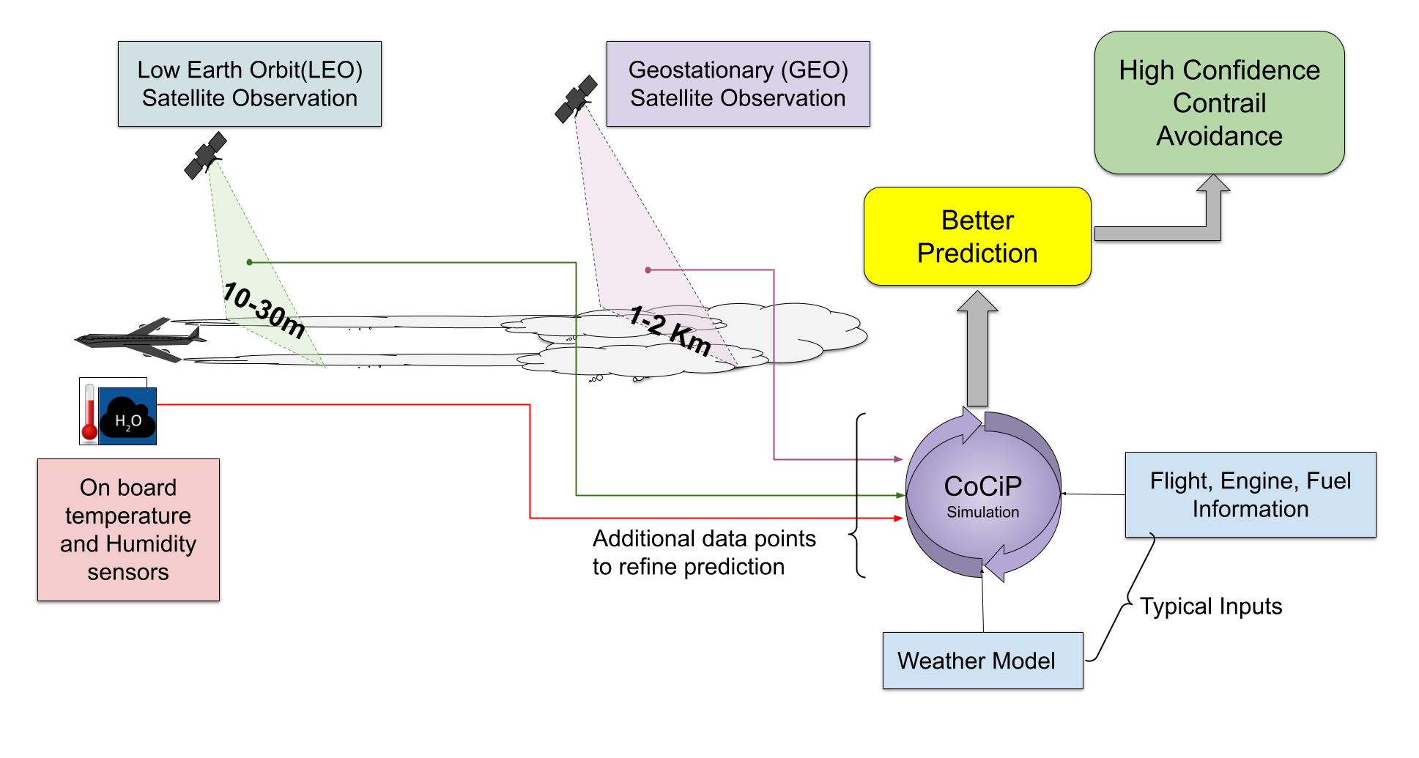
Figure 1. Hypothesis diagram. Data fusion (IAGOS, LEO, GEO) validates CoCiP lifecycle predictions. Along-track IAGOS in situ RHi measurements are integrated with low-Earth-orbit (LEO) and geostationary (GEO) satellite observations to calibrate CoCiP inputs and validate per-flight contrail life cycles, enabling higher-confidence contrail-avoidance strategies.

Methods
Flight selection and preprocessing
IAGOS flight track and sensor data were downloaded as netCDF files and filtered for valid along-track measurements of relative humidity with respect to ice (RHi) (Figure 3a) and temperature, with latitude-longitude bounds corresponding to flights to and from the continental United States (CONUS) within the GOES-16 field of view (17,18). The retained flights were cleaned in Python and converted into PyContrails-compatible trajectory formats using pandas, following the data models required by the PyContrails library (19) (Figure 2). Where applicable, ADS-B trajectories from the OpenSky Network were queried to assist with trajectory reconstruction for the operational case study (20).
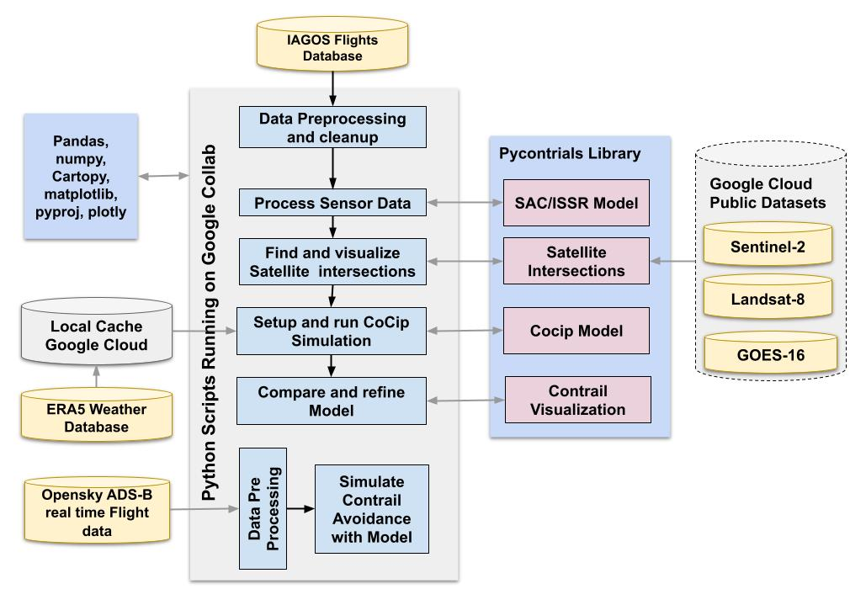
Figure 2. Data sources and processing pipeline. Flowchart of the data inputs and processing workflow. IAGOS flight tracks and in-situ RHi/temperature were downloaded as netCDF, cleaned in Python, and converted to PyContrails trajectories. LEO intersections were computed in PyContrails using Google BigQuery metadata for Sentinel-2 and Landsat-8/9. Geodetics and mapping used pyproj and cartopy. ERA5 pressure-level fields were retrieved via the Copernicus CDS API into PyContrails to drive single-flight CoCiP simulations (formation, evolution, EF). Model outputs (presence, length/width proxies, persistence, EF) were time-aligned with GOES-16 GEO imagery within the PyContrails framework. OpenSky ADS-B flight data was queried for the contrail-mitigation case study.
Satellite intersection logic and LEO contrail detection
Within PyContrails, we computed intersections between flight waypoints and low-Earth-orbit (LEO) satellite scenes using Google BigQuery tables containing Landsat-8/9 Operational Land Imager (OLI) and Sentinel-2 Multi Spectral Instrument (MSI) metadata (Figure 2). An "intersection" was defined as a satellite scene whose sensing time was bracketed by at least one flight waypoint before and one after the scene timestamp, and whose footprint spatially contained the great-circle segment between those waypoints (19, 21, 22) (Figure 3b). Because LEO revisit rates were low (days), we analyzed 2,580 IAGOS flights spanning ≈2017-2022 to increase the probability of path-scene overlaps. For scenes meeting the intersection criteria, we downloaded the corresponding LEO images and performed visual detection of young contrails in reflective cirrus bands: Landsat band 9 and Sentinel-2 band B10, which enhanced the contrast of linear ice features at high altitude (21, 22) (Figure 3c). Geodetic transformations and map projections were handled with the pyproj library, and visualization used cartopy library together with PyContrails' Landsat and Sentinel utilities to place contrails accurately over basemaps and to facilitate later comparison with GOES-16 imagery (Figure 2).
GEO imagery acquisition and lifecycle tracking
For each candidate flight with LEO evidence of a nascent contrail, we acquired overlapping GOES-16 Advanced Baseline Imager (ABI) scenes at 10-minute cadence to track contrail evolution, spreading, and dissipation over time (Figure 3d-e). We used the ABI "ash" RGB composite (bands 11, 14, 15), which has been applied in prior contrail-detection work, to enhance linear ice features against surrounding cloud fields and surface backgrounds (18). LEO and GEO image sequences were co-registered to the flight timeline to establish a per-trajectory observation record (Figure 3f-h). Because the intersection methodology yielded many frames that were not expected to contain contrails (true negatives), we manually curated the sequences to remove noisy or unreliable scenes (e.g., cloud obstruction, illumination artifacts) and to prune obvious true negatives (e.g., along-track RHi < 50%), yielding a de-noised, more balanced set of flights for model evaluation.
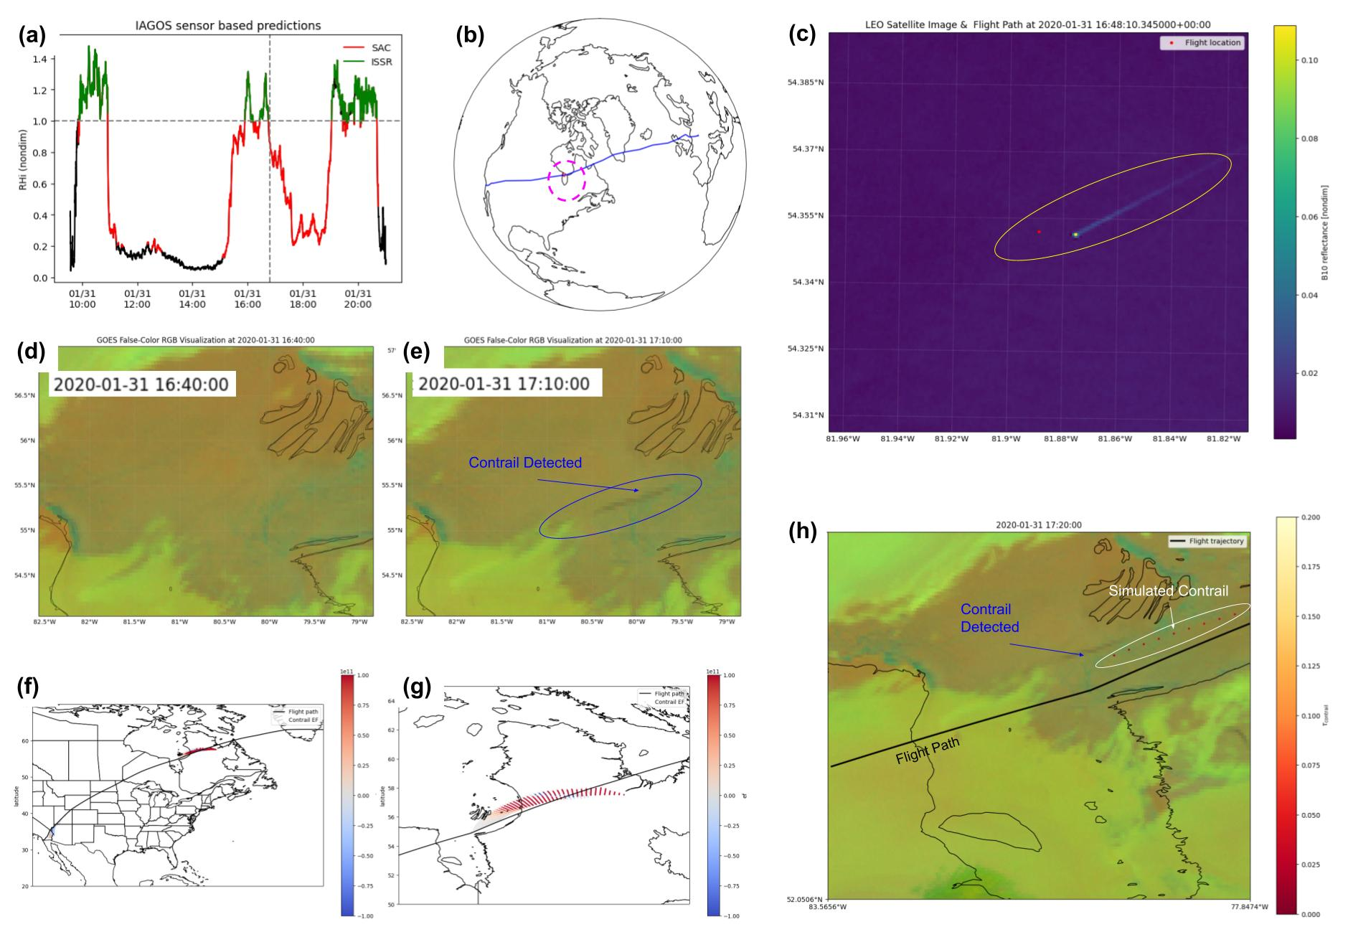
Figure 3. Methods visual flow. End-to-end workflow from along-track humidity to satellite intersection, detection, and CoCiP validation. (a) In-track IAGOS RHi along the flight, indicating segments satisfying SAC and ISSR criteria. (b) Global projection showing the flight path intersecting a LEO swath. (c) LEO image at the intersection, with the young contrail highlighted in yellow. (d-e) Corresponding GEO (GOES-16) image at the intersection time (contrail too small to resolve) and 30 min later when the contrail becomes visible at GEO resolution. (f-g) CoCiP-simulated contrail overlaid on a map; red denotes warming EF. (h) CoCiP simulation overlaid on the GEO image and flight track, used to compare observed contrails (blue tones) with simulated contrails (white highlight).
Meteorological inputs and CoCiP configuration
We drove CoCiP with ERA5 reanalysis, downloading the required pressure-level variables via the Copernicus Climate Data Store API through PyContrails interfaces (23). ERA5 provided 37 pressure levels from 1000 to 1 hPa; levels near typical cruise altitudes (≈200 hPa at 10-12 km) were included to represent upper-tropospheric thermodynamics relevant for contrail formation and persistence (23). For each selected trajectory, we ran single-flight CoCiP simulations to predict contrail formation, evolution, and associated energy forcing (EF). Model outputs (e.g., predicted contrail presence, length/width proxies, and persistence) were time-aligned with GEO imagery and compared qualitatively and quantitatively against the LEO+GEO observation record.
Humidity bias adjustment (RHi scaling) and validation protocol
To examine sensitivity to humidity biases, we compared ERA5 along-track RHi to IAGOS in situ RHi and applied two adjustments to the CoCiP inputs: a constant multiplicative scaling (Eq 6) and an exponential "boost" derived from empirical multivariate bias fitting to the IAGOS measurements (Eq 7). The exponential boost represented a bias-aware correction calibrated on the joint distribution of observed and modeled humidity rather than a heuristic factor. For validation, each flight timeline was discretized into spatiotemporal windows and labeled by coincidence with observed persistent contrails in the co-registered imagery. We computed accuracy, precision, recall, and F1 score from the resulting confusion matrix and compared baseline versus bias-adjusted runs to assess detection skill.
Operational case study
To evaluate potential operational benefit, we simulated 200 commercial flights over CONUS during a 12-hour nighttime period using both baseline and RHi-adjusted CoCiP. For each flight, we estimated total EF and identified segments predicted to form persistent contrails under prevailing conditions. We then applied altitude adjustments of approximately 1,000-1,500m to avoid ice-supersaturated regions (ISSRs) where feasible and recomputed EF to estimate achievable reductions and the fraction of flights requiring reroutes. This case study illustrated how bias-aware inputs could influence per-flight mitigation decisions under conditions conducive to warming contrails (Figure 4).
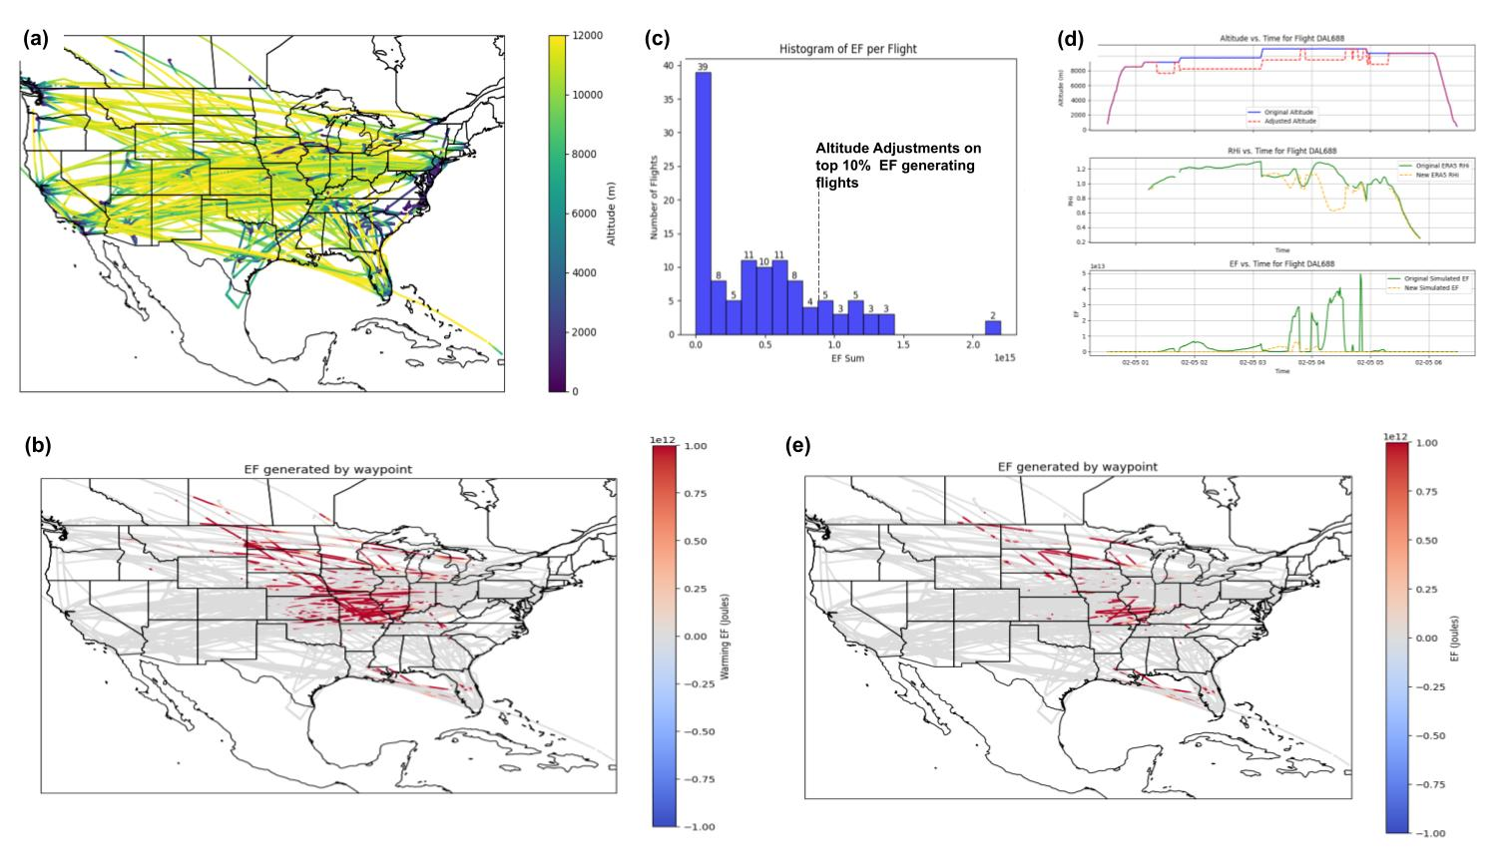
Figure 4. Navigational contrail mitigation case study. Results from a 200-flight contrail-mitigation rerouting case over a 12-h nighttime period in the USA. (a) Trajectories and altitudes of the 200 flights. (b) CoCiP-simulated heat map of contrail energy forcing (EF) per flight using ERA5 RHi with exponential boosting; red denotes warming. (c) Histogram of EF across flights; altitude adjustments are applied to the top 10% of flights by EF. (d) Example flight showing applied altitude changes, the resulting RHi at the new altitude, and the reduction in EF. (e) Post-mitigation CoCiP heat map demonstrating reduced warming EF for the top 10% EF flights.

Results
CoCiP validation against satellite observations
To assess the accuracy and identify potential input biases of the Contrail Cirrus Prediction (CoCiP) model, we integrated satellite observations with in-track ground-truth data, aiming to enhance the model's reliability in predicting contrail formation. We focused on IAGOS flights with reliable in-situ relative humidity (RHi) and temperature data. To address the challenge of detecting nascent, narrow contrails, we required precise alignment of IAGOS flight paths with low-Earth-orbit (LEO) swaths from satellite missions such as Sentinel-2 and Landsat, despite their low revisit rates. Of 2,580 IAGOS flights (2017-2022), 345 exhibited spatiotemporal overlap with LEO imagery, and 205 had corresponding GEO coverage (Figure 5b). Our sampling strategy involved broad spatiotemporal intersections along flight paths with GOES-16 sequences, which led to a predominance of true negatives in the dataset. To de-noise the dataset and mitigate this inherent class imbalance, we quality-controlled GOES-16 image sequences and along-track RHi, removed unreliable scenes (e.g., cloud obstruction, glare, interference), and pruned obvious true negatives (RHi < 50%). From the dataset, we selected 25 flights that exhibited clear contrail visibility and robust in situ data (Figure 5a). These flights were crucial for a detailed evaluation of the CoCiP model, validation against satellite observations, and testing for bias correction, such as RHi scaling.
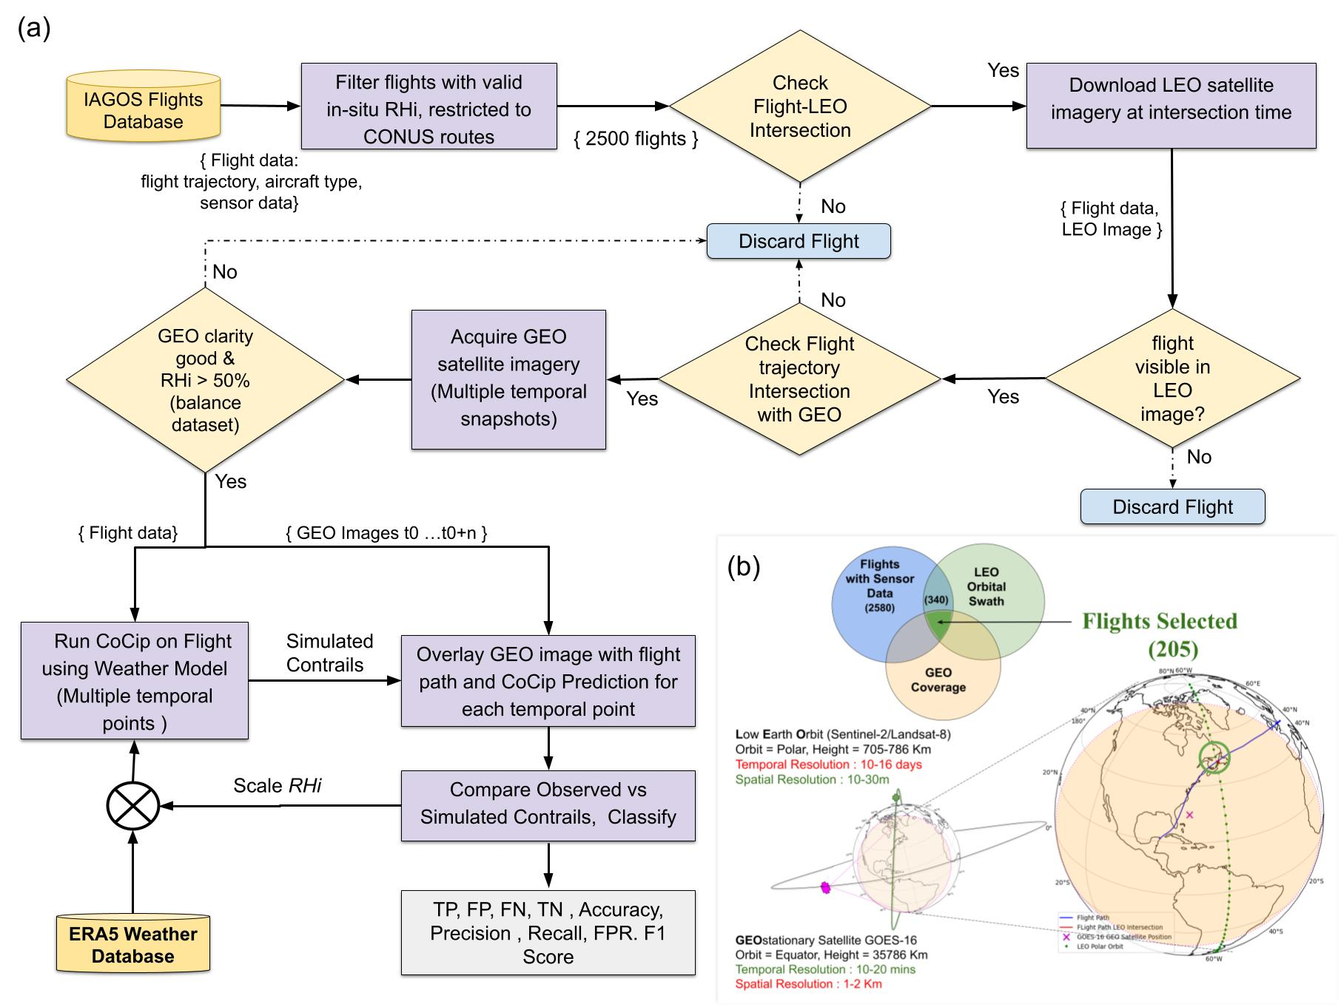
Figure 5. Methods workflow and selection constraints. Flowchart showing the project methodology and Venn diagram showing flight selection criteria. (a) IAGOS tracks (RHi/temperature) were filtered within the GOES-16 CONUS view; 2,580 flights were screened for LEO (Sentinel-2/Landsat) intersections, young contrails were visually identified, and overlapping GOES-16 ABI (10-min) traced evolution. Sequences were manually curated (noise removed; obvious true negatives pruned, RHi < 50%). CoCiP (ERA5-driven) was run per trajectory; outputs were time-aligned with LEO+GEO observations, RHi was bias-corrected against IAGOS (constant and exponential scaling), and performance was evaluated via accuracy, precision, recall, and F1. (b) Venn diagram illustrating how candidate flights were selected only when three conditions overlapped: (i) IAGOS waypoints with valid in situ RHi/temperature, (ii) LEO swath coincidence near the waypoint time (low temporal revisit; Sentinel-2/Landsat), and (iii) GEO (GOES-16) coverage within the CONUS field of view (coarser spatial resolution).
For each of the 25 selected flights, we ran ERA5-driven, single-trajectory CoCiP simulations at 30-min intervals from the initial LEO intersection (t₀) through t₀ + 4 h. The CoCiP prediction at t₀ was first compared to the LEO detection (Figure 5a). Subsequent predictions were then benchmarked against co-registered GOES-16 observations sampled on the same cadence. For evaluation, each flight path was divided into spatiotemporal windows and labeled by coincidence with observed contrails, yielding a confusion matrix with true positives (TP), false positives (FP), false negatives (FN), and true negatives (TN). We evaluated model performance using standard classification metrics. Accuracy denotes the proportion of windows assigned the correct label (Eq 1). Precision quantifies the fraction of model-identified contrail windows that were truly contrails, reflecting susceptibility to false alarms (Eq 2). Recall quantifies the fraction of contrail windows present in the data that the model correctly identified, reflecting susceptibility to missed detections (Eq 3). The false-positive rate (FPR) indicates the proportion of non-contrail windows that were incorrectly flagged as contrails (Eq 4). Finally, the F1 score summarizes performance by balancing precision and recall in a single measure, providing a concise indicator of detection quality under class imbalance (Eq 5).
Accuracy = (TP + TN) / (TP + TN + FP + FN) (Equation 1)
Precision = TP / (TP + FP) (Equation 2)
Recall = TP / (TP + FN) (Equation 3)
FPR = FP / (FP + TN) (Equation 4)
F1 = (2 × Precision × Recall) / (Precision + Recall) (Equation 5)
In the initial assessment, CoCiP's baseline performance achieved 76% accuracy, 75% precision, 75% recall, 23% FPR, and 75% F1 (Figure 6a).
Constant Scaling:
RHi_ConstScaling = RHi_ERA5 / RHi_Adjust, where RHi_Adjust ∈ {0.8, 0.9} (Equation 6)
Exponential Boost:
RHi_ExpBoost = RHi_ERA5 / a, if (RHi_ERA5 / a) ≤ 1; otherwise min[(RHi_ERA5 / a)^b, 1.65] (Equation 7)
We then tested two RHi-input adjustments, a constant multiplicative scaling (Eq 6) and an exponential boost (Eq 7), which is applied when RHi > 1 and is derived from empirical multivariate bias fitting to the IAGOS measurements (12). Constant scaling increased recall by converting some missed events to true positives but also turned a subset of true negatives into false positives, reflecting a recall-precision tradeoff (Figure 6b-c, 7). The exponential-boosted RHi yielded overall gains, accuracy increased to 84%, precision to 79%, recall to 92%, and F1 to 85%, indicating substantially fewer misses (lower FN) and stronger balanced detection (Figure 6d). Despite these improvements, the false-positive rate remained elevated (≈23%), indicating that RHi scaling alone was insufficient to suppress false alarms. This suggests that additional features or sensors would likely be required to reduce FP without compromising recall, pointing to potential areas for future research and development.
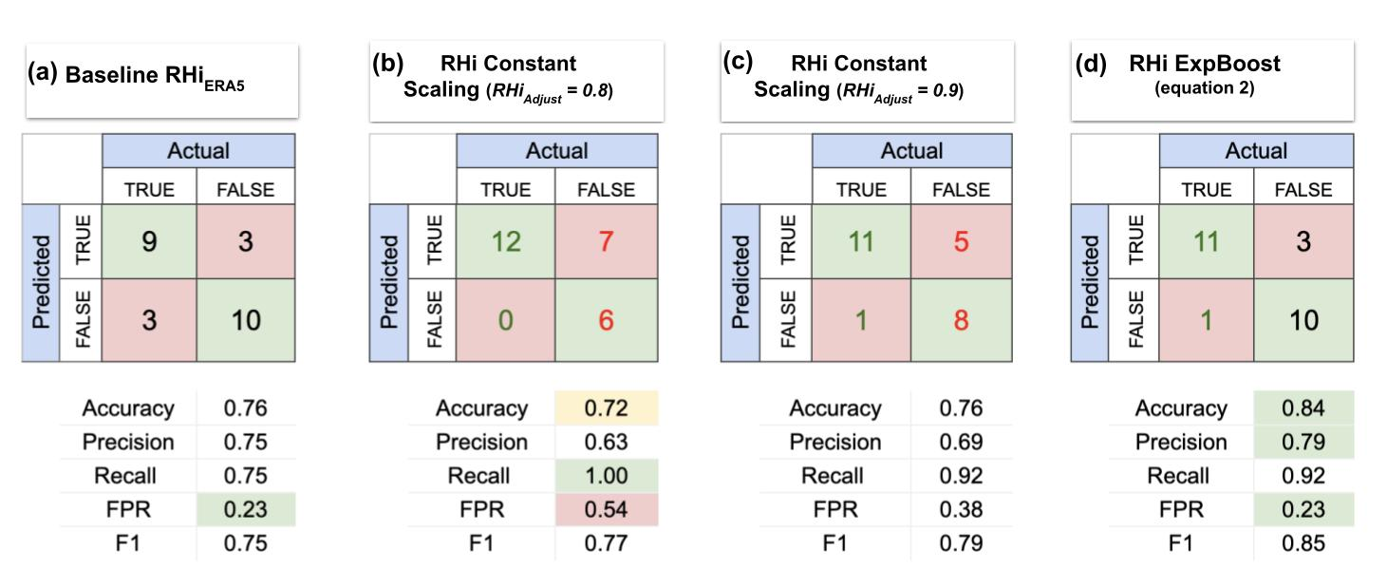
Figure 6. Confusion matrices and metrics under RHi scaling. Panels show confusion matrices and summary metrics for (a) baseline, (b) constant scaling = 0.8, (c) constant scaling = 0.9, and (d) exponential boost. Accuracy and F1 were closely matched across panels (e.g., baseline ≈ 76%/75%; exponential boost ≈ 84%/85%), indicating a balanced evaluation set. Constant scaling increased recall (fewer false negatives) but at the cost of higher false positives, with the trade-off growing as the scale factor increased. In contrast, the exponential boost improved both accuracy (76% ⇒ 84%) and F1 (75% ⇒ 85%) simultaneously, reflecting better balanced detection. Notably, the false-positive rate (≈23%) remained largely unchanged across scalings, indicating that RHi scaling alone could not reduce false positives and that other factors (e.g., unresolved vertical structure, shear, timing/geo-registration) likely dominated.
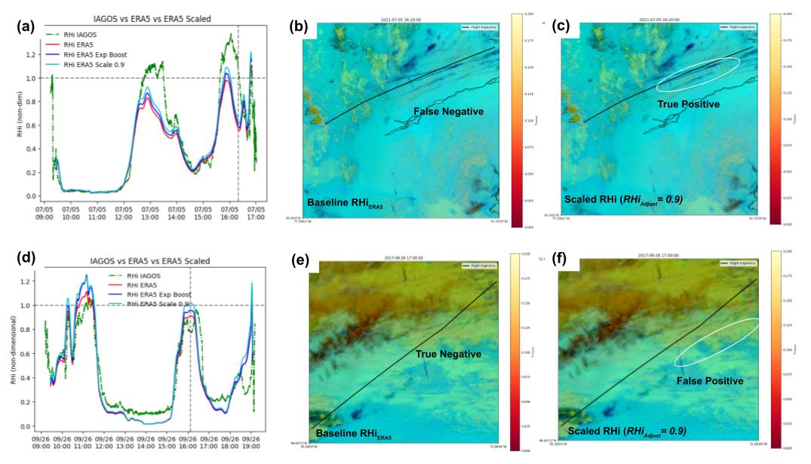
Figure 7. RHi-scaling impact on contrail prediction. Two flight examples illustrate how constant and exponential RHi scaling change CoCiP detections relative to LEO/GEO observations. (a) Flight timeline of RHi: IAGOS (green), ERA5 (red), constant scale 0.9 (blue), exponential boost (cyan). ERA5 tracked measurements when RHi < 1 but lagged near/above unity; both scalings raised RHi in those regions. (b) GOES image overlaid with flight path (black) and CoCiP (baseline ERA5 RHi): observed contrails (dark blue) with no prediction, a false negative. (c) CoCiP with constant scale 0.9: predicted contrails (red dots, white highlight) align with observed, so the false negative becomes a true positive. (d) Another flight where measured RHi was just below 1 at the intersection (dashed line); ERA5 and exponential boost stayed below 1, but constant 0.9 scaling crossed >1. (e) Baseline ERA5 case: no contrails observed or predicted, a true negative. (f) Constant 0.9 scaling: contrails predicted (red dots, white highlight) when none observed, a false positive. Overall, scaling improved true-positive detection but could increase false positives depending on the scheme.
Navigational contrail mitigation case study
We evaluated the efficacy of enhanced, RHi-corrected CoCiP-based contrail mitigation via flight replanning in a case study of 200 commercial flights over CONUS during a 12-hour nighttime period, when warming contrails were more likely. For each flight, we computed total EF using both the baseline CoCiP and the RHi-corrected CoCiP. The baseline underestimated total EF by ≈34%, showing the benefit of using the multivariate statistical scaling. Applying altitude adjustments of +/- 1,000-1,500m to avoid regions predicted to create contrails showed that rerouting ≈10% of flights with the most computed EF, reduced total contrail EF by 40-45%, demonstrating the effectiveness of the strategy (Table 1).
 |  | Baseline Model |  |  | Scaled Model (ExpBoost)
Total Flights | Altitude Adjustment (m) | Flights Rerouted (10%) | Total Warming EF (J) | % Change EF | Flights Rerouted (10%) | Total Warming EF (J) | % Change EF
200 | +1500 | 20 | 1.95E+16 | -45.83% | 20 | 3.02E+16 | -44.89%
200 | +1000 | 20 | 2.17E+16 | -39.72% | 20 | 3.13E+16 | -42.88%
200 | 0 | 20 | 3.60E+16 | 0.00% | 20 | 5.48E+16 | 0.00%
200 | -1000 | 20 | 2.18E+16 | -39.44% | 20 | 3.63E+16 | -33.76%
200 | -1500 | 20 | 2.00E+16 | -44.44% | 20 | 3.22E+16 | -41.24%
Table 1. Navigational contrail-mitigation case study results. The table shows side-by-side EF totals for baseline vs RHi-boosted CoCiP, plus impacts of altitude adjustments on the top 10% highest-EF flights. Per-flight energy forcing (EF) was computed with baseline CoCiP (ERA5 RHi) and RHi-corrected CoCiP (exponential boost) at regular waypoints and with ±1,000 m / ±1,500 m altitude adjustments applied to the top 10% EF flights. Across 200 CONUS nighttime flights, the baseline underestimated total EF by ≈34% (3.6×10¹⁶ vs 5.48×10¹⁶ J), and targeted rerouting of ≈10% of flights reduced total EF by 40-45%, with larger reductions at ±1,500 m.

Discussion
In an operational case study of 200 CONUS nighttime flights over 12 hours, the baseline model underestimated total energy forcing (EF) by about 34%, and altitude adjustments of 1,000-1,500 m suggested that rerouting roughly 10% of flights reduced contrail EF by ≈40-45%. These results indicated that bias-aware humidity inputs improved contrail detection and that targeted operational avoidance could significantly reduce EF with minimal rerouting, aligning with prior assessments of aviation's non-CO₂ climate impacts (4-5).
Interpreting these metrics, the primary gain appeared in recall, indicating fewer missed opportunities to identify and avoid warming contrails. The more modest improvement in precision and the persistence of false positives, suggested that humidity scaling alone did not fully address overprediction of persistence. Contributing factors may have included unresolved vertical humidity structure near the tropopause, shear-driven spreading that complicates temporal matching, microphysical parameter choices governing ice growth and settling, and timing or geolocation mismatches between model output and satellite observation. Importantly, while precision, recall, and F1 scores characterized event detection, they did not directly measure the magnitude of warming. Our EF analysis complemented these metrics by providing insights into climate relevance. However, both lines of evidence should be read together and interpreted considering the methodological limitations discussed below.
Methodologically, our stringent intersection filter, which required reliable IAGOS ground truth, LEO coverage for detecting nascent contrails, GEO coverage for tracking lifecycle evolution, and favorable humidity (RHi ≥ 100%), strengthened attribution for each trajectory. However, this approach significantly reduced the analyzable sample from 2,580 flights, affecting the generalizability of our findings. This tradeoff favored rigor over size and likely biased the set toward geometries coincident with LEO swaths. A practical way to expand coverage without relaxing attribution would be to augment LEO+GEO with ground-based observations, thereby widening observation windows while preserving per-flight linkage. At the same time, our humidity correction should not be viewed as a limitation. The exponential boost was deliberately fit to multivariate biases using IAGOS along-track measurements, aligning with the broader literature on bias-aware inputs and complementing formal quantile-mapping approaches (12). For labeling, we chose manual ground-truthing by design. Given GEO parallax, multi-layer cloud scenes, variable illumination, and cloud advection that can confound automated detectors, manual identification prioritized high precision for this small, critical validation set for assessing contrail impacts. Finally, the 12-hour CONUS nighttime analysis was presented explicitly as a case study meant to illustrate operational implications under conditions favorable for warming contrails; broader temporal, regional, and diurnal generalization remains to be tested.
The significance of these findings is twofold. First, they demonstrated a practical validation framework that linked IAGOS in situ humidity with co-registered LEO and GEO observations of the same flights' contrails and CoCiP predictions based on ERA5. Second, they indicated that enhancing humidity inputs can decrease the number of missed detections in flight planning tools and that specific altitude adjustments for a small percentage of flights can lead to significant reductions in effective forcing.
Looking ahead, several promising directions for future research and application have emerged. For instance, expanding coverage with ground-based sensors and additional satellite constellations could help mitigate selection effects while preserving per-flight attribution. Advancing multivariate bias-correction or assimilation schemes that integrate along-track humidity and temperature may further improve inputs (12,16). Scaling validation with automated detectors should proceed cautiously, ideally with EF-aware metrics and routine human audit, to maintain label quality at volume (24, 25). Most importantly, embedding EF-aware logic and explicit CO₂-equivalence choices within operational planners is essential because contrail EF is short-lived and variable, while CO₂ forcing accumulates over decades; thus, climate cost must be balanced with operational realities and safety constraints (4, 26). Complementary technology levers, such as soot-reducing fuels and engines, also warranted evaluation alongside operational avoidance, given evidence that they can reduce contrail cloudiness and warming potential (26).
In summary, the use of empirically bias-corrected humidity inputs significantly improved detection performance in CoCiP. Additionally, selective altitude changes for a few flights led to substantial EF reductions in a nighttime CONUS case study, highlighting the potential of these strategies for broader contrail mitigation. Although stringent intersection criteria limited the sample size and manual labeling reduced throughput, the methodology and results suggest the need for specific, scalable contrail-avoidance strategies that require further testing and integration into flight planning (4, 5, 11, 12, 26).

Conclusion
This study validated CoCiP contrail predictions by fusing IAGOS in situ humidity with co-registered LEO and GEO satellite observations along individual flight trajectories. Baseline CoCiP showed reasonably balanced performance but missed a meaningful fraction of persistent contrails, consistent with systematic underestimation of ice supersaturation in ERA5 as a likely contributor.
Adjusting for this humidity bias improved detection primarily by reducing false negatives, in line with known ERA5 dry biases near the tropopause. These corrections were tested on a small, carefully curated dataset and should be treated as sensitivity analyses rather than general calibration results, but the direction of the change is consistent and worth testing at larger scale.
An operational case study under nighttime CONUS conditions showed that altitude adjustments targeting the top 10% of high-EF flights could reduce modeled total contrail energy forcing by 40-45%. These numbers depend on model assumptions and simplified routing constraints, so they are best read as an upper-bound estimate of what bias-corrected flight planning might achieve in practice.
The main constraints on this work are the small sample imposed by requiring simultaneous IAGOS, LEO, and GEO coverage, the use of manual labeling, and the absence of an independent validation set for bias correction. Relaxing any of these, through ground-based sensor augmentation, automated detection with human audit, or expanded IAGOS coverage, represents the clearest path to scaling this approach beyond curated validation.
The core contribution is a reproducible per-flight validation framework that connects atmospheric measurements, satellite observations, and model predictions in a single pipeline. Bias-aware humidity inputs appear to be a practical lever for improving contrail avoidance decisions, and the framework developed here provides a foundation for evaluating this approach at operational scale.

Acknowledgements
I would like to thank Thuy-Anh Nguyen, science teacher at Archbishop Mitty High School, for her guidance and support throughout this research.

References
1. Appleman, H. S. (1953). Formation of exhaust condensation trails by jet aircraft. Bulletin of the American Meteorological Society, 34(1), 14-20. https://doi.org/10.1175/1520-0477-34.1.14
2. Kärcher, B. (2018). Formation and radiative forcing of contrail cirrus. Nature Communications, 9, 1824. https://doi.org/10.1038/s41467-018-04068-0
3. Schumann, U., Graf, K., & Mannstein, H. (2011). Potential to reduce the climate impact of aviation by flight level changes. Proceedings of the 3rd AIAA Atmospheric and Space Environments Conference. https://doi.org/10.2514/6.2011-3376
4. Lee, D. S., Fahey, D. W., Skowron, A., Allen, M. R., Burkhardt, U., Chen, Q., et al. (2021). The contribution of global aviation to anthropogenic climate forcing for 2000 to 2018. Atmospheric Environment, 244, 117834. https://doi.org/10.1016/j.atmosenv.2020.117834
5. Teoh, R., Schumann, U., Majumdar, A., & Stettler, M. E. J. (2020). Mitigating the climate forcing of aircraft contrails by small-scale diversions and technology adoption. Environmental Science & Technology, 54(5), 2941-2950. https://doi.org/10.1021/acs.est.9b05608
6. Wolf, K., Bellouin, N., & Boucher, O. (2023). Long-term upper-troposphere climatology of potential contrail occurrence over the Paris area derived from radiosonde observations. Atmospheric Chemistry and Physics, 23(1), 287-309. https://doi.org/10.5194/acp-23-287-2023
7. Reutter, P., Neis, P., Rohs, S., & Sauvage, B. (2020). Ice supersaturated regions: Properties and validation of ERA-Interim reanalysis with IAGOS in-situ water vapour measurements. Atmospheric Chemistry and Physics, 20(2), 787-804. https://doi.org/10.5194/acp-20-787-2020
8. Gierens, K., Matthes, S., & Rohs, S. (2020). How well can persistent contrails be predicted? Aerospace, 7(12), 169. https://doi.org/10.3390/aerospace7120169
9. Haywood, J. M., Allan, R. P., Bornemann, J., Forster, P. M., Francis, P. N., Milton, S., et al. (2009). A case study of the radiative forcing of persistent contrails evolving into contrail-induced cirrus. Journal of Geophysical Research: Atmospheres, 114(D24), D24201. https://doi.org/10.1029/2009JD012650
10. Schumann, U. (2012). A contrail cirrus prediction model. Geoscientific Model Development, 5(3), 543-580. https://doi.org/10.5194/gmd-5-543-2012
11. Martín Frías, A., Shapiro, M. L., Engberg, Z., Zopp, R., Soler Arnedo, M. F., & Stettler, M. E. J. (2024). Feasibility of contrail avoidance in a commercial flight planning system: An operational analysis. Environmental Research: Infrastructure and Sustainability, 4(1), 015001. https://doi.org/10.1088/2634-4505/ad310c
12. Wolf, K., Bellouin, N., Boucher, O., Rohs, S., & Li, Y. (2025). Correction of ERA5 temperature and relative humidity biases by bivariate quantile mapping for contrail formation analysis. Atmospheric Chemistry and Physics, 25, 157-181. https://doi.org/10.5194/acp-25-157-2025
13. NOAA GOES-R Program. (n.d.). Instruments: Advanced baseline imager (ABI). https://www.goes-r.gov/spacesegment/abi.html. Retrieved April 21, 2026.
14. Copernicus Data Space Ecosystem. (2023). Sentinel-2 documentation. https://documentation.dataspace.copernicus.eu/Data/SentinelMissions/Sentinel2.html
15. U.S. Geological Survey. (n.d.). Landsat 8. https://www.usgs.gov/landsat-missions/landsat-8. Retrieved April 21, 2026.
16. Petzold, A., Thouret, V., Gerbig, C., Zahn, A., Brenninkmeijer, C. A. M., Gallagher, M., et al. (2015). Global-scale atmosphere monitoring by in-service aircraft, current achievements and future prospects of the European research infrastructure IAGOS. Tellus B: Chemical and Physical Meteorology, 67, 28452. https://doi.org/10.3402/tellusb.v67.28452
17. Boulanger, D., Blot, R., Bundke, U., Gerbig, C., Hermann, M., Nédélec, P., et al. (2018). IAGOS final quality controlled observational data L2, time series [Data set]. Aeris. https://doi.org/10.25326/06
18. National Oceanic and Atmospheric Administration. (n.d.). GOES-16 data (advanced baseline imager). https://www.nesdis.noaa.gov/. Retrieved April 21, 2026.
19. Engberg, Z., Teoh, R., Abbott, T., Dean, T., Stettler, M. E. J., & Shapiro, M. L. (2023). PyContrails: Python library for modeling aviation climate impacts. https://doi.org/10.5281/zenodo.7775435
20. The OpenSky Network. (n.d.). OpenSky API. https://opensky-network.org/. Retrieved April 21, 2026.
21. U.S. Geological Survey. (n.d.). Landsat data products. https://www.usgs.gov/landsat-missions/landsat-data-products. Retrieved April 21, 2026.
22. European Space Agency. (n.d.). Copernicus Sentinel-2 mission data (MSI). https://sentinels.copernicus.eu/. Retrieved April 21, 2026.
23. Hersbach, H., Bell, B., Berrisford, P., Hirahara, S., Horányi, A., Muñoz-Sabater, J., et al. (2020). The ERA5 global reanalysis. Quarterly Journal of the Royal Meteorological Society, 146(730), 1999-2049. https://doi.org/10.1002/qj.3803
24. Ng, J. Y.-H., McCloskey, K., Cui, J., Meijer, V. R., Brand, E., Sarna, A., et al. (2023). OpenContrails: Benchmarking contrail detection on GOES-16 ABI. arXiv. https://doi.org/10.48550/arXiv.2304.02122
25. Geraedts, S., Brand, E., Dean, T. R., Eastham, S., Elkin, C., Engberg, Z., et al. (2024). A scalable system to measure contrail formation on a per-flight basis. Environmental Research Communications, 6(1), 015008. https://doi.org/10.1088/2515-7620/ad11ab
26. Voigt, C., Kleine, J., Sauer, D., Moore, R. H., Bräuer, T., Le Clercq, P., et al. (2021). Cleaner burning aviation fuels can reduce contrail cloudiness. Communications Earth & Environment, 2, 114. https://doi.org/10.1038/s43247-021-00174-y

