**Assignment 1: Automated Instance Management Using AWS Lambda and Boto3**

**Launch EC2 Instances**

**1. In the AWS Console, search for EC2 in the search bar and click EC2.  
 2. Click Launch instances.  
 Name:** NikhilAutoStop **Tag:  
 Key:** Action **Value:** Auto-Stop

**Name:** NikhilAutoStart **Tag:  
 Key:** Action **Value:** Auto-Start

**AMI :** Ubuntu **Instance Type :** t2.micro **Key pair (login):  
 Network settings:** Allow SSH (port 22) from My IP.  
 Allow HTTP (port 80)

**Click Launch instance**

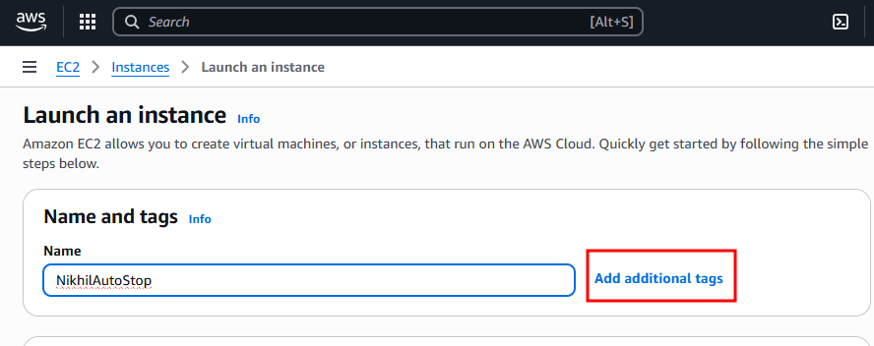

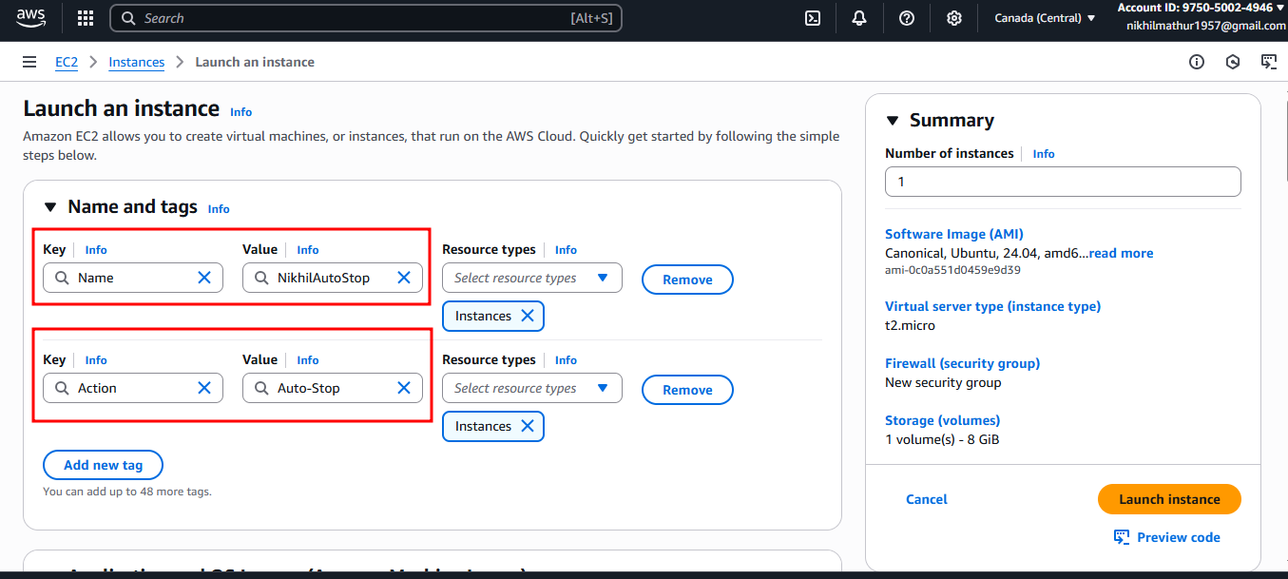

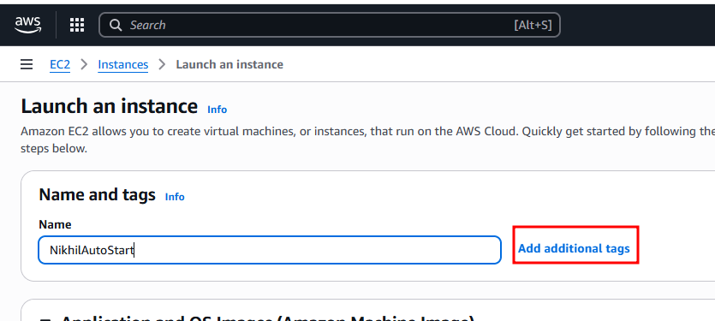

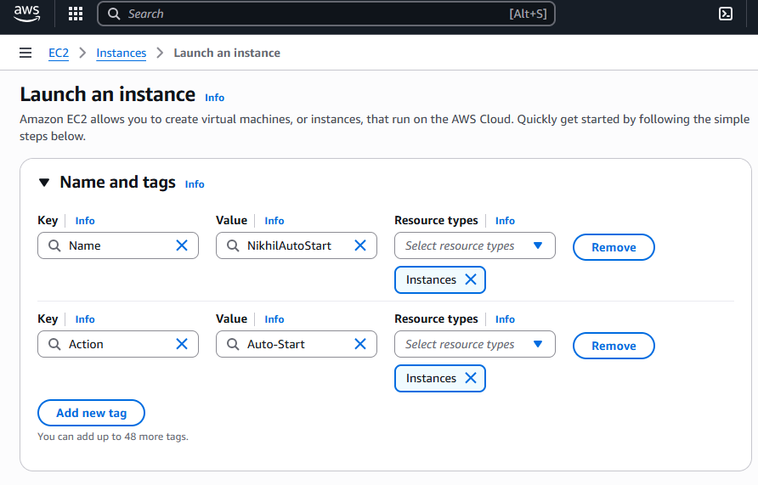

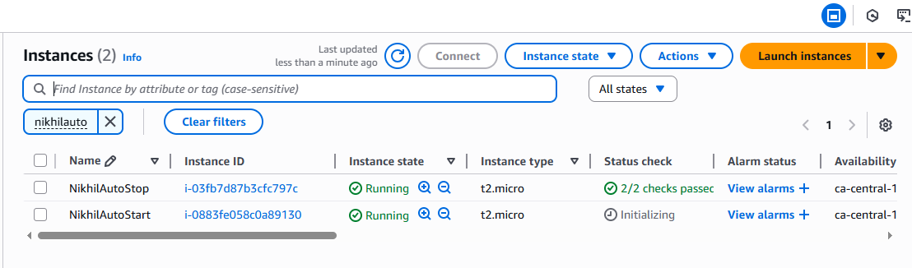

**Lambda Function Creation:**

1. **Create an IAM Role for Lambda**

* AWS Console => IAM =>Roles => Create role.
* Trusted Entity type: AWS Services
* Use Case: Lambda
* Click Next

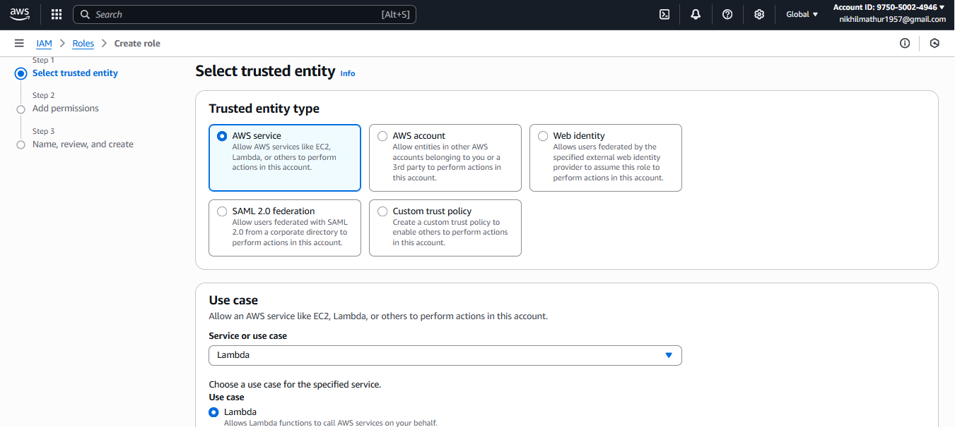

**Permissions policies:** AmazonEC2FullAccess

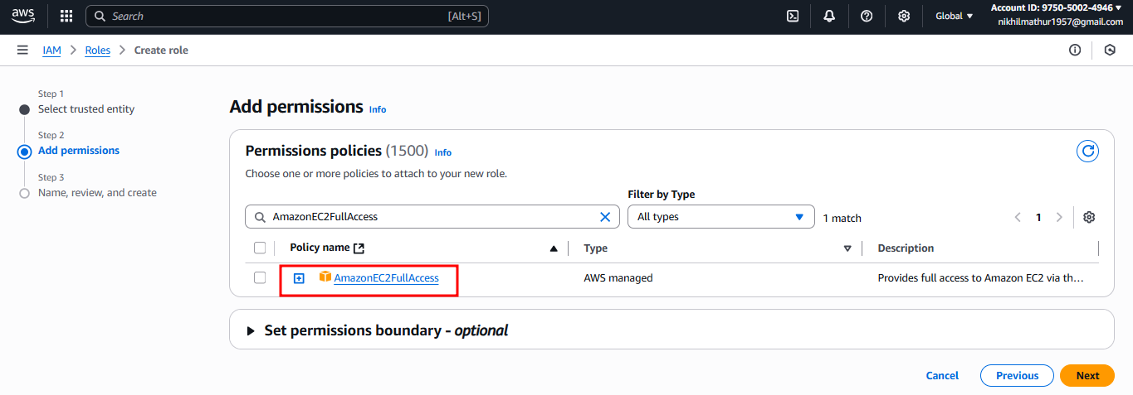

**Role name:** NikhilLambdaEC2ControlRole  
**Click Create role.**

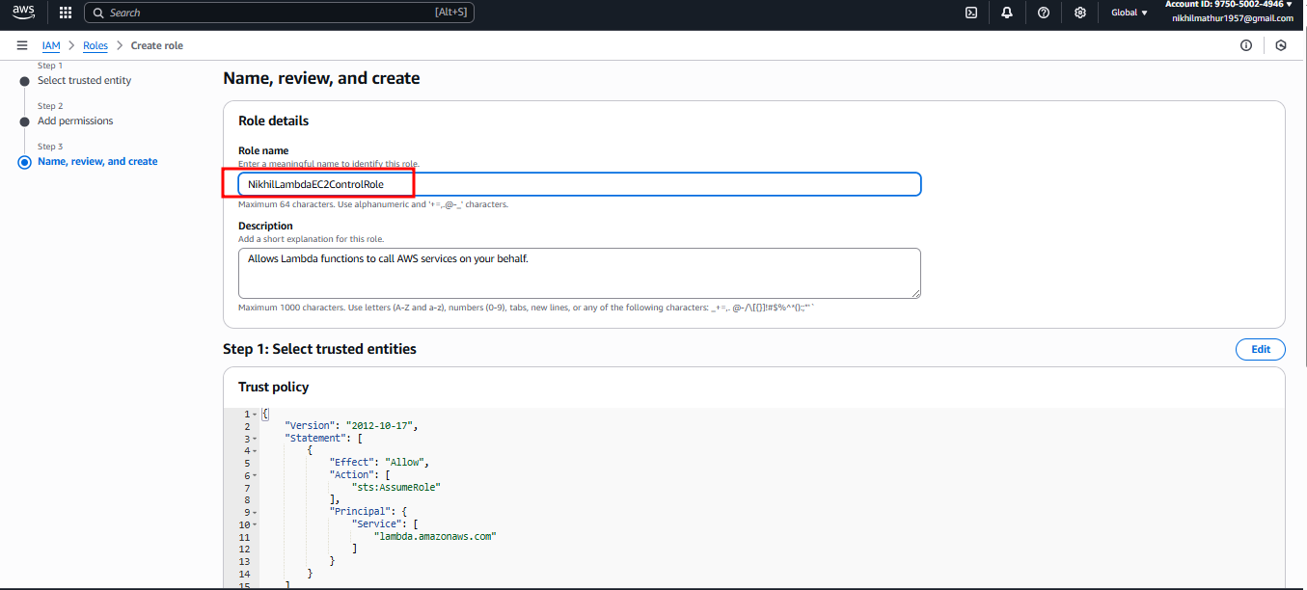

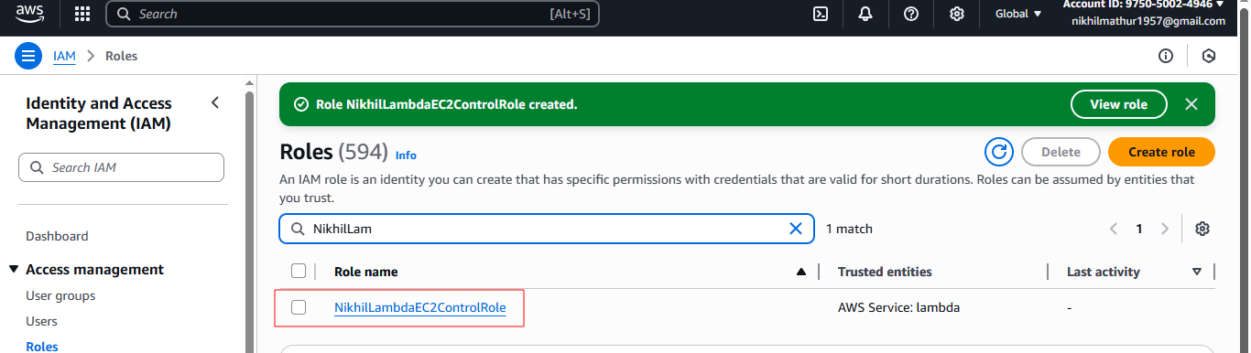

1. **Create the Lambda Function**Go to AWS Console => Lambda.  
   **Click Create function.**  
   Select Author from scratch  
   Function name: **NikhilEC2TagBasedControl**  
   Runtime: Python 3.13.  
   Permissions:  
   Expand Change default execution role.  
   Select Use an existing role.  
   Choose **NikhilLambdaEC2ControlRole** from the dropdown.  
   **Note** => I choose the role **prashantb12-role-9p53470y** for permission access to run the code.  
   **Click Create function.**

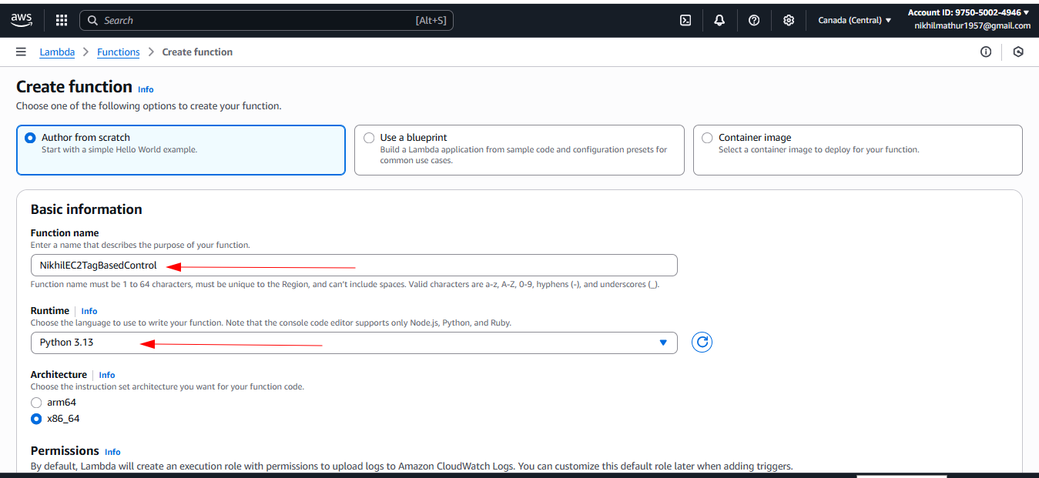

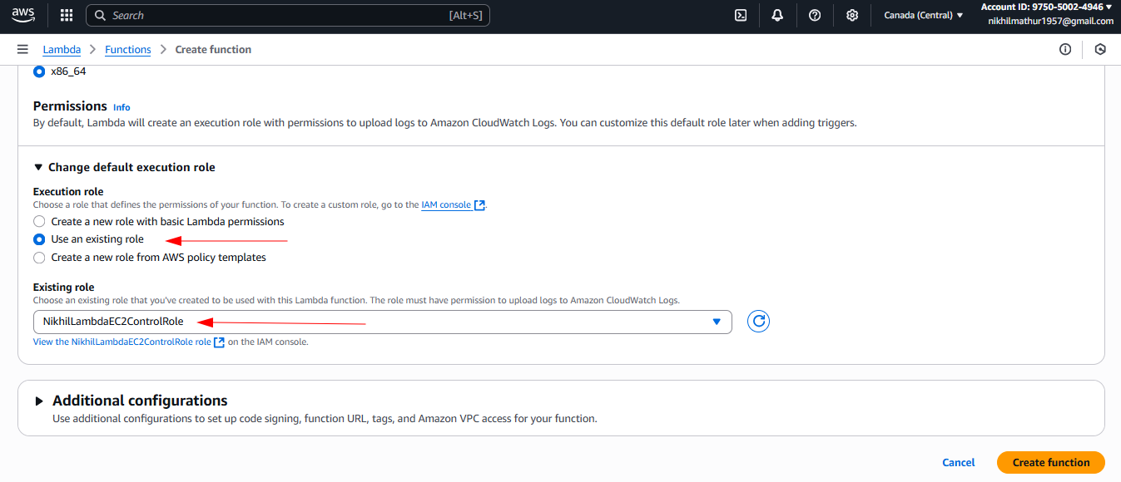

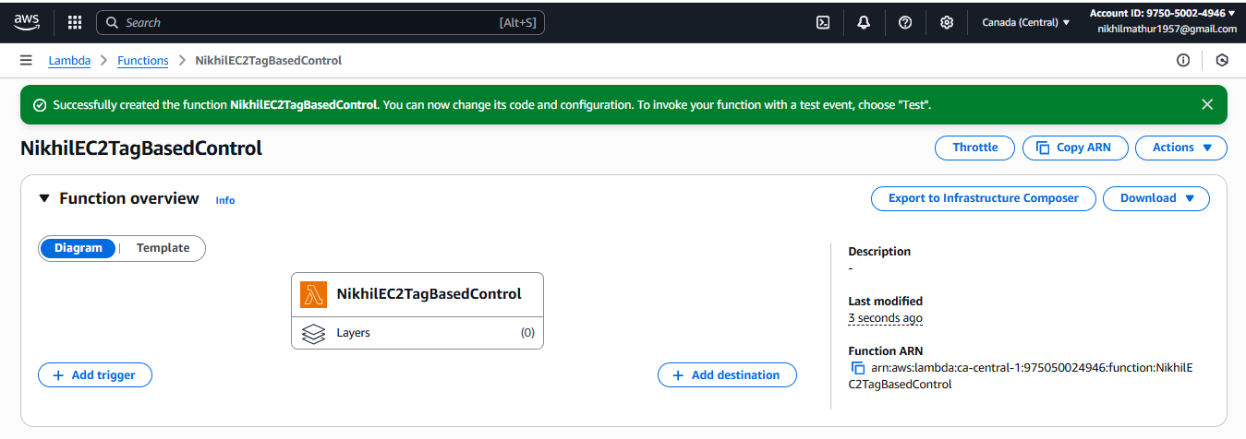

1. **Add Python Code to Control EC2**

* **prints instance IDs** with a given tag:
* **Code to print instances with Auto-Stop (testing code)**

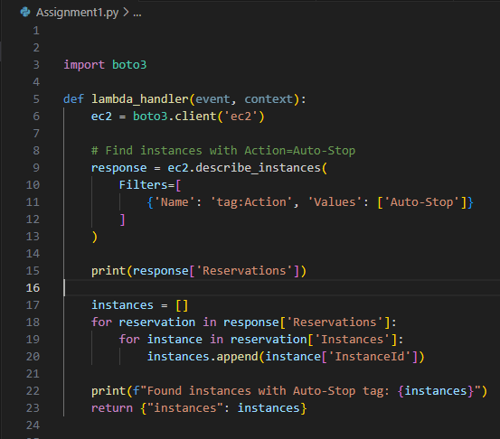

* **Full Code**

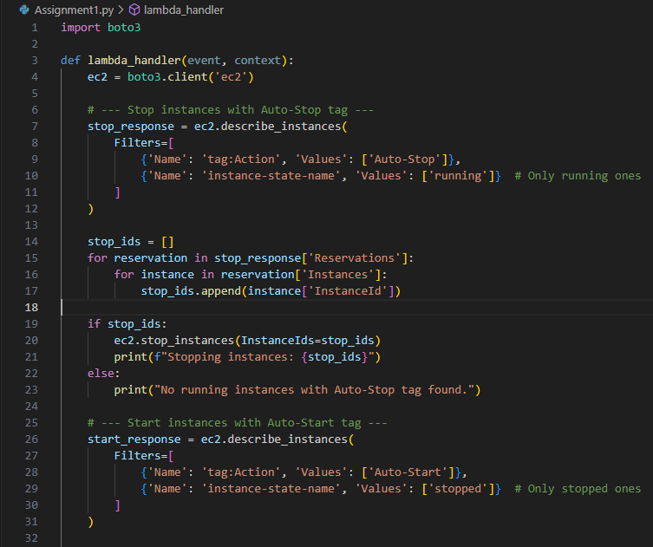

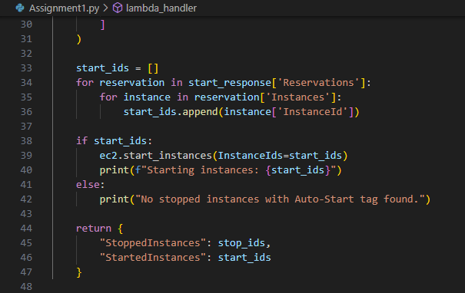

**Create the test case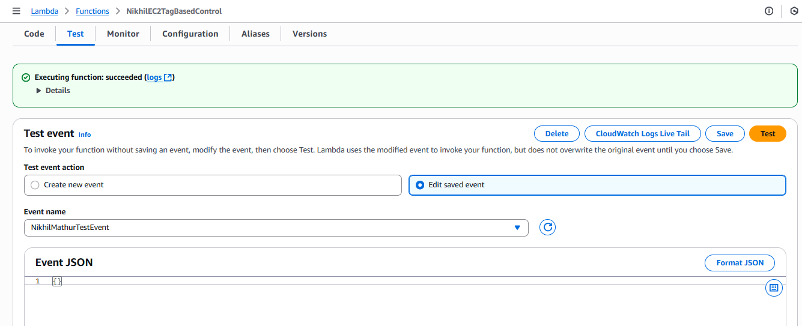 Click for deploy the code**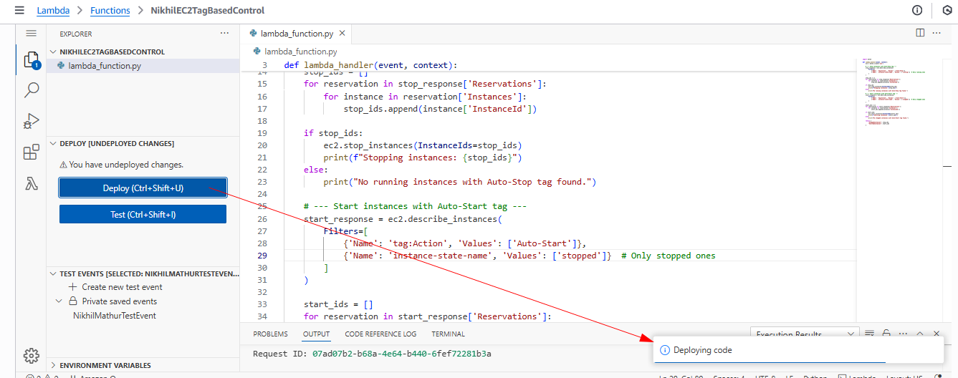

**Click on test for Output**

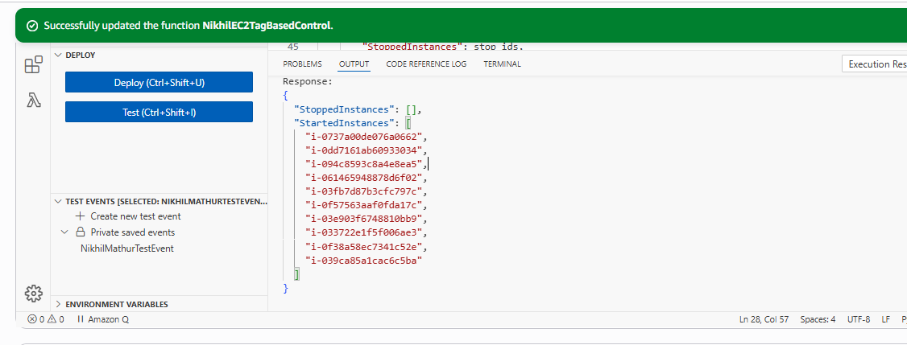

**Verification**