**Assignment 15: Implement a Log Cleaner for S3**

**Objective: Create a Lambda function that automatically deletes logs in a specified S3 bucket that are older than 90 days.**

1. **Create a new Lambda function.**

Go to Lambda.  
 Click Create function.  
 Function name: nikhilS3LogCleanup90Days  
Runtime: Python 3.13  
Permissions: Choose Use an existing role (prashantb12-role-9p53470y).

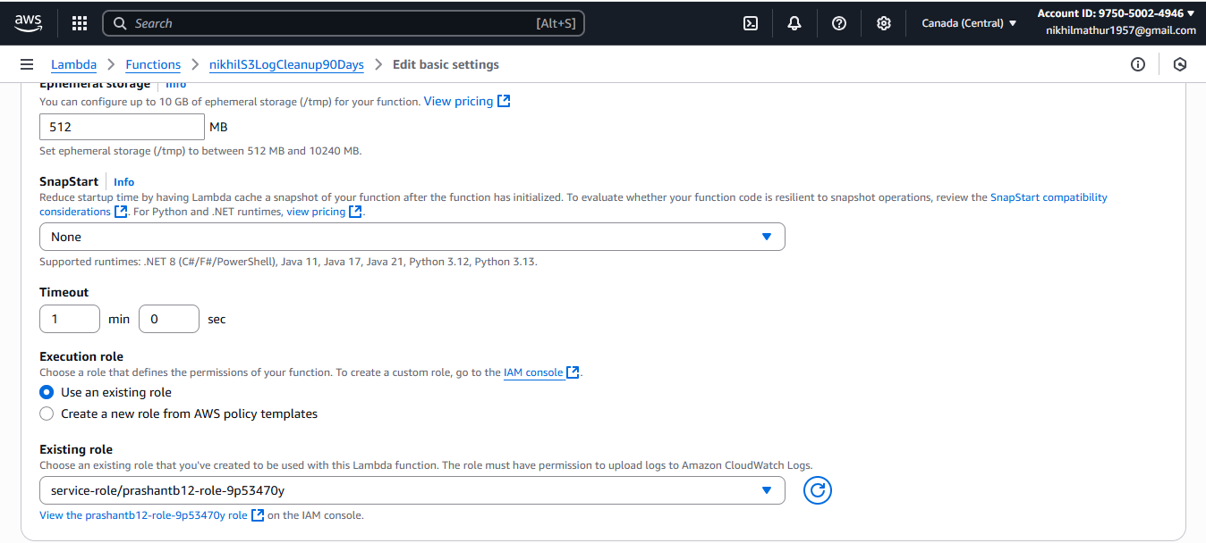

**Add Python Code** 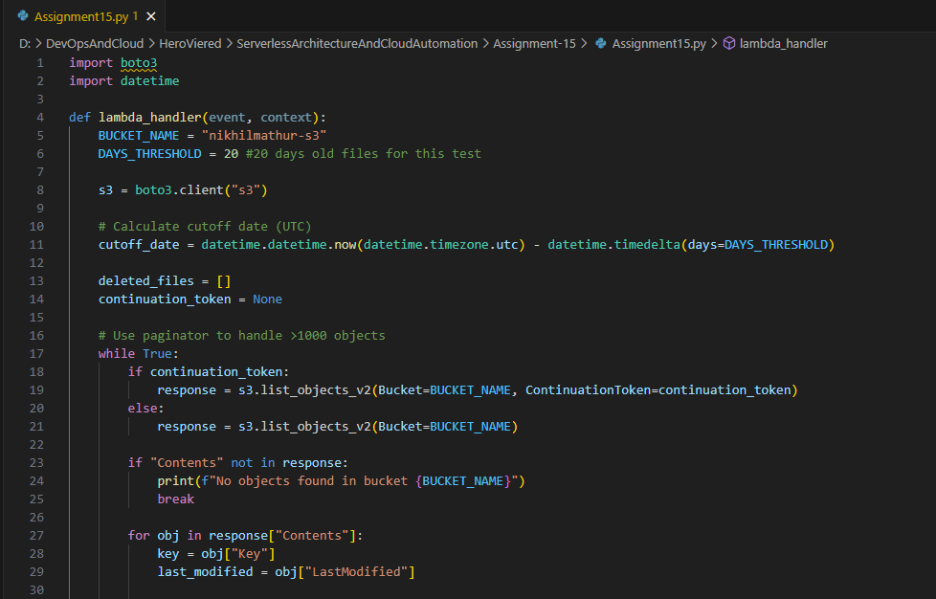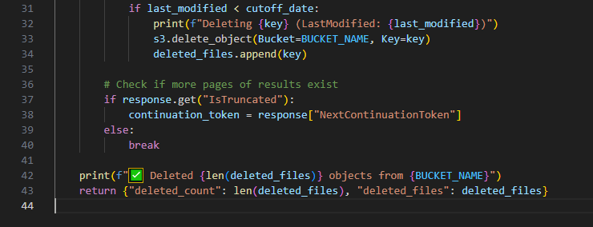

**Click on test for Output**

