**Assignment 2: Automated S3 Bucket Cleanup Using AWS Lambda and Boto3**

**Task: Automate the deletion of files older than 30 days in a specific S3 bucket.**

1. **S3 Setup: (I used old bucket for the task)**
   1. **Navigate to the S3 dashboard and create a new bucket.**
      1. Click the orange Create bucket button.
      2. Bucket name: **nikhilmathur-static-signup-site** (Must be globally unique)
      3. Choose your preferred region (Keep it consistent with other resources (like EC2, Lambda))
      4. Open your bucket by clicking its name.
      5. Click Upload → Add files (choose any file from your computer).
      6. Click Upload at the bottom.

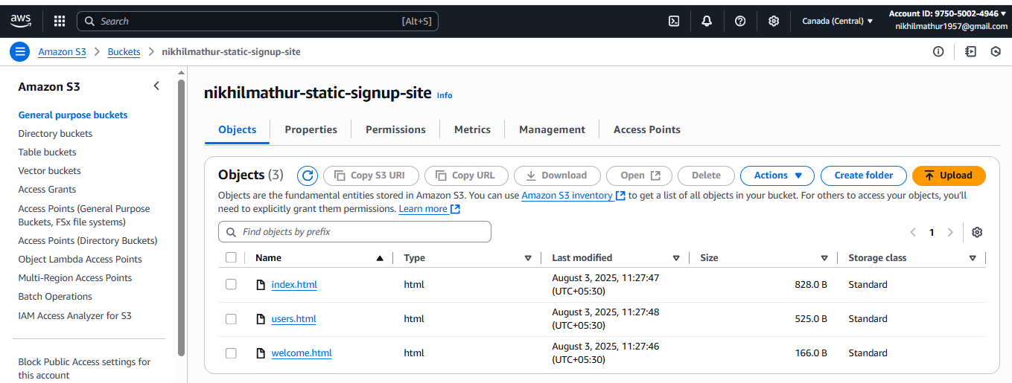

1. **Lambda Function:**
   1. **Create an IAM Role for Lambda**
      1. **AWS Console => IAM =>Roles => Create role.**
      2. **Trusted Entity type: AWS Services**
      3. **Use Case: Lambda**
      4. **Click Next**
      5. **Permissions policies: AmazonS3FullAccess**
      6. **Role name: NikhilLambdaS3CleanupRole**

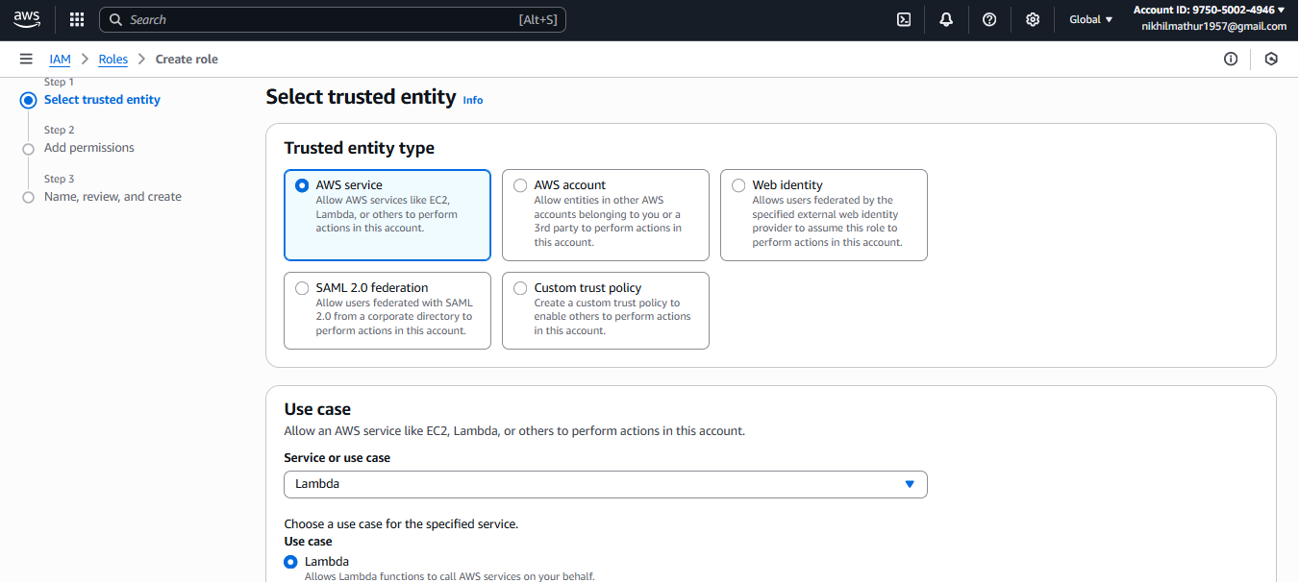

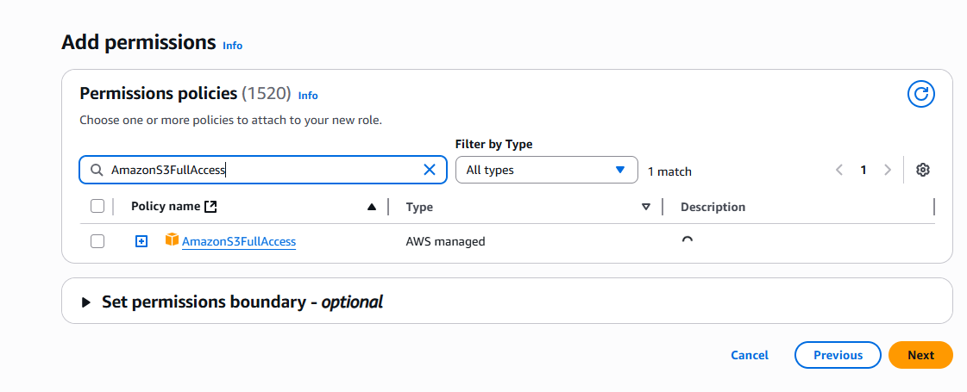

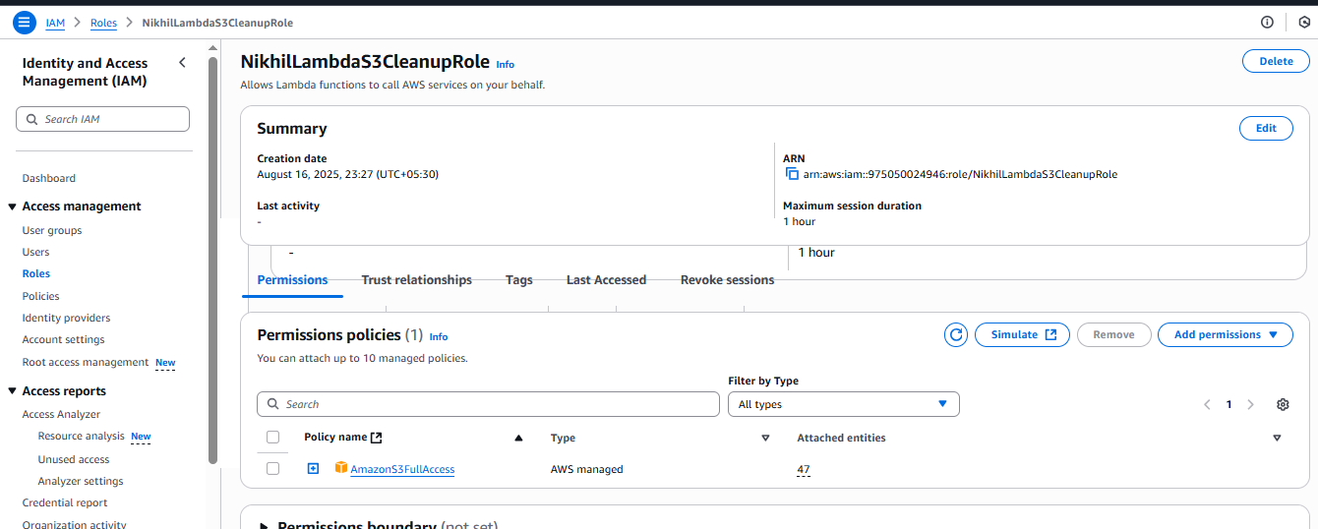

* 1. **Create the Lambda Function**
     1. **Go to AWS Console => Lambda.**
     2. **Click Create function.**
     3. **Select Author from scratch**
     4. **Function name: NikhilS3BucketCleanup**
     5. **Runtime: Python 3.13**
     6. **Permissions:**
     7. **Expand Change default execution role.**
     8. **Select Use an existing role.**
     9. **Choose NikhilLambdaS3CleanupRole from the dropdown.**
     10. **Note => I choose the role prashantb12-role-9p53470y for permission access to run the code.**
     11. **Click Create function.**

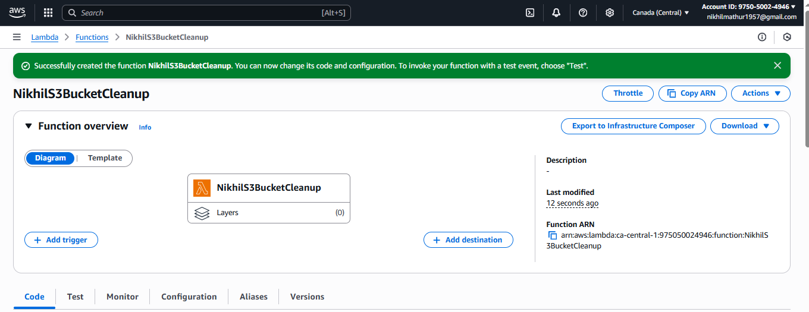

**Code** 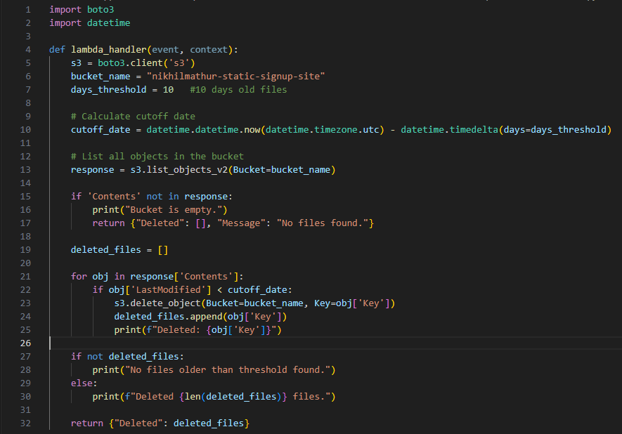

**Click for deploy the code  
Click Test → Create test event → name it CleanupTest.  
Keep event JSON as {}.  
Run the test.**

**Check the Logs for deleted files list.**

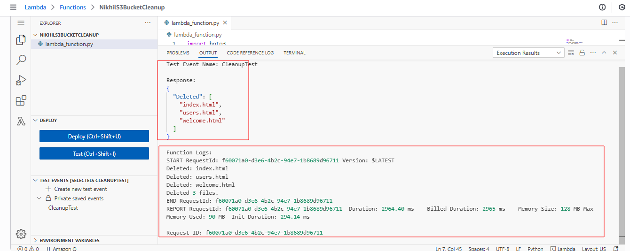

1. **Manual Invocation:**

**Before function run**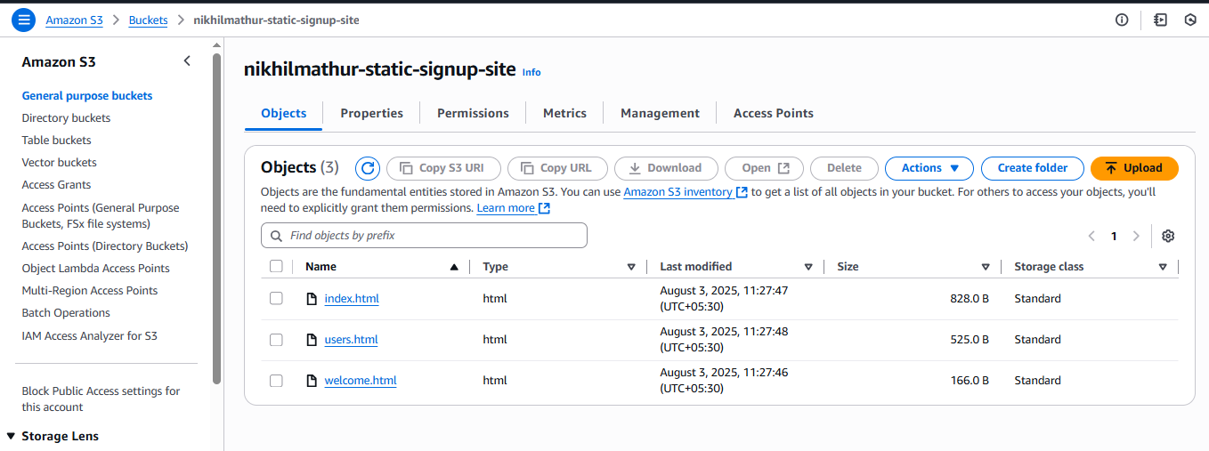

**After run the function**

