**Assignment 3: Monitor Unencrypted S3 Buckets Using AWS Lambda and Boto3**

**Objective: To enhance your AWS security posture by setting up a Lambda function that detects any S3 bucket without server-side encryption.**

**Task: Automate the detection of S3 buckets that don't have server-side encryption enabled.**

**Lambda Function Creation:**

1. **Create an IAM Role for Lambda**

* AWS Console => IAM =>Roles => Create role.
* Trusted Entity type: AWS Services
* Use Case: Lambda
* Click Next

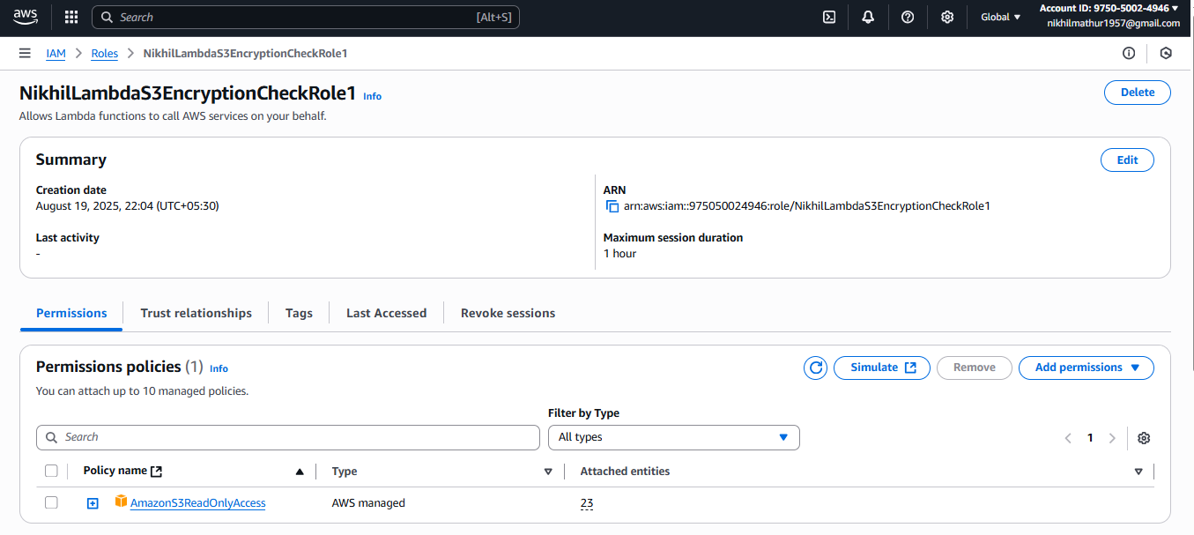

**Permissions policies:** AmazonEC2FullAccess  
**Role name:** NikhilLambdaEC2ControlRole1  
**Click Create role.**

1. **Create the Lambda Function**Go to AWS Console => Lambda.  
   **Click Create function.**  
   Select Author from scratch  
   Function name: **NikhilS3EncryptionCheck**  
   Runtime: Python 3.13  
   Permissions:  
   Expand Change default execution role.  
   Select Use an existing role.  
   Choose **NikhilLambdaEC2ControlRole1** from the dropdown.  
   **Note** => I choose the role **prashantb12-role-9p53470y** for permission access to run the code.  
   **Click Create function.**

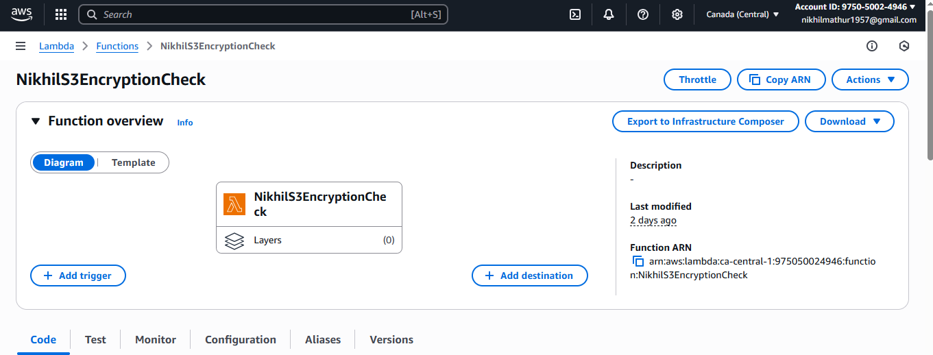

1. **Add Python Code to Control EC2**

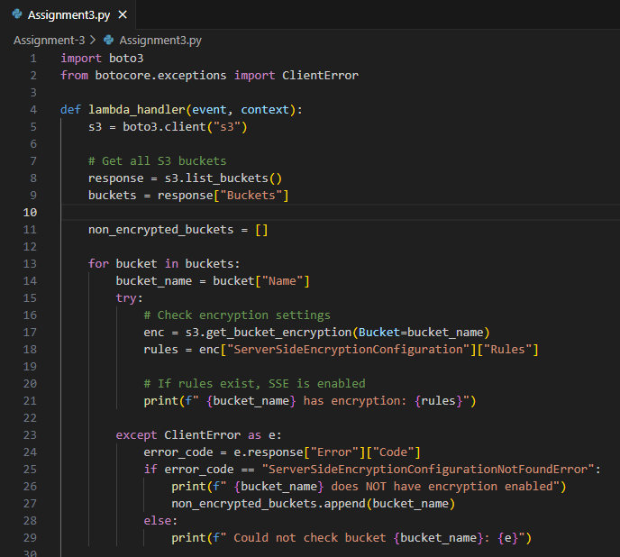

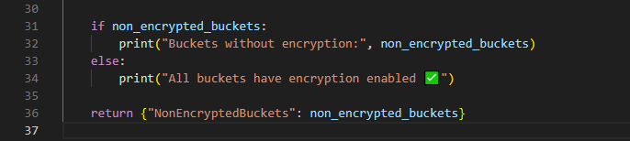

**Create the test case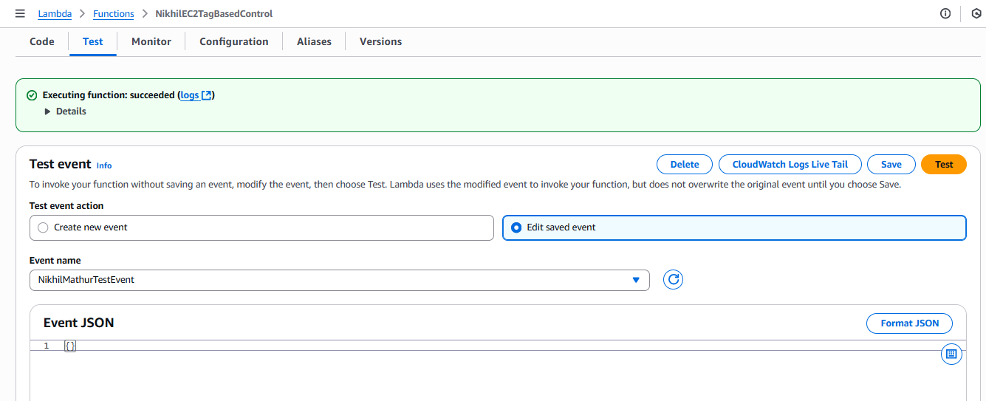 Click for deploy the code**

**Test the code**

