**Assignment 5: Auto-Tagging EC2 Instances on Launch Using AWS Lambda and Boto3**

**Task: Automatically tag any newly launched EC2 instance with the current date and a custom tag.**

**Lambda Function Creation:**

1. **Create an IAM Role for Lambda**

* AWS Console => IAM =>Roles => Create role.
* Trusted Entity type: AWS Services
* Use Case: Lambda
* Click Next

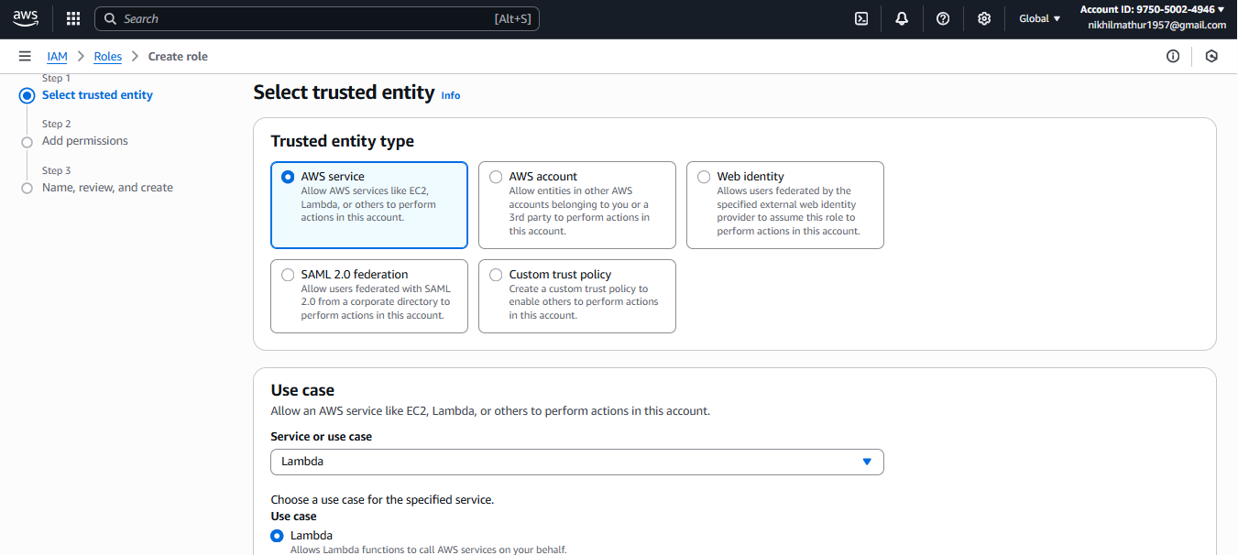

**Permissions policies:** AmazonEC2FullAccess

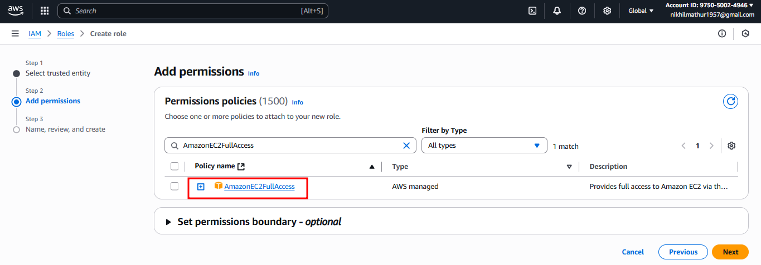

**Role name:** NikhilLambdaEC2ControlRole  
**Click Create role.**

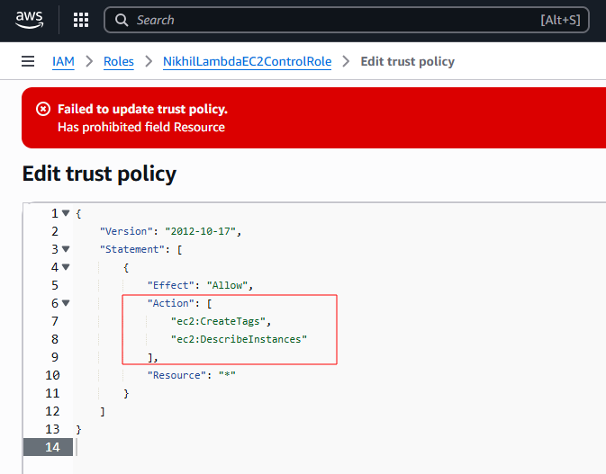

**However, the policy update is prohibited for me.**

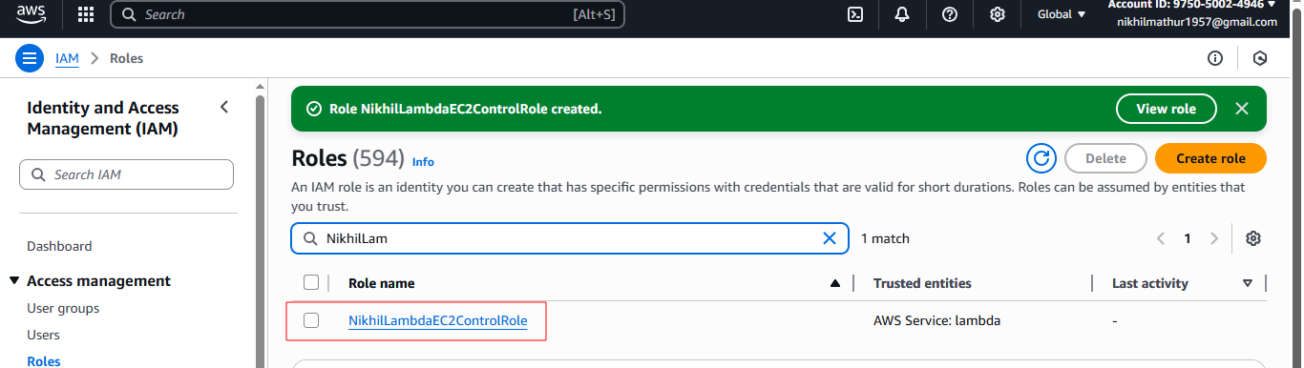

1. **Create the Lambda Function**Go to AWS Console => Lambda.  
   **Click Create function.**  
   Select Author from scratch  
   Function name: **NikhilEC2AutoTagOnLaunch**  
   Runtime: Python 3.13  
   Permissions:  
   Expand Change default execution role.  
   Select Use an existing role.  
   Choose **NikhilLambdaEC2ControlRole** from the dropdown.  
   **Note** => I choose the role **prashantb12-role-9p53470y** for permission access to run the code.  
   **Click Create function.**

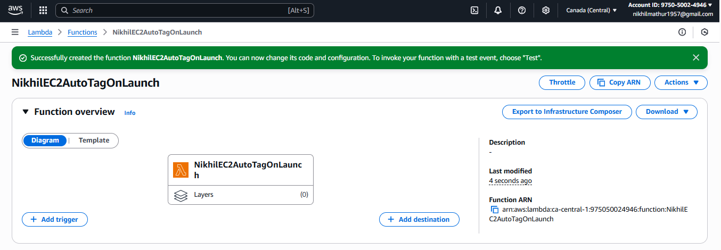

1. **Add Python Code to Control EC2**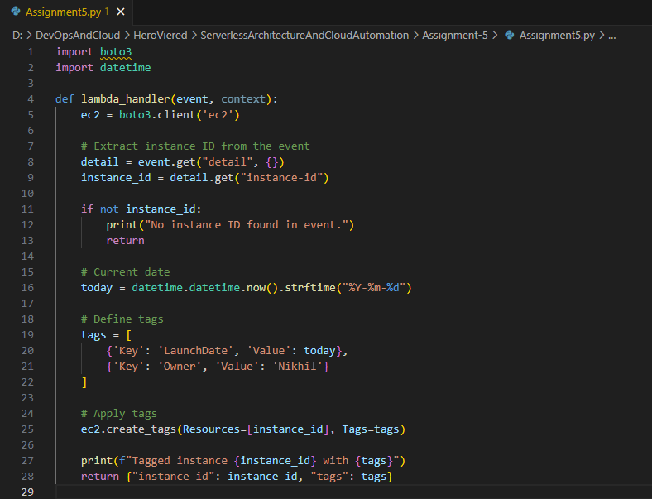

**Create the test case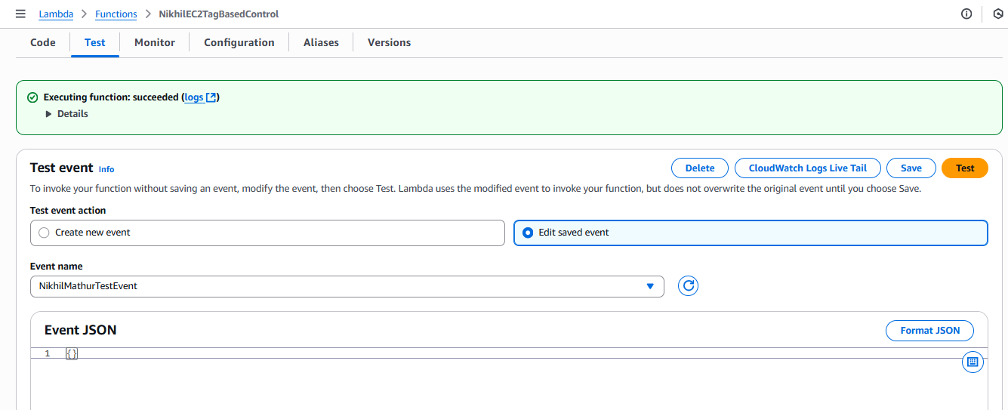 Click for deploy the code**

**Trigger Lambda on Instance Launch**

**Go to EventBridge → Rules → Create rule**  
 **Name**: NikhilEC2AutoTagOnLaunchRule.  
 **Rule type**: Event pattern.  
**Event source**: Service: EC2  
**Event type**: EC2 Instance State-change Notification  
**Specific state**: running  
**Target**: Select the Lambda function (**NikhilEC2AutoTagOnLaunch**).  
**Click Create rule**

