# Discounts

To maintain the discounts offered by the souvenir store, click “Manage” in the menu bar -> “Discounts”.

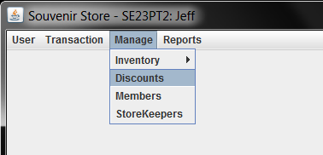

The maintenance panel will be displayed as below,

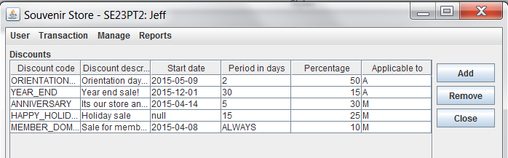

**Adding of Discounts:**

Press the *“Add”* button on the “Discounts” panel, the Add Discount dialog will be shown.

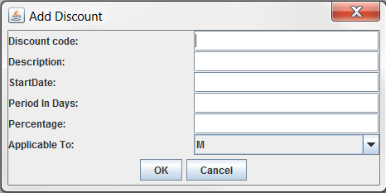

Admins are supposed to enter all the fields with the following two conditions/checks

* StartDate: must follow the ‘yyyy-MM-dd’ format
* Period In Days: must be numeric value

If the conditions are not met, then an alert will pop up to remind admins that some input values are invalid. In this case, the entry will NOT be added to data store.

For example, in the below snapshot, the Start Date was entered as ‘20140802’ which doesn’t follow the prescribed format. Consequently, an alert pops up.

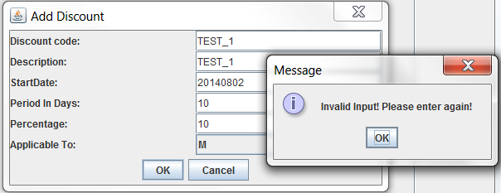

Now if you correct the Start Date to ‘2014-08-02’ then a new record will be added and displayed on the main UI.

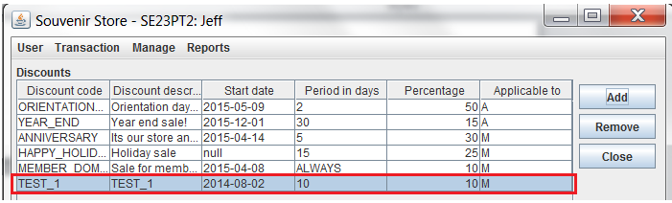

**Remove of Discounts:**

Click any record on the main UI, then ‘Remove’ button on the right, a confirmation dialog will pop up to ask if you confirm to remove this selected discount.

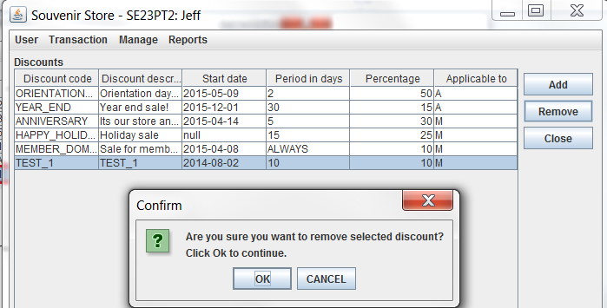

And if you click ‘OK’, the selected discount will be removed from main UI. If you click ‘Cancel’, then nothing will be removed.

**Editing of Discounts:**

Admins are allowed to update discounts on the main UI directly. Note that ‘Discount Code’ is non-editable as it is the primary key for each discount record.

The editing of other fields will be like below,

* **Discount description**

This is a normal string field. Admins can simply click this field and update the string value there.

* **Start Date**

Double click this field to launch a date chooser as below. The chooser allows admin to find any date within +/-20 years range.

To change year, admins should click the combo box.

To change month, admin should click the left/right button.

To select date, admin should directly pick a date from the main chooser.

Then click ‘OK’ to confirm you have selected a date.

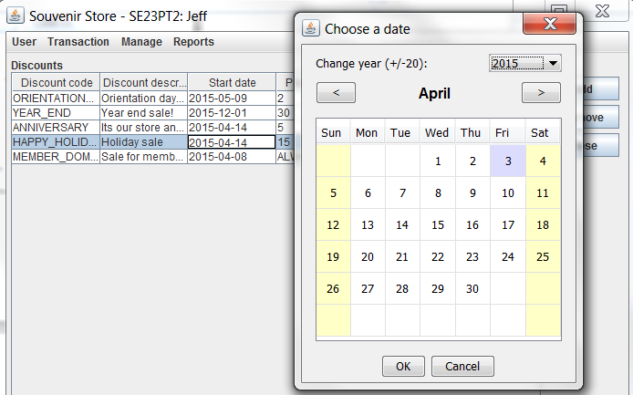

If an invalid date (i.e., any empty cell) was picked, the UI will pop up an alert dialog to remind you.

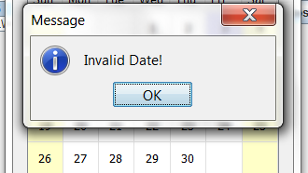

* **Period in Days**

This field must contain only numeric characters. Nonetheless, admins are allowed to enter “ALWAYS” to indicate this discount is a permanent one.

If the entered value is neither “ALWAYS” nor numeric characters, an “Invalid value” alert will pop up to remind you (i.e., highlighted cell below – “15s” is not a value input).

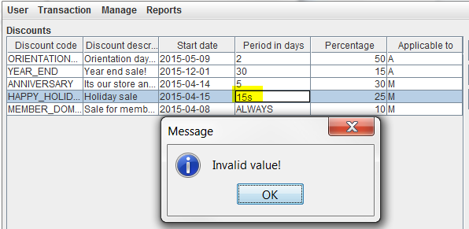

* **Percentage**

This field was designed as “double” date type.

Admins should enter only numeric values. Otherwise it won’t be updated.

* **Applicable To**

This field is designed as a combo box.

Admins should select either “M” or “A” from the drop-down list.

* “M” means it is applicable to members only
* “A” means it is applicable to all customers

