# Members UI

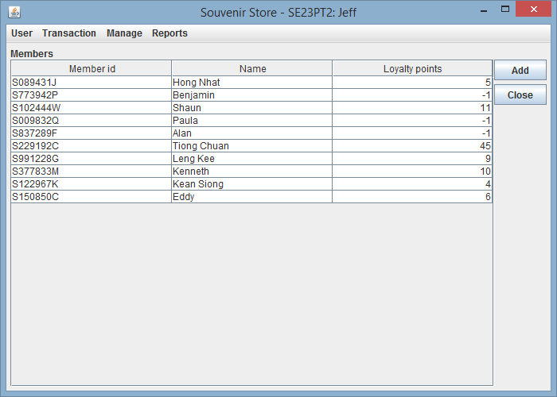

**Adding of Members:**

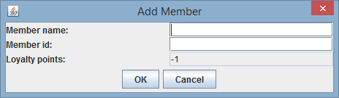

Press the *“Add”* button on the members panel, the Add Member dialog will be shown.

You need to fill in the member name, member id in the provided text field. Loyalty points always start at -1 and is not editable.

Press *“OK”* to confirm addition. Press *“Cancel”* to go back to the members panel.

**Editing of Members:**

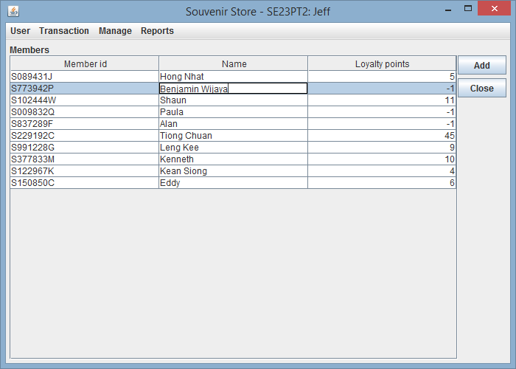

Simply click on the member’s name that you want to edit. Only the name is editable.