# Vendor

To maintain the vendor offered by the souvenir store, click “Manage” in the menu bar -> “Inventory” -> Vendors.

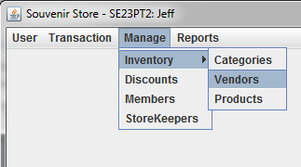

The maintenance panel will be displayed as below,

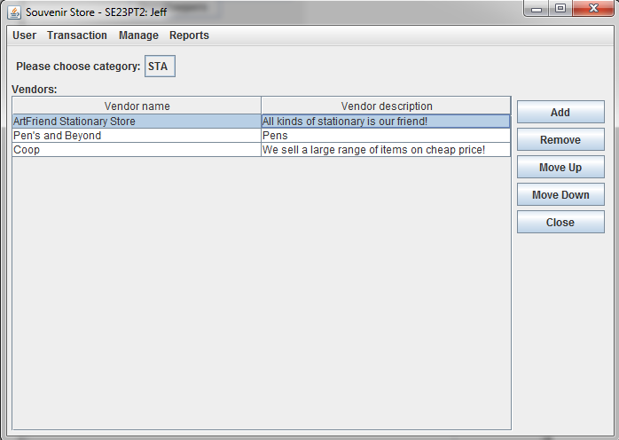

**Adding of Vendor:**

First choose the category, then press the *“Add”* button on the “Vendor” panel, the Add Vendor dialog will be shown.

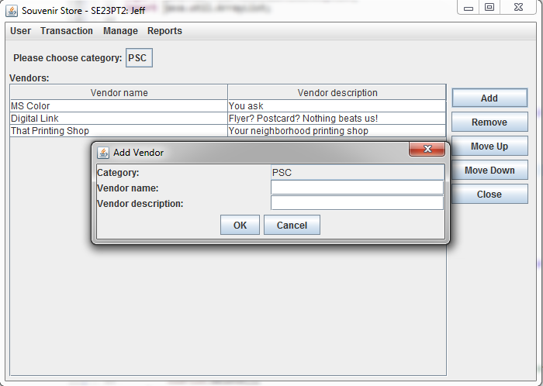

Vendor name and vendor description are mandatory.

If the conditions are not met, then an error message will pop up to remind admins that some input values are missing. In this case, the entry will NOT be added to data store.

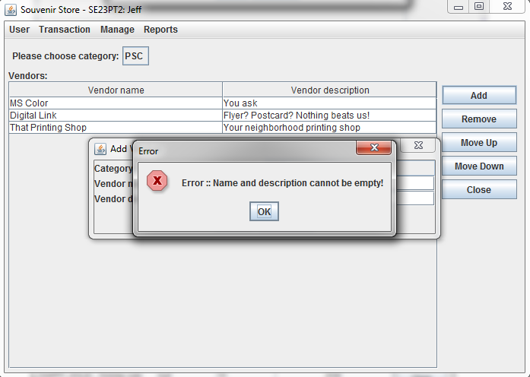

If add duplicate vendor for one category, one error message will popup.

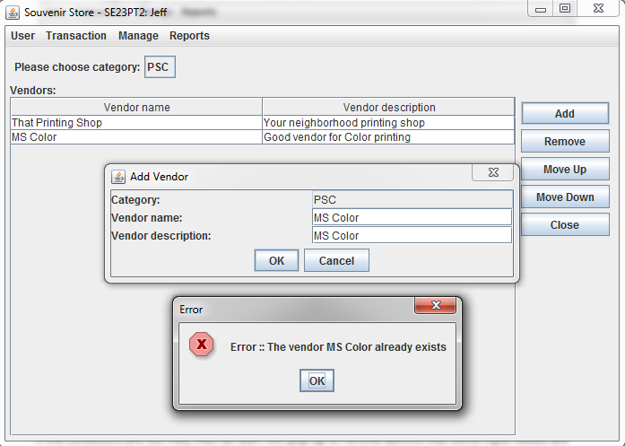

**Remove of Vendor:**

Click any record on the Vendor panel, then ‘Remove’ button on the right, a confirmation dialog will pop up to ask if you confirm to remove this selected vendor.

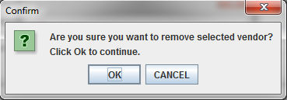

And if you click ‘OK’, the selected vendor will be removed. If you click ‘Cancel’, then nothing will be removed.

**Editing of Vendor:**

Admins are allowed to update vendors on the vendor panel directly. Note that ‘Vendor Name’ is non-editable as it is the primary key for each vendor record.

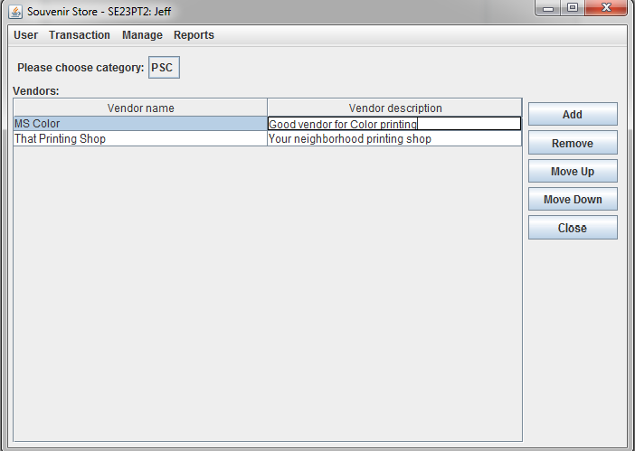

**Change sequence of Vendor:**

Admins are allowed to change the sequence of vendors in the order of preference.

Click any record on the Vendor panel, then ‘Move Up / Move Down” buttons on the right to move the selected vendor to preferred position.

