**ASSIGNMENT:2 (JAVA ASSIGNMENT) [MID:1095607]**

**Operators**

1. Write a program to calculate the sum of digits of a 3-digit number

Example : Input : **232**  => Output: **7**

**CODE:**

**import** java.util.*;

**public** **class** SumOfDigits {

**public** **static** **void** main(String args[]) {

Scanner in=**new** Scanner(System.***in***);

System.***out***.println("Enter a 3 digit Number");

**int** a=in.nextInt();

**int** sum=0;

**while**(a>0) {

**int** rem=a%10;

sum=sum+rem;

a=a/10;

}

System.***out***.println("The sum of 3 digit number is : "+ sum);}

}

}

**OUTPUT:**

}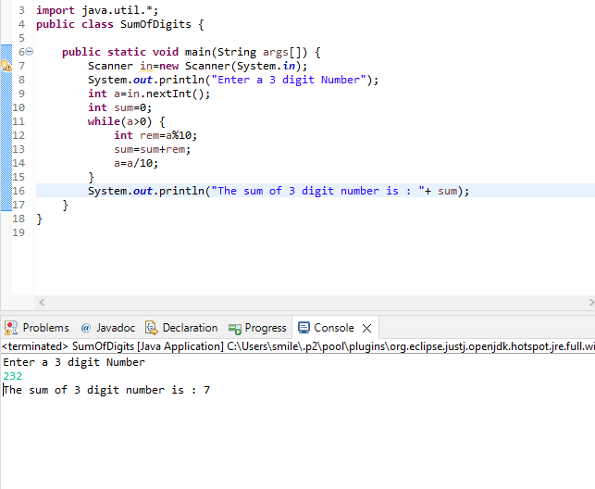

1. What will happen if you compile and run the following program

**CODE:**

**public** **class** Test {

**public** **static** **void** main(String args[]) {

**int** i=0;

**int** j=i++ + ++i;

System.***out***.println("J :"+ j);

}

}

**OUTPUT:**

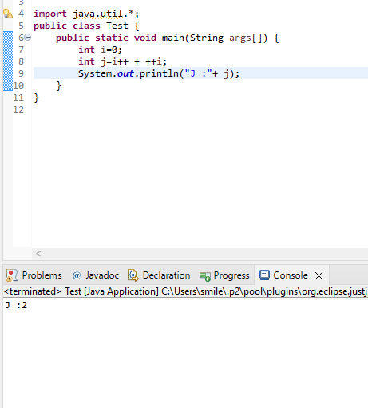

1. What will happen if you compile and run the following program

**CODE:**

**public** **class** Test {

**public** **static** **void** main(String args[]) {

**boolean** b1=**true**,b2=**false**,b3=**true**;

System.***out***.println(b1&&b2&&!b3);

}

}

**OUTPUT:**

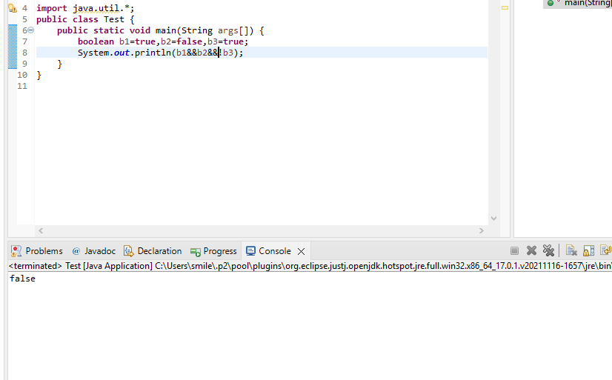

**Arrays**

1. Take 12 integer inputs from user and the count how many positive and how many odd numbers are there in the array.

**CODE:**

**import** java.util.*;

**public** **class** PositiveEvenOdd {

**public** **static** **void** main(String args[]) {

Scanner in=**new** Scanner(System.***in***);

**int** a=12; //12 Integer Inputs

**int** positive=0;**int** odd=0;**int** even=0;

**int** array[]= **new** **int**[a];

System.***out***.println("Enter 12 Integers");

**for**(**int** i=0;i<a;i++) {

array[i]=in.nextInt();

}

**for**(**int** i=0;i<array.length;i++) {

**if**(array[i]>0) {

positive+=1;

}

**if**(array[i]%2==0) {

even+=1;

}

**if**(array[i]%2!=0) {

odd+=1;

}

}

System.***out***.println("The number of positive numbers : "+positive );

System.***out***.println("The number of Odd numbers : "+odd );

System.***out***.println("The number of Even numbers : "+even );

}

}

**OUTPUT:**

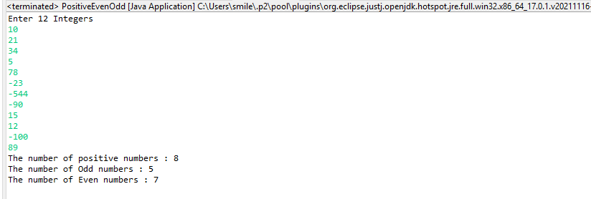

1. Create an array of integer of size 10 . Restructure the array in such a manner so that all even numbers will come followed by all odd numbers.

Example: Initially Array : int a[]={2,7,21,45,4,10,17,30,41,20}

After restructuring : int b[]={2,4,10,30,20,7,21,45,17,41}

**CODE:**

**import** java.util.*;

**public** **class** EvenFollowedByOdd {

**public** **static** **void** main(String args[]) {

Scanner in=**new** Scanner(System.***in***);

System.***out***.println("Enter the integers");

**int** array[]=**new** **int**[10];

**for**(**int** i=0;i<array.length;i++) {

array[i]=in.nextInt();

}

**int** restructured[]=**new** **int**[array.length];

//Adding even numbers to restructured Array

**int** even=0;

**for**(**int** i=0;i<array.length;i++) {

**if**(array[i]%2==0) {

restructured[even]=array[i];

even++;

}

}

//Adding odd numbers to restructured Array

**int** odd=even;

**for**(**int** i=0;i<array.length;i++) {

**if**(array[i]%2!=0) {

restructured[odd]=array[i];

odd++;

}

}

System.***out***.print("After Restructuring ");

**for**(**int** i=0;i<array.length;i++) {

System.***out***.print(restructured[i]+" ");

}

}

}

**OUTPUT:**

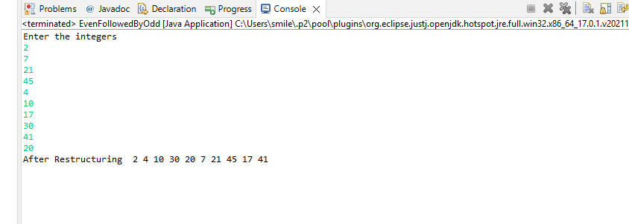

1. Take 12 integer inputs from user and store them in an array. Now copy all the elements in an another array but in reverse order.

**CODE:**

**import** java.util.*;

**public** **class** CopyArrayReverse {

**public** **static** **void** main(String args[]) {

Scanner in=**new** Scanner(System.***in***);

**int** a[]=**new** **int**[12];

System.***out***.println("Enter the integers");

**for**(**int** i=0;i<a.length;i++) {

a[i]=in.nextInt();

}

**int** b[]=**new** **int**[a.length];

**int** z=0;

**for**(**int** i=a.length-1;i>=0;i--) {

b[z]=a[i];

z++;

}

System.***out***.print("Array in reverse order ");

**for**(**int** i=0;i<b.length;i++) {

System.***out***.print(b[i]+" ");

}

}

}

**OUTPUT:**

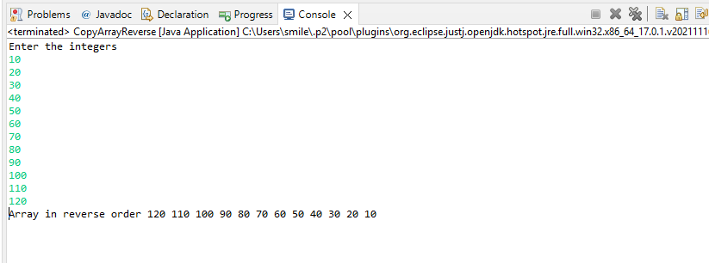

**2D Array**

1. Create an 2D array of 4x4 elements. Print the elements of the array in matrices format.

**CODE:**

**import** java.util.*;

**public** **class** TwoDimArray {

**public** **static** **void** main(String args[]) {

Scanner in=**new** Scanner(System.***in***);

**int** arr[][]=**new** **int**[4][4];

System.***out***.println("Enter the 4x4 matrix");

**for**(**int** i=0;i<4;i++) {

**for**(**int** j=0;j<4;j++) {

arr[i][j]=in.nextInt();

}

}

System.***out***.println("The 4x4 Matrix is");

**for**(**int** i=0;i<4;i++) {

**for**(**int** j=0;j<4;j++) {

System.***out***.print(arr[i][j]+" ");

}

System.***out***.println();

}

}

}

**OUTPUT:**

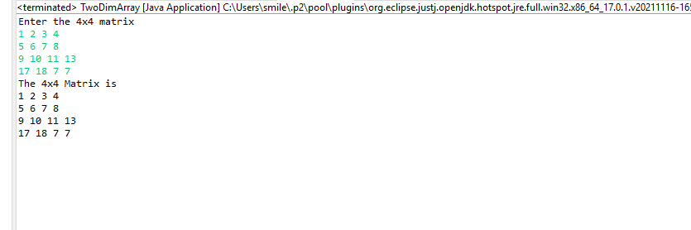

1. Create an 2D array of 4x4 elements.The swap of the first row with the last row of the 2D array and then print the matrices.

**CODE:**

**import** java.util.*;

**public** **class** SwapFirstLastRow {

**public** **static** **void** main(String args[]) {

Scanner in=**new** Scanner(System.***in***);

**int** arr[][]=**new** **int**[4][4];

System.***out***.println("Enter the 4x4 Matrix");

**for**(**int** i=0;i<arr.length;i++) {

**for**(**int** j=0;j<arr[i].length;j++) {

arr[i][j]=in.nextInt();

}

}

**int** temp[]=**new** **int**[4];

**for**(**int** i=0;i<arr.length;i++) {

**for**(**int** j=0;j<arr[i].length;j++) {

**if**(i==0) {

temp[j]=arr[i][j];

arr[i][j]=arr[arr[i].length-1][j];

arr[arr[i].length-1][j]=temp[j];

}

}

}

System.***out***.println("The 4x4 Matrix after swapping first and last row");

**for**(**int** i=0;i<arr.length;i++) {

**for**(**int** j=0;j<arr[i].length;j++) {

System.***out***.print(arr[i][j]+" ");

}

System.***out***.println();

}

}

}

**OUTPUT:**

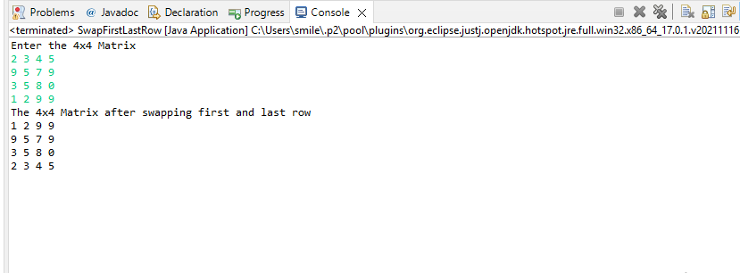

**Strings**

1. Take any input string and print it in a reverse order.

**CODE:**

**import** java.util.*;

**public** **class** ReverseString {

**public** **static** **void** main(String args[]) {

Scanner in=**new** Scanner(System.***in***);

System.***out***.println("Enter the String");

String word=in.nextLine();

String reverse="";

**for**(**int** i=0;i<word.length();i++) {

**int** length=word.length()-(i+1);

reverse+=word.charAt(length);

}

System.***out***.println("The reversed String is: "+reverse);

}

}

**OUTPUT:**

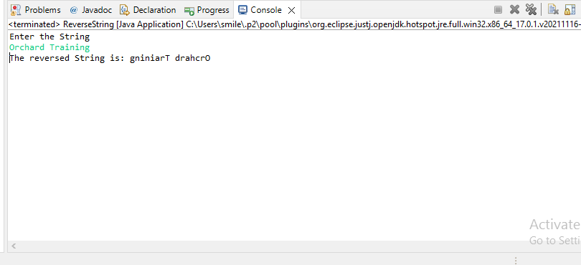

1. Take an input string and print all words of the string line by line.

Example: **Input:** “**Welcome to Orchard**”

**Output: Welcome**

**To**

**Orchard**

**CODE:**

**import** java.util.*;

**public** **class** LineByLine {

**public** **static** **void** main(String args[]) {

Scanner in=**new** Scanner(System.***in***);

System.***out***.println("Enter the String");

String sentence=in.nextLine();

**int** length=sentence.length();

**int** start=0;

String word="";

**for**(**int** i=0;i<length;i++) {

**if**(sentence.charAt(i)==' ') {

word=sentence.substring(start, i);

start=i+1;

System.***out***.println(word);

}

}

word=sentence.substring(start,length);

System.***out***.println(word);

}

}

**OUTPUT:**

**a.)**

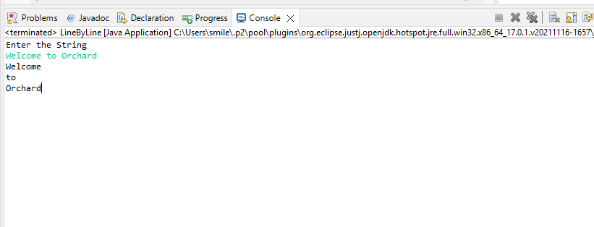

**b.)**

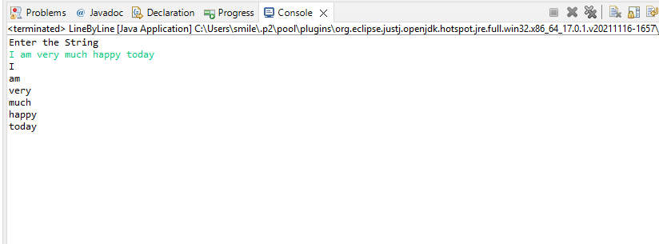

1. Take any input string.Count how many vowels are there in that input String. **Example:** **Input : “Welcome to Orchard”**

**Output: 6**

**CODE:**

**import** java.util.*;

**public** **class** VowelsCount {

**public** **static** **void** main(String args[]) {

Scanner in=**new** Scanner(System.***in***);

System.***out***.println("Enter the String");

String words=in.nextLine();

**int** length=words.length();

words=words.toLowerCase();

**int** counter=0;

**for**(**int** i=0;i<length;i++) {

**char** letter=words.charAt(i);

**if**(letter=='a'||letter=='e'||letter=='i'||letter=='o'||letter=='u') {

counter+=1;

}

}

System.***out***.println("Count: "+counter);

}

}

**OUTPUT:**

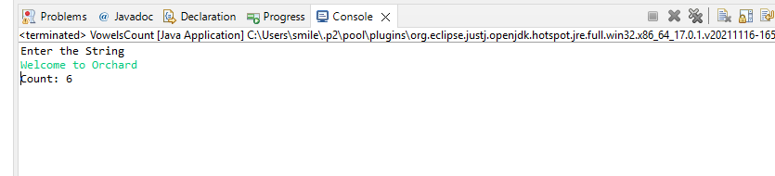

1. Take any input String and print the input string in such a way that it should be in alternative uppercase and lowercase. Example: **Input : “Goodmorning” Output : ”GoOdMoRnInG”**

**CODE:**

**import** java.util.*;

**public** **class** UpperLower {

**public** **static** **void** main(String args[]) {

Scanner in=**new** Scanner(System.***in***);

System.***out***.println("Enter the String");

String word=in.nextLine();

**int** length=word.length();

word=word.toLowerCase();

String newWord="";

**for**(**int** i=0;i<length;i++) {

**if**(i%2==0) {

**if**(word.charAt(i)>='a' && word.charAt(i)<='z') {

**char** letter=word.charAt(i);

letter-=32;

newWord+=letter;

}

**else** {

**char** letter=word.charAt(i);

newWord+=letter;

}

}

**else** {

**char** letter=word.charAt(i);

newWord+=letter;

}

}

System.***out***.println(newWord);

}

}

**OUTPUT:**

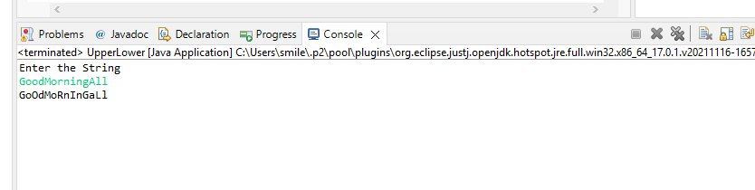

1. Take any input string example: “**India is our country**”. Count the number of occurrences of each character (No case sensitive). Example: **i ->3 , n->2, d->1...**

**CODE:**

**import** java.util.*;

**public** **class** CharOccurence {

**public** **static** **void** main(String args[]) {

**int** array[]=**new** **int**[26];

System.***out***.println("Enter the string");

Scanner in=**new** Scanner(System.***in***);

String word=in.nextLine();

**int** len=word.length();

word=word.toLowerCase();

**for**(**int** i=0;i<len;i++) {

**if**(word.charAt(i)!=' ')

{

array[(**int**)word.charAt(i)-97]++;

}

}

**for**(**int** i=0;i<26;i++) {

**if**(array[i]!=0) {

System.***out***.println((**char**)(i+97)+" --> "+ array[i]);

}

}

}

}

**OUTPUT:**

**a.)**

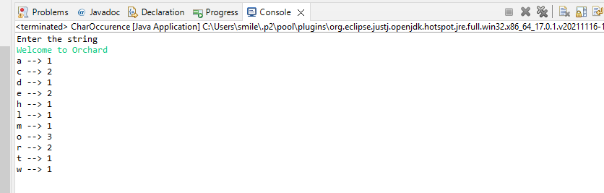

**b.)**

