**ASSIGNMENT:6 MID:M1095607**

**SQL**

Run the following queries which will create the table an insert the records into the table. Please solve the assignment questions at the end of the document after the table and records are created.

CREATE TABLE Worker ( WORKER ID INT NOT NULL PRIMARY KEY AUTO_INCREMENT, FIRST NAME CHAR(25), LAST NAME CHAR(25), SALARY INT(15), JOINING DATE DATETIME, DEPARTMENT CHAR(25)

INSERT INTO Worker (WORKER ID, FIRST_NAME, LAST NAME, SALARY, JOINING DATE, DEPARTMENT) VALUES (001, 'Monika', 'Arora', 100000, '14-02-20 09.00.00', 'HR'), (002, 'Niharika', 'Verma', 80000, '14-06-11 09.00.00', 'Admin'), (003, 'Vishal', 'Singhal', 300000, '14-02-20 09.00.00', 'HR'), (004, 'Amitabh', 'Singh', 500000, '14-02-20 09.00.00', 'Admin'), (005, 'Vivek', 'Bhati', 500000, '14-06-11 09.00.00', 'Admin'), (006, 'Vipul', 'Diwan', 200000, '14-06-11 09.00.00', 'Account'), (007, 'Satish', 'Kumar', 75000, '14-01-20 09.00.00', 'Account'), (008, 'Geetika', 'Chauhan', 90000, '14-04-11 09.00.00', 'Admin');

CREATE TABLE Bonus ( WORKER_REF_ID INT, BONUS AMOUNT INT(10),BONUS DATE DATETIME, FOREIGN KEY (WORKER_REF_ID) REFERENCES Worker(WORKER_ID) ON DELETE CASCADE

INSERT INTO Bonus (WORKER_REF_ID, BONUS AMOUNT, BONUS_DATE) VALUES (001, 5000, '16-02-20'), (002, 3000, '16-06-11'), (003, 4000, '16-02-20'), (001, 4500, '16-02-20'), (002, 3500, '16-06-11');

CREATE TABLE Title WORKER_REF_ID INT,WORKER TITLE CHAR(25), AFFECTED FROM DATETIME, FOREIGN KEY (WORKER_REF_ID) REFERENCES Worker(WORKER_ID) ON DELETE CASCADE

INSERT INTO Title (WORKER_REF_ID, WORKER TITLE, AFFECTED_FROM) VALUES (001, 'Manager', '2016-02-20 00:00:00'), (002, 'Executive', '2016-06-11 00:00:00'), (008, 'Executive', '2016-06-11 00:00:00'), (005, 'Manager', '2016-06-11 00:00:00'), (004, 'Asst. Manager', '2016-06-11 00:00:00'), (007, 'Executive', '2016-06-11 00:00:00'), (006, 'Lead', '2016-06-11 00:00:00'), (003, 'Lead', '2016-06-11 00:00:00');

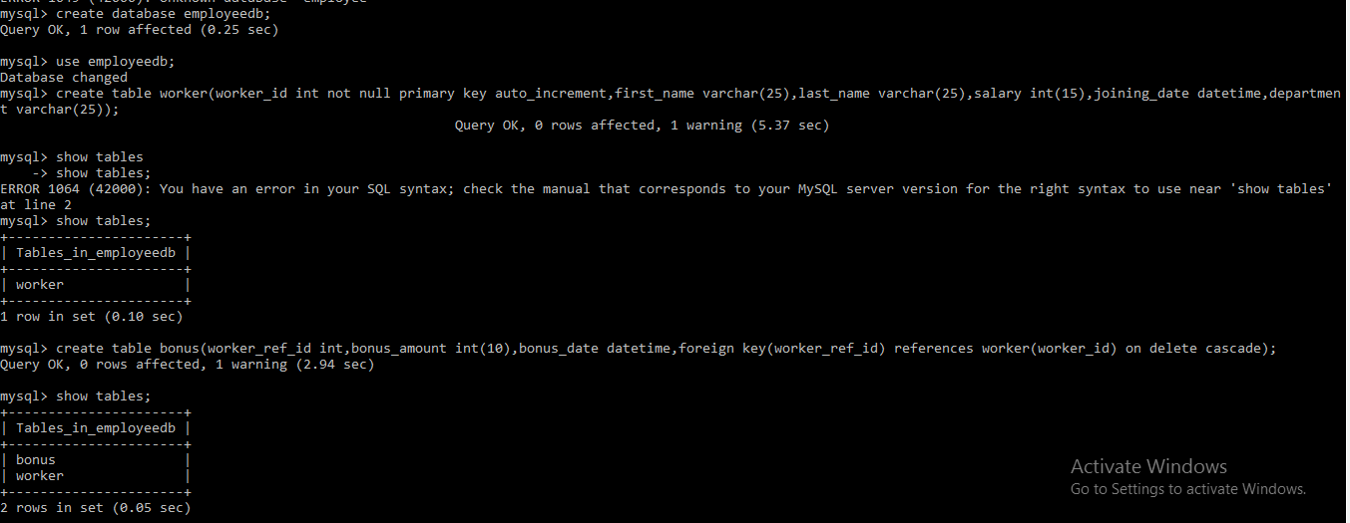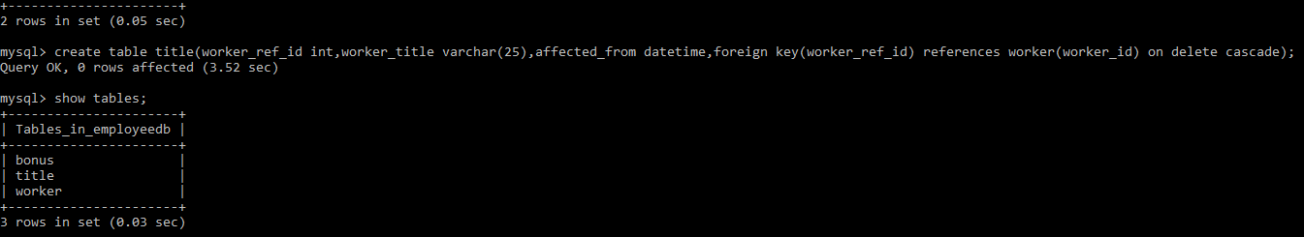

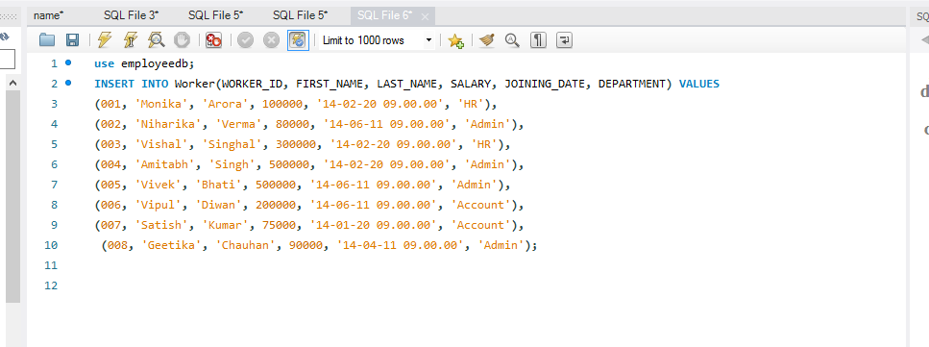



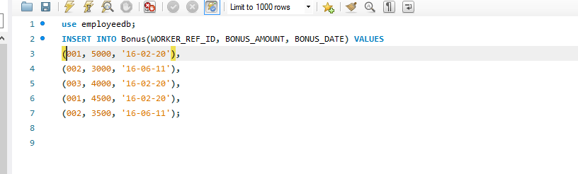

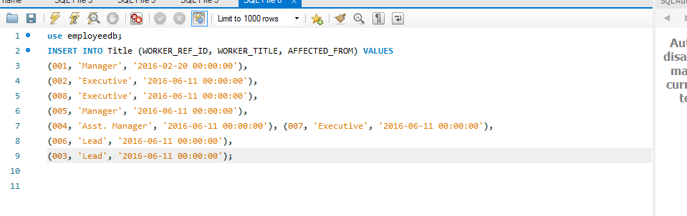

1. Write a SQL query to fetch the count of employees working in the department ‘Admin’;

**Answer**

Use employeedb;

select department,count(*) as count from worker group by department having department=’admin’;

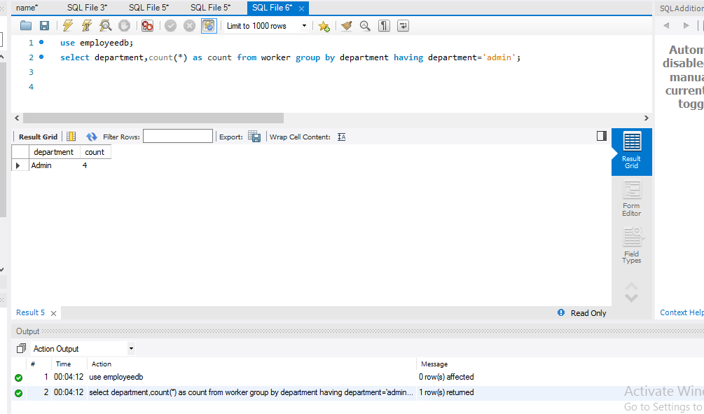

1. Write a SQL query to fetch the no. of workers for each department in the descending order.

**Answer**

use employeedb;

select department, count(*) as no_of _workers from worker group by

department;

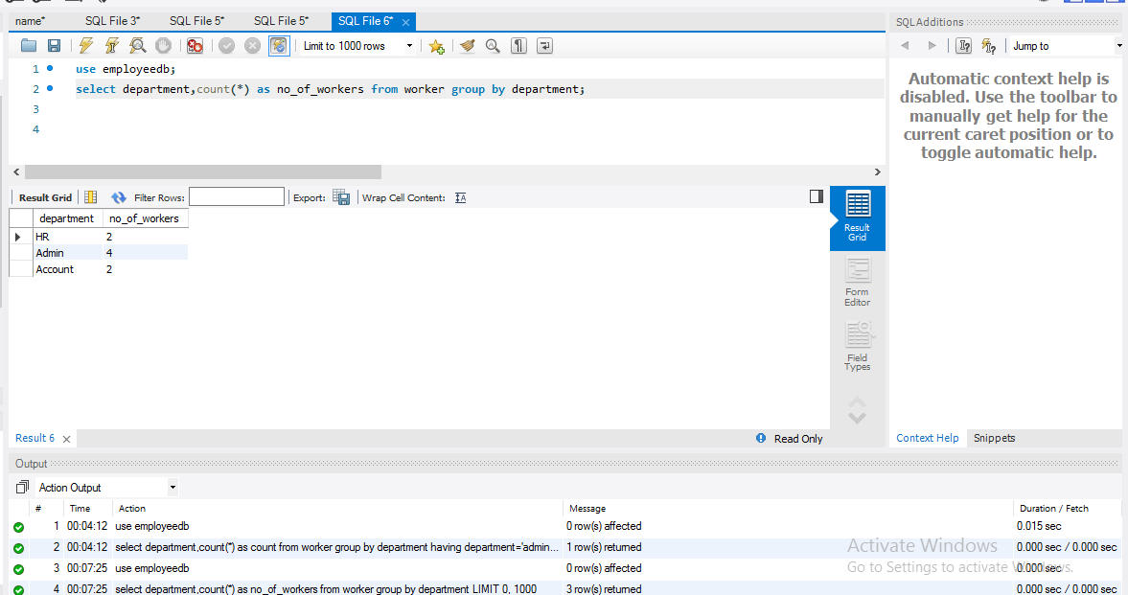

1. Write a SQL query to print details of the workers who are also managers.

**Answer**

use employeedb;

select * from worker left join title on worker.worker_id=title.worker_ref_id where title.worker_title=’manager’;

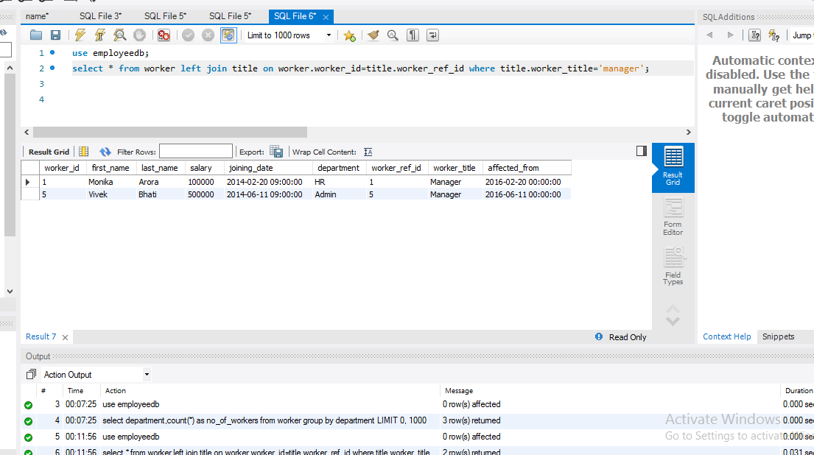

1. Write a SQL query to fetch the departments that have less than people in it.

**Answer**

use employeedb;

select department,count(department) as department from worker group by department having count(department)<5;

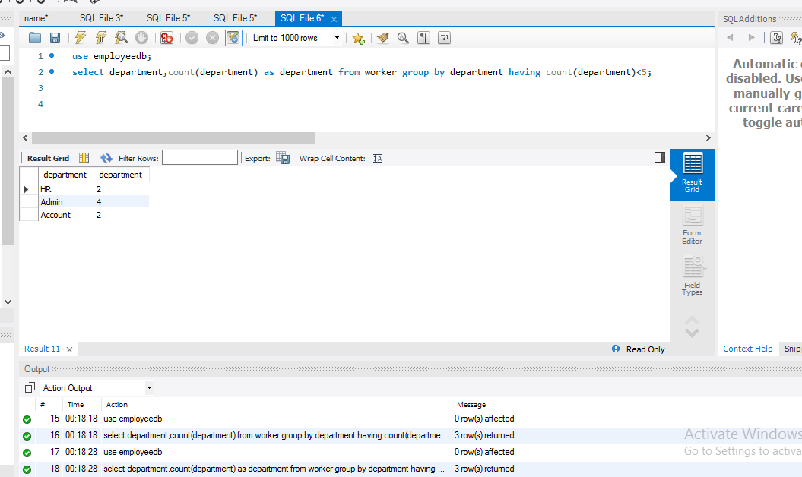

1. Print the worker details with title who have not got any bonus.

**Answer**

use employeedb;

select * from worker left join title on worker.worker_id=title.worker_ref_id where worker.worker_id in (select worker.worker_id from worker left join bonus on worker.worker_id=bonus.worker_ref_id where bonus.worker_ref_id is null);

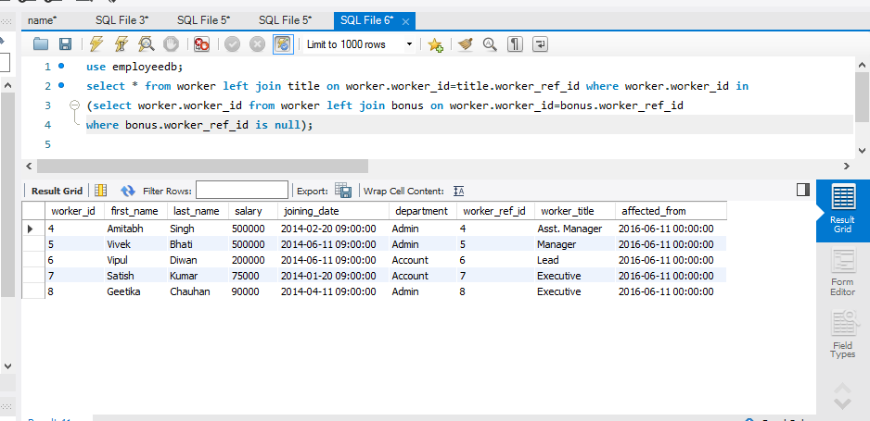

1. Write a SQL query to fetch departments along with the total salaries paid for each of them.

**Answer**

use employeedb;

select department,sum(salary) as total_Salary from worker group by department;

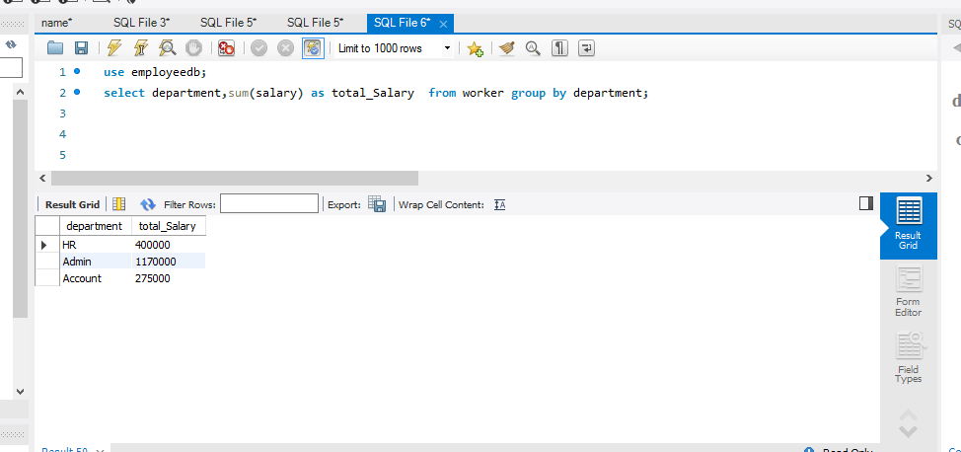

1. Write a SQL query to display the top 3 workers as per the salary earned.

**Answer**

use employeedb;

select * from worker order by salary desc limit 3;

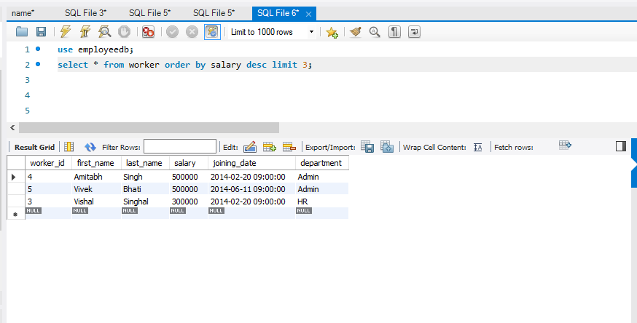

1. Write a SQL query to display title details with most number of workers.

**Answer**

use employeedb;

select * from worker left join title on worker.worker_id = title.worker_ref_id where title.worker_title= (select worker_title from title group by worker_title order by count(worker_title) desc limit 1);

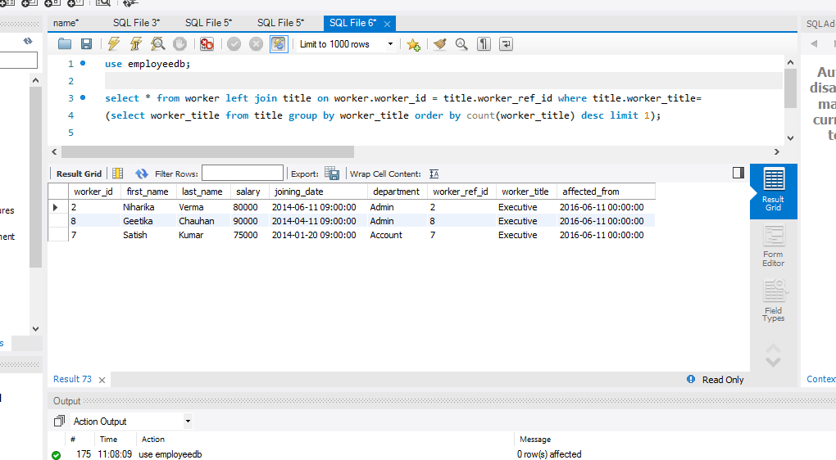

1. Write a SQL query to display worker details with who have more than one bonus.

**Answer**

use employeedb;

select * from worker where worker.worker_id in (select worker_ref_id from bonus group by worker_ref_id having count(worker_ref_id)>1);

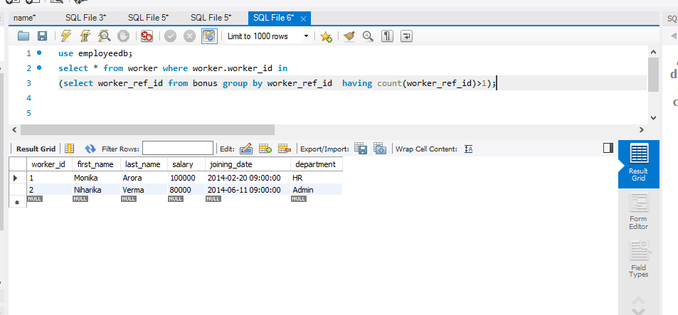

1. Write a SQL query to display average bonus amount of workers.

**Answer**

use employeedb;

select worker_id,worker.first_name,worker.last_name,worker.salary, avg(bonus.bonus_amount) as Average_Salary from bonus left join worker on worker.worker_id=bonus.worker_ref_id group by worker_ref_id ;

