For the purposes of this article, we’re working on a Red Hat Enterprise Linux 7.2 server which has been registered to the Red Hat Network for updates using subscription-manager register --auto-attach. The easiest way to install Ansible is by adding a third-party repository named EPEL (Extra Packages for Enterprise Linux), which is maintained over at<http://fedoraproject.org/wiki/EPEL>. You can easily add the repo by running the following command:

rpm -Uvh<https://dl.fedoraproject.org/pub/epel/epel-release-latest-7.noarch.rpm>

No other software is required as Ansible utilizes SSH to interact with remote servers.

### **Installing Ansible**

Now that we’ve added the EPEL repository, we’re ready to install Ansible! This can be done by running yum -y install ansible on the command line. This will install a bunch of python dependencies during the process, but will only take around 30 seconds to complete.

Once the above has completed, you can confirm that Ansible is installed and ready to go by running ansible --version.

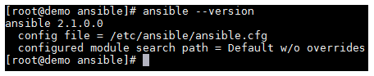

### **Ansible Layout**

Before we create a basic configuration, I want to take a moment to explain the Ansible file/folder structure. You’ll note that if you list the files/folders in /etc/ansible that you’re presented with the following. Alongside, I have included an explanation for each file or folder.

* /etc/ansible — The main configuration folder which encompasses all Ansible config
* /etc/ansible/hosts — This file holds information for the hosts/and host groups you will configure
* /etc/ansible/ansible.cfg — The main configuration file for Ansible
* /etc/ansible/roles — This folder allows you to create folders for each server role, web/app/db, etc.