BenneKaffi Self-Ordering System
Complete User Guide & Flow Walkthrough
Staff & owner reference

1. Overview
This system lets guests order from their phone by scanning a table QR code, while your staff manage the menu, orders, kitchen tickets and settings from an admin panel. It has three parts:
- Customer ordering (guest phones) - browse the menu, add to cart, place the order, pay at the counter.
- Admin panel (owner / manager) - menu, tables, orders, kitchen tickets, reports and settings.
- Kitchen (chef) screen - the live queue of items to cook and mark ready.
The sections below walk through every screen and the options on it.

2. Customer Ordering Flow

2.1 Landing page
The public home page shown at your website address. Guests can view the menu highlights, story, outlets and reach the ordering flow. All sections are editable from Admin > Landing Page.
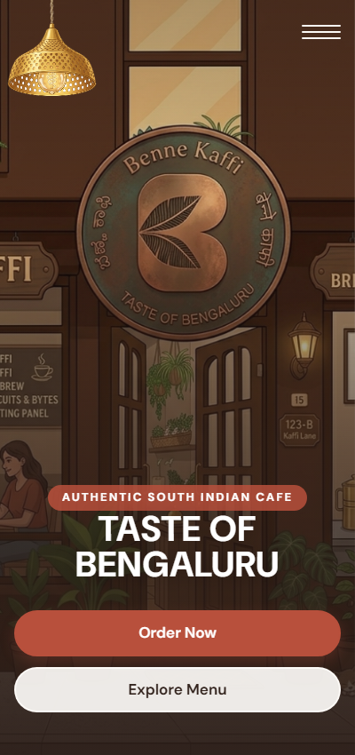
The public landing page.

2.2 Start an order
Scanning a table's QR code opens the sign-in for that table. A guest table only needs a name; a numbered table asks for the PIN printed on its QR stand.
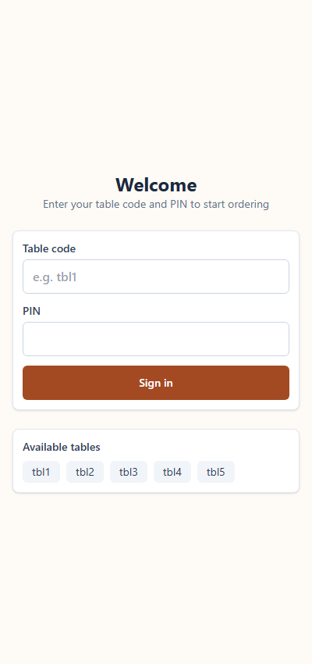
Table sign-in screen.

2.3 Enter your details
The guest enters their name (and optionally mobile number) and party size to start the order.
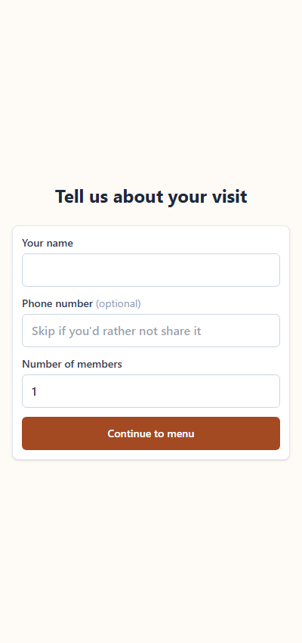
Guest details screen.

2.4 Browse the menu
The menu is grouped by category with photos, veg / non-veg marks, ratings and bestseller tags.
- Search - find a dish by name or description.
- Category tabs - jump to a section.
- Veg and Bestsellers filters, and a Sort control (price, name, bestsellers first).
- Quick requests - one tap to notify staff (call waiter, clean table, water, bill).
- ADD / the +/- stepper add items to the cart; the bottom bar shows the running total and 'Place order'.
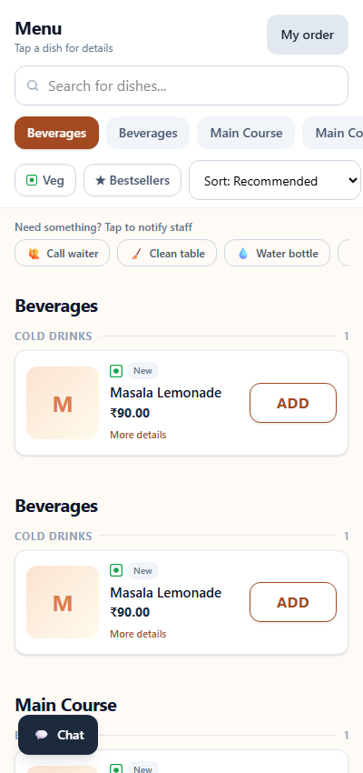
The customer menu with photos and filters.

2.5 Dish details
Tapping a dish opens its full details with the photo, price and description, and an add control.
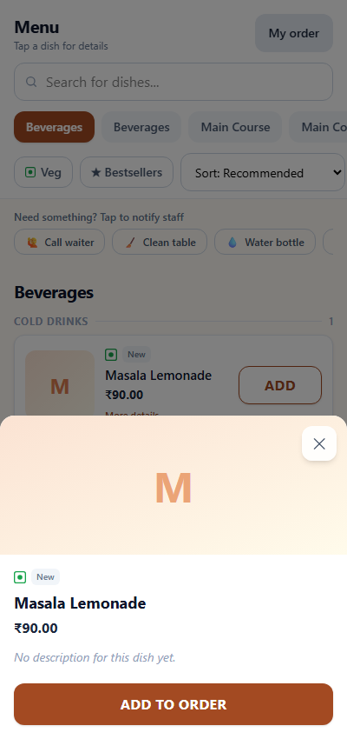
Dish detail popup.

2.6 Your order & checkout
After placing the order the guest sees a live bill with each item's status.
- Estimated ready time banner (configurable in Settings).
- Apply a coupon code.
- Order more, request checkout (staff are notified to take payment at the counter), or download the invoice.
- Chat with staff and leave feedback.
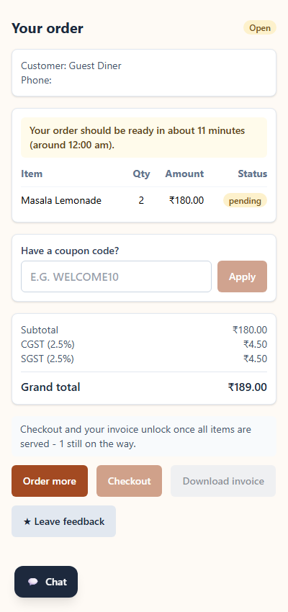
The guest's live order and checkout screen.

3. Admin Panel

3.1 Signing in
Open /admin and sign in with your admin username and password. Forgot-password uses your security answer.
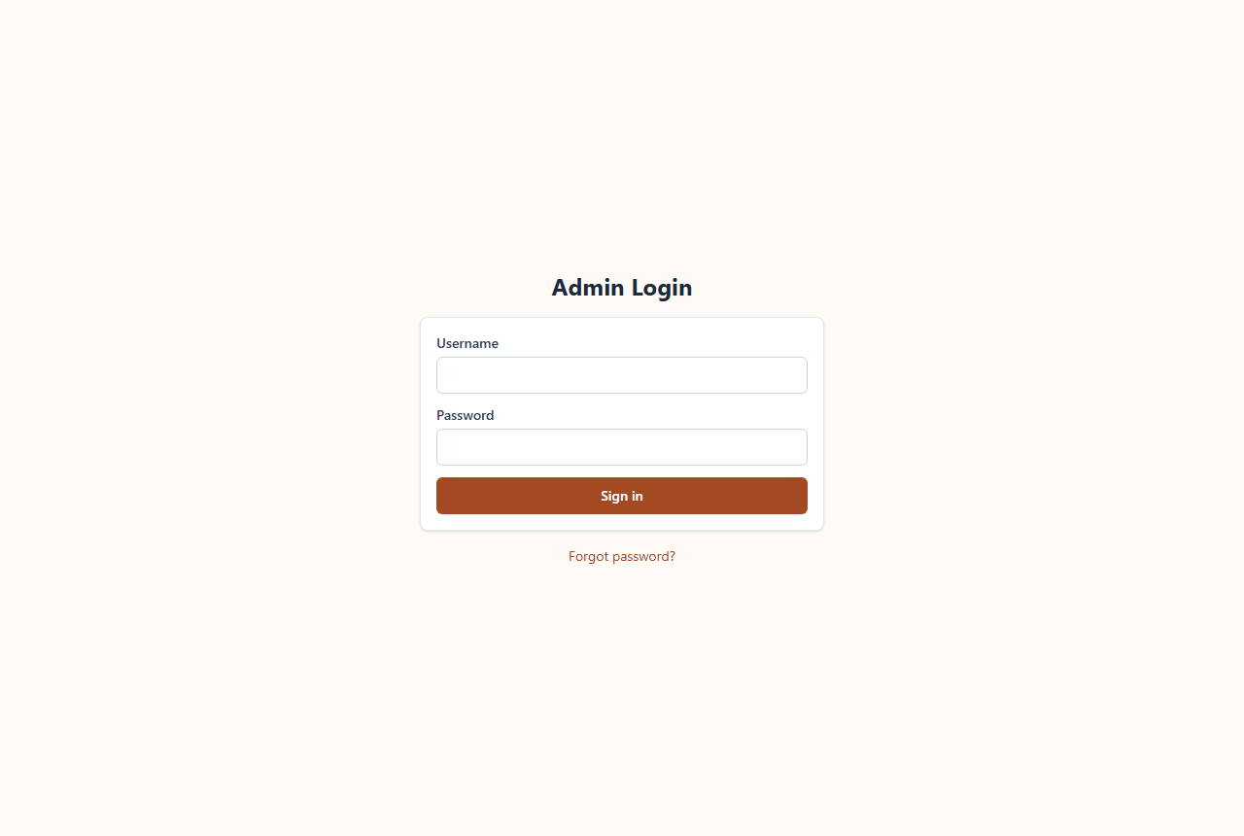
Admin sign-in.

3.2 Dashboard
The home screen after login shows today's figures and the open orders. The '+ New order' button starts a counter order directly.
- Open / closed orders today, sales today, pending kitchen items.
- 'Today' follows your configured day-end time and timezone (see Settings).
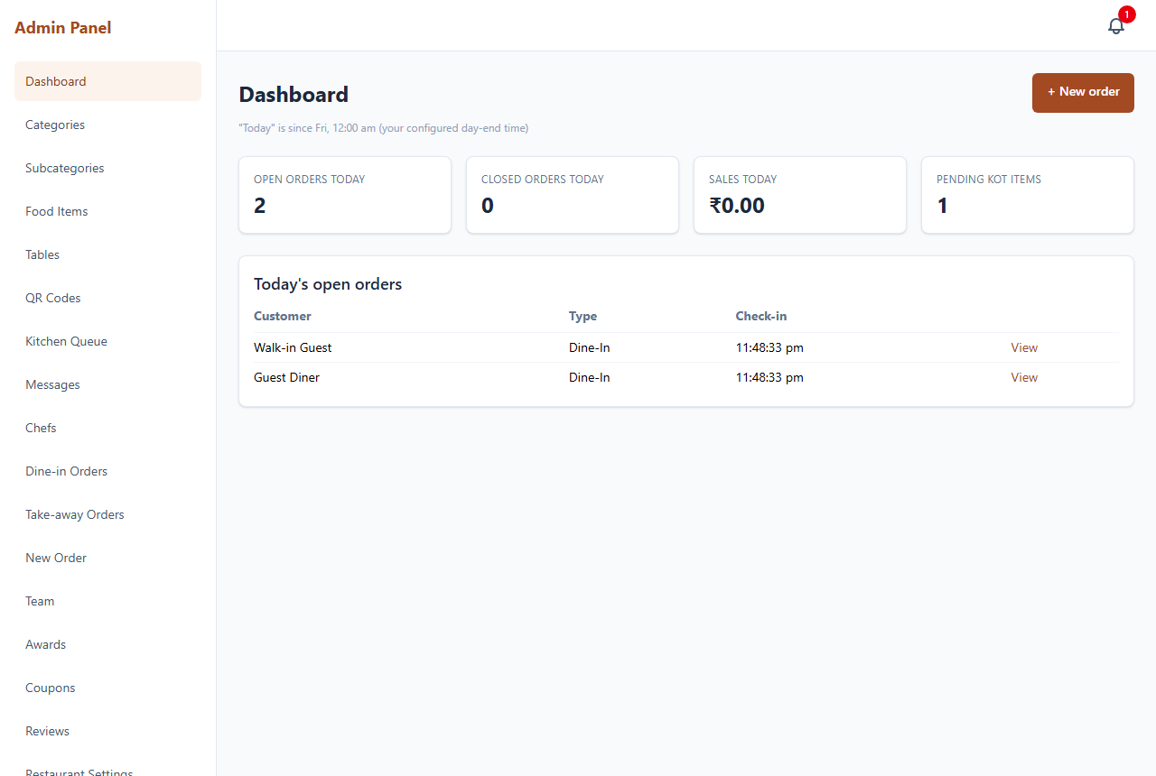
Admin dashboard.

3.3 Menu setup
Build the menu in three levels: Categories, Subcategories and Food Items.
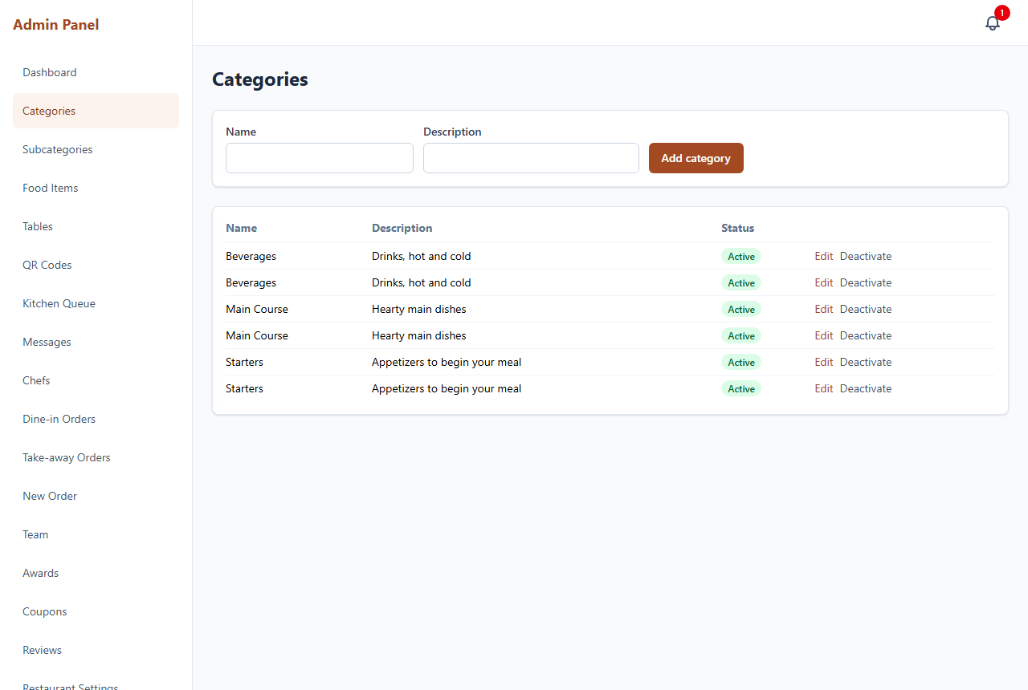
Categories.
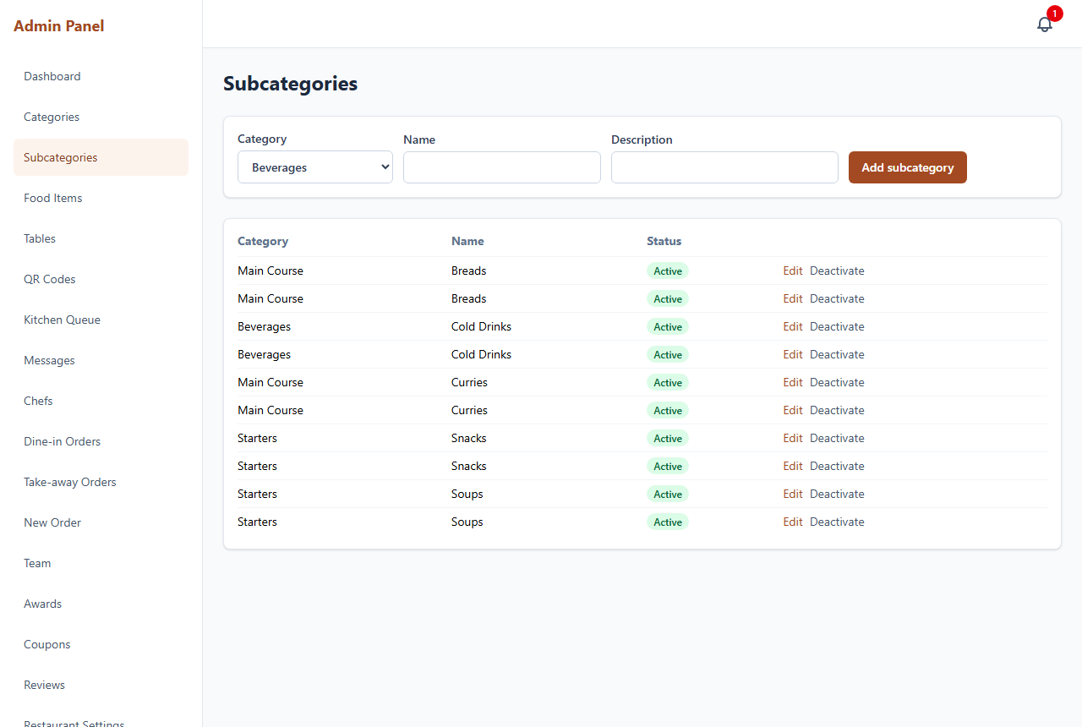
Subcategories.
Each food item carries its photo, price, food type (veg / non-veg / egg), rating, bestseller tag and a prep time in minutes (used to estimate when an order will be ready).
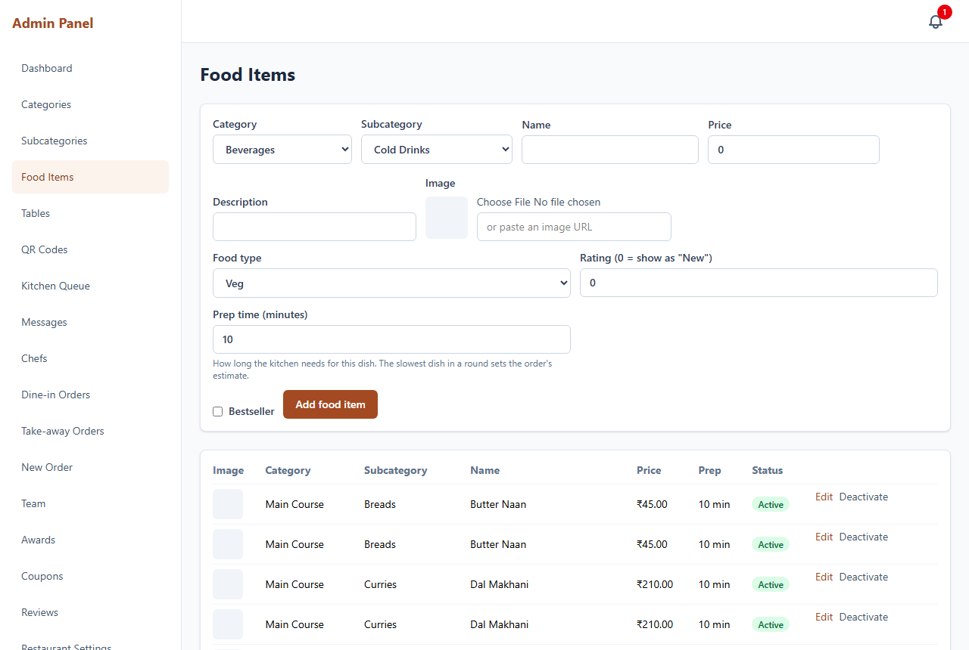
Food items, with prep time and bestseller options.

3.4 Tables & QR codes
Manage every table and its QR sign-in.
- Add a table with a code and PIN; tick 'Guest table' for a shared walk-in / counter table.
- Auto-release after (minutes): a global default plus a per-table override (shown in hours/minutes). An abandoned occupied table frees itself and cancels any order it never sent to the kitchen.
- Per row: reset PIN, release, view KOT, delete, and an 'occupied since' indicator.
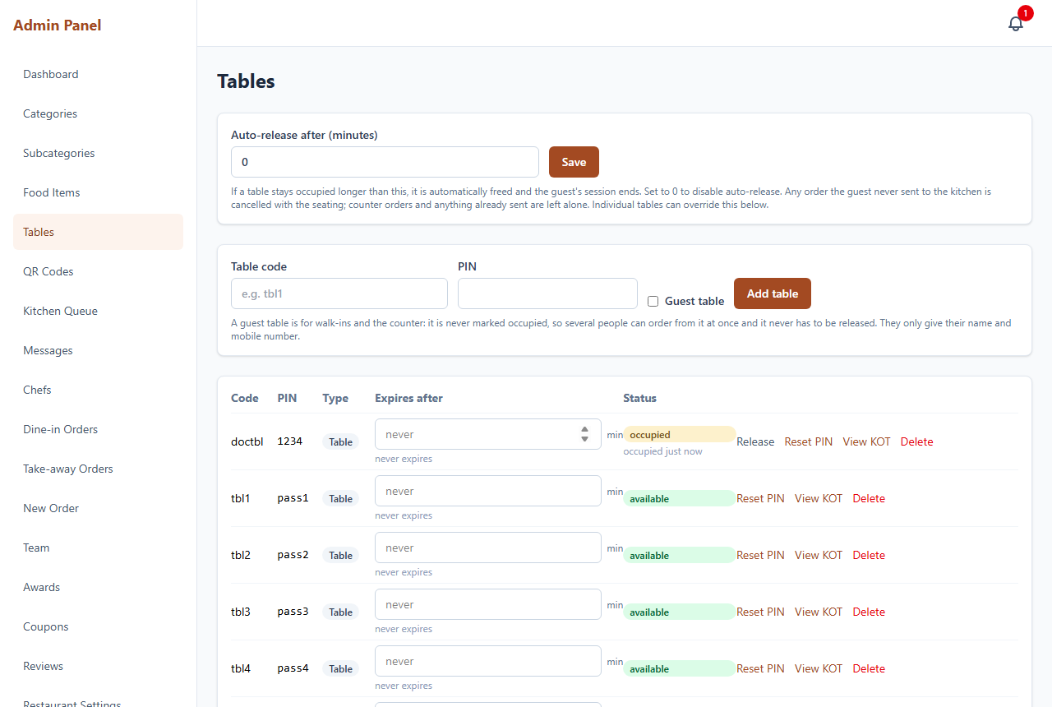
Tables, with per-table expiry.
The QR Codes screen produces a printable QR for each table.
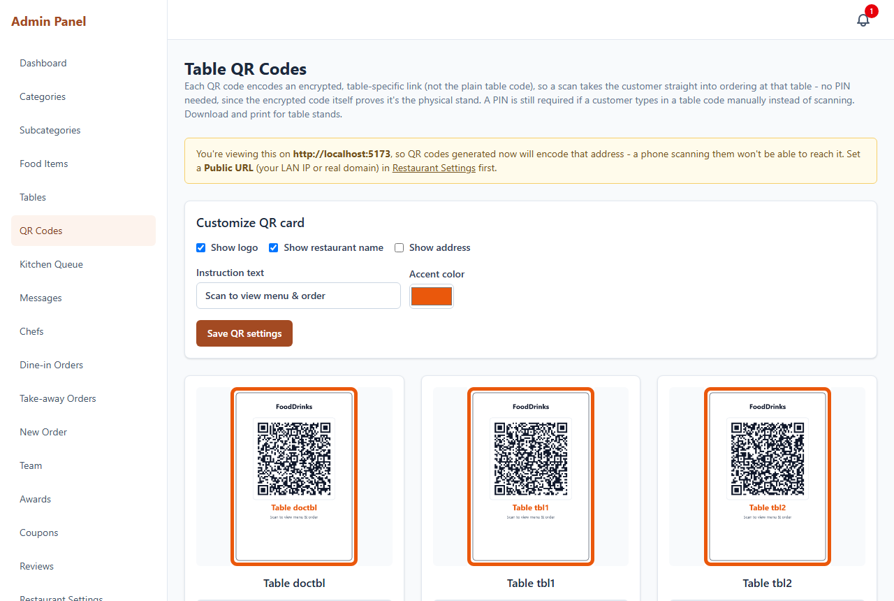
Printable table QR codes.

3.5 Taking a counter order
Use '+ New order' (dashboard) or the New Order menu to start an order at the counter - no table needed.
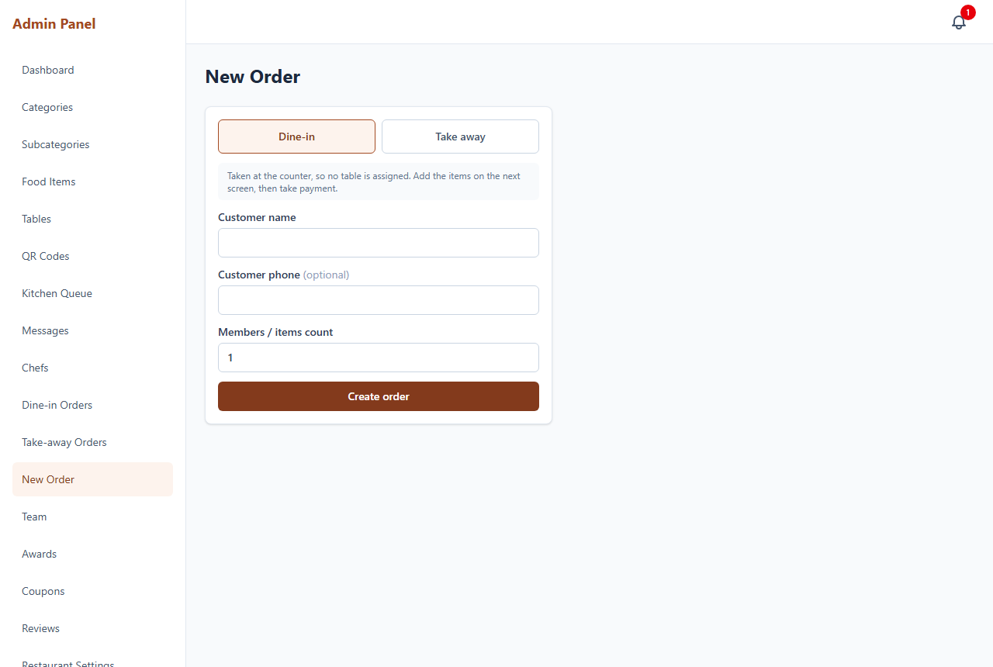
New counter order form.
The Order Detail screen is the counter workspace. The item picker looks like the customer menu, with an 'All items' tab plus category tabs and dish cards with photos.
- Tap ADD / +/- to build a selection, then 'Add to order'.
- Apply a coupon, take payment (cash / online / card) with 'Mark paid', or print the invoice.
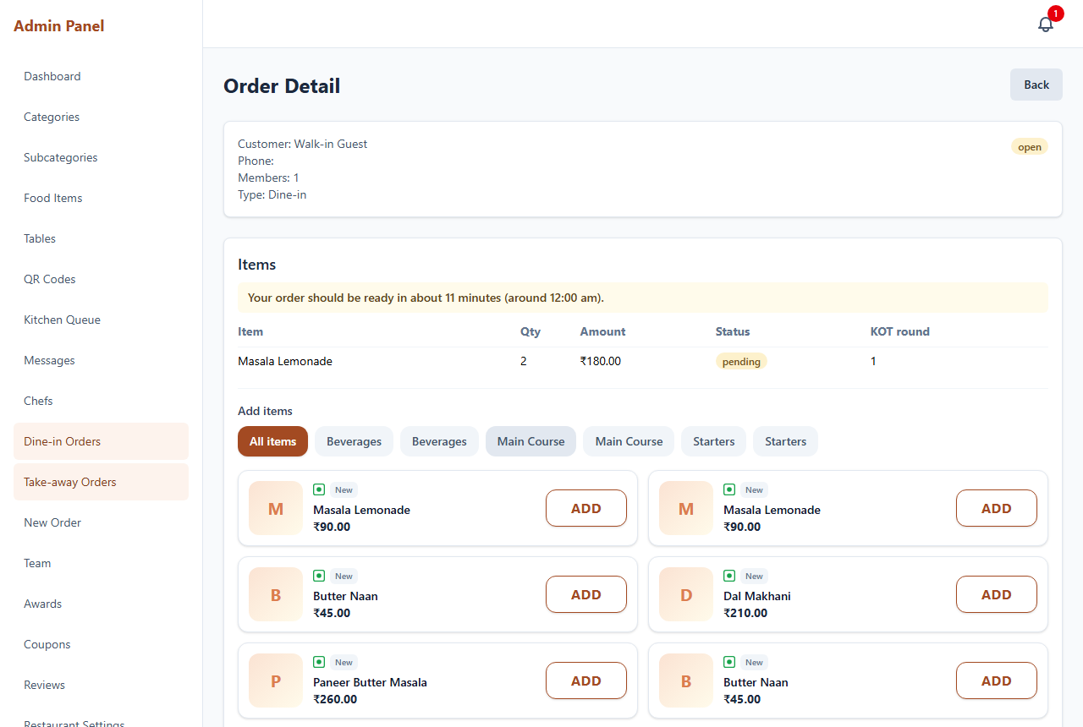
Counter Order Detail with the visual menu picker.

3.6 Kitchen tickets (KOT)
Kitchen tickets can be sent from the Order Detail's KOT section or from the Kitchen Queue.
- Send new items - prints the not-yet-sent items on a new ticket with a NEW token number.
- Reprint KOT - re-opens an already printed ticket using its ORIGINAL token; it never issues a new one.
- Take-away / delivery tickets print a 'PACK' instruction.
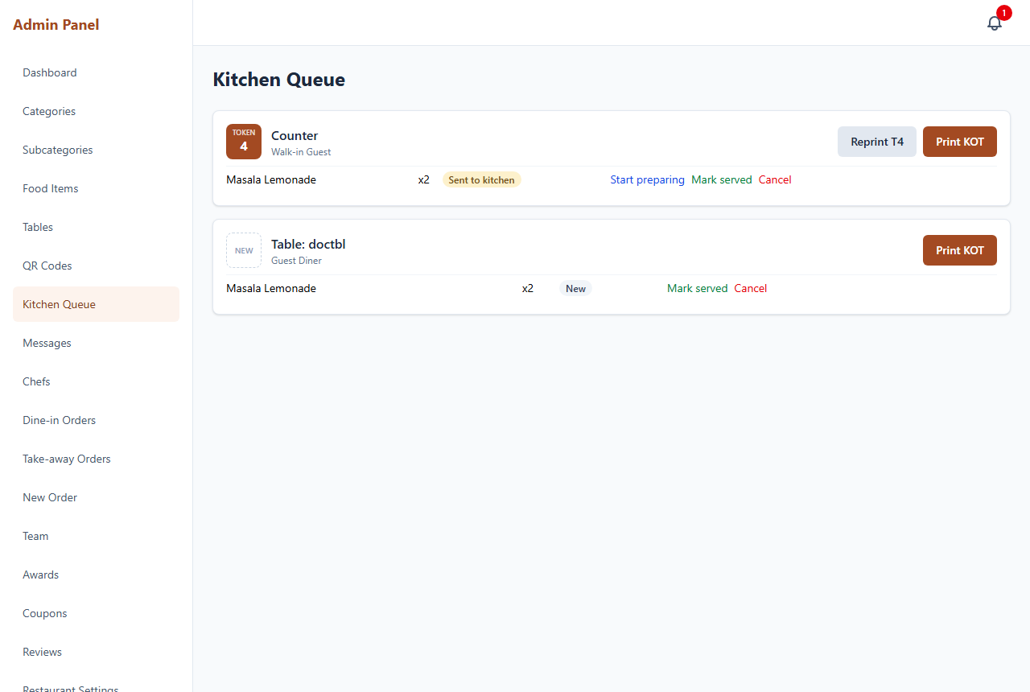
Kitchen Queue with Print KOT and Reprint.

3.7 Orders & reports
Dine-in Orders and Take-away Orders list orders with filters by type, status and date. Yesterday / Today shortcuts and a From / To range all follow your business day-end time.
- Download CSV - a spreadsheet of the filtered orders with totals.
- Download PDF - a printable report; the file name includes the date.
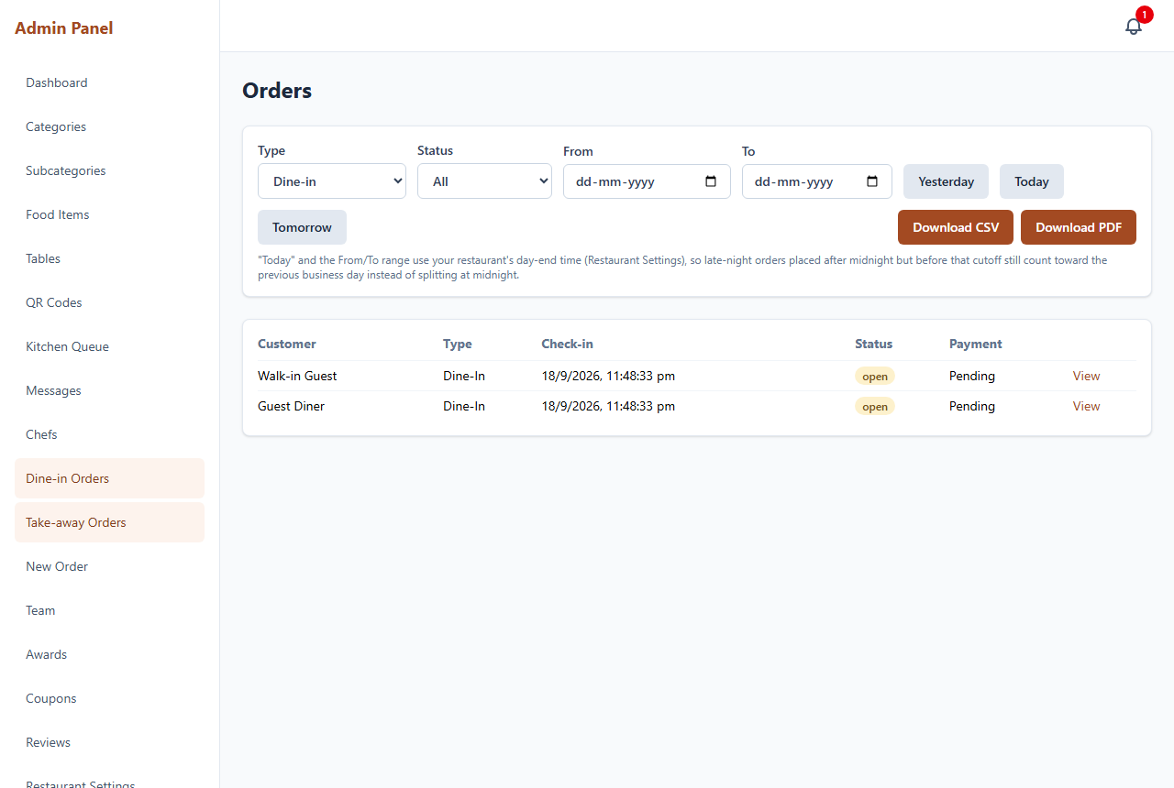
Dine-in orders with date filters and report downloads.
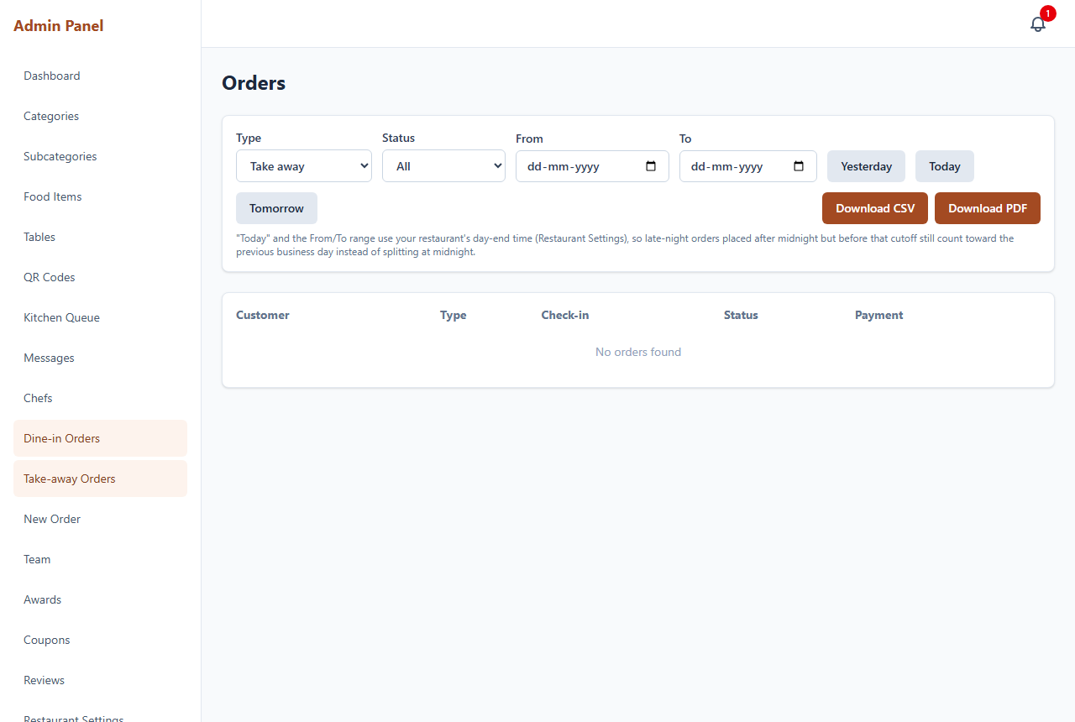
Take-away orders.

3.8 Messages & chat filter
Chat with guests per order. An abuse/violence filter cleans or blocks offensive messages; filtered messages are marked here. Configure it in Settings.
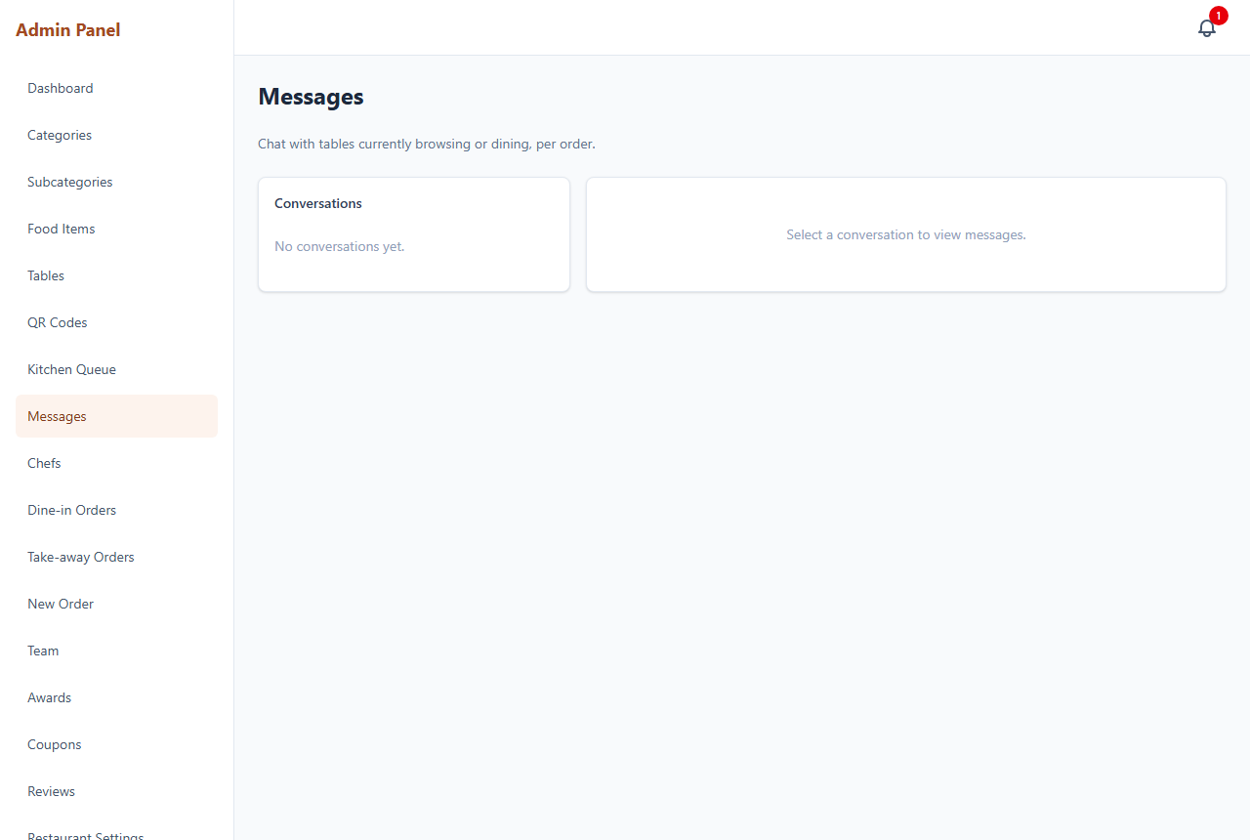
Guest messages.

3.9 Chefs
Create kitchen staff logins for the chef screen.
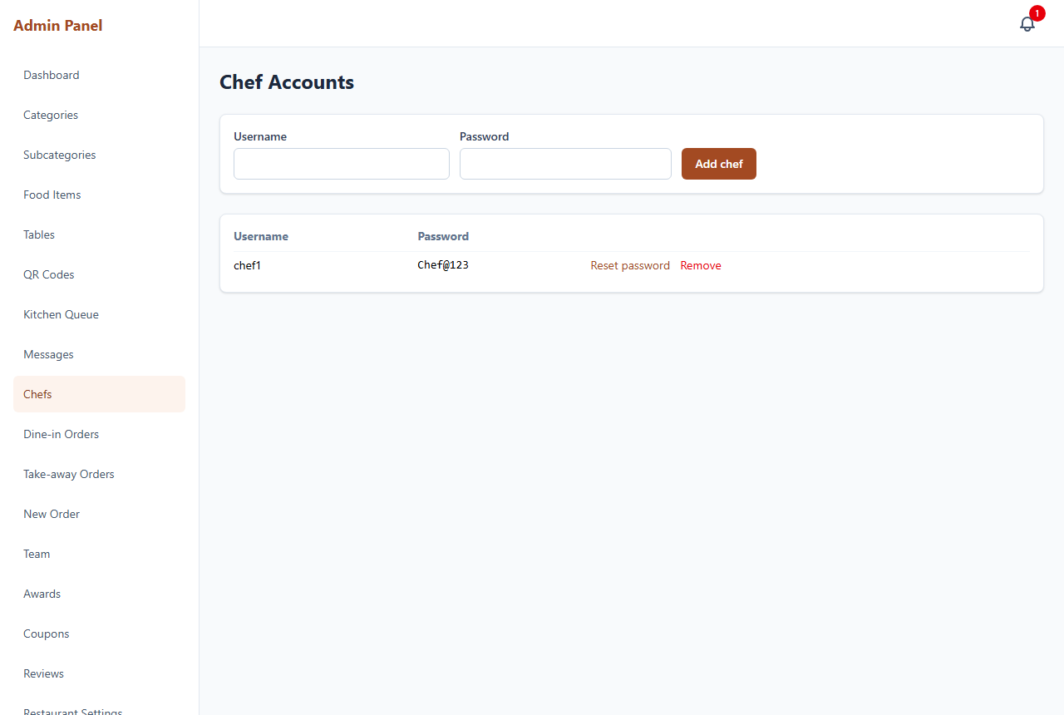
Chef accounts.

3.10 Team, Awards, Coupons & Reviews
Manage the people shown on the landing page (Team), accolades (Awards), discount codes (Coupons) and guest reviews (Reviews, with approval).
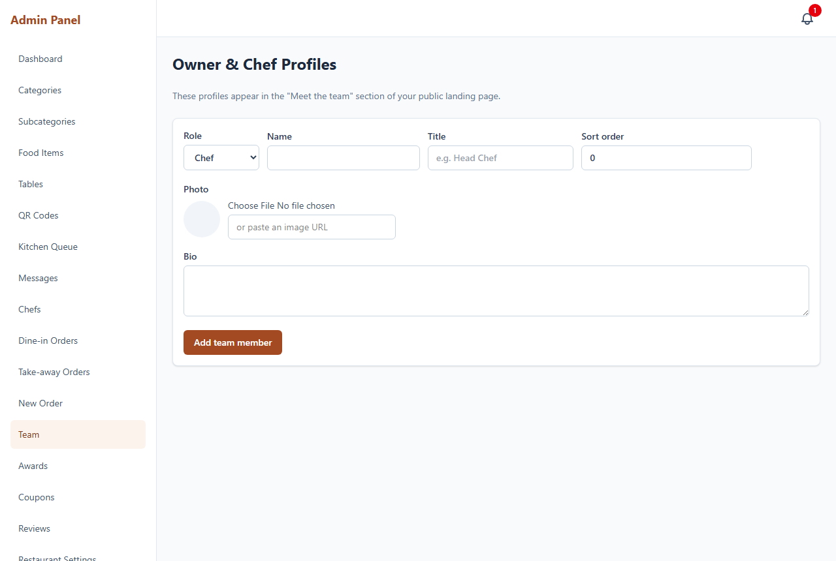
Team members.
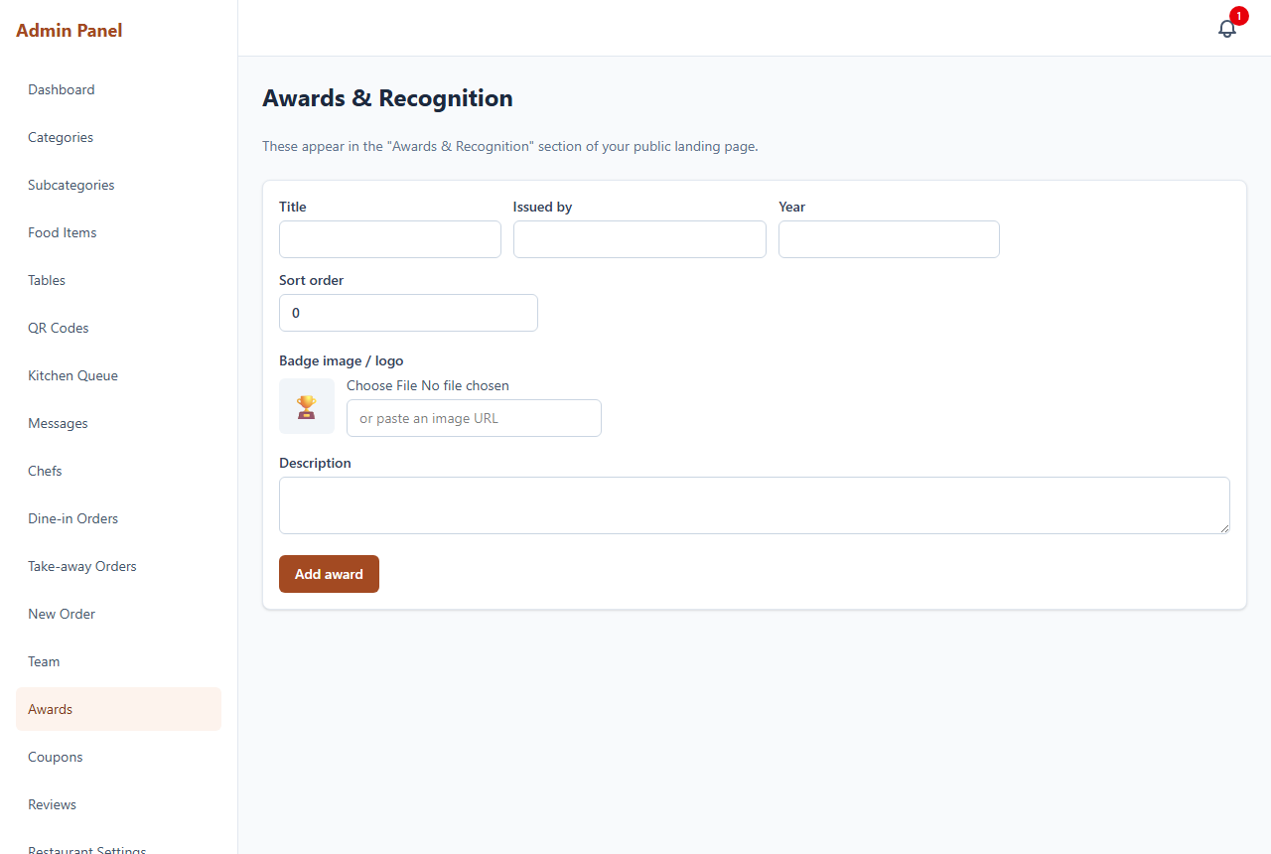
Awards.
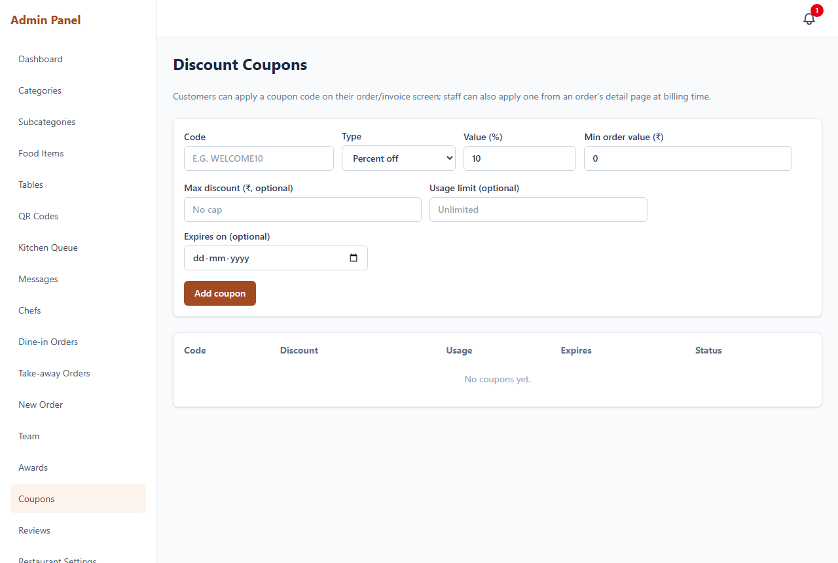
Coupons.
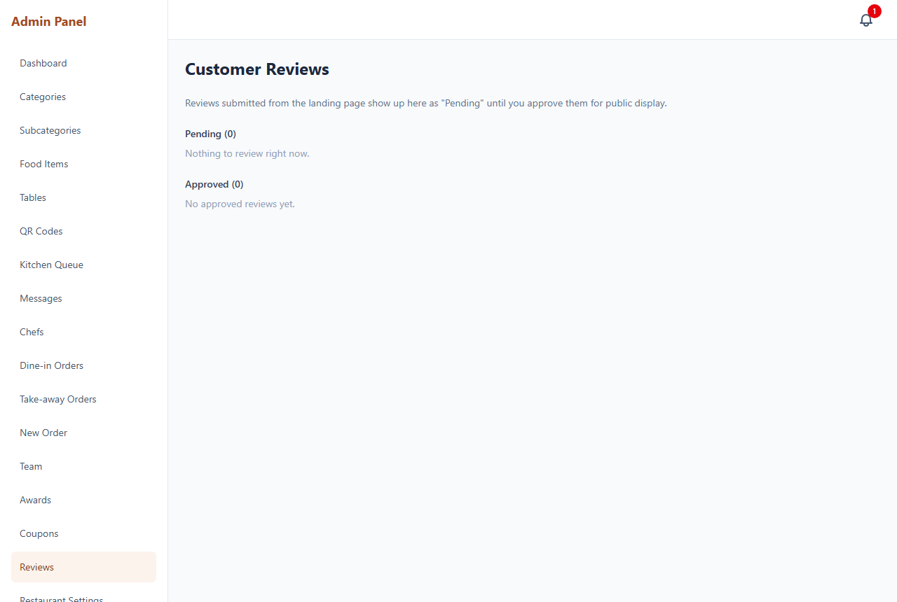
Reviews.

3.11 Restaurant Settings
Central settings for the whole system:
- Name, logo, favicon, address, GST / FSSAI, public URL for QR codes.
- Day-end time - when the business day rolls over (keep 00:00 unless you trade past midnight).
- Timezone - the zone your business day and reports are measured in.
- Preparation time - a delay buffer and the ready-time message guests see.
- Chat abuse filter - on/off, mask or block, and your own banned words.
- Tax rates, and KOT / invoice print settings.
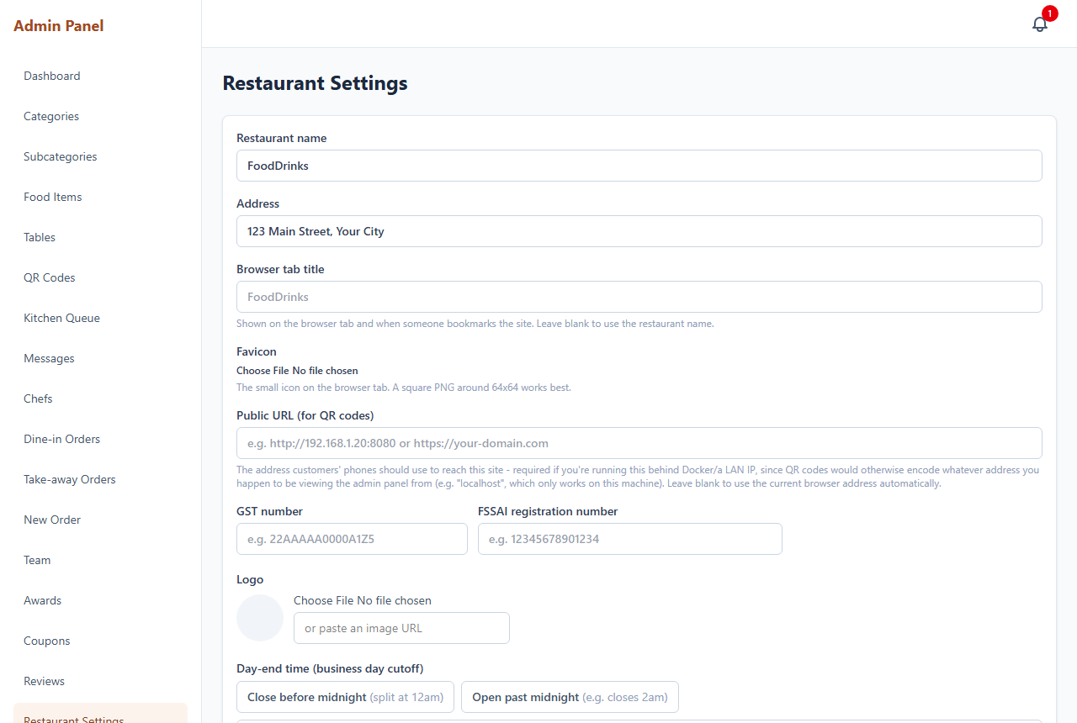
Restaurant settings.
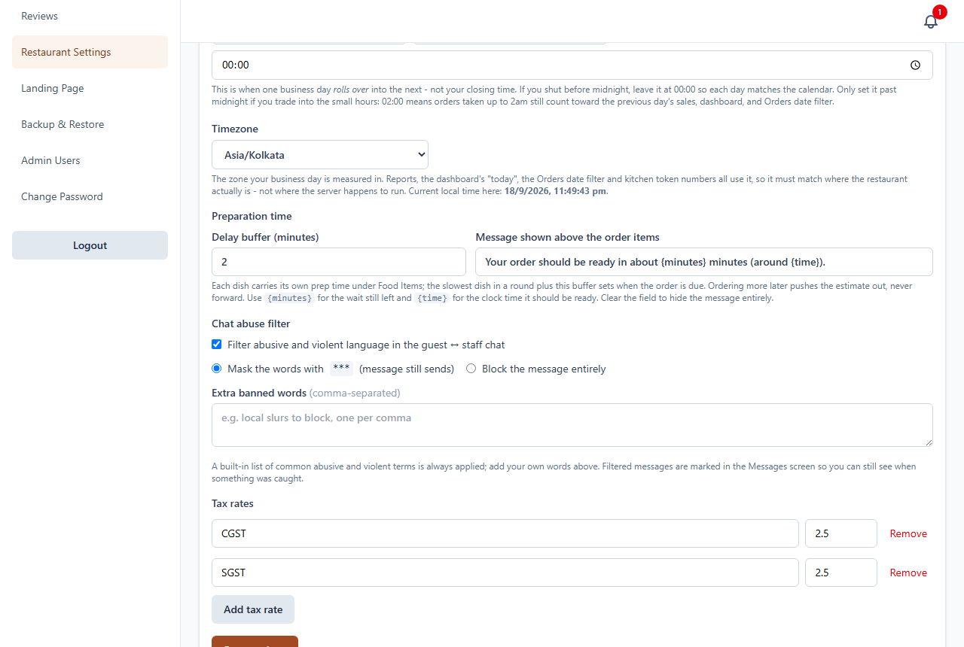
Preparation time and chat abuse filter settings.

3.12 Landing Page editor
Edit every section of the public landing page - hero banner (text, alignment, show/hide, images), what we serve, menu, story, outlets, reels, partnership and footer.
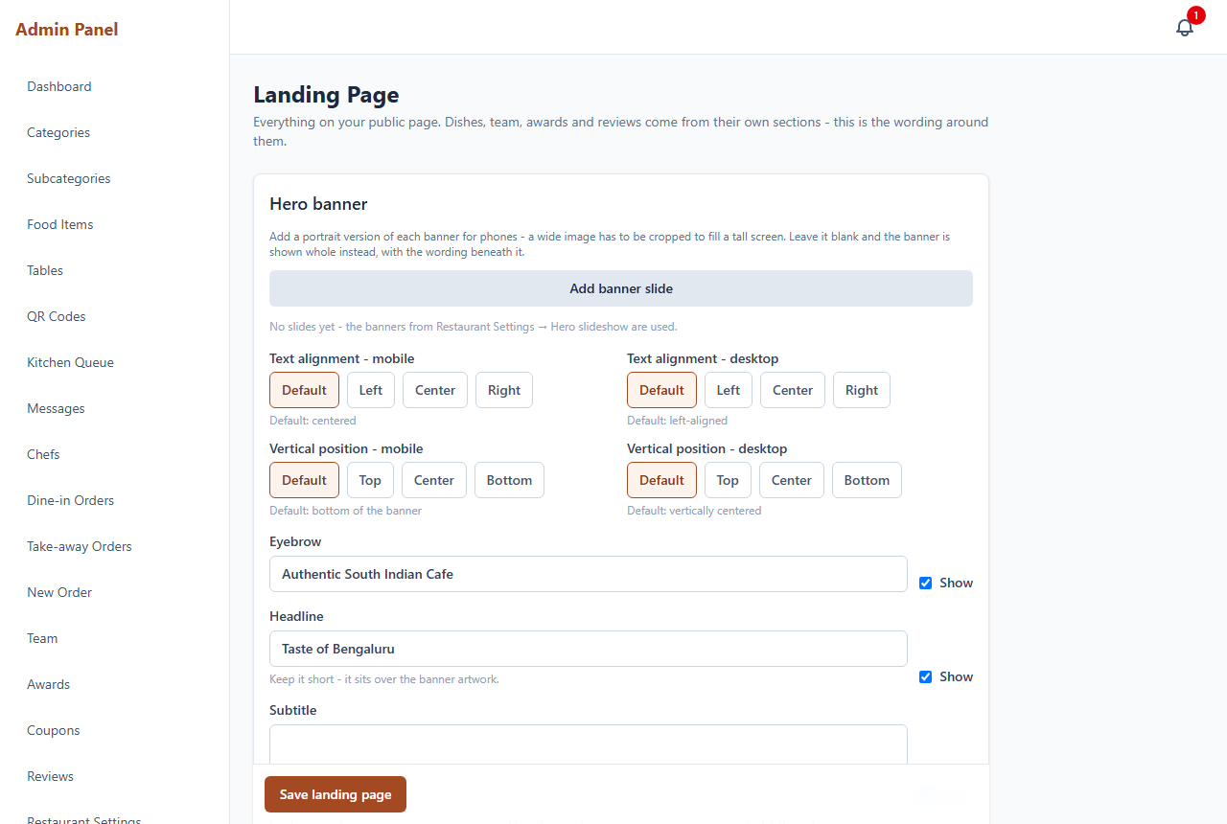
Landing page content editor.

3.13 Backup & Restore
Protect your data.
- Download backup - saves a snapshot to your device (works on any host).
- Generate backup (save on server) and an automatic daily schedule, where server storage is available.
- Restore from a saved backup or an uploaded file.
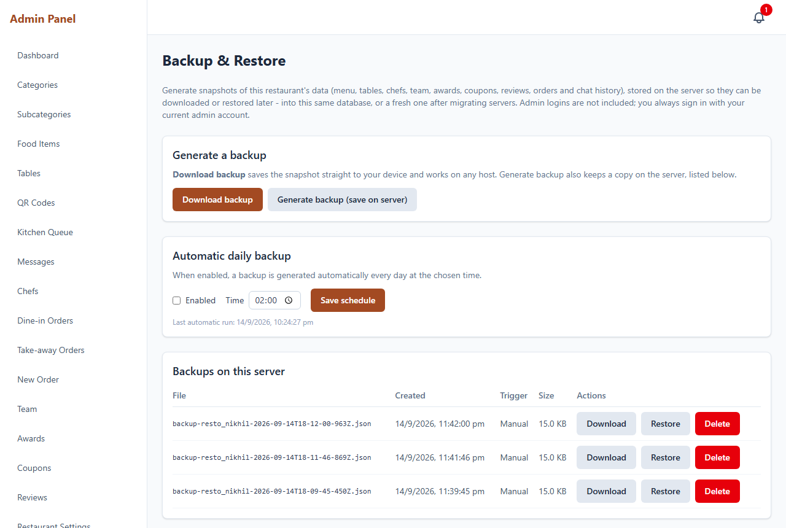
Backup & restore.

3.14 Admin users & permissions
Create additional admin accounts and grant each one view or edit access per module. The owner account always has full access.
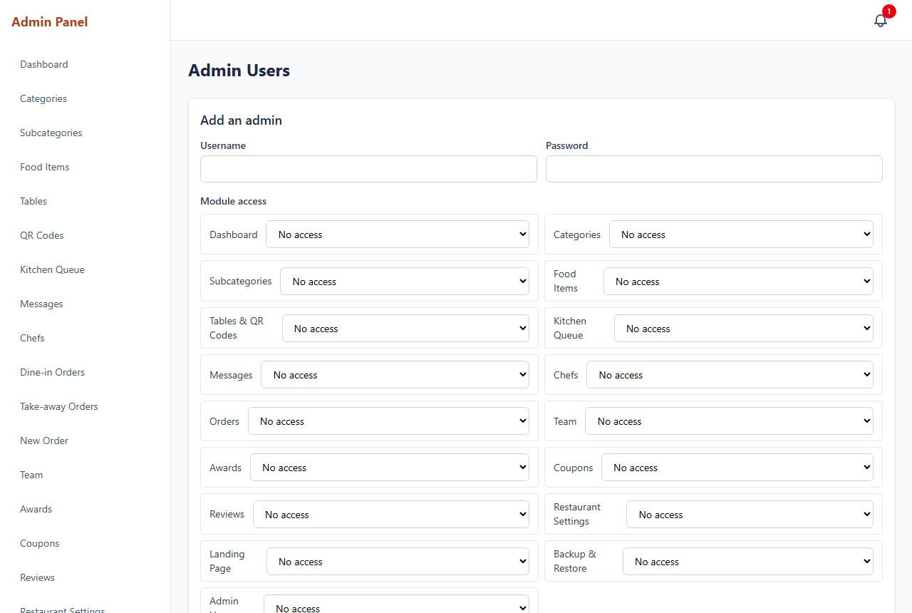
Admin users and permissions.

4. Kitchen (Chef) App
Kitchen staff sign in at /chef to see the live queue.
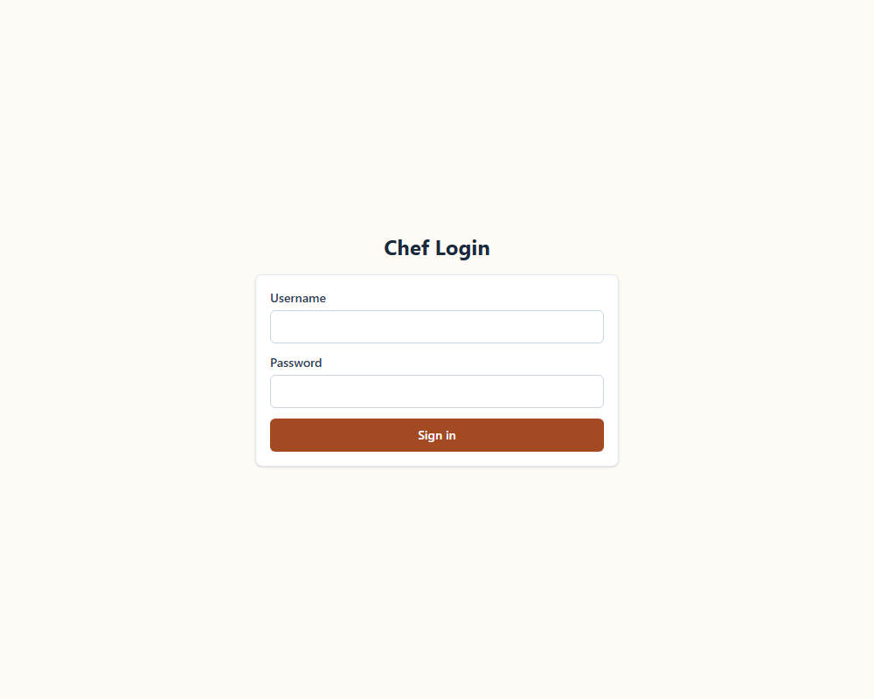
Chef sign-in.
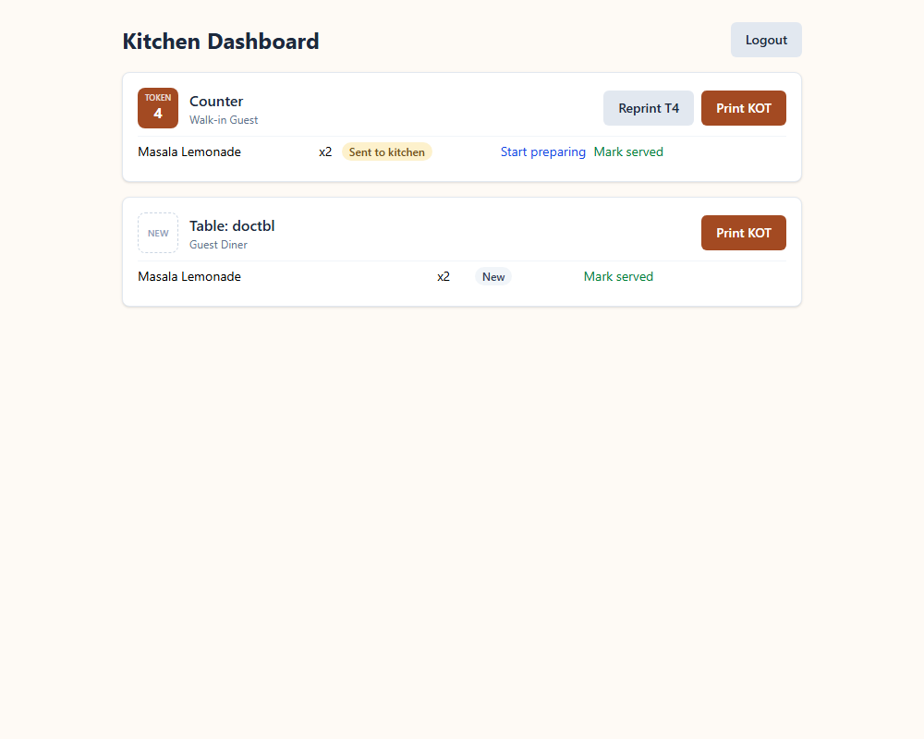
Chef live kitchen queue.

5. Good to know
- Business day & timezone: 'today', reports and kitchen token numbering all follow the day-end time and timezone set in Restaurant Settings - so set them to where the restaurant actually is.
- KOT tokens: a token is issued only when new items are sent to the kitchen; reprinting keeps the same token.
- Guest tables are shared and never lock, so several walk-ins can order from one at once.

