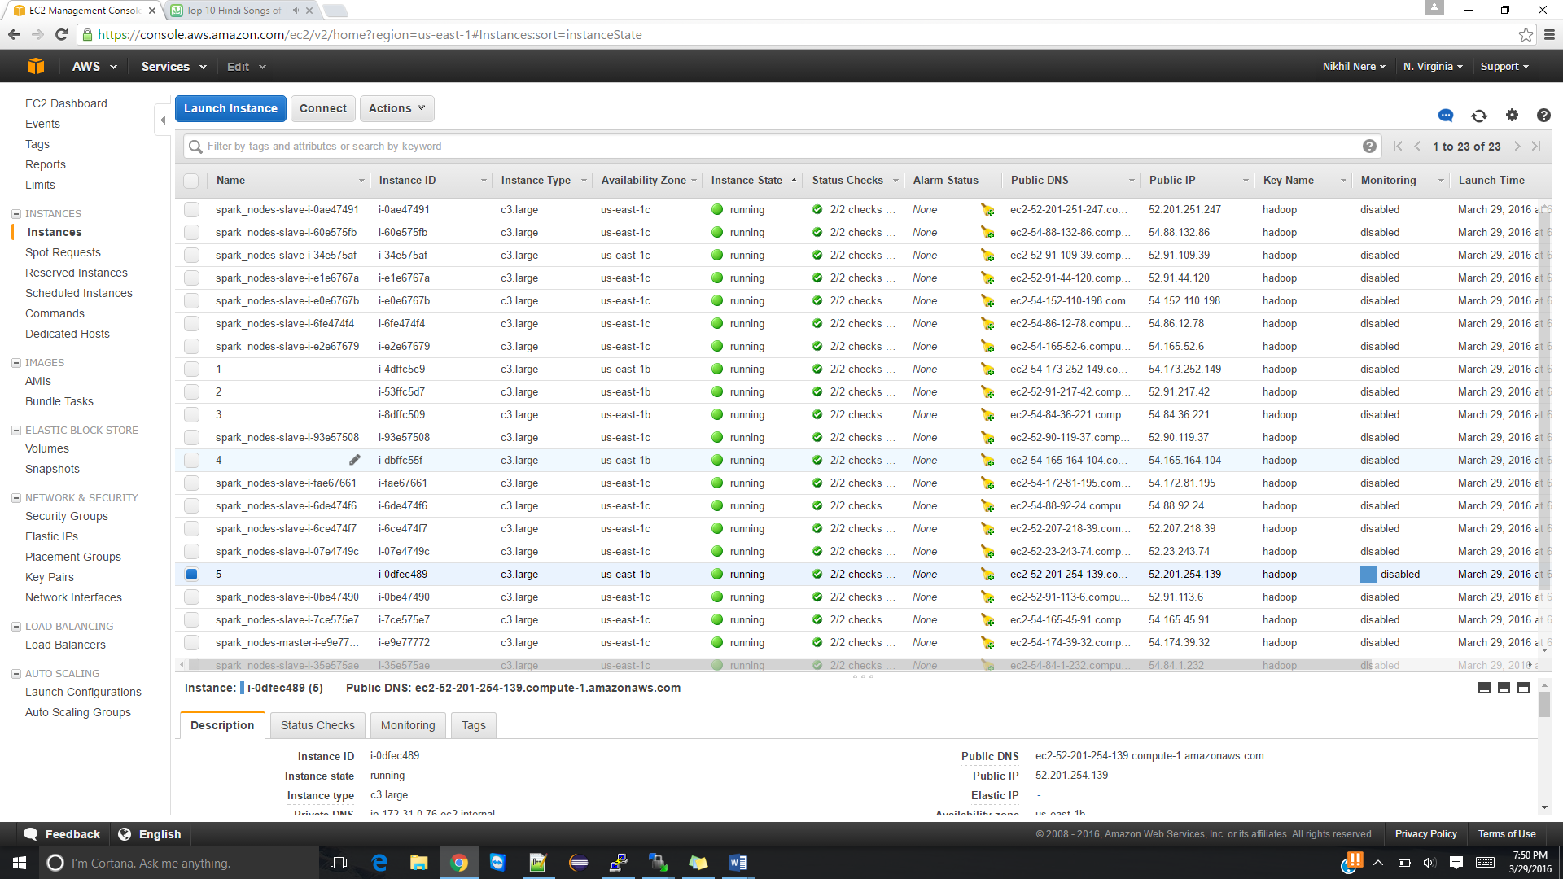

scp -i hadoop.pem -r sharedmemory ubuntu@54.173.252.149

scp -i hadoop.pem -r sharedmemory ubuntu@52.91.217.42

scp -i hadoop.pem -r sharedmemory ubuntu@54.84.36.221

scp -i hadoop.pem -r sharedmemory ubuntu@54.165.164.104

scp -i hadoop.pem -r sharedmemory [ubuntu@52.201.254.139](mailto:ubuntu@52.201.254.139)

