git clone https://github.com/shubhamkushwah123/bootcamp10.git

Cloning into 'bootcamp10'...

remote: Enumerating objects: 223, done.

remote: Counting objects: 100% (223/223), done.

remote: Compressing objects: 100% (158/158), done.

remote: Total 223 (delta 43), reused 208 (delta 32), pack-reused 0

Receiving objects: 100% (223/223), 30.37 MiB | 35.96 MiB/s, done.

Resolving deltas: 100% (43/43), done.

ubuntu@ip-172-31-31-116:~$ ls

bootcamp10

ubuntu@ip-172-31-31-116:~$ cd bootcamp10

ubuntu@ip-172-31-31-116:~/bootcamp10$ ls

Dockerfile README.md addressbook_screenshot.png build.properties build.xml docker-compose.yml index.html pom.xml src target

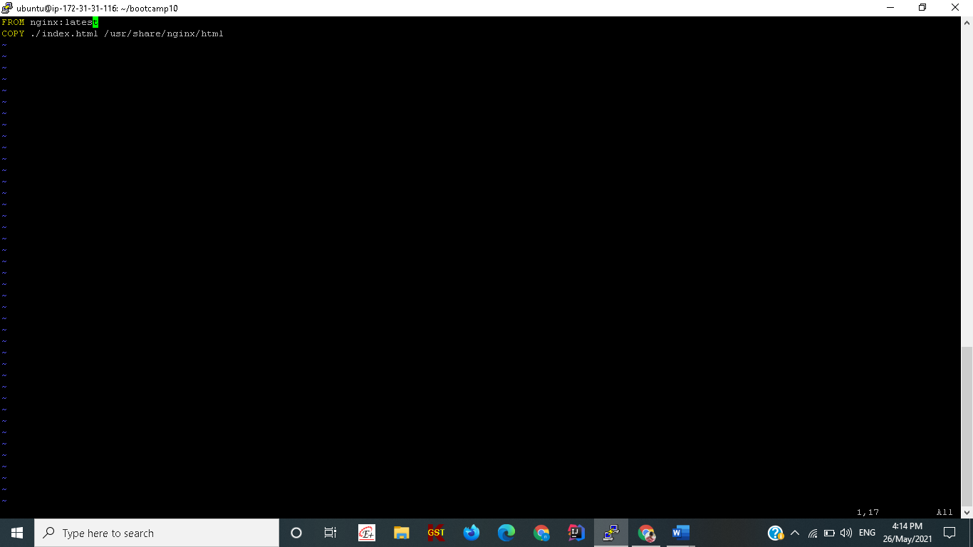

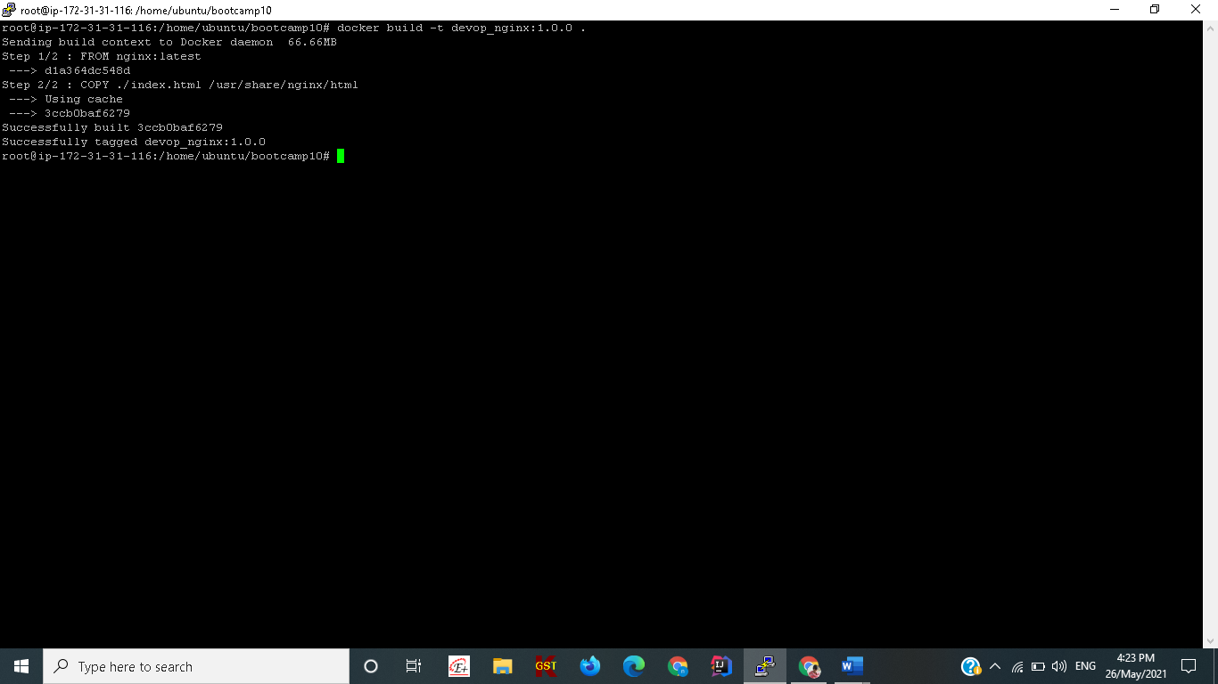

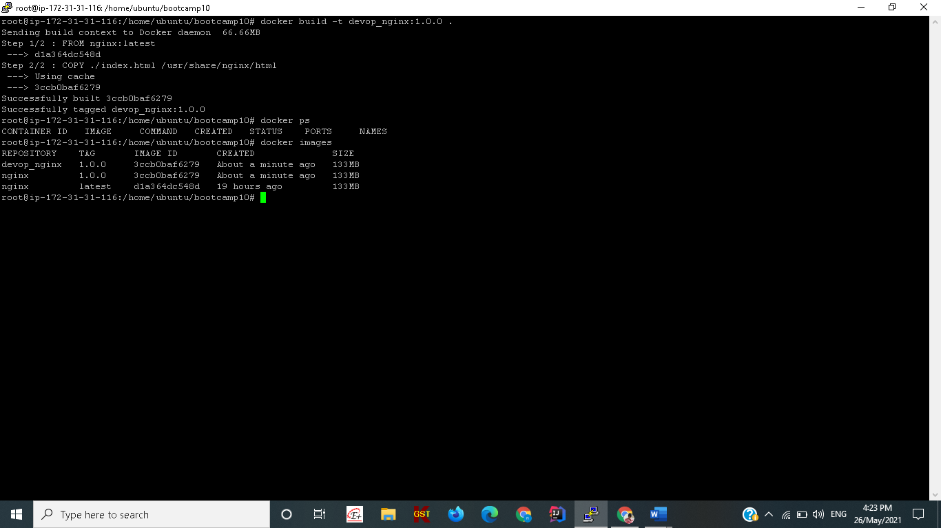

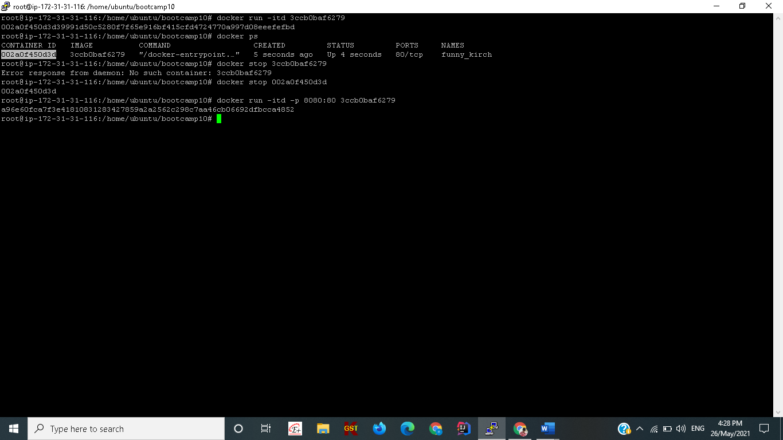

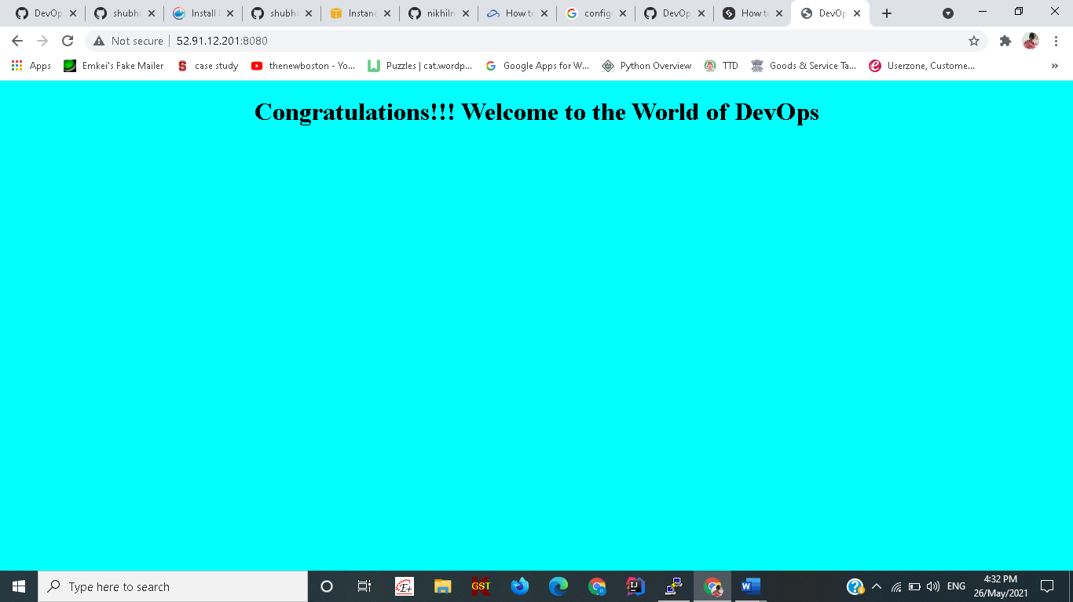

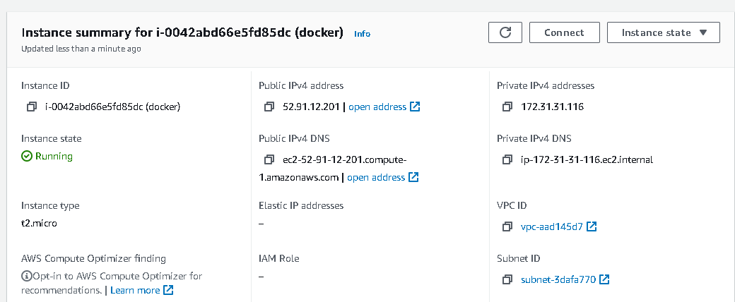

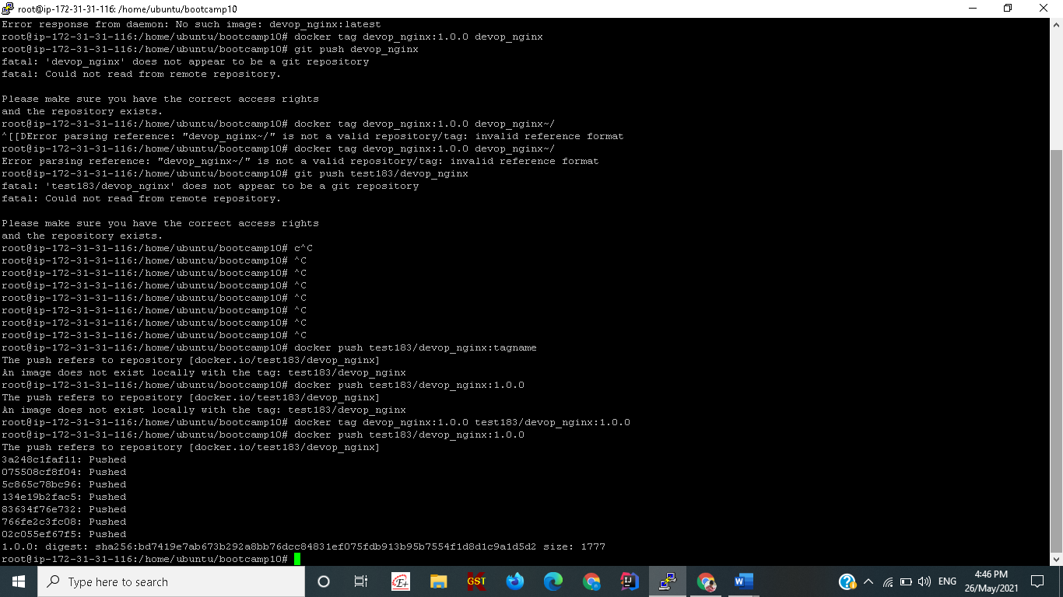

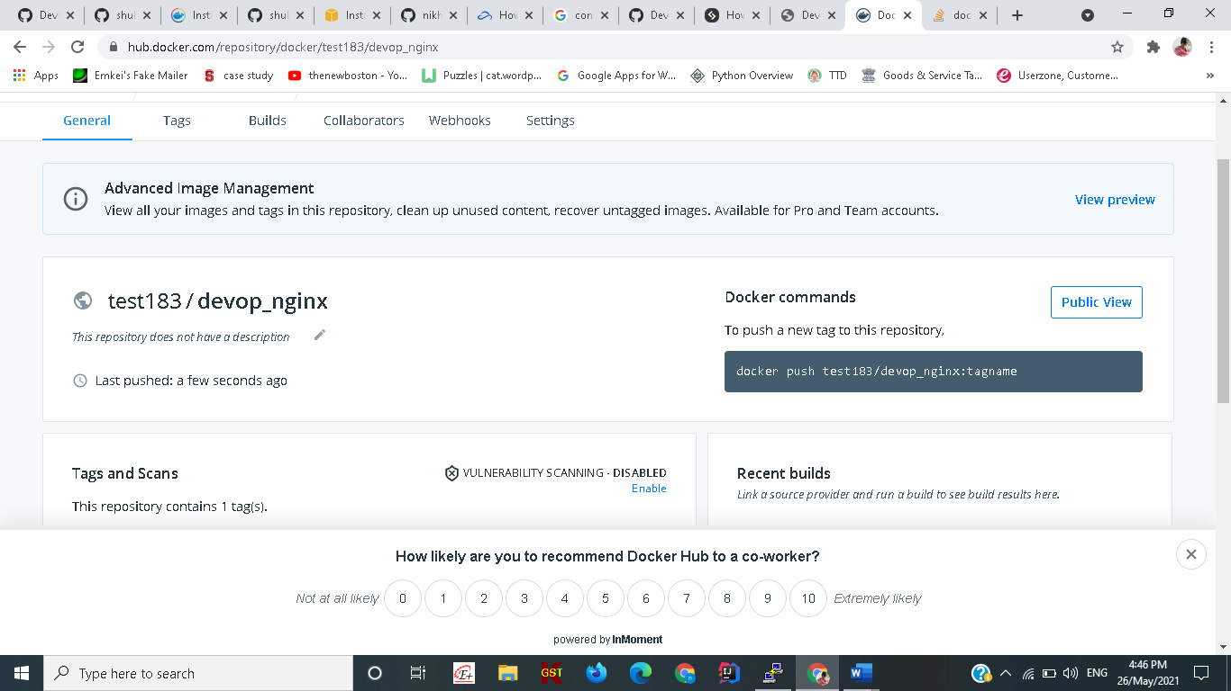

**Docker pull and run**

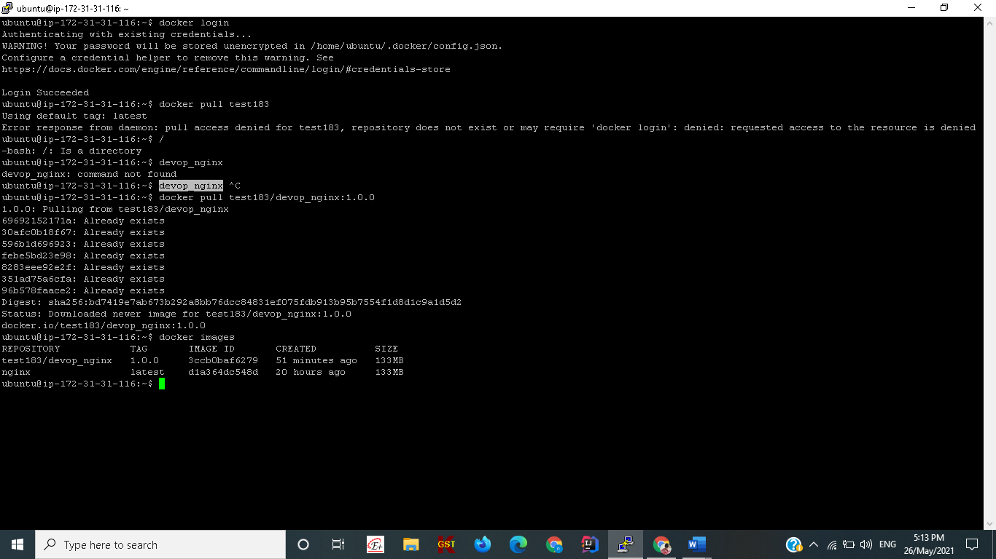



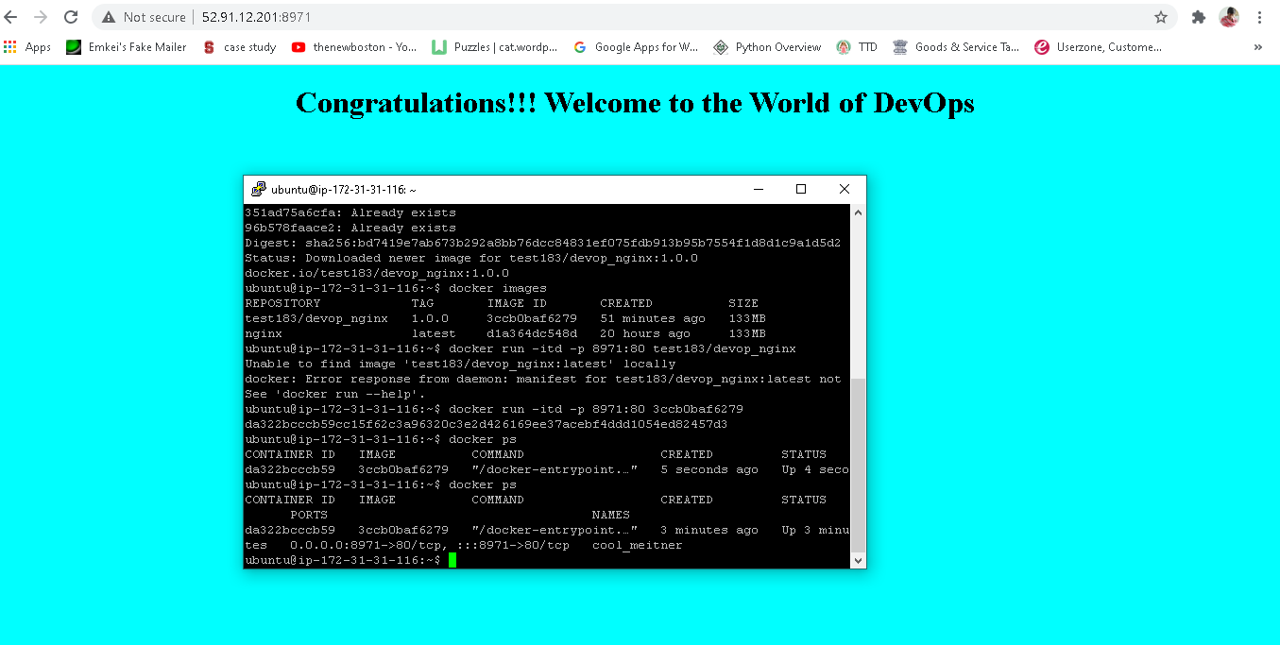



**Docker-Compose**

