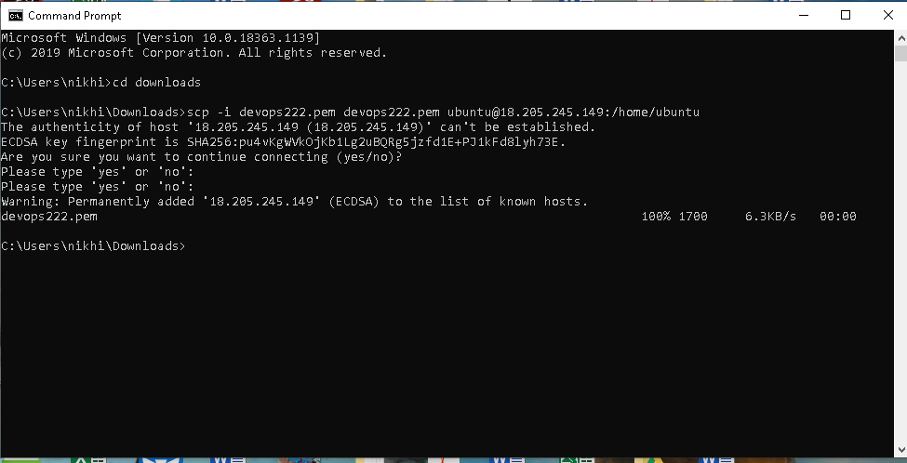

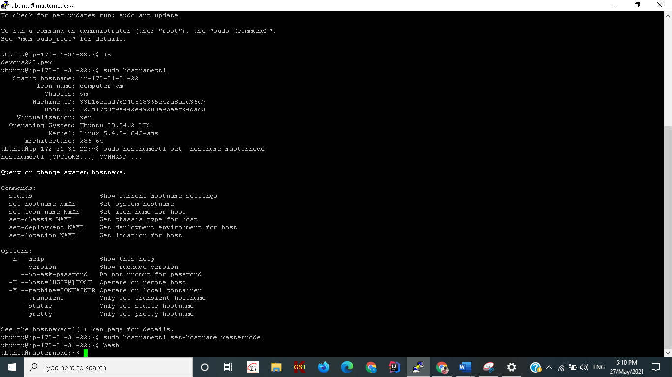

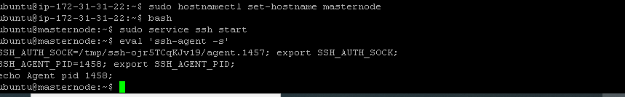

sudo service ssh start

eval `ssh-agent -s`

chmod 400 devops222.pem

sudo chown -R ubuntu:ubuntu /home/ubuntu

ssh-add devops222.pem

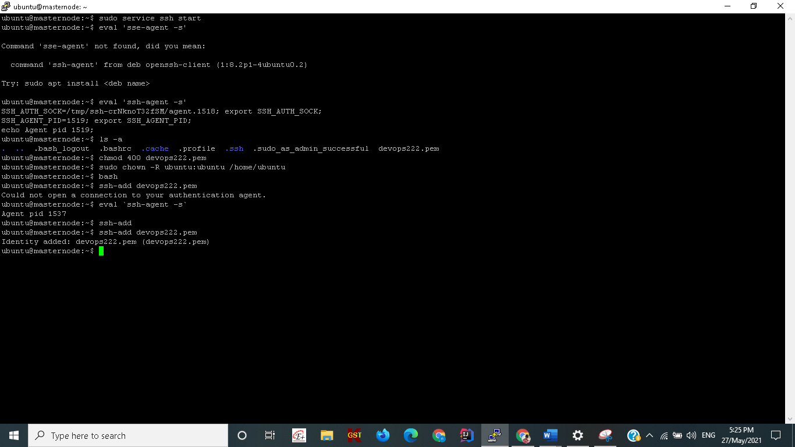

ssh ubuntu@54.147.162.247

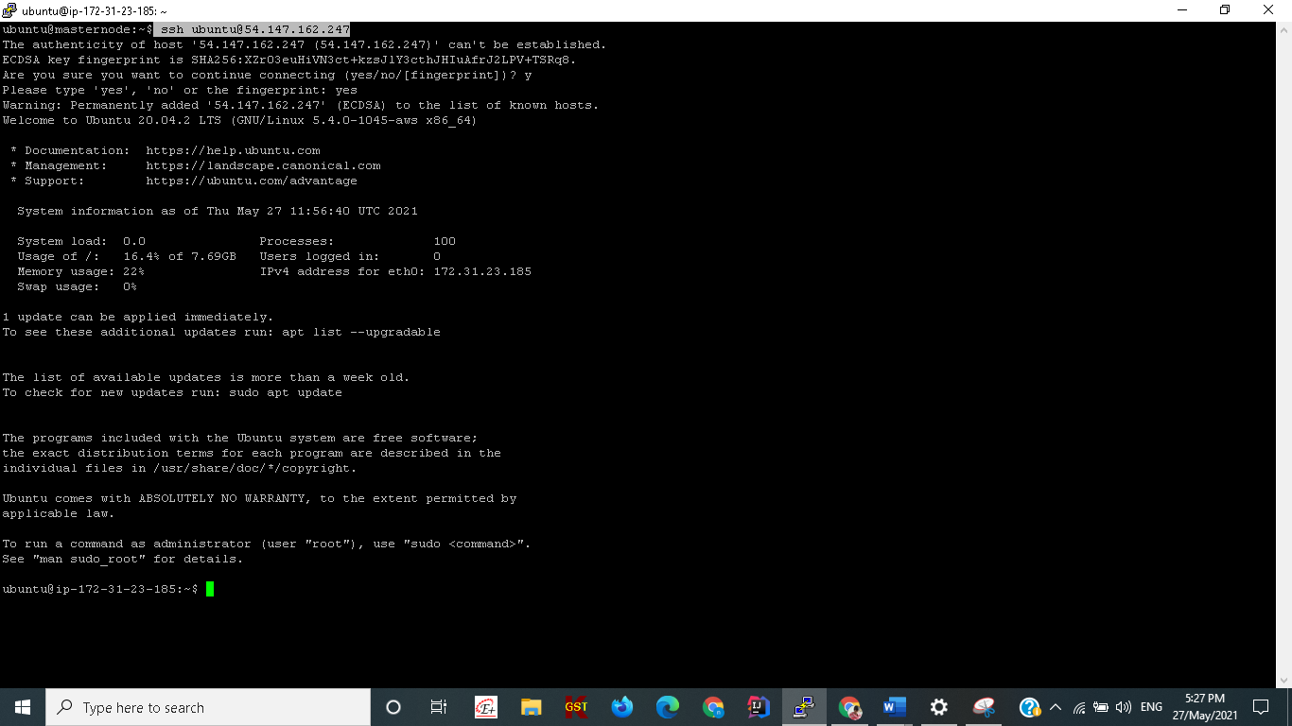

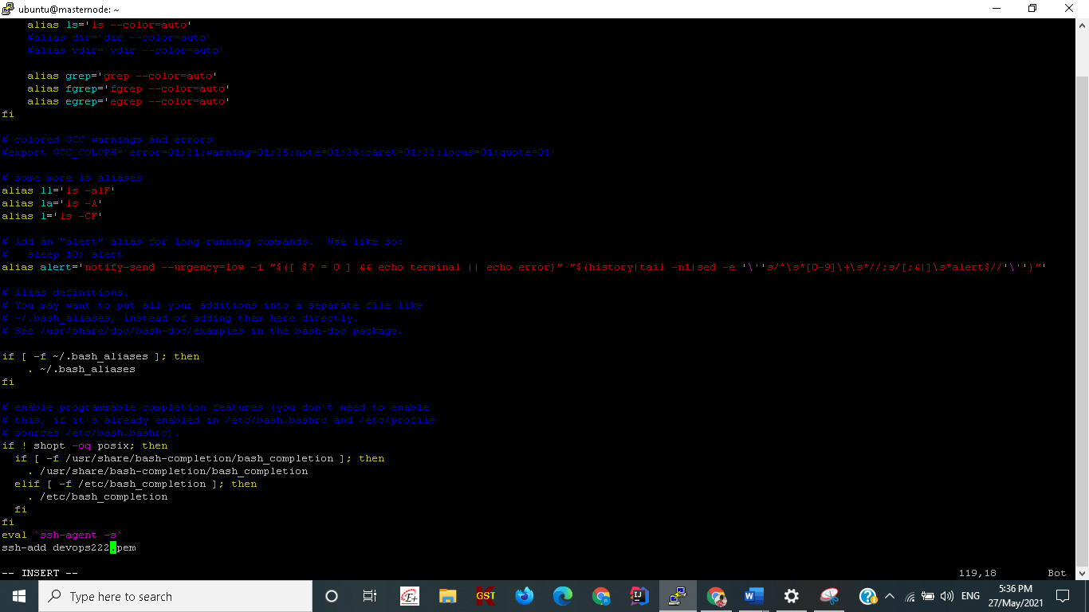

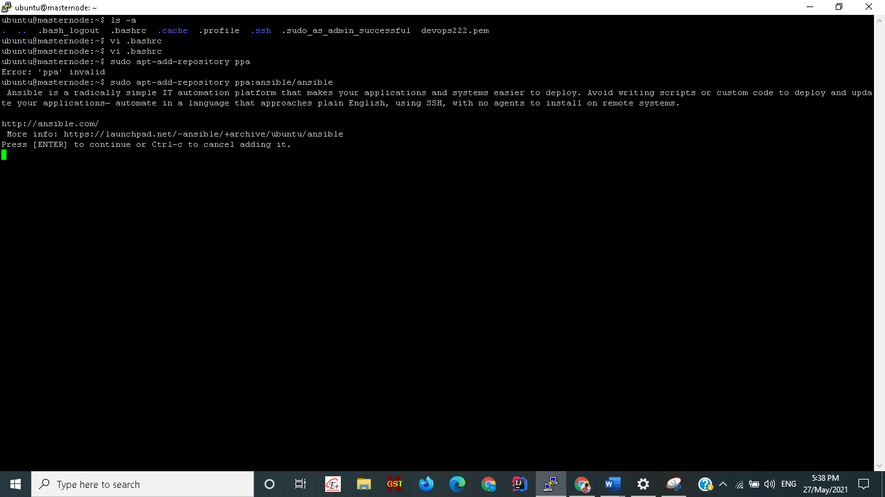

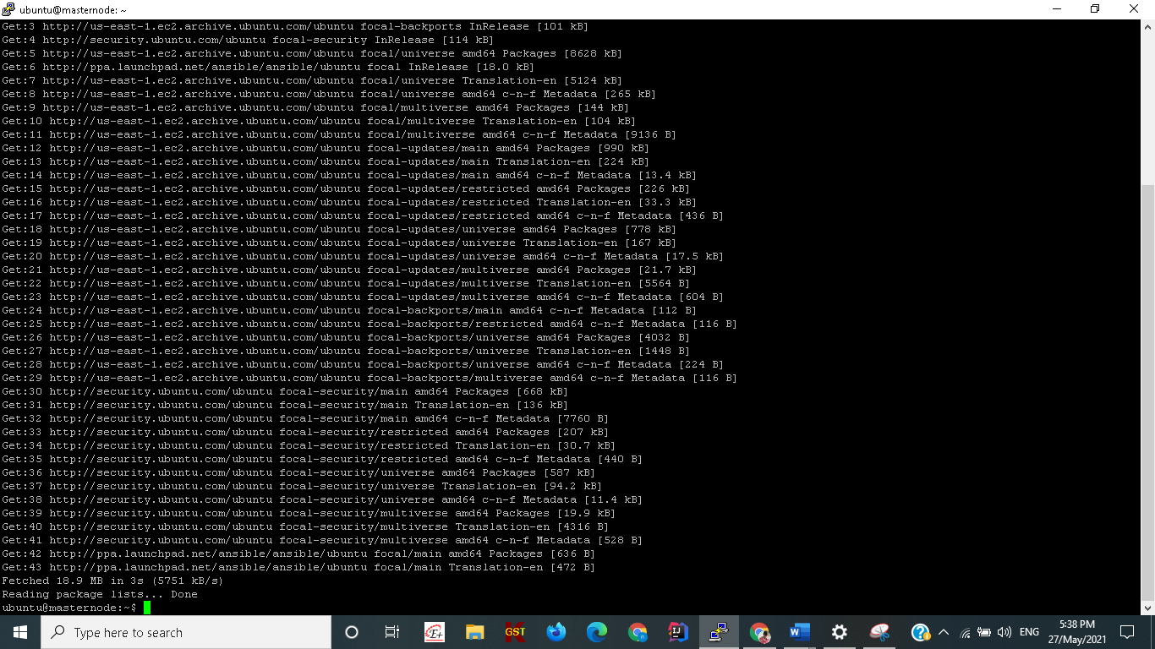

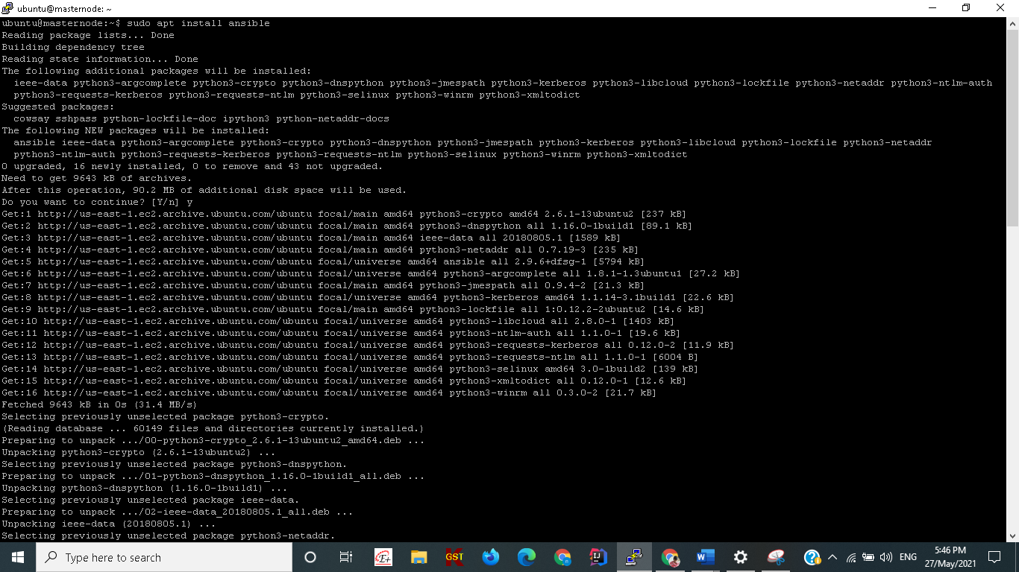

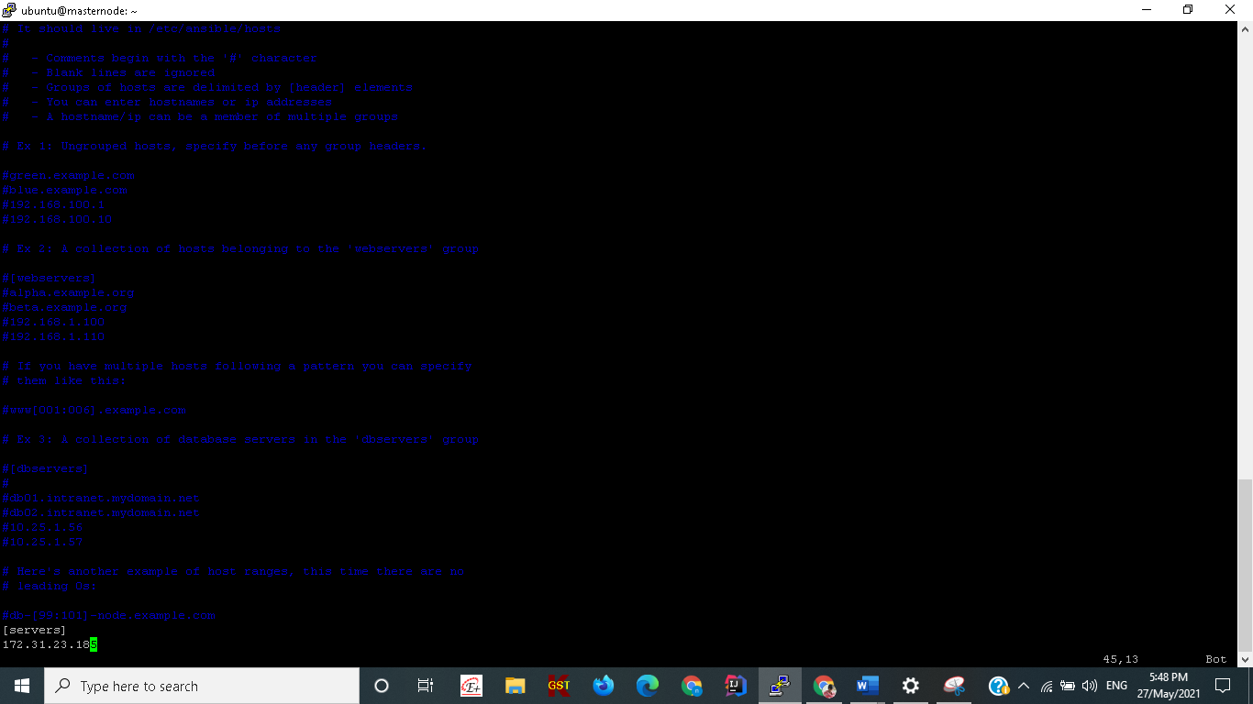

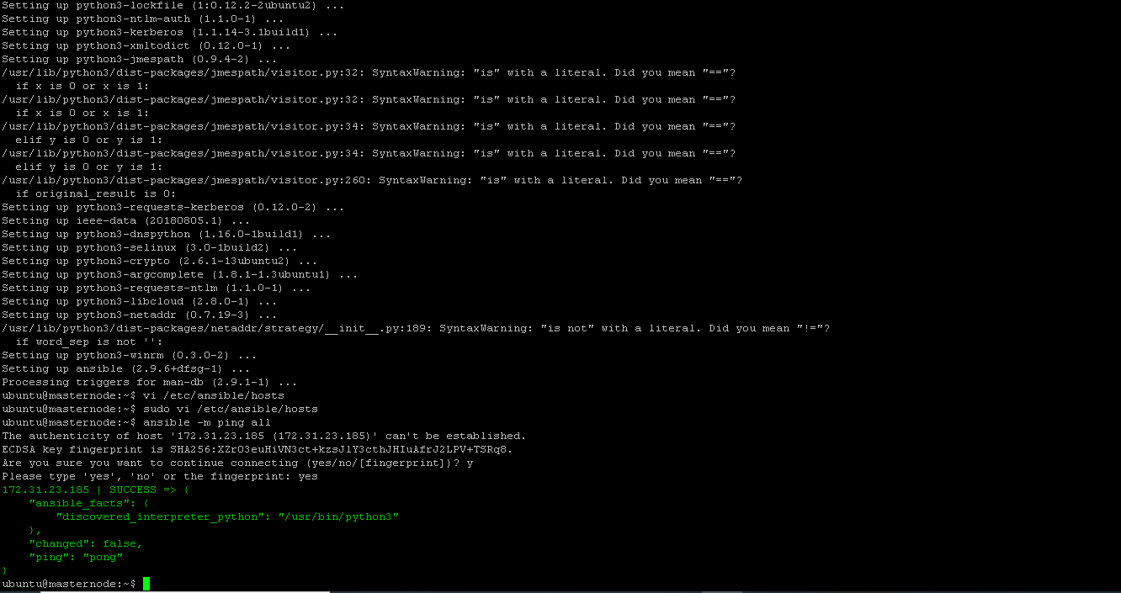

---

- hosts: all

become: true

tasks:

- name: install default-jre

become: true

apt: default-jre state=latest

- name: install maven

become: true

apt: maven

- name: install nginx server

become: true

apt: nginx state=present

- name: install docker

become: true

apt: docker.io

- name: start docker server

service:

name: docker

status: started

enabled: true

- name: docker run service

command: sudo docker run -itd -p 8080:80 shubhamkushwah/addressbook:1.0

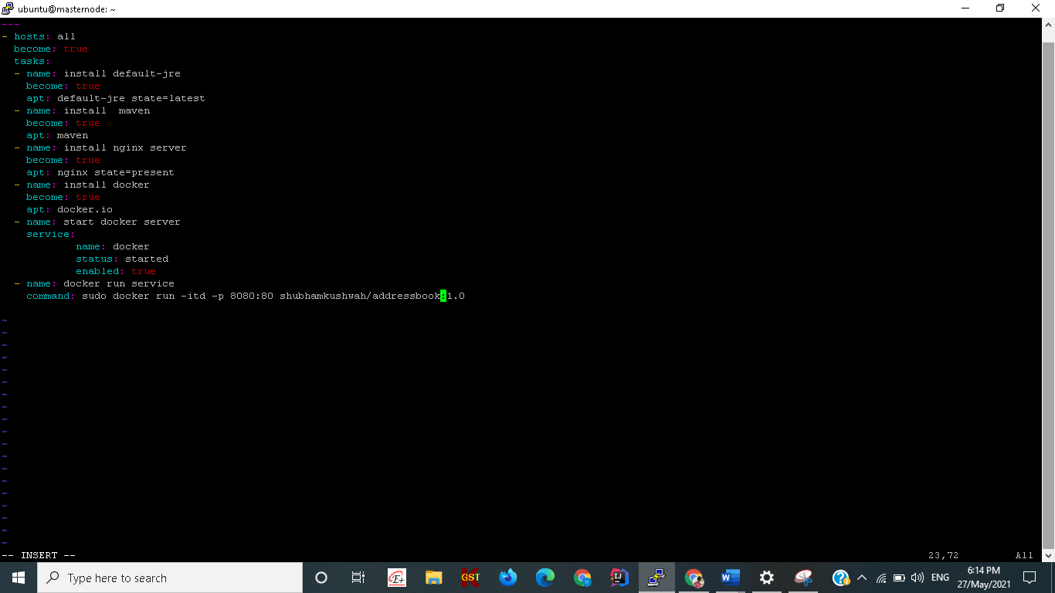

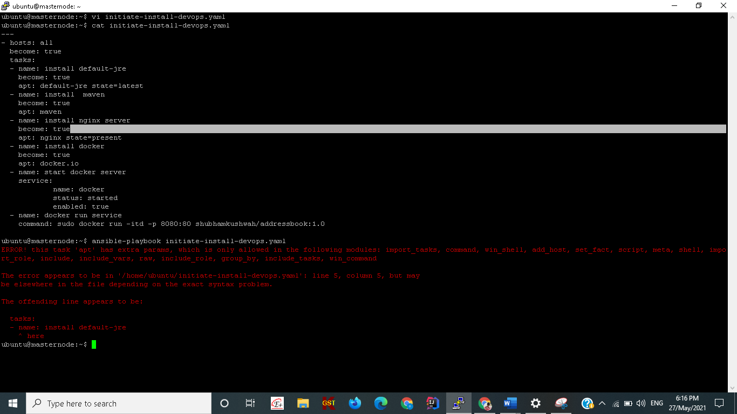

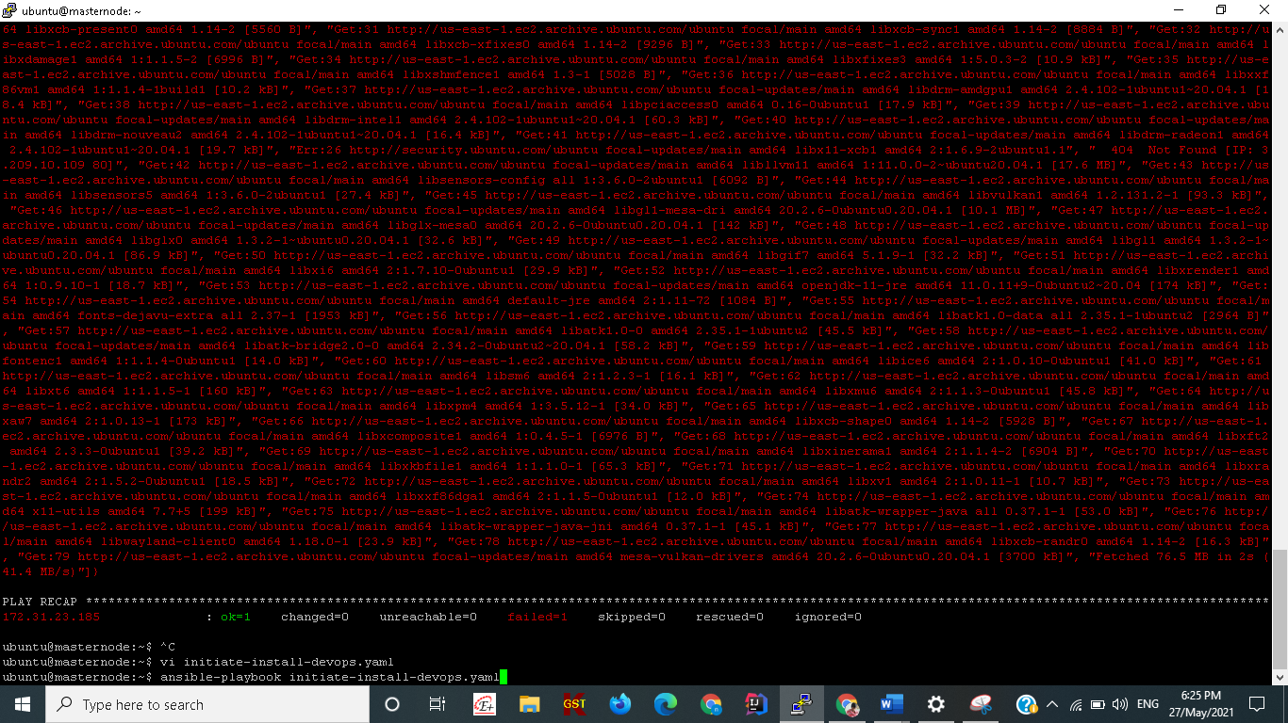

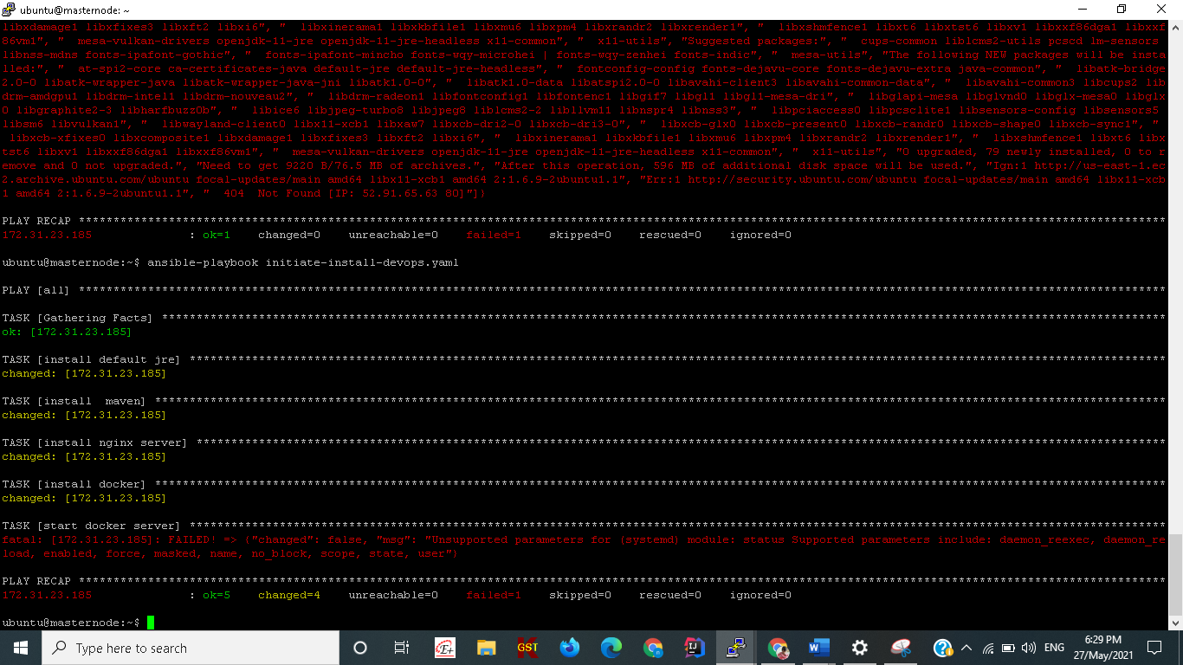

ubuntu@masternode:~$ cat initiate-install-devops.yaml

---

- hosts: all

become: true

tasks:

- name: install default jre

become: true

apt:

pkg: default-jre

state: present

- name: install maven

become: true

apt:

pkg: maven

state: present

- name: install nginx server

become: true

apt:

pkg: nginx

state: present

- name: install docker

become: true

apt:

pkg: docker.io

state: present

- name: start docker server

service:

name: docker

state: started

enabled: true

- name: docker run service

command: docker run -itd -p 8085:8080 test183/addressbook:2.0

ubuntu@masternode:~$

