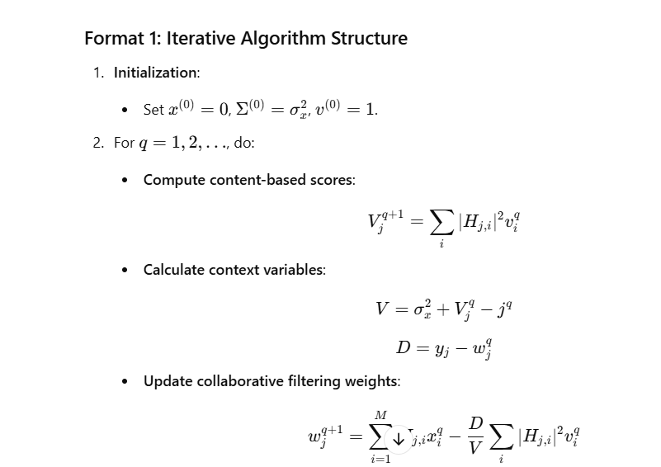

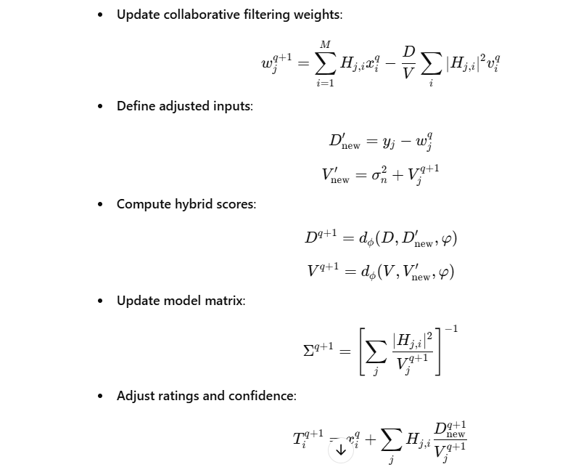

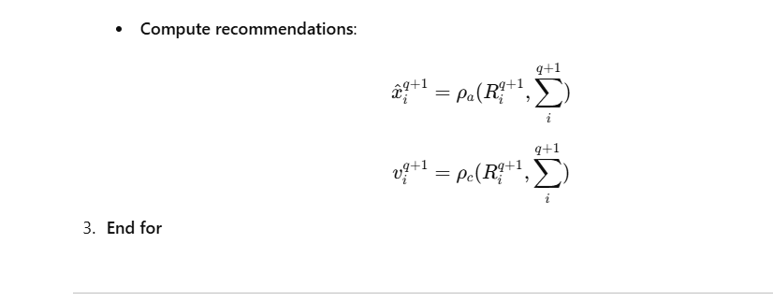

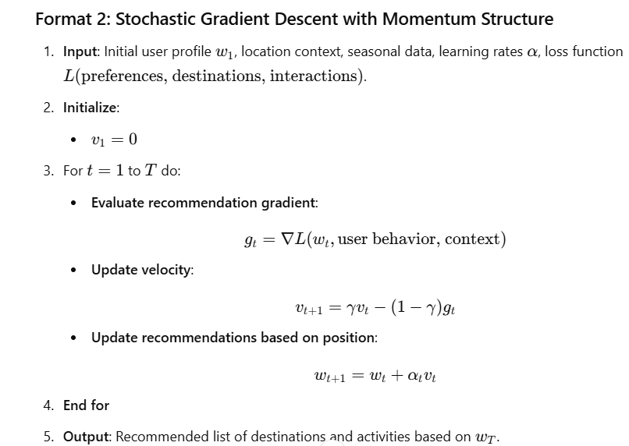

EXPLANATION

**1. Initialization of User Profile**

* **User Interests**: Begin by setting up a user profile with general preferences, like interests in adventure, cultural experiences, relaxation, etc.
* **Starting Recommendations**: Use default values or popular options to kickstart recommendations for new users who haven’t yet interacted with the platform.

**2. Iterative Recommendation Process**

For each user interaction (e.g., clicking on a destination, saving an activity), update recommendations in a loop to refine suggestions:

* **Content-Based Filtering (Lines 4-6)**
  + Calculate content-based scores by analyzing the features of destinations (e.g., activity types, descriptions, popularity) and comparing these with user interests.
  + Use attributes like “nature,” “urban,” “beach,” or “mountain” to determine what matches the user’s preferences and filter out irrelevant options.
  + Adjust recommendations based on current location and season—for instance, suggesting ski resorts in winter or beach destinations in summer.
* **Collaborative Filtering (Lines 7-9)**
  + Use collaborative filtering to identify similar users and recommend destinations that these users have liked.
  + Adjust weights based on similarity to other users who have visited similar destinations or shown similar interests.
  + For example, if multiple users who like hiking have given high ratings to a particular mountain destination, this place might be recommended to a new user who also likes hiking.
* **Hybrid Filtering (Lines 10-12)**
  + Combine both content and collaborative filtering scores to create a balanced recommendation.
  + Calculate the hybrid score, considering both destination features and the collective preferences of similar users.
  + This helps the system generate more accurate and relevant suggestions by leveraging both types of data.

**3. Context-Aware Filtering (Lines 13-15)**

* **Seasonal Adjustments**: Use seasonal and time-based adjustments to filter recommendations, e.g., suggesting cooler places in summer or winter-specific activities.
* **Location-Based Suggestions**: Show nearby attractions and activities if the user is already at a destination, considering their radius and preferences.
* **Event-Based Recommendations**: Include recommendations based on events happening near the user's location, like festivals or local gatherings, making the experience timely and location-specific.

**4. Applying Stochastic Gradient Descent for Real-Time Adjustment (Second Format)**

* As users interact with recommendations (e.g., click, save, or book), apply a gradient-based adjustment to refine their profile in real time.
* **Update Velocity and Position (Lines 5-6)**:
  + Each interaction is treated as feedback. The algorithm updates the recommendation velocity and position, adjusting the user’s profile to better match current preferences.
  + For example, if a user frequently interacts with adventure-related activities, increase the weight for adventure-type recommendations.

**5. Real-Time Feedback Loop**

* **Adjust Recommendations Based on User Feedback (Final Output)**:
  + Continuously update recommendations based on actions such as saving or ignoring suggestions.
  + The algorithm learns from these interactions, adjusting both collaborative and content-based scores.
  + For instance, if the user repeatedly ignores beach recommendations, the system will deprioritize them and favor activities or destinations that better match their actions.

**6. Final Output: Personalized Recommendations**

* The algorithm provides a ranked list of travel destinations, activities, and accommodations tailored to the user's profile and recent behavior.
* This list adapts dynamically as users provide more input, becoming more accurate over time.

**Practical Application Flow**

1. **User Signs Up or Logs In**: Initialize the user profile with preferences or demographic data.
2. **User Browses Destinations**: The algorithm generates a mix of popular and personalized recommendations.
3. **User Interacts with Recommendations**: The system updates preferences using collaborative filtering and gradient adjustments.
4. **Recommendations Refined**: As the user interacts more, the recommendations become more relevant to their interests and context.
5. **Feedback Loop**: The process repeats with continuous adjustments, optimizing for long-term personalization and engagement.

By implementing this algorithm, the tourism platform can offer a more interactive, responsive experience, making it easier for users to find suitable destinations, activities, and travel services that align with their preferences and contexts.